Received 00th January 20xx,

1. School of Pharmacy, University of Nottingham, NG7 2RD Nottingham, U.K.
2. ​ Department for Molecular Microbiology and Biotechnology, Tel Aviv University, 6997801 Tel Aviv, Israel
3. Department of Oral Biology, The Goldschleger School of Dental Medicine, Sackler Faculty of Medicine, Tel Aviv University, 6997801 Tel Aviv, Israel

*₸*Current address*: Centro Singular de Investigación en Química Biolóxica e Materiais Moleculares (CIQUS) and Departamento de Química Orgánica, Universidade de Santiago de Compostela, Jenaro de la Fuente s/n, 15782 Santiago de Compostela, Spain.*

†Corresponding author: [Rhiannon.Creasey@gmail.com](mailto:Rhiannon.Creasey@gmail.com), current address: *University of Queensland, School of Chemical Engineering, Qld 4072, Australia*.

‡ Corresponding author: [Saul.Tendler@york.ac.uk](mailto:Saul.Tendler@york.ac.uk), current address: *University of York, YO10 5DD York, U.K.*

Electronic Supplementary Information (ESI) available: Additional AFM images, measurement statistics, and morphology measurements. See DOI: 10.1039/x0xx00000x

Accepted 00th January 20xx

DOI: 10.1039/x0xx00000x

www.rsc.org/

Disruption of Diphenylalanine Assembly by a Boc-Modified Variant

Rhiannon C. G. Creaseya†, Iria Louzaoa₸, Zohar A. Arnonb, Pini Marcob, Lihi Adler-Abramovichc, Clive J. Robertsa, Ehud Gazitb, and Saul J. B. Tendlera‡

Peptide-based biomaterials are key to the future of diagnostics and therapy, promoting applications such as tissue scaffolds and drug delivery vehicles. To realise the full potential of the peptide systems, control and optimisation of material properties are essential. Here we invesigated the co-assembly of the minimal amyloid motif peptide, diphenylalanine (FF), and its tert-butoxycarbonyl (Boc)-modified derivative. Using Atomic Force Microscopy, we demonstrated that the co-assembled fibers are less rigid and show a curvier morphology. We propose that the Boc-modification of FF disrupts the hydrogen bond packing of adjacent N-termini, as supported by Fourier transform infrared and fluorescence spectroscopic data. Such rationally modified co-assemblies offer chemical functionality for after-assembly modification and controllable surface properties for tissue engineering scaffolds, along with tunable morphological *vs.* mechanical properties.

Introduction

Functional biomaterials have recently gained interest for various applications such as drug delivery vehicles, tissue engineering scaffolds, structural and antibacterial composites, and nanoelectronics1–4. Owing to the chemical and structural properties of amino acid building blocks, peptides are an ideal component for developing self-assembling materials with biological compatibility5–9. Thus, short peptides have gathered considerable attention in recent medical research, as they represent core motifs in a range of protein aggregation disorders, such as Alzheimer’s and prion diseases10–12. A fundamental understanding of peptide self-assembly is required in medical research for the diagnosis and treatment of such disorders. Additionally, the spatial, temporal and structural control of self-assembled structures is vital for realizing the widespread potential of applicable functional peptide materials.

One avenue of exploration for the development of peptide materials is to rationally modify their properties, including mechanical and chemical functionality13–16, *via* incorporation of multiple monomers into the self-assembled structure. Diphenylalanine (FF), the core recognition module of the -amyloid polypeptide, readily forms uniquely rigid tubular and ordered structures with intriguing optical17, piezoelectric18 and mechanical properties in aqueous conditions19,20,21. The introduction of additional amino acids, such as cysteine22 or another phenylalanine,23 alters the morphology and mechanical properties of such self-assembly products. In addition, modifications of the FF termini24,25 have shown that a range of structures can be created under the same conditions. To further understand and exploit the full range of properties available using short peptide sequences, co-assemblies have been investigated13,26,27. For example, a mixture of di-D-2-napthylalanine and FF resulted in tunable mechanical properties *via* non-homogeneous co-assembly13. As the aromatic residues are essential for the formation and stabilization of FF assemblies28,29, it is not surprising that these co-assembled fibers displayed lower stiffness relative to the unmodified FF tubes.

Herein, we explore the effects of a chemical alteration of the N-terminus of the peptide backbone on the assembly of FF by the addition of a tert-butoxycarbonyl (Boc)-modified FF variant, which was recently used to control the physical length of FF nano-assemblies27. Using atomic force microscopy (AFM), we show that a mixture of FF and Boc-FF forms fibers in aqueous conditions, and that these mixed peptide fibers are less rod-like than pure FF fibers due to their reduced stiffness. The intermolecular interactions were investigated *via* fluorescence and FTIR spectroscopy, displaying a change in the hydrogen bonding and π-π interactions.

The tunable morphological, chemical, and mechanical properties observed are of interest in the field of regenerative medicine1,30. Additionally, this kind of co-assembling behavior is of value for further understanding amyloid fibril formation, and for development of pharmaceutical agents to treat amyloid-associated pathologies31.

Experimental

Molecular models

FF and Boc-FF chemical structures were built using ChemBioDraw Ultra (CambridgeSoft, v. 14). These structures were imported into freeware VegaZZ32 (v. 3.0.5), where a 20 molecules deep water layer was added before NAMD energy minimisation. Following removal of water molecules, the polar surface area was calculated.

Self-assembly

Conditions used were as seen previously27. Briefly, FF (Sigma-Aldrich) was dissolved in water to a concentration of 2 mg/mL (ultrapure, 18.2 MΩ) and heated while stirred until dissolved. Boc-FF (Bachem) was dissolved in ethanol (Sigma-Aldrich) to a concentration of 50 mg/mL. Boc-FF solution was added to hot (approx. 90 °C) FF solutions to final concentrations of 0.16, 0.32, 0.64 and 1.3 mM with stirring. Samples were allowed to cool to RT without stirring to precipitate assemblies.

After cooling, 5 μL of solution, including visible precipitates, was transferred onto freshly cleaved mica (for AFM analysis, see supporting information) and onto cleaned Silicon wafer (for FTIR analysis).

Atomic Force Microscopy

AFM topography, adhesion and stiffness images were acquired using an Icon FastScan (Bruker instruments) AFM in Peakforce QNM (quantitative nanomechanical mapping) mode using nominal cantilever properties (Bruker RTESPA probes, nominal f ~ 300 kHz, k ~ 40 N/m, tip radius 10 nm). Image analysis was undertaken using freeware Gwyddion33 v2.37 and ImageJ v1.49 (http://imagej.nih.gov/ij/). The number of fibers measured for rigidity was 51, 38, 41, 31, 43, and 19 for 6 mM FF alone, 40:1, 20:1, 10:1, 5:1 ratio of FF:Boc-FF, and 10 mM Boc-FF alone, respectively. Rigidity was defined as the ratio between the end-to-end distance and fiber length (supporting information).

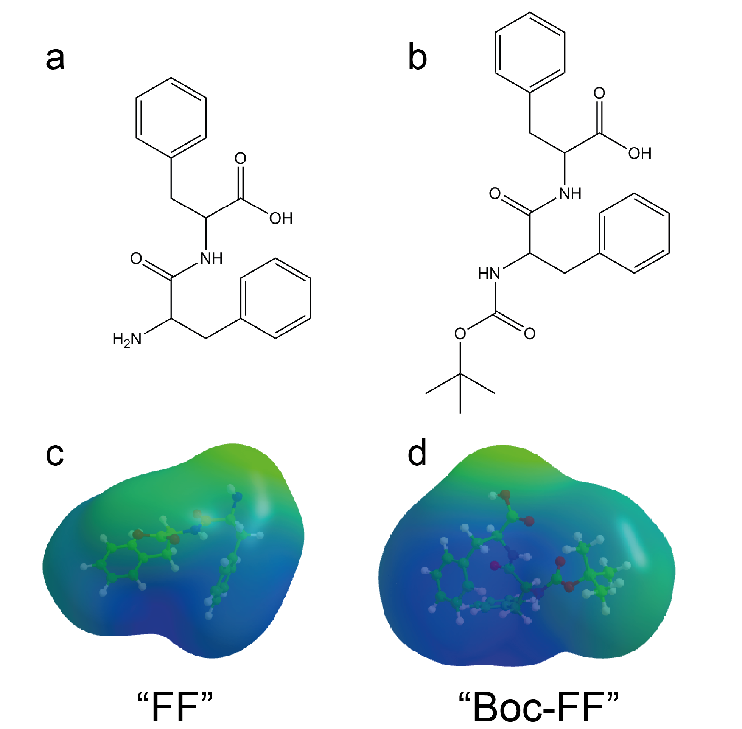

Figure 1: (a,b) Chemical structure of (a) diphenylalanine (FF) and (b) Boc-modified diphenylalanine (Boc-FF). (c,d) 3D stick models with a polar surface area overlay where green to blue is more to less polar, respectively, for (c) FF and (d) Boc-FF.

AFM single point mechanical measurements were performed on an Asylum MFP3D (Oxford Instruments) using Bruker MPP-13120 probes (nominal f ~ 525 kHz, k ~ 200 N/m). Mechanical analyses were performed using Asylum Research software (Igor Pro v6, AR v13.11.94) *via* the inbuilt JKR model (more information provided in supporting information). Tip shape was estimated using indentation of a calibration polymer sample. All fibers measured were >100 nm in diameter, with a minimum of 10 curves acquired per spot. The number of fibers measured was 18, 10, 8, 8, 2 and 12 for 6 mM FF solely, 40:1, 20:1, 10:1, 5:1 ratio of FF:Boc-FF, and 10 mM Boc-FF solely, respectively. Statistics were prepared using Microsoft Excel 2010. All errors stated are standard deviation.

Spectrophotometry

ATR-FTIR data was collected on an Agilent Cary 630 FTIR over 64 scans with 2 cm-1 resolution. Final spectra were averaged from two repeat samples.

Fluorescence data was acquired with a Varian Cary Eclipse fluorescence spectrophotometer at an excitation of 265 nm. Final spectra were averaged from two 1 mL aliquots of undiluted solution with visible precipitates in quartz cuvettes of 1 cm pathlength.

Results and Discussion

To explore co-assembly properties, we have used a mixture of FF and Boc-FF monomers. The uncharged Boc group has been added to the N-terminus of the dipeptide (Figure 1 [a,b]), leaving the aromatic residues free to interact.

It has been previously shown that removing the N-terminus charge *via* addition of a Boc group still allows for FF-like structure formation24,25. Molecular dynamics simulations suggest that the N-terminus is responsible for stabilizing early-stage aggregates, while the final tube structure does not rely on the charged termini regions34. As seen in Figure 1 (c), the N-terminus and amide backbone regions are the most polar areas of FF, aligning along one side of the molecule. The Boc-FF polar areas are less segregated (Figure 1 ([d]), leading to less obvious amphiphilic orientation of the molecule and reduced opportunities for intermolecular hydrogen bonding.

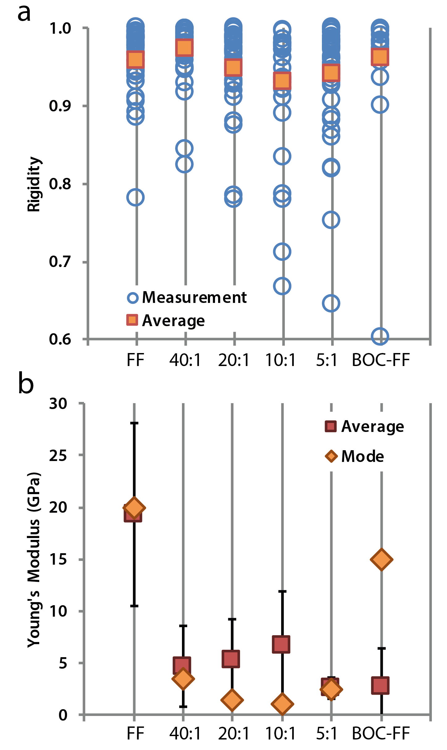

Figure 3: (a) Graph of fiber rigidity described as a ratio between the end-to-end distance and the fiber length, where 1 represents a perfectly straight rod. Circle markers show the direct measurement and square markers show the average rigidity for FF alone, 40:1 FF:Boc-FF, 20:1 FF:Boc-FF, 10:1 FF: Boc-FF, 5:1 FF:Boc-FF, and Boc-FF alone, from left to right, as labelled. (b) Graph of Young’s modulus measurements of the peptide assemblies on mica for FF alone, 40:1 FF:Boc-FF, 20:1 FF:Boc-FF, 10:1 FF: Boc-FF, 5:1 FF:Boc-FF, and Boc-FF alone, from left to right, as labelled. Diamond markers show the mode and square markers show the average (± standard deviation) Young’s modulus.

Morphology

An aqueous mixture of FF and Boc-FF resulted in fibrous structures. While maintaining FF concentration at 6 mM, the relative amount of Boc-FF was gradually increased in order to evaluate the effect on fiber assembly. This was done in hot solution to maintain FF solubility and quickly evaporate ethanol during the Boc-FF addition. The assemblies were visually observed to precipitate from the solution during cooling. The precipitates were then examined using AFM, as shown in Figure 2, where fibers of diameter <500 nm were imaged. Straight FF fibers were observed (Figure 2 [a]), which became less linear and rod-like with the addition of Boc-FF in a concentration-dependent manner (Figure 2 [b-e]). In addition, the fibers formed from a mixture of FF and Boc-FF showed a larger range of cross-section diameters, including more fibers of smaller diameter (<100 nm). Sample regions with fine mesh-like structures (such as that shown in Figure 2 [e]) or apparently amorphous layers were more commonly observed in the co-assemblies containing a higher Boc-FF concentration. These fibrils are similar to those observed in Boc-FF transition states between spheres and tubes25, and may consist of Boc-FF only27.

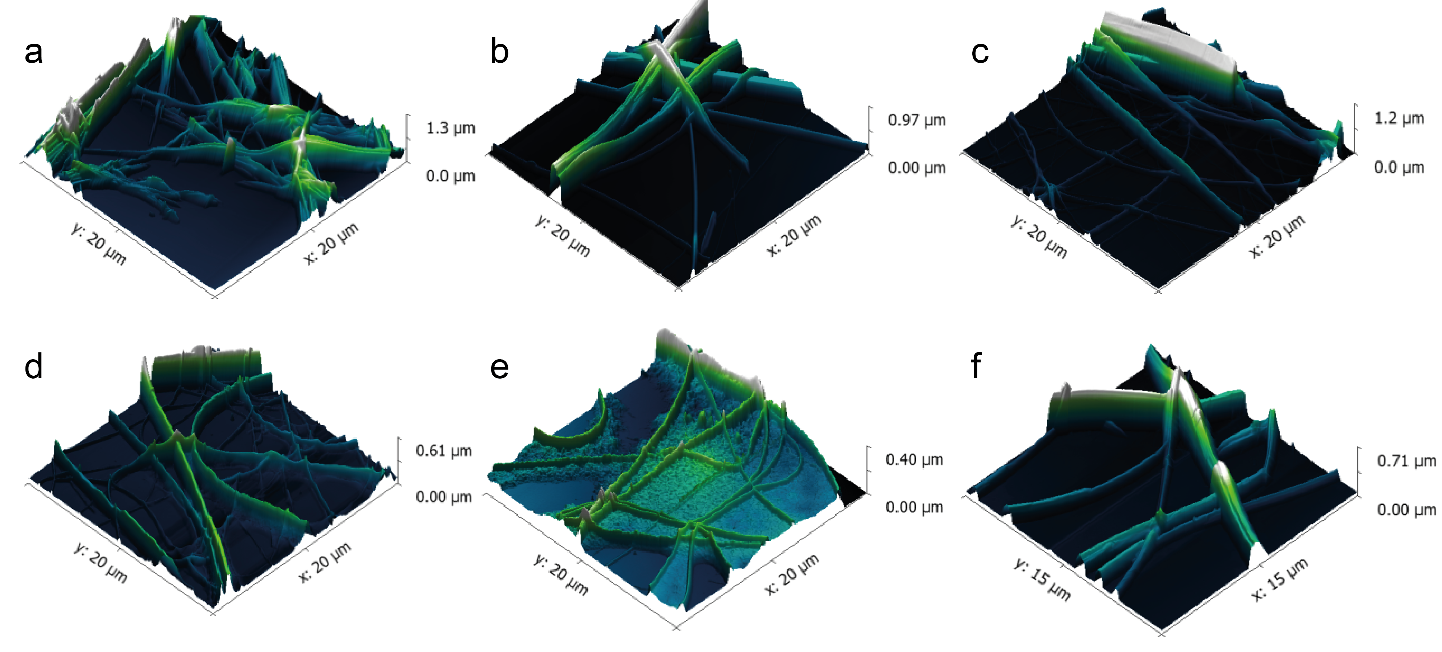

Figure 2: (a – f) 3D AFM topography images of the peptide assemblies on mica using constant concentration of the FF peptide and an increasing ratio of Boc-FF concentration as follows: (a) FF alone, (b) 40:1 FF:Boc-FF, (c) 20:1 FF:Boc-FF, (d) 10:1 FF: Boc-FF, (e) 5:1 FF:Boc-FF, and (f) Boc-FF alone.

The observation that fibers were more flexible in the co-assemblies was quantified by measuring the end-to-end distance of the fibers and calculating rigidity as shown in Figure 3 (a) and summarized in Table 1.

As the concentration of Boc-FF increased, the distribution of rigidity also increased, except for the 5:1 sample (observed in Figure 3[a] and Table S1). This difference was most marked in fibers <150 nm in diameter (Figure S3). There is less spread in the rigidity measurements of the sole dipeptide assemblies, in line with the bulk phase observation of more rod-like assemblies (as observed visually). We suggest that these observations reflect a change in the bending strength of the fibers, as supported by Young’s modulus measurements via point indentation measurements using AFM (Figure 3 [b]).

Table 1: Measurements from AFM data on fibers

|  |  |  |  |
| --- | --- | --- | --- |
| Ratio  FF:Boc-FF | Rigidity | Young’s Modulus (GPa) | |
| Average | Average | Mode |
| FF solely | 0.96 | 19.3 ± 8.8 | 20 |
| 40:1 | 0.97 | 4.6 ± 3.9 | 3.5 |
| 20:1 | 0.95 | 5.2 ± 4.0 | 1.5 |
| 10:1 | 0.93 | 6.6 ± 5.2 | 1 |
| 5:1 | 0.94 | 2.6 ± 1.0 | 2.5 |
| Boc-FF solely | 0.96 | 2.7 ± 3.7 | 15 |

Mechanical Properties

The modulus seen for FF assemblies was similar to expected values35, although there was a relatively large spread in the data. AFM images of the surface of fibers showed that mono-assemblies exhibit rougher surfaces on the top of the fiber compared to co-assemblies (Figure S4). However, in the case of FF fibers, this roughness was more structured (*e.g*., lamellae or ridges), whereas the co-assembled surfaces were more random in appearance. Correspondingly, contrast was also observed in the adhesion and stiffness images. Hence, the large spread in data may be due to the difficulty in reproducibly placing the AFM tip precisely on the top and center of the fiber. The large data spread may also be due to the variable nature of the interior of the fibers. Further investigations utilizing indentation and analyzing the indentation portion of the retraction curve may yield information about the interior nature of the nanotubes.

The average Young’s modulus, summarized in Table 1, did not follow a linear trend relative to the ratio of Boc-FF added. As the Boc-FF was increased, the average modulus also increased until the 5:1 FF:Boc-FF ratio, where it dropped sharply (similarly to the rigidity data in Figure 3). Simultaneously, the mode of the modulus decreased until the 5:1 FF:Boc-FF ratio where a slight increase was observed. The discrepancy in mode and average values reflects an asymmetrical spread in the data. Given this asymmetry, it is appropriate to use the mode rather than the average for evaluation of the mechanical properties of the fibers in bulk. It should also be noted that co-assembly data of 5:1 FF:Boc-FF was collected from two fibers only, as it was difficult to locate separated fibers of sufficient diameter to include in the data set, although a large number of curves (>100) were collected on each fiber.

The co-assemblies show lower rigidity and Young’s modulus than the mono-assemblies, reflecting their weaker mechanical properties. This trend continues for the 40:1 – 10:1 FF:Boc-FF ratios. However, the 5:1 ratio has a higher average rigidity and mode modulus than the other assemblies, suggesting a saturation point in terms of Boc-FF addition after which co-assemblies are no longer the dominant aggregation pathway. In combination with the AFM results in Figure 2 (e), the precipitates of the 5:1 ratio may be phase segregated fibrils of Boc-FF and FF mono-assemblies25,27. Investigation of this saturation point may offer more options and control for tunable mechanical strength *vs*. morphology of fibers for materials applications. This would be of particular interest in tissue engineering and cell culture, where the nanoscale morphological and mechanical environment is vital for controlling stem cell differentiation36,37.

We have observed two resulting effects of co-assembly of Boc-FF and FF: 1, a change in morphology (an increase of fiber bundling and bending), and 2, reduction of point mechanical strength. While these effects could be due to capping by regions composed of Boc-FF, it is more likely that the Boc group is disrupting the formation of the assemblies, resulting in defected sites within the fibers. This is in agreement with the second observation, with fibers becoming more flexible / weaker with increased Boc-FF. Therefore, fluorescence and ATR-FTIR spectroscopies were used to examine the intermolecular environment of the co-assembled fibers.

Fluorescence

It is known that excitation of phenylalanine results in broad or shifted fluorescence emission peaks when the phenylalanine residue participates in π-π stacking with adjacent phenylalanines38,39. As shown in Figure 4, the main peak associated with phenylalanine (285 nm) is slightly red-shifted compared to reference spectra40, along with small additional peaks at 361 and 423 nm. These features are consistent with an altered electronic state of the aromatic rings41,42. The Boc-FF fibers show a further red-shift and broadening of the main peak at 287 nm, as well as a reduction of the additional small peaks. These data reflect a different aromatic stacking arrangement in the Boc-FF fibers compared to the FF fibers. Further fluorescence changes were observed when the co-assemblies π-π stacking was examined (Figure 4 [b]).

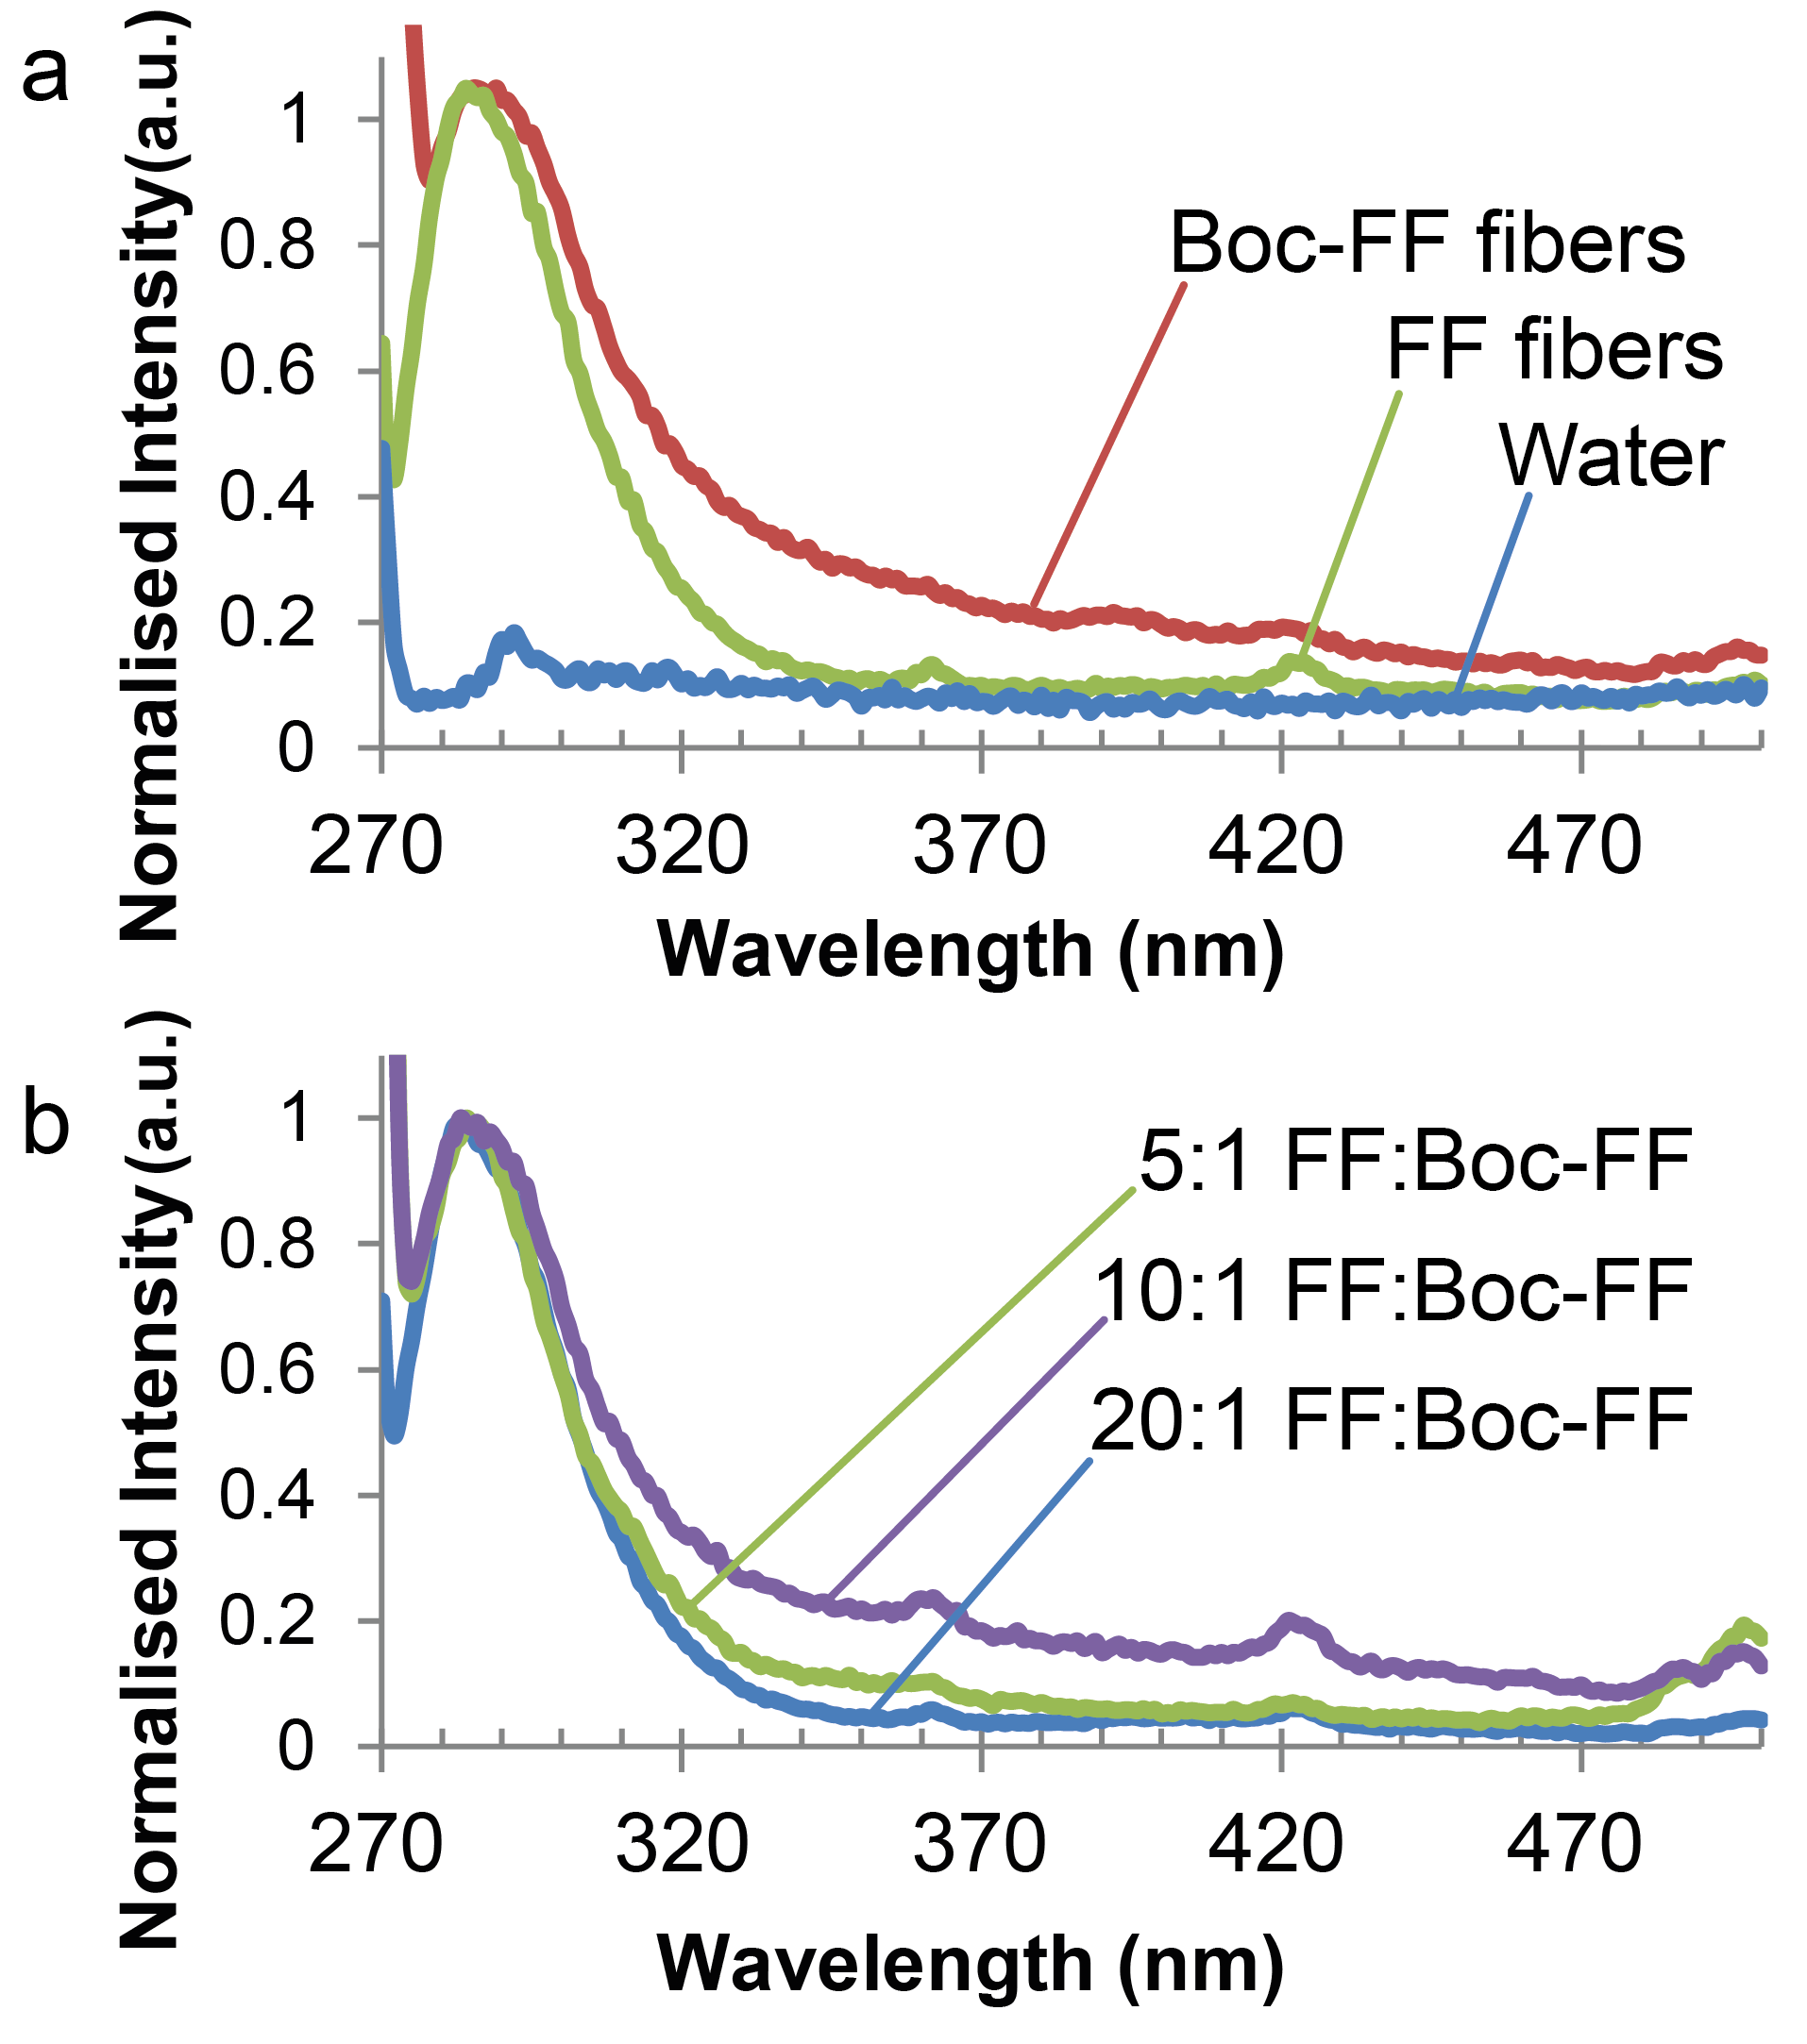

Figure 4: Fluorescence emission spectra of peptides in water with excitation of 265 nm. (a) Boc-FF alone, FF alone, and water. (b) 5:1 FF:Boc-FF, 10:1 FF: Boc-FF, 20:1 FF:Boc-FF co-assemblies.

FTIR

To obtain a detailed understanding of the arrangement of the co-assemblies, ATR-FTIR was performed. FTIR spectra were collected on solid-state precipitates of Boc-FF alone, 5:1 FF:Boc-FF, 10:1 FF:Boc-FF, 20:1 FF: Boc-FF, 40:1 FF:Boc-FF, and FF alone (Figure 5, from top to bottom). As expected, the CO stretching at 1700 – 1750 cm-1 increased in intensity relative to the proportion of Boc-FF. Additionally, the peak at 1696 cm-1 may be attributed to the carbamate28,43, suggesting that the first Amide I peak shift could similarly reflect the change in the chemistry of the peptide monomers. The Amide I (CO stretching) and Amide II (NH bending and CN stretching) regions are of interest for intermolecular changes (Figure 5 [b] and Table 2). The two Amide I bands seen for FF alone can be attributed to antiparallel -sheet arrangement44–46, in agreement with previously proposed structures for FF fibers12,47. The Boc-FF band at 1663 cm-1 indicates a change in secondary structure, suggesting a different hydrogen bonding arrangement in the Boc-FF fibers. X-Ray crystallography of analogous dipeptides containing one tyrosine attributed a kink-like structure for those fibrils, which have shown similar bands to Boc-FF fibers in their FT-IR spectra48, but other structures such as 310 helix49 cannot be ruled out. The co-assemblies reflect a mixture of the peaks observed for the mono-assemblies, with the 40:1 and 20:1 samples showing peaks similar to FF, while the 10:1 and 5:1 samples are more similar to Boc-FF.

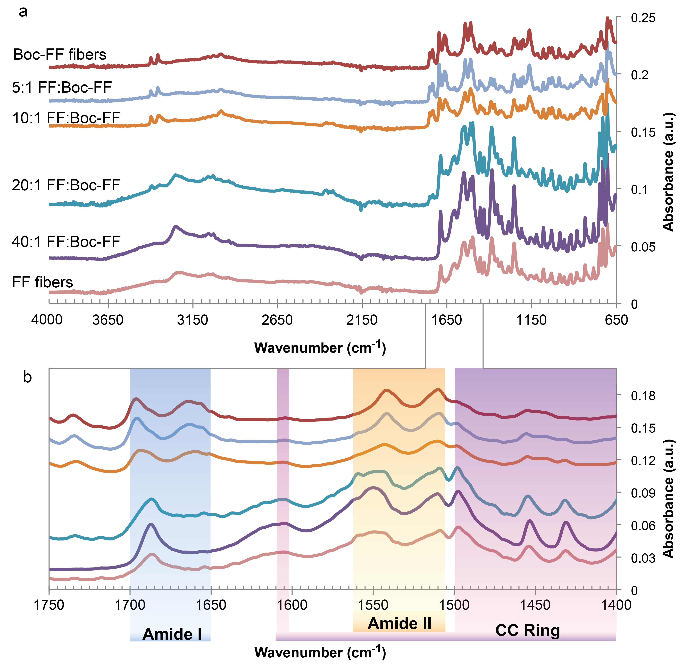

Figure 5: Offset ATR-FTIR of assembled peptides in the solid-state showing (a) the full spectrum, and (b) highlighting the Amide I & II and C-C ring vibrational regions for BOC-FF fibers, 5:1 FF:BOC-FF, 10:1 FF:BOC-FF, 20:1 FF: BOC-FF, 40:1 FF:BOC-FF, and FF fibers, from top to bottom.

The Amide II region shows two bands for the FF fibers at around 1550 cm-1, and at 1543 cm-1 for Boc-FF fibers. The co-assemblies have a variety of changes relative to the mono-assemblies in this region. The 40:1 mixture has a narrower band at 1550 and the second peak is slightly red-shifted relative to the FF fibers. The 20:1 mixture has a significantly more pronounced shoulder at 1559 cm-1, and slightly more of a shoulder at 1517 cm-1. The 10:1 and 5:1 samples are more similar to the Boc-FF fibers, with the band showing at 1542 and 1541 cm-1, respectively.

Table 2: Peak positions for FTIR measurements on fibers in Amide regions

|  |  |  |  |
| --- | --- | --- | --- |
| Ratio  FF:Boc-FF | Amide I cm-1 | | Amide II cm-1 |
| FF solely | 1686 | 1606 | 1542 – 1553 |
| 40:1 | 1687 | 1605 | 1545 – 1553 |
| 20:1 | 1687 | 1606 | 1542 – 1553 |
| 10:1 |  | 1663 | 1542 |
| 5:1 |  | 1663 | 1541 |
| Boc-FF solely |  | 1663 | 1543 |

The Amide A region (3310 – 3270 cm-1, NH stretching) is independent of the secondary structure, while very sensitive to the strength of hydrogen bonds. FF fibers show a broad band of absorption in this region, particularly at lower frequencies, indicating the presence of strong hydrogen bonds. This band is present in all of the co-assembly spectra; however, when increasing the relative amount of Boc-FF, the band declines and two additional peaks increase in intensity at 3347 and 3495 cm-1. These new peaks suggest that some NH functionalities are very weakly or not at all involved in hydrogen bonds 50,51. Taken together, the data suggests that the supramolecular interactions such as hydrogen bonding and the aromatic ring interactions are stronger in the FF mono-assemblies, conferring strength to the fibers35. This is an unexpected result, as highly rigid Boc-FF structures have been observed utilizing different assembly conditions52. The co-assemblies of FF and Boc-FF did not present significantly altered spectroscopic data compared to mono-assemblies, although reduced hydrogen bonding was apparent in the 10:1 sample (the highest concentration of Boc-FF in which co-assemblies could stably form).

Mechanism of Assembly

The co-assembly of FF and Boc-FF is facilitated by the central diphenylalanine common major recognition interface. As demonstrated in the crystal structure of the diphenylalanine assemblies by Gorbitz53, the aromatic moieties provide a high-affinity interface that includes aromatic interactions as well as hydrogen bonding. While both FF and Boc-FF share this common module that allow strong interactive process, the incorporation of the additional bulky Boc group results in steric hindrance that disturbs the canonical growth. This produces new architectures which are significantly shorter. In addition, the Boc group adds steric bulk onto the periphery of the structure, preventing the close interaction of the peptide backbone seen in modelling of FF tube formation19,20,34. This causes a disruption of the aromatic interactions, shifting the orientation of the benzenes π-π stacking. Such a change prevents interlocking aromatic ‘zippers’19 between oligomers, thereby reducing the likelihood of hierarchical growth. This explains the smaller diameters and increased bundling of the co-assembled fibers. If the aromatic ‘zippers’ are misaligned, there will be a lesser chance for further peptide aggregation and more hydrophobic residues (such as the Boc and non-stacked aromatic groups) present at the surface, leading to more bundling of fibers in water. These surface groups may be utilized for chemical interactions, such as fiber crosslinking or adding specific recognition moieties for tissue engineering applications. They may also provide supramolecular sites for drug delivery candidates.

Conclusions

We have investigated the co-assembly of FF and Boc-FF to form fibers under aqueous conditions. The fibers are not phase separated and represent a molecular co-assembly. Co-assembled fibers show reduced Young’s modulus and rigidity as measured by AFM. Using fluorescence and FTIR spectroscopy, a reduction in hydrogen bonding and an alteration of the electronic state of the aromatic residues in the co-assemblies was observed. Therefore, we propose that the change in physical properties of the fibers is due to a reduction in the hydrogen bonding and an alteration of the π-π stacking between monomers, altering the packing of FF and Boc-FF assembly. The addition of a Boc group allows the fibers to be grown with varying morphologies and mechanical properties depending on the ratio of the two monomeric dipeptides, while also altering the chemical groups available for functionalization for novel materials applications. Investigations are ongoing to determine the precise mechanism of assembly. However, from the current data, there is a significant range of potential applications resulting from the controlled assembly of FF-modified variants utilizing the controllable mechanical and chemical properties demonstrated.

Acknowledgements

The authors gratefully acknowledge the European Molecular Biology Organisation for the short-term travel fellowship of R. Creasey, and Professor Xinyong Chen for experimental assistance.

References

1. 1 R. Ravichandran, M. Griffith and J. Phopase, *J. Mater. Chem. B*, 2014, **2**, 8466–8478.
2. 2 N. Stephanopoulos, J. H. Ortony and S. I. Stupp, *Acta Mater.*, 2013, **61**, 912–930.
3. 3 L. Adler-Abramovich and E. Gazit, *Chem. Soc. Rev.*, 2014.
4. 4 D. Woolfson and M. Ryadnov, *Curr. Opin. Chem. Biol.*, 2006, **10**, 559–567.
5. 5 J. H. Collier and T. Segura, *Biomaterials*, 2011, **32**, 4198–4204.
6. 6 A. Lakshmanan, S. Zhang and C. E. Hauser, *Trends Biotechnol.*, 2012, **30**, 155–65.
7. 7 R. Fairman and K. S. Akerfeldt, *Curr. Opin. Struct. Biol.*, 2005, **15**, 453–63.
8. 8 B. J. Pepe-Mooney and R. Fairman, *Curr. Opin. Struct. Biol.*, 2009, **19**, 483–94.
9. 9 N. Amdurksy, P. Beker and G. Rosenman, in *Peptide Materials: From Nanostructures to Applications*, eds. C. Alemán, A. Bianco and M. Venanzi, John Wiley & Sons, Chichester, UK, 2013.
10. 10 G. Invernizzi, E. Papaleo, R. Sabate and S. Ventura, *Int. J. Biochem. Cell Biol.*, 2012, **44**, 1541–1554.
11. 11 F. Chiti and C. M. Dobson, *Annu. Rev. Biochem.*, 2006, **75**, 333–366.
12. 12 M. Reches and E. Gazit, *Science*, 2003, **300**, 625–7.
13. 13 V. L. Sedman, X. Chen, S. Allen, C. J. Roberts, V. Korolkov and S. J. B. Tendler, *J. Microsc.*, 2013, **249**, 165–72.
14. 14 J. P. Jung, A. K. Nagaraj, E. K. Fox, J. S. Rudra, J. M. Devgun and J. H. Collier, *Biomaterials*, 2009, **30**, 2400–2410.
15. 15 R. Chapman, M. Danial, M. L. Koh, K. Jolliffe and S. Perrier, *Chem. Soc. Rev.*, 2012, **41**, 6023–6041.
16. 16 A. D. Martin, A. B. Robinson and P. Thordarson, *J. Mater. Chem. B*, 2015, **3**, 2277–2280.
17. 17 N. Amdursky, M. Molotskii, E. Gazit and G. Rosenman, *J. Am. Chem. Soc.*, 2010, **132**, 15632–15636.
18. 18 A. Kholkin, N. Amdursky and I. Bdikin, *ACS Nano*, 2010, **4**, 610–614.
19. 19 I. Azuri, L. Adler-Abramovich, E. Gazit, O. Hod and L. Kronik, *J. Am. Chem. Soc.*, 2014, **136**, 963–969.
20. 20 Y. Song, S. R. Challa, C. J. Medforth, Y. Qiu, R. K. Watt, J. E. Miller, V. Swol, J. Shelnutt, W. Lafayette, A. March, D. Pena, J. E. Miller, F. van Swol, J. Shelnutt, V. Swol, J. Shelnutt, W. Lafayette and A. March, *Chem. Commun.*, 2004, 1044–1045.
21. 21 X. Yan, P. Zhu and J. Li, *Chem. Soc. Rev.*, 2010, **39**, 1877–1890.
22. 22 M. Reches and E. Gazit, *Nano Lett.*, 2004, **4**, 581–585.
23. 23 C. Guo, Y. Luo, R. Zhou and G. Wei, *Nanoscale*, 2014, **6**, 2800–2811.
24. 24 M. Reches and E. Gazit, *Isr. J. Chem.*, 2005, **45**, 363–371.
25. 25 A. Levin, T. O. Mason, L. Adler-Abramovich, A. K. Buell, G. Meisl, C. Galvagnion, Y. Bram, S. A. Stratford, C. M. Dobson, T. P. J. Knowles and E. Gazit, *Nat. Commun.*, 2014, **5**, 5219.
26. 26 H. Vilaça, G. Pereira, T. Castro, B. Hermenegildo, J. Shi, T. Q. Faria, N. Micaelo, R. Brito, B. Xu, E. M. S. Castanheira, J. A. Martins and P. M. Ferreira, *J. Mater. Chem. B*, 2015.
27. 27 L. Adler-Abramovich, P. Marco, Z. A. Arnon, R. C. G. Creasey, T. C. T. Michaels, A. Levin, D. J. Scurr, C. J. Roberts, T. P. J. Knowles, S. J. B. Tendler and E. Gazit, *ACS Nano*, 2016, acsnano.6b01587.
28. 28 S. Fleming and R. V. Ulijn, *Chem. Soc. Rev.*, 2014, **43**, 8150–8177.
29. 29 O. S. Makin, E. Atkins, P. Sikorski, J. Johansson and L. C. Serpell, *Proc. Natl. Acad. Sci. U. S. A.*, 2005, **102**, 315–320.
30. 30 X. Li, Y. Yang, Y. Fan, Q. Feng, F. Z. Cui and F. Watari, *J. Biomed. Mater. Res. - Part A*, 2014, **102**, 1580–1594.
31. 31 R. Scherzer-Attali, M. Convertino, R. Pellarin, E. Gazit, D. Segal and A. Caflisch, *J. Phys. Chem. B*, 2013, **117**, 1780–1789.
32. 32 A. Pedretti, L. Villa and G. Vistoli, *J. Comput. Aided. Mol. Des.*, 2004, **18**, 167–173.
33. 33 D. Nečas and P. Klapetek, *Cent. Eur. J. Phys.*, 2012, **10**, 181–188.

34 J. Jeon, C. E. Mills and M. S. Shell, *J. Phys. Chem. B*, 2013, **117**, 3935–3943.

35 N. Kol, L. Adler-Abramovich, D. Barlam, R. Z. Shneck, E. Gazit and I. Rousso, *Nano Lett.*, 2005, **5**, 1343–1346.

36 P. Y. Wang, L. R. Clements, H. Thissen, A. Jane, W. B. Tsai and N. H. Voelcker, *Adv. Funct. Mater.*, 2012, **22**, 3414–3423.

37 G. C. Reilly and A. J. Engler, *J. Biomech.*, 2010, **43**, 55–62.

38 R. C. G. Creasey, Y. Shingaya and T. Nakayama, *Mater. Chem. Phys.*, 2015, **158**, 52–59.

39 K. E. Marshall, K. L. Morris, D. Charlton, N. O’Reilly, L. Lewis, H. Walden and L. C. Serpell, *Biochemistry*, 2011, **50**, 2061–2071.

40 F. Teale and G. Weber, *Biochem. J.*, 1957, **1**, 476–482.

41 A. Handelman, A. Natan and G. Rosenman, *J. Pept. Sci.*, 2014, **20**, 487–493.

42 N. Amdursky, E. Gazit and G. Rosenman, *Biochem. Biophys. Res. Commun.*, 2012, **419**, 232–237.

43 S. Fleming, P. W. J. M. Frederix, I. Ramos Sasselli, N. T. Hunt, R. V. Ulijn and T. Tuttle, *Langmuir*, 2013, **29**, 9510–9515.

44 P. I. Haris and D. Chapman, *Biopolymers*, 1995, **37**, 251–263.

45 A. Barth, *Biochim. Biophys. Acta - Bioenerg.*, 2007, **1767**, 1073–1101.

46 T. Miyazawa and E. R. Blout, *J. Am. Chem. Soc.*, 1961, **83**, 712–719.

47 P. Tamamis, L. Adler-Abramovich, M. Reches, K. Marshall, P. Sikorski, L. Serpell, E. Gazit and G. Archontis, *Biophys. J.*, 2009, **96**, 5020–5029.

48 S. Bera, P. Jana, S. K. Maity and D. Haldar, *Cryst. Growth Des.*, 2014, **14**, 1032–1038.

49 J. Kong and S. Yu, *Acta Biochim. Biophys. Sin.*, 2007, **39**, 549–559.

50 S. H. Gellman, G. P. Dado, G. B. Liang and B. R. Adams, *J. Am. Chem. Soc.*, 1991, **113**, 1164–1173.

51 G. P. Dado and S. H. Gellman, *J. Am. Chem. Soc.*, 1994, **116**, 1054–1062.

52 L. Adler-Abramovich, N. Kol, I. Yanai, D. Barlam, R. Z. Shneck, E. Gazit and I. Rousso, *Angew. Chem. Int. Ed. Engl.*, 2010, **49**, 9939–9942.

53 C. H. Görbitz, *Chem. Commun*., 2006, **22**, 2332–2334.