Table S1. Lipid to BMA ratio and corresponding %mol.
BMA to lipid ratio | %mol of BMA | Lipid (mmol) | BMA (mmol)
0:1 | 0 | 20 | 0
1:1 | 50 | 20 | 20
3:1 | 75 | 20 | 60
4:1 | 80 | 20 | 80

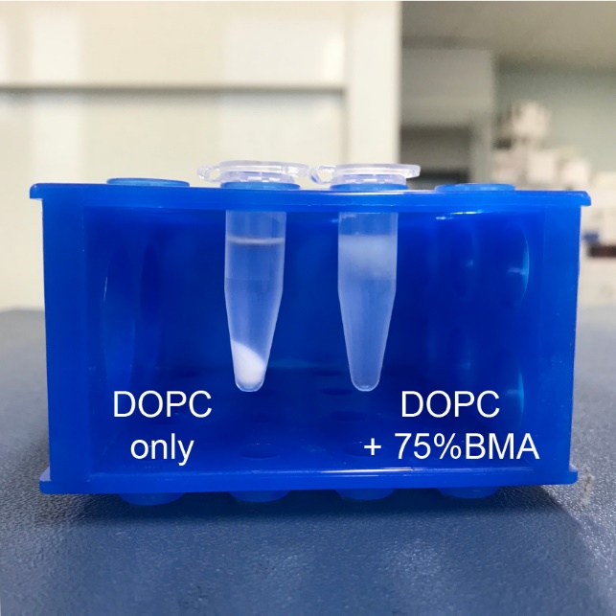
Figure S1. Hydrated liposome of DOPC and DOPC with 75%mol BMA incorporated after centrifugation for 20 mins.
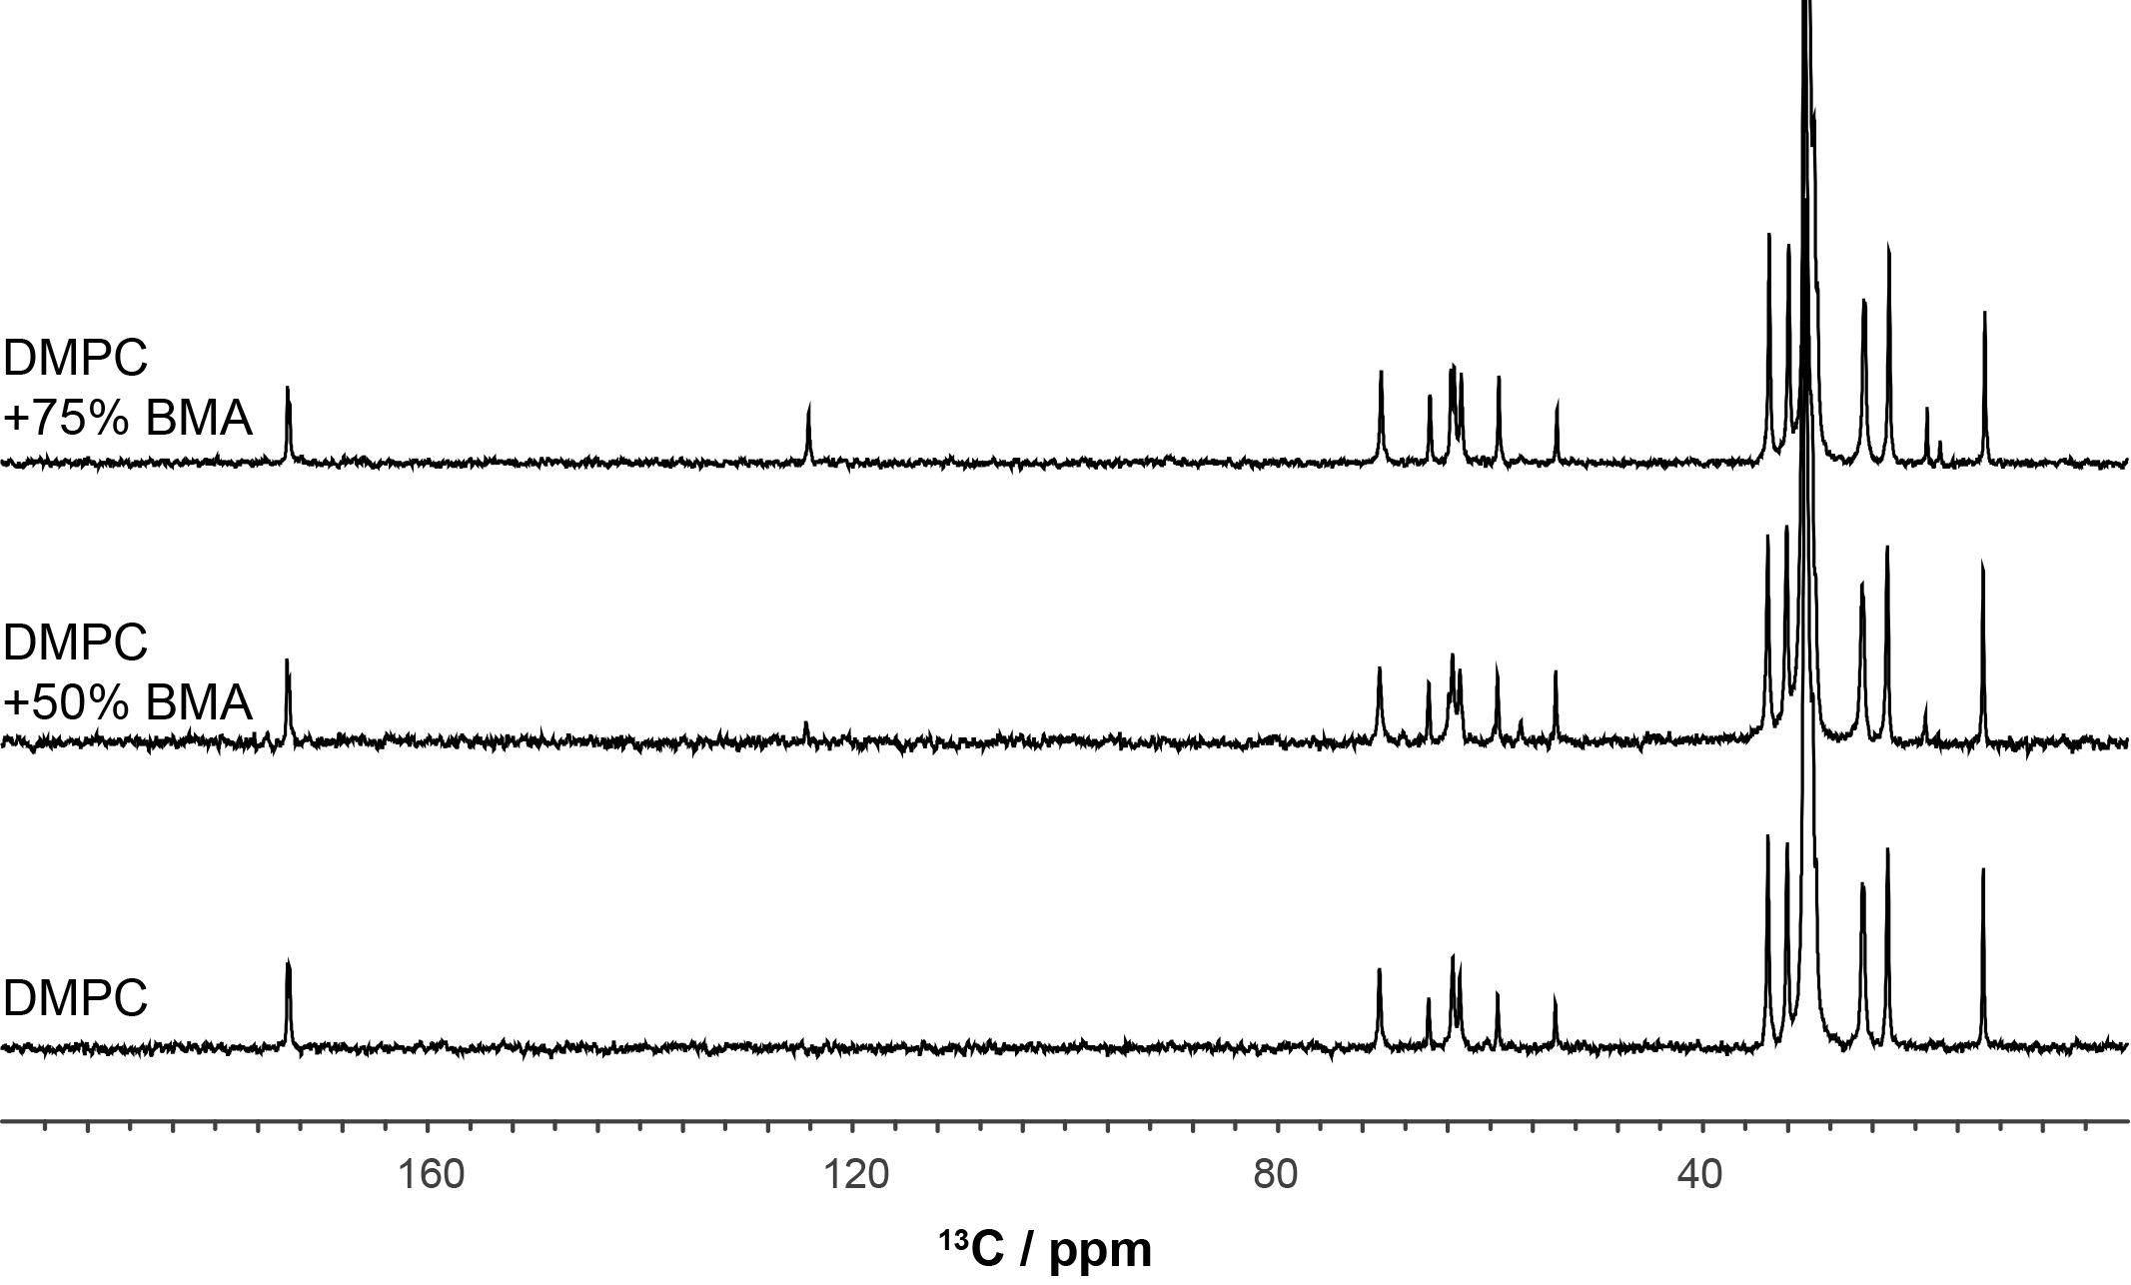
Figure S2. 13C MAS CP NMR spectra of DMPC alone, DMPC with 50%mol BMA and DMPC with 75%mol BMA recorded under SPINAL proton decoupling during acquisition.

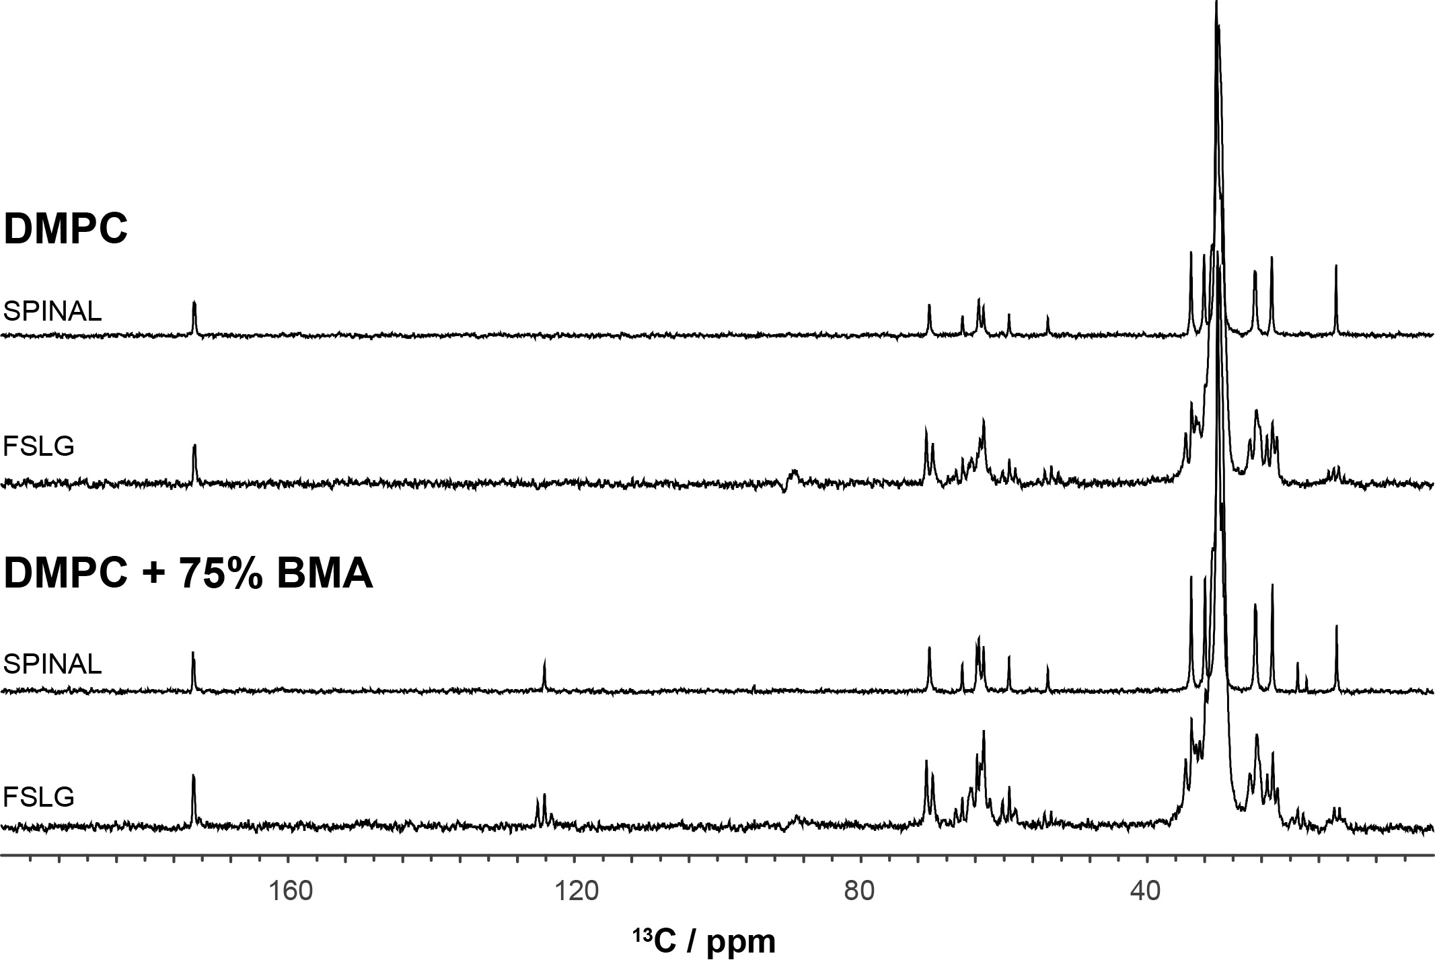
Figure S3. ¹³C MAS CP NMR spectra of DMPC with and without 75%mol BMA incorporated using FSLG or SPINAL proton decoupling during acquisition.
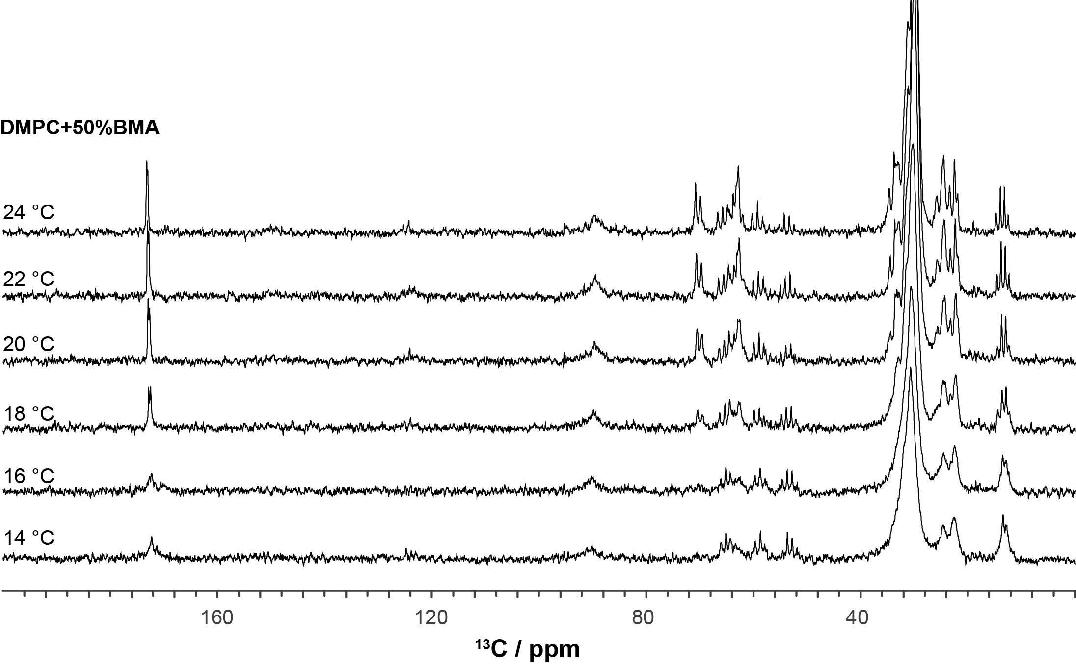
Figure S4. 13C MAS CP NMR spectra of DMPC with 50%mol BMA incorporated using FSLG decoupling scheme, recorded at various temperature.

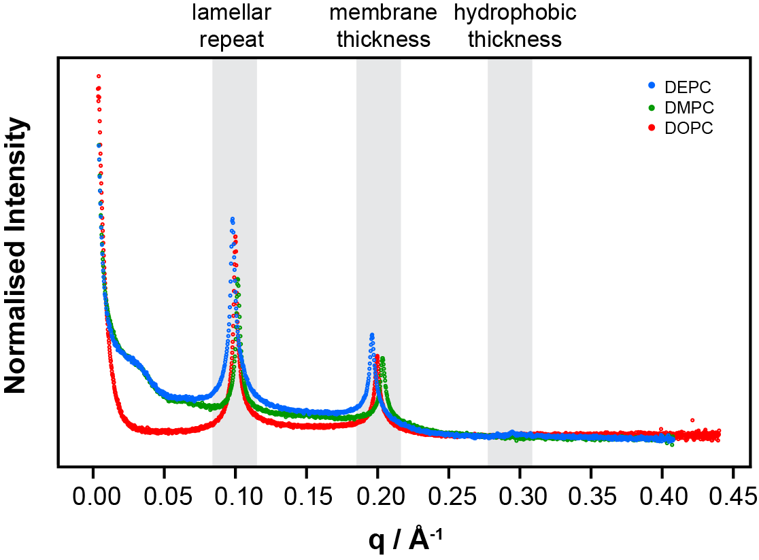
Figure S5. SAXS scattergram of DOPC, DMPC and DEPC MLV.

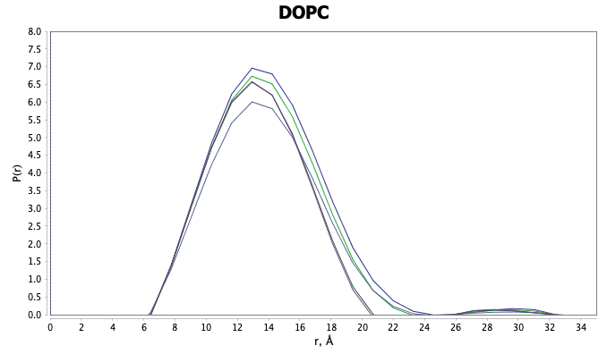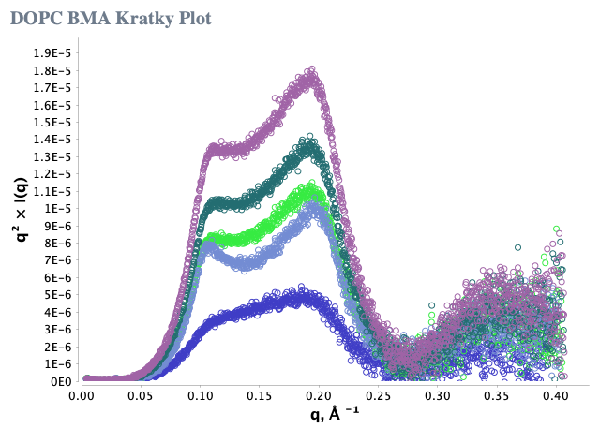
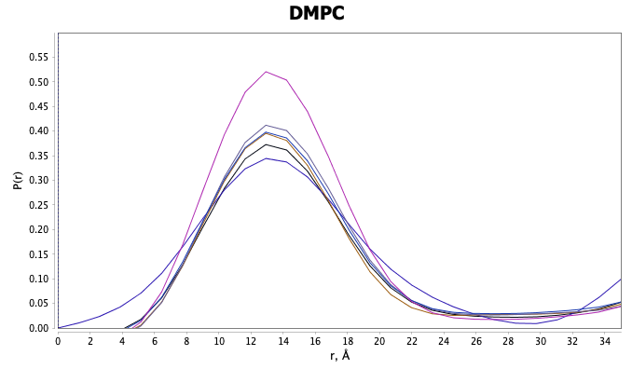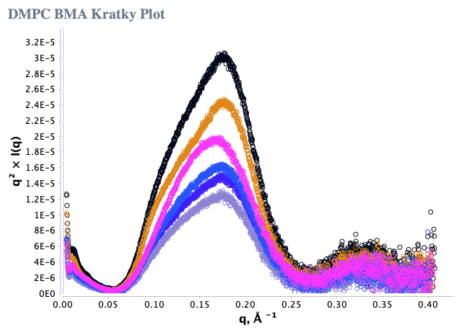
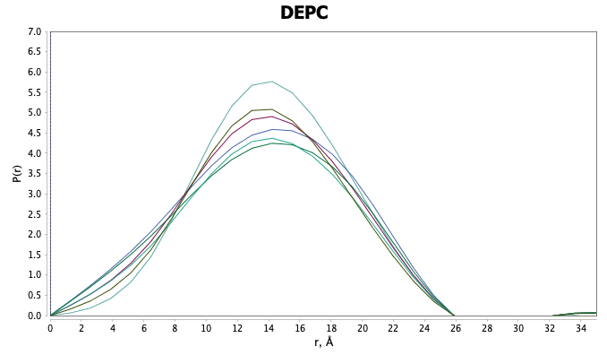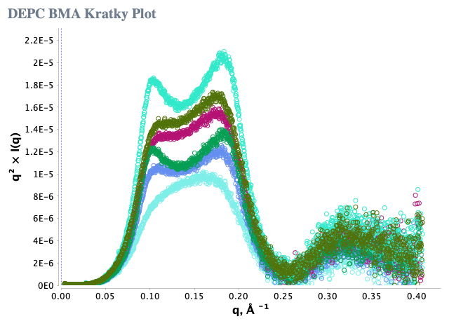
Figure S6. Real space and Kratky plots from DOPC, DEPC and DMPC without or with 25, 50, 67, 75 or 80 mole% BMA. The mean bilayer thickness varies from 26 to 29Å between the three lipids but remains practically unchanged on addition of BMA up to 80 mol%.

