**Opening a Window on Probation Cultures: a Photographic Imagination**

**Anne Worrall, Keele University,**

**Nicola Carr, Queens University Belfast, and**

**Gwen Robinson, Sheffield University.**

**Abstract**

Probation workers are among the least visible in the criminal justice system. Drawing on a pilot photographic project involving probation workers from several European countries, this chapter considers selected photographs and photo-elicitation data from England and Wales and Northern Ireland. It concludes that (amateur, democratized) photography has the potential to empower and give ‘voice’ to practitioners. Further, photo-elicitation suggests that photographs invoke imaginative debate about both the empirical realities and the normative dimensions of probation work and cultures.

**Introduction**

Probation officers are on sight unrecognizable, except perhaps to one another. Even then recognition is doubtful, so nondescript in every way is their appearance. Unlike clergymen, scurrying about like black beetles, and made familiar by their collars, court missionaries remain shrouded in anonymity. A caricaturist cannot typify them, since outwardly they present no striking feature for him to seize upon. To describe them in words is difficult enough; and after four years in their company I find myself unable to do them justice. (Stokes 1950: 223)

In this vivid account of his life as a probation officer working in London in the 1940s, Sewell Stokes notes the lack of imagery associated with probation and the difficulty of ‘describing in words’ what it is that a probation officer does. More than seventy years on probation still lacks a visual iconography, particularly when compared with other agencies within the criminal justice system (Worrall and Mawby 2014). This lack of visibility of a profession that works in the liminal space between custody and community has led some to describe probation as the ‘Cinderella’ of the criminal justice system (Robinson, forthcoming) - hidden from the limelight and receiving little credit for its efforts.

The lack of visibility of probation and community sanctions within the criminal justice system is mirrored in criminological research. In the sociological literature on punishment the penal gaze is invariably directed towards the prison (see Simon and Sparks 2013) - a focus that has become even more acute with the rise of mass incarceration (Robinson, forthcoming). In this context other domains of penality are occluded, notwithstanding the fact that in many countries there has also been a significant rise in the numbers of people subject to supervision in the community (McNeill and Beyens 2013).

Drawing on a wider project that used visual methods to document the spatial context of community supervision - specifically the architecture and environs of probation offices - this chapter focuses on data collected in two jurisdictions (England and Northern Ireland)[1]. In this research we asked a small convenience sample of probation workers to take photographs of the environment in which offender supervision takes place. We provided participants with a set of instructions and asked them to take photographs of specific areas of their offices and work. We also invited participants to generate any other images that they thought relevant. For ethical reasons and given the scale of the project we also included a proviso that the photographs should not include any identifiable images of people subject to probation supervision. This limitation is discussed further below and full details of the methodology are reported in Carr *et al.* (2015).

Drawing on the images, which were generated by practitioners, we explore the nature of probation practice which has a long lineage in both countries, but which is currently undergoing significant structural changes. We consider what images can tell us about the practices and culture(s) of probation in these contexts. We also begin to explore the potential of photo-elicitation to investigate the normative aspects of probation: that is, how it *ought* to be, from the perspectives of stakeholders and other interested audiences.

**Probation in context**

The emergence of probation as a penal institution in the late nineteenth century has been well documented in a variety of historical accounts (e.g.: Garland 1985; Simon 1993; Mair and Burke 2012). In the latter half of the twentieth century the underpinning rationales for probation supervision and the legal mandates allowing the same have shifted in line with broader penal trends. This has included a reconfiguration of the concept of ‘rehabilitation’ influenced by the advance of risk-based orthodoxies, an increased focus on public protection and a more expressively punitive tenor most evident in the re-casting of probation as ‘punishment in the community’ (Worrall & Hoy 2005; Robinson 2008; Robinson *et al.* 2013).

In England and Wales the role and function of probation has been subject to increased government intervention from the mid-1980s onwards evident in the imposition of various standards and approved modes of working, accompanied by new artefacts including risk assessment instruments (Burke and Collett 2015). This has recently culminated in the privatization of a large proportion of probation services under the government’s *Transforming Rehabilitation* programme (Deering and Feilzer 2015). Northern Ireland has seen similar trends, but here the governance arrangements for probation differ and the legacy of three decades of violent political conflict endures. This is manifest in the continued segregation of communities and the fact that criminal justice remains a contested space (Carr 2015).

Even in the context of wider cultural and structural transformations and analyses of these such as those described above, the question of what probation entails or what probation officers do is one that endures. The analogy of the ‘black box’ has been employed both to explain the inherent ‘mystery’ of the interaction between a probation officer and supervisee, but also to suggest that opening up practice to scrutiny would yield details of the flight path (Raynor *et al.* 2014). Recent research conducted in England and Wales, shows the continued importance of the relationship between probation officers and their clients and enduring elements of probation practice cultures over time (Annison *et al.* 2008; Deering 2011; Mawby and Worrall 2013; Robinson *et al.* 2014). Indeed without readily accessible iconography, the relationship between probation workers and the people they supervise is perhaps the most important cultural signifier of the profession (Worrall and Mawby 2014).

Yet conveying a visual sense of what probation workers *do* behind closed doors in their relationships with supervisees is not something that can easily be captured directly, not least for ethical reasons. One ingenious attempt by Aardman Animations entitled ‘On Probation : Steve’s Brother’[2] can be found on YouTube at: [www.youtube.com/watch?v=KYbd-6KLexQ](http://www.youtube.com/watch?v=KYbd-6KLexQ) . In the absence of such creative talent or resources, the remainder of this chapter recounts some aspects of our attempts to utilize photography to ‘open a window’ on some of the *context* within which the cultures of probation work are located.

**Photography in Probation research**

As indicated above and detailed elsewhere (Carr *et al*. 2015), we have been experimenting with the use of photography to give probation workers a ‘voice’ beyond the use of words alone. A key rationale for our pilot study was the finding that the extant empirical literature on probation practice in Europe was very heavily based on interview and survey data (Robinson & Svensson 2013). In this chapter, we focus on a number of aspects of the research that relate to the physical context of probation work in England and Northern Ireland and in this section we consider three theoretical challenges that we encountered:

1. Photovoice and the empowerment of probation workers.
2. Unpeopled photographs and the ‘presence of absence’ (Mitchell 2011).
3. Buildings and a ‘sense of place’ in the shaping of probation work.

*Photovoice and the empowerment of probation workers*

Many photographs that are analysed by cultural criminologists are produced by professionals or, at the least, are created for formal research purposes by researchers. Yet, as Carrabine points out (2012), photography has been democratized by digital technology. Compelling photography can be produced with minimal, or no, skill or understanding of the genre.

Photovoice is now a well recognized participatory community-based research method:

Photovoice, at its most basic level, is the use of photographic equipment, usually digital, to capture a visual image, and then to transform this image into a vehicle for generating information and discussion.

(Delgado 2015: 7)

It is perhaps best known for its ability to empower marginalized groups within society but, as Delgado observes, it can equally well focus on everyday life in a range of geographical settings with different population groups (Delgado 2015:10).

Consequently, the use of photography as a collaborative and empowering research method is now possible, though not unproblematic. Not only is it possible to ask research subjects to take their own photographs, but it is also possible to photograph them encountering their own and other people’s photographs. The layers are endless. But, as Kanstrup (2002) demonstrates in her study of photographing teachers and their classroom practices, the exercise raises more questions than answers and the extent to which it is possible to analyse work practices through amateur photographs, analysed democratically, remains contested.

As noted above, we asked probation workers to take photos of their working environment, using a number of headings, but left them largely free to choose the range and number of photos. We also asked for a brief comment on each photo, highlighting what they considered good or bad about their environment, what they would like to change and so on. In this way, we hoped, at a very simple level, to give them a ‘voice’ beyond words and in the midst of organizational and political turbulence.

*Unpeopled photographs and the ‘presence of absence’*

One of the more heated discussions of the wider project was whether or not we should include people in our photographs. As discussed above, the relationship between probation workers and their clients is an iconic cultural signifier and it is not unreasonable to argue that photographs that do not include workers and clients give an impoverished, perhaps even distorted, picture of the work. From a practical perspective, however, the ethical complications of including people presented too great an obstacle for our modest project and we eventually obtained a pragmatic consensus to exclude people. However, some of us disagreed that unpeopled photographs were of less value than those with people:

Perhaps contemporary photography’s dumbest ‘debate’ is whether it is possible to take humanist pictures if one doesn’t portray humans. These pictures [sic] are unpeopled, dismal stage sets for forgotten dramas.

(Norfolk 2007, Foreword)

These words are from Simon Norfolk’s Foreword to Edmund Clark’s brilliant photo book of the older prisoners’ wing at HM Prison Kingston, entitled *Still Life: Killing Time* (2007). The pictures are taken by a professional documentary photographer (a point discussed above) and include no prisoners. Yet, they are overflowing with ‘meaning’, ‘significance’ or what is known as ‘vanitas’ in the traditional art world – the act of imbuing everyday objects with the deeper symbolism of mortality. A simple walking stick by the side of an otherwise ordinary prison bed, a stair lift attached to an unmistakable prison corridor wall, a dog-eared newspaper guide to decimal currency (circa 1971) pinned to a cell noticeboard – the invitation to imagine the people who reside here and the lives they live is startlingly explicit. Indeed, Norfolk goes on to express his deep discomfort at being made to feel sympathy for old men who have, nevertheless, probably committed unspeakably awful crimes. The approach of unpeopled documentary photography is usually said to start with Martha Rosler’s work on the Bowery in the 1970s, which highlighted the inadequacy of words and pictures to convey social distress and the danger of romanticizing the suffering of photogenic victims. In contrast, her images contained just traces of, for example, alcoholism (eg. an empty bottle left in a doorway), giving a haunting quality to the ‘presence of absence’ (Carrabine 2015:114-5).

Mitchell (2011:115) argues that studying the ‘presence of absence’ can form part of the systematic analysis of photos. In addition to asking contextual questions about ‘where?’, ‘when?’, ‘by whom?’, ‘for whom?’ photos are produced, Mitchell exhorts us to ask ‘what is shown and what is not shown?’. By asking ourselves, as researchers, these questions when we viewed the photos, we became aware of the differences of perception between us. This was both a discomforting experience (because we hankered after a ‘truth’) and a stimulating experience (because we were forced to explain our perceptions and their implications). A photo-elicitation exercise described below demonstrates something similar.

*Buildings and a ‘sense of place’ in the shaping of probation work*

In our pilot research, we considered the physical environment of probation work and this included photographs of the exteriors of buildings and their surroundings. In our attempts to understand the significance of these photos we found ourselves considering cultural criminological perspectives, for example, on urban regeneration and its role in (re)producing responsible/responsibilized subjects (Coleman 2009). We noted the outer appearance and locations of probation offices and the extent to which they contribute to a sense of civic pride in the locality, or alternatively symbolize the anti-social nature of the criminals passing through their doors. We explored whether the appearance of probation offices reflects the ‘broken windows’ discourse of managing crime and criminals (Coleman 2009:68) – the smarter the buildings, the more effective and socially acceptable the work (cf. Mawby and Worrall’s discussion of probation work as ‘dirty work’ with ‘undeserving’ people, 2013). We also considered what Shah (2015) has referred to as the ‘linguistic landscape’ depicted in our photographs of building exteriors: that is, the ways in which probation buildings and entrances are labelled and thus rendered more or less visible, both to service users and to the wider community. In sum, we considered the extent to which our photos offered a ‘sense of place’ and identity for those who produced them and those who might inhabit them (Spencer 2011).

Buildings both reflect and create their function. As Gieryn says, ‘buildings stabilize social life’, defining policy, practice and behavior, and resisting change (2002:35). Some of our photographs depicted the interior of probation offices and included the artefacts of the job – security glass, notices on walls, waiting rooms, interview rooms, computers and, in some cases, specialised clothing and equipment. In their study of probation work cultures, Mawby and Worrall (2013) discuss the changing physical nature of probation offices and the differing ways in which they represent ‘punishment in the community’ (2013:48). Similarly, Phillips (2014) explores the impact that architecture has on the routines of probation work and the potential experiences of offenders within probation premises.

**“Say what you see”: collaborative analysis and the exposure of culture**

Although we sought to impose a degree of structure on our participants by suggesting some themes we wanted them to attend to (see above), each participant engaged somewhat differently, both in terms of the numbers of images they generated (which ranged from 6 to 149 per participant across all 5 jurisdictions) and the extent to which they adhered to or departed from our suggested themes. This presented us with some challenges for analysis, and led us to a more prosaic analytical framework, based on exteriors and interiors; front- and back-stage locations; artefacts and signage; and so on. We then spent some time looking at each group of photographs (which were printed and displayed on a row of tables) and verbalizing our initial impressions, in an effort to achieve a ‘collaborative analysis’ (Kanstrup, 2002).

One of our first observations emerged from the collection of images of interview rooms: that is, locations designated for one-to-one meetings between probation workers and clients (Photo 1). Whilst these rooms differed somewhat in terms of their décor and furnishings, they proved extremely powerful in communicating the ‘presence of absence’ alluded to above. This collection of relatively sparse rooms with the shared central feature of two empty chairs drew our attention to the fact that the core of probation work continues to happen in the absence of ‘tools’ or ‘props’ - though not, of course, in the absence of people. In other words, the absence of people in these rooms powerfully reinforced the idea that it is the relationship which is formed between the probation worker and the client which is the worker’s main instrument, and the worker him or herself – albeit equipped with professional and personal experience, skills, virtues and values - who is still the main asset or resource of the profession (see also Robinson *et al.* 2014).

Photo 1

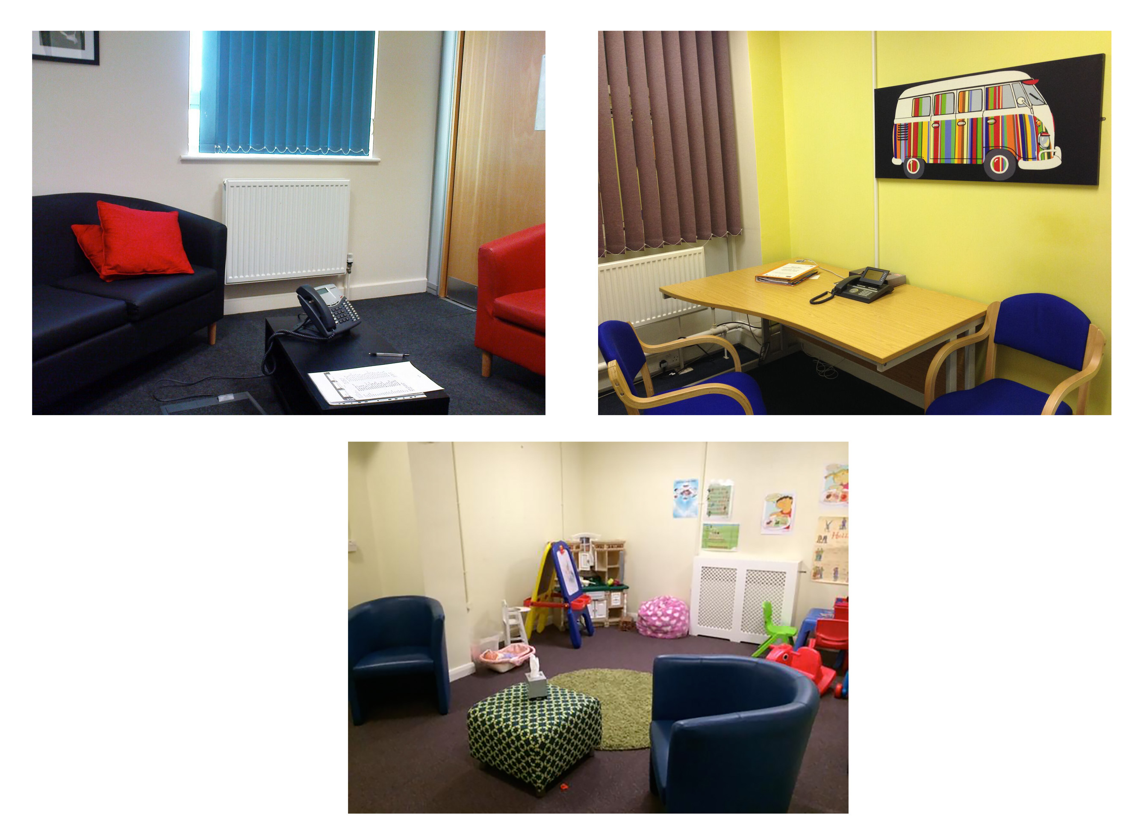

That is not of course to say that probation work is without tools, technologies or artefacts, but in our pictures these were to be found in the ‘backstage’ areas in the workers’ (usually communal) office spaces. Most of our participants included pictures of such spaces and of desks and PCs which were virtually indistinguishable across jurisdictions, and some included images of case files (both paper and on screens). But in several cases these images were accompanied by written comments which confirmed that this was not where the participant felt that they were doing their most important work, or where they felt most comfortable. For example, one English participant provided text alongside an image of his desk and PC which read: ‘My desk – an obstacle to work in lots of ways, although also a place where a large part of the “work” takes place. Systems feel a hindrance, laboured and outdated’.

Another cluster of pictures, which attracted our attention centred on places beyond the probation office. Viewed together, these images conveyed a desire to escape the confines and constraints of office spaces in which much probation work is now situated, both with and without clients. For example, one Northern Irish participant included a picture of the nearby coast as a place where they would like to ‘spend more time doing work’; another provided a picture of a local scenic spot ‘where I often walk around on my lunch break’ as a place they wished to be able to spend more time. Other participants included pictures of clients’ homes or local cafés – and text that indicated they too would like to spend more time in such locations, getting to know people in their own social contexts rather than the artificial environment of the probation office. These pictures sent powerful signals to us about the disconnect between contemporary probation work and the communities it is supposed to serve and potentially strengthen, and about the ways in which contemporary probation work creates ‘dividuals’ (Deleuze 1995) defined as clusters of risks and needs, divorced both from economic and social structures and from the sorts of social and relational capital that might help them to desist (McNeill & Weaver 2010; Bottoms 2008). That said, the Northern Irish participants were keen to point out (via images of local newspaper headlines and sectarian artwork on buildings and walls) that ‘community’ could in that particular context also be a barrier to effective probation practice, and in particular to the ‘ideal’ of reintegration for some service users (see also Carr 2015).

A further group of pictures which prompted vigorous discussions about probation’s location in communities featured exterior shots of entrances and their signage – or the ‘linguistic landscape’ of probation (Shah 2015). In our larger sample of photographs across five countries, we found examples of external signage that ranged from extremely prominent to decayed and/or graffiti-covered and therefore virtually invisible, and from explicit to ambiguous. Viewed together, these images began to prompt questions – both empirical and normative - about the role of exterior signage in the creation and communication of messages about stigma and/or reintegration, and in promoting the visibility of probation to the general public. These are themes which we explore further below in the context of a photo-elicitation exercise conducted by one of us.

**Two photo-elicitation sessions: a pre-piloting exercise**

We recognize the need to distinguish between photovoice and photo-elicitation. Delgado (2015: 7) argues that the latter can be linked to a variety of research methodologies, while the former is a specific methodology for participatory community-based research. Nevertheless, in our project we have sought to bring the two approaches closer by asking people who have been involved in producing photos, and those with a keen interest in the photos, to engage in photo-elicitation as a pre-piloting exercise, before disseminating the photos to others.

One of us conducted two photo-elicitation sessions, to see if the photographs had any resonance at all with people interested in probation work, and to begin to explore the ‘ought’ of its spaces and places. The first session was a focus group of three postgraduate students studying criminology and social work. The second was an interview with an experienced probation officer who had been involved previously in producing some of the photos for our project. The participants were invited to view a selection of our photos and to reflect on them. They were asked to consider the following questions:

* What do you recognise/ what is familiar?
* As a worker, what environment would you prefer?
* As an offender, what environment do you think would be preferred?
* Do buildings matter?

In both sessions, the participants had no difficulty responding to the photos and developing a narrative about offender supervision, although the two narratives were very different. For the purposes of this chapter, we have selected two photos of the exteriors of probation offices, from England and Northern Ireland and we reproduce the comments from the participants.

Photo 2

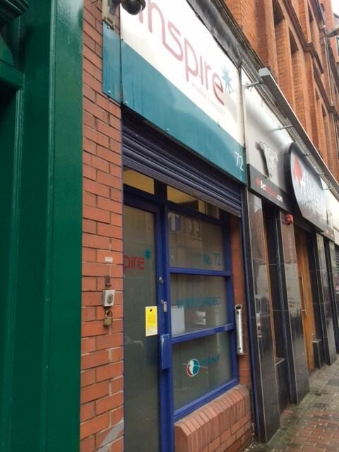



Comparing the two buildings, the focus group discussion ran thus:

R1: So this [Photo 2] is a little bit run down, kind of, on a main street or something that's accessible to people. I imagine there's a bus route going through, in my head. Yeah, just, kind of, a bit rundown really and a bit neglected.

R3: Somewhere on the high street, somewhere accessible.

I: And do you think that would be a good place to work or for offenders?

R1: No, neither really for a worker or an offender.

R2: It's too visible for offenders going in…

R2: It's stigmatising because it's too…you know, they know…people know what it is, they'll know why it's there and they'll know why you're going in. So it's…

R1: Yeah, it's quite exposed …

R1: Yeah, because that [Photo 3] looks…I'd say that looks welcoming in terms of both kind of groups. It's neutral.

I: It's neutral?

R1: Yeah. It's not obvious.

R2: Like, to me, it's still a bit like prison estate-y for me.

R3: I was going to say, it's quite clinical.

R2: But yeah, but it's more like you could be going there for another purpose, couldn't you? It's not…there's no…

R3: Yeah. You could imagine that being like a hospital place that you'd go, or like a doctor's or something.

At the end of the whole exercise, the interviewer asked the more general question ‘Do buildings matter?’ and the group reviewed its previous discussion. In particular, it went back to the first pictures of the building exteriors and changed its mind about some of the views initially expressed, suggesting that the group developed ideas during the viewing.

I: From what you've been looking at and the things you've been saying, does it actually matter what sort of buildings you're dealing with?

R1: Yeah, I think definitely.

R2: Yeah.

R3: Absolutely. I think it can set the tone of how you act…

R1: Yeah, instantly.

R3: …how a worker acts, how an offender will act coming into that place, a service user would…you know, it changes your tone.

R1: Yeah. Well, you instantly get a feeling or a…

R3: How you're expected to act and how you then would intend to act …

R2: Yeah, because they tell such a story without people that you…You might think on that first one where it was on the high street, we all said that was really negative…

R1: Yeah, whereas actually…

R2: That might have been chosen specifically to say you are part of the community…

R3: This is a building, it says 'Inspire', it doesn't say 'Probation' you know.

R2: But it could be that the culture of wherever that's taken is that offenders are less excluded and more included…

Whereas the focus group responded very much to the symbolism of the photos, the practitioner (who had produced Photo 3, above) used the photos more to trigger concrete comments about his working experience. His comments on the two photos ran thus:

R: I mean, I guess it's whether you come to it from a personal point of view, in terms of the modern offices are more likely to have decent welfare facilities for staff, high quality office accommodation. If you're coming to it from a user perspective, then the one here [Photo 2] looks like it's situated in an area where there'd be lots of other agencies for offenders to be able to have access to, and for you to be able to refer them to. And to that extent, it's a bit more welcoming…

R: To work in it [Photo 3], it feels fine because it's just another standard office unit that's unobtrusive on an industrial estate. So it doesn't stand out as being particularly probation. In fact, sometimes service users find the office difficult to find because it doesn't leap out at them. The disadvantage for service users is accessing it, because the business park that it's on is, you know, two miles outside of the city centre. It isn't really on any major bus routes. It's at the back of the business park, so it makes it more difficult to find. But the standard of accommodation for staff is good. All the offices are bright, airy, plenty of office space. You know, it's got kitchen facilities and so on that are all of a fairly high standard. So to work in, it's quite a nice office to work in, but it's not particularly convenient either for staff or particularly for offenders.

At the end, in response to the question ‘Do buildings matter?’ the practitioner talked about his ideal office:

R: In an ideal world, I'd like staff to operate from a multiagency building which was shared use, based in local communities. So while there are facilities in there to do some challenging work on people's thinking skills or their belief systems or their attitudes, where they've got issues that are linked to managing budgets or housing or employment, you're working in the same building with other agencies who focus on those areas. So you can just say to the offender, right, you know, I'll give John a ring, ask him if he can pop down, and he can talk to you about employment opportunities, or he can sort your welfare benefits out, or he can do this, that or the other. And it's all in essentially a one-stop-shop. But we don't operate like that, we take ourselves off onto business parks, have an autonomous office.

**Conclusions**

Probation workers are among the least visible in the criminal justice system and we have experimented with the use of photography to ‘open a window’ on what they do and how they do it. In so doing, we have been left with more questions than answers, some methodological (Carr *et al.* 2015) and others to do with the nature of probation work – what it is and what it *ought* to be. Making probation work more visible poses a dilemma, as our photo-elicitation exercise demonstrated. What do buildings tell us about the conflict between social inclusion and social exclusion? Should probation work take place on the high street or tucked away on a business park or industrial estate? Which is more welcoming for offenders – and *should* they feel welcomed or exposed? And which environments are considered preferable by probation workers?

One can argue that this tension between visibility and anonymity and the perceived benefits or otherwise of either approach helps to illuminate an inherent tension at the core of probation’s project - a project, which, as we have described at the outset, has been subject to various oscillating rationales. Questions of what and whom probation is for are raised in the discussions of these images depicting the locations in which ‘offender supervision’ takes place. Is it a private enterprise involving the rehabilitation of the individual or does it and should it involve the wider community, and if so to what extent?

In his consideration of this question Bottoms (2008) has noted the paradoxical development of an increased emphasis on visibility in relation to ‘Community Payback’ (or unpaid work in the community) within England and Wales, at a time when Probation Services were withdrawing from communities. Driven by a managerialist imperative probation retreated to functional offices in business parks such as those depicted in Photo 3 above. Various commentators have noted the problems of legitimacy that arise from unyoking ‘community penalties’ from community contexts both for those subject to such penalties and for the wider public (Rex 2004; Weaver 2009; Shah 2015). Indeed the links that probation practitioners have with the communities they serve and the question of the legitimacy of the probation enterprise for practitioners is also something that reflections on these images raise.

We would like to think that offering probation workers a photovoice has been empowering, especially in the current turbulent political and economic climate in England and Wales and Northern Ireland. But we have learned that the ‘meaning’ of photographic images is negotiated:

The capacity of images to affect us as viewers and consumers is dependent on the larger cultural meanings they invoke and the social, political and cultural contexts in which they are viewed.

(Sturken and Cartwright 2001:25)

Central to that negotiation is an informed imagination. Each viewer projects on to the image (the sign) their own culturally determined understanding of what it is (the signifier), what it represents (the signified). Thus, the probation worker, who may be empowered by their production of signs, nevertheless loses control over those signs when they are viewed by others. We can, then, enlist practitioners in the co-production of research data via the use of photography, but the process of ‘meaning making’ can – and, if we are interested in exploring the ‘ought’ of probation work, definitely should – extend far beyond the researcher/practitioner dyad.



**References**

Bottoms, A. (2008) The community dimension of community penalties. *Howard Journal of* *Criminal Justice,* 47, 2: 146–169.

Burke, L. & Collett, S. (2015) *Delivering Rehabilitation: The Politics, Governance and Control of Probation,* London: Routledge

Carr, N. (2015) ‘Contingent legitimacy: Community sanctions in Northern Ireland’ in G. Robinson & F. McNeill (eds) *Community Punishment. European Perspectives,* London: Routledge

Carr, N., Bauwens, A., Bosker, J., Donker, A., Robinson, G., Sucic, I. & Worrall, A. (2015) ‘Picturing Probation: Exploring the utility of visual methods in comparative research’*European Journal of Probation xx,x,xx-x*

Carrabine, E. (2012) ‘Just images: aesthetics, ethics and visual criminology’, *British Journal of Criminology,* 52, 2, 463-89

Carrabine, E. (2015) ‘Visual criminology: history, theory and method’ in H. Copes and J.M.Miller (eds) *Routledge Handbook of Qualitative Criminology,* London: Routledge, 103-121

Clark, E. (2007) *Still Life: Killing Time,* Stockport, Dewi Lewis Publishing

Coleman, R. (2009) ‘Policing the working class in the city of renewal: the state and social surveillance’ in R. Coleman, J. Sim, S. Tombs & D. Whyte (eds) *State, Power, Crime,* London: Sage

Deering, J. (2011) *Probation Practice and the New Penology: Practitioner Reflections,* Aldershot: Ashgate

Deering, J. & Feilzer, M.Y. (2015)*Privatising Probation: Is Transforming Rehabilitation the End of the Probation Ideal?* Bristol: Policy Press

Delgado, M. (2015) *Urban Youth and Photovoice: Visual Ethnography in Action,* Oxford: Oxford University Press

Deleuze, G. (1995) ‘Postscript on the societies of control’, in G. Deleuze, *Negotiations: 1972-1990,* New York: Columbia University Press

Garland, D. (1985) *Punishment and Welfare: A History of Penal Strategies,* Aldershot: Gower

Gieryn, T. (2002) ‘What buildings do’, *Theory and Society,* 31, 1, 35-74

Kanstrup, A.M. (2002) ‘Picture the practice: using photography to explore the use of technology within teachers’ work practices’, *Forum: Qualitative Social Research,* 3, 2, Art.17

McNeill, F. & Beyens, K. (2013) *Offender Supervision in Europe,* Hampshire: Palgrave Macmillan.

McNeill, F. and Weaver, B. (2010) Changing Lives? Desistance Research and Offender Management. SCCJR Project Report; No.03/2010. Available at: http://www.sccjr.ac.uk/publications/changing-lives-desistance-research-and-offender-management/

Mair, G. & Burke, L. (2012) *Redemption, Rehabilitation and Risk Management: A History of Probation,* London: Routledge

Mawby, R. & Worrall, A. (2013) *Doing Probation Work: Identity in a Criminal Justice Occupation,* Abingdon: Routledge

Mitchell, C. (2011) *Doing Visual Research,* London: Sage

Norfolk, S. (2007) ‘Foreword’ in E. Clark (2007) *Still Life: Killing Time,* Stockport: Dewi Lewis Publishing

Phillips, J. (2013) ‘The architecture of a probation office: a reflection of policy and an impact on practice’, *Probation Journal,* 61, 2: 117-31

Raynor, P., Ugwudike, P. & Vanstone, M. (2014) ‘The impact of skills in probation work: A reconviction study,’ *Criminology and Criminal Justice,* 14, 2: 235-249

Rex, S. (2004) ‘Punishment as communication’ in A. Bottoms, S. Rex & G. Robinson (Eds.)  *Alternatives to Prison. Options for an Insecure Society,* Cullompton: Willan, 113-134

Robinson, G. (2008) ‘Late-modern rehabilitation : The evolution of a penal strategy,’ *Punishment and Society,* 10, 4: 429-445

Robinson, G., McNeill, F. & Maruna, S. (2013) ‘Punishment *in* Society: The Improbable Persistence of Probation and Other Community Sanctions and Measures’ in J. Simon & R. Sparks (Eds.) *The Sage Handbook of Punishment and Society,* 321-340

Robinson, G., Priede, C., Farrall, S., Shapland, J. & McNeill, F. (2014) ‘Understanding “quality” in probation practice: Frontline perspectives in England and Wales,’ *Criminology and Criminal Justice,* 14, 2: 123-142

Robinson, G. & McNeill, F. (2015) *Community Punishment: European Perspectives,* London: Routledge

Robinson, G. (2015 forthcoming) ‘The Cinderella Complex: Punishment, society and community sanctions’ *Punishment and Society x, x:xx-xx*

Shah, R. (2015) ‘Expanding the community: An exploratory analysis of an American parole office’s location and its impact on parolees’, *British Journal of Criminology,* 55, 2: 321-40

Simon, J. (1993) *Poor Discipline: Parole and the Social Control of the Underclass 1890-1990,* London: University of Chicago Press

Simon, J. & Sparks, R. (eds) (2013) *The Sage Handbook of Punishment and Society,* London: Sage

Spencer, S. (2011) *Visual Research Methods in the Social Sciences: Awakening Visions,* London: Routledge

Stokes, S. (1950) *Court Circular,* London: Michael Joseph

Sturken, M. & Cartwright, L. (2001) *Practices of Looking: An Introduction to Visual Culture,* Oxford: Oxford University Press

Weaver, B. (2009) ‘Communicative punishment as a penal approach to supporting desistance,’ *Theoretical Criminology,* 13, 1: 9-29

Worrall, A. & Hoy, C. (2005) *Punishment in the Community: Managing offenders, making choices* (2nd Edition),Cullompton: Willan

Worrall, A. & Mawby, R. (2014) ‘Probation worker cultures and relationships with offenders,’ *Probation Journal,* 61, 4: 346-357

1. The wider research project involved participants from five European countries: Belgium, Croatia, the Netherlands, England and Northern Ireland. The small-scale comparative study was conducted under the auspices of the COST Action (IS1106) on Offender Supervision in Europe. Fourteen Probation practitioners in five countries participated in the project taking photographs to generate a visual account of the environment in which ‘offender supervision’ takes place.
2. We are grateful to Rob Mawby for drawing our attention to this ‘Conversation Piece’.