Contrasting effects of viscous and particulate fiber on colonic fermentation in vitro and in vivo, and their impact on intestinal water studied by magnetic resonance imaging in a randomized trial. D Gunn et al, Online supplementary material

Supplementary Methods

MRI protocol
Subjects were scanned on a research-dedicated 3.0 T Philips Achieva scanner (Best, The Netherlands) using a parallel imaging SENSE 16-element torso coil. A range of MRI sequences were used to image the abdomen including:
1) A balanced gradient echo (called balanced turbo field echo, bTFE or trueFISP) sequence (TR = 3.0 ms, TE = 1.5 ms, FA 80º, SENSE factor 2.0) to acquire 50 transverse images each with an in-plane resolution of 2.00 mm x 1.77 mm and slice thickness of 5 mm, with no gap between slices. This was used to measure gastric volumes. 2) A single shot, fast spin echo sequence (rapid acquisition with relaxation enhancement, RARE) to acquire in a single breath-hold 24 coronal images with in-plane resolution interpolated to 0.78 mm x 0.78 mm and a slice thickness of 7 mm, with no gap between slices (TR = 8000 ms, TE_{eff} = 320 ms, AQR = 1.56 mm x 2.90 mm). This sequence yields high intensity signals from areas with fluid and little signal from body tissues and was used to measure small bowel water content. 3) A high resolution bTFE sequence to acquire images of the contents of the ascending colon (TR = 3.1 ms, TE = 1.56 ms, acquired resolution = 1.50 mm x 1.50 mm, reconstructed resolution= 0.86 x 0.86, 8 slices 5 mm thick, up to 5.0 mm gap to cover whole ascending colon, flip angle 45º). 4) Segmental colonic volume and T1 of colonic contents were assessed using previously published methods(41).
Images were acquired with an expiration breath-hold between 13 and 24 seconds. Participants spent approximately 15 minutes inside the magnet at any one time.

Fiber analysis methods

Chemicals
Absolute ethanol (HPLC grade), sodium acetate trihydrate (HPLC electrochemical detection), and sodium hydroxide (46-51%, analytical reagent grade) were purchased from Fisher Scientific (Loughborough, UK). Analytical sugar standards (D-fructose, D-glucose, D-mannitol, maltose, D-raffinose, 1-kestose/kestotriose, nystose/1,1-kestotetraose, and sucrose), chicory inulin (catalog #I2255), and corn starch (catalog # S4126) were purchased from Sigma-Aldrich (Gillingham, UK). 1,1,1-kestopentaose was obtained from Megazyme (Bray, IE). Ultra-pure water was prepared daily using Avidity Science Duo™ water purification system (Bucks, UK).

Sugar extraction and sample preparation
Fructan quantification with psyllium was not possible due to the formation of an irreversible gel during aqueous extraction of the fructans. In each nopal and wheat bran sample (300mg), 0.6 mL absolute ethanol was added to inactivate enzyme activity and prevent hydrolysis during the extraction process. Ultrapure water (5 mL) was subsequently added and mixture was sonicated for 15 minutes at 50°C using a sonication bath (0.5 gallon, 50 watts, Sonicor, West Babylon, US). Samples were centrifuged (3000 × g) at ambient conditions for 10 minutes (Megafuge 16, Heraeus, Hanau, DE), supernatant removed, and solids re-suspended with water (5 mL). This was repeated a total of 3 times, supernatant was pooled, and resulted in a total volume of 15 mL of aqueous extract. Supernatant was freeze-dried prior to analysis. Chicory inulin and a purified corn starch served as positive and negative controls, respectively. They were subjected to the same extraction process. Separate, quadruplicate extractions for each ingredient were analyzed. Dried extracts were redissolved at 1mg/mL or 0.5mg/mL on the day of high-performance anion exchange chromatography (HPAEC) analysis in ultrapure water.

Preparation of sugar standards and calibration curves
Primary stock solution of each single sugar standard was prepared by dissolving mannitol, glucose, and fructose at 2 mg/mL and remaining sugars (maltose, raffinose, kestose, 1,1,1-kestopentaose, nystose, and sucrose) to 8 mg/mL. All stock solutions were stored in the refrigerator at -25°C until required for analysis. Retention times for each sugar was determined individually using 0.5mg/mL. Calibrations were generated using a working cocktail of nine aforementioned sugars at seven concentration levels. Specifically, the concentration range of 0.4–50mg/L for mannitol, 0.8–100 mg/L for glucose, 0.8–100 mg/L for fructose, 3.9–500 mg/L for sucrose, 3.9–500 mg/L for raffinose, 3.9–500 mg/L for 1-kestose, 2.6–333 mg/L for maltose, 5.3–667 mg/L for nystose and 3.9–500 mg/L for kestopentose. Regression equations revealed a good linear relationship (R² = 0.9799–0.9996) within the test ranges. The working stock was diluted further to determine the signal-to-noise (S/N) ratio. The limits of detection (LOD) and quantitation (LOQ) were determined to be an S/N ratio of 3 and10, respectively. Values between LOD and LOQ were identified as trace and those that were below LOD were denoted as not detectable.

Sugar quantification
Sugar analysis was performed by HPAEC with pulsed amperometric detection (PAD) using methods adapted from Ziegler et al,(42) using a Dionex ICS-3000 system (Sunnyvale, CA, USA) equipped with an autosampler at 25°C. A CarboPac-PA100 guard column (4 × 50 mm) and a CarboPac-PA100 analytical column (4 × 250 mm) at 30°C was the stationary phase. Detection was facilitated by PAD with a gold working electrode and an Ag/AgCl reference electrode. Integration was performed using a Chromeleon 6.8 chromatography data system. The mobile phase included 85mM NaOH with 25mM sodium acetate (eluent A) and 300mM NaOH with 100mM sodium acetate (eluent B). Eluents were degassed using helium and maintained under helium atmosphere. Gradient elution began with binary eluents (A:B) at 100:0, progressed linearly to 85:15 in 20 min and then to 0:100 at 60 min, and returned to 100:0 at 85 min. Total run time was 85 min at flow rate of 0.25 mL/min with an injection volume of 2 uL. All quadruplicate extracts were analyzed in duplicate. Individual sugars and their sum were reported as per 100g of dry matter. Fructans of higher DP (6–11) were not quantified but presence verified by chromatography. Absence of fructan was confirmed using Megazyme HK Fructan kit (Megazyme, Bray, Ireland).

Supplementary Tables and Figures

Supplementary Table 1
Breakfast | Energy (kcal) | Carbohydrate (g) | Protein (g) | Fat (g) | Fiber (g)
30g rice pops cereal (Sainsbury’s) with 100mL lactose free milk | 158 | 29.6 | 5.5 | 1.9 | 0.4
coffee/ tea 125mL  with lactose free milk (dash) | 9.6 | 0.6 | 0.8 | 0.3 | 0.6
Lunch | Energy (kcal) | Carbohydrate (g) | Protein (g) | Fat (g) | Fiber (g)
220 g Sainsbury’s creamed rice pudding | 211 | 37 | 6.8 | 3.7 | <0.5
34g Sainsbury’s seedless raspberry jam | 85 | 21 | <0.5 | <0.5 | 0.9
100 mL Sainsbury’s pure orange juice from concentrate | 42 | 8.6 | 0.6 | <0.5 | <0.5
Dinner | Energy (kcal) | Carbohydrate (g) | Protein (g) | Fat (g) | Fiber (g)
Lean corned beef (Princes) 200g | 194 | 1.0 | 25 | 10 | -
Half of 300g tinned whole carrots in water (Sainsbury’s) | 25 | 4.3 | 0.5 | 0.3 | 1.9
Steamed basmati plain rice (Tilda) 250g | 358 | 70.4 | 7.2 | 4.8 | 1.8
2 Highland All Butter Shortbread finger biscuits (Sainsbury’s) | 208 | 23.8 | 2 | 11.6 | 1

Supplementary Table 1: Nutritional composition of low fiber, low FODMAP meals provided to participants the day before the study day

Supplementary Figure 1
Assessed for eligibility (n=14)
Excluded (n=0)
Analysis:
T1AC (n= 14, male=5, female=7)
Hydrogen (n=11, male=5, female=6)
Colonic volume (n=14, male 5, female 9)
SBWC (n=11, male=4, female=7)
Nopal (n=14)
Completed all three interventions (n=14)
Randomized (n=14)
Wheat bran (n=14)
Psyllium (n=14)
Analysis:
T1AC (n= 14, male=5, female=9)
Hydrogen (n=11, male=5, female=6)
Colonic volume (n=14, male 5, female 9)
SBWC (n=11, male=4, female=7)

Analysis:
T1AC (n= 14, male=5, female=9)
Hydrogen (n=12, male=5, female=7)
Colonic volume (n=14, male 5, female 9)
SBWC (n=11, male=4, female=7)
Excluded from analysis:
T1AC (n=0)
Hydrogen (n=1)
Colonic volume (n=0)
SBWC (n=0)
Excluded from analysis:
T1AC (n=0)
Hydrogen (n=1)
Colonic volume (n=0)
SBWC (n=0)
Excluded from analysis:
T1AC (n=0)
Hydrogen (n=1)
Colonic volume (n=0)
SBWC (n=0)
Supplementary Figure 1: CONSORT flow chart. T1AC – T1 of the ascending colon, SBWC – small bowel water content.

Supplementary Figure 2
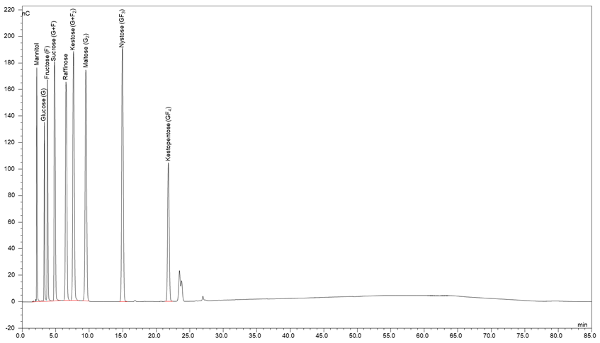
High-performance anion exchange chromatography with pulsed amperometric detection (HPAEC-PAD) chromatogram of analytical sugar standards

Supplementary Figure 3
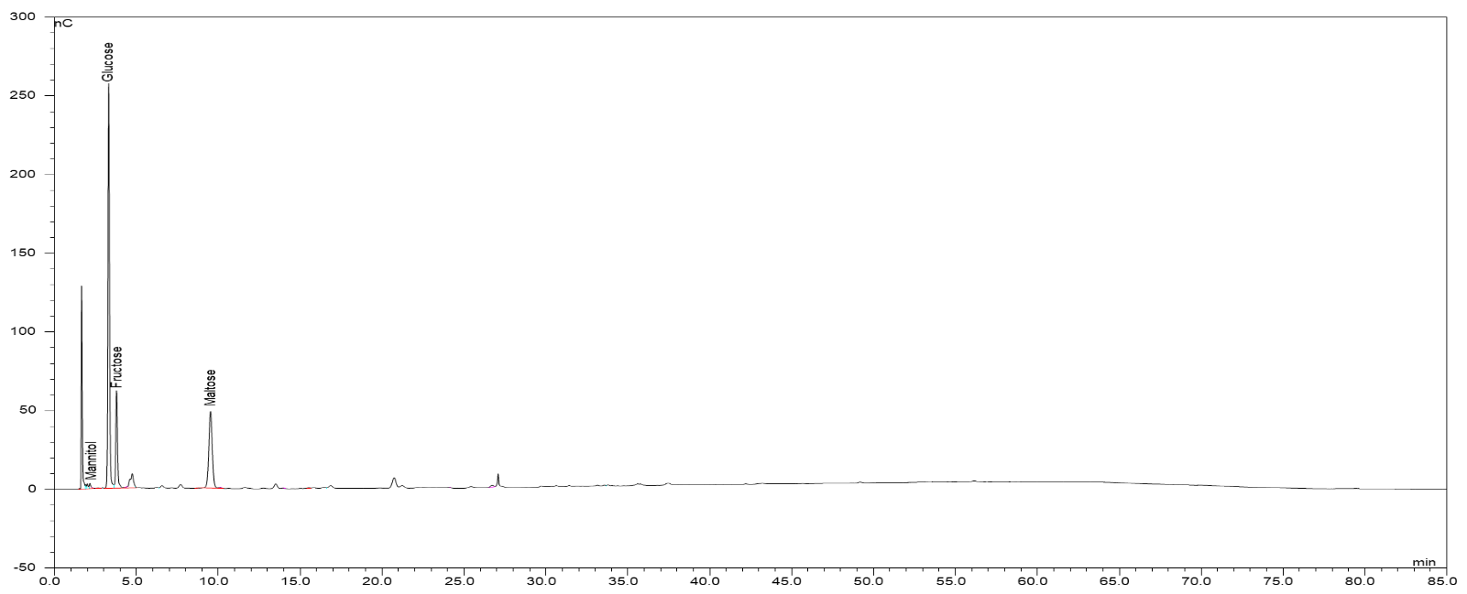
High-performance anion exchange chromatography with pulsed amperometric detection (HPAEC-PAD) chromatogram of wheat bran

Supplementary Figure 4

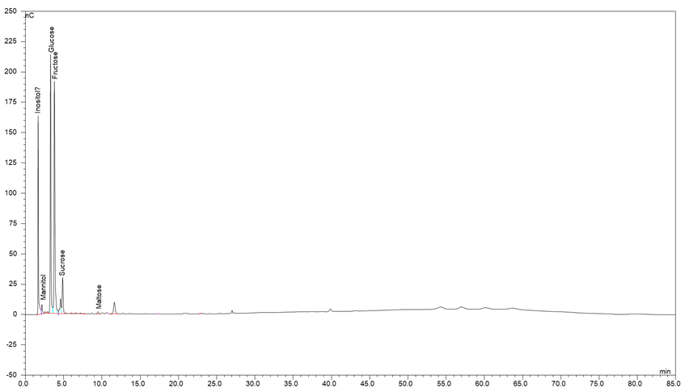
High-performance anion exchange chromatography with pulsed amperometric detection (HPAEC-PAD) chromatogram of nopal

Supplementary Figure 5

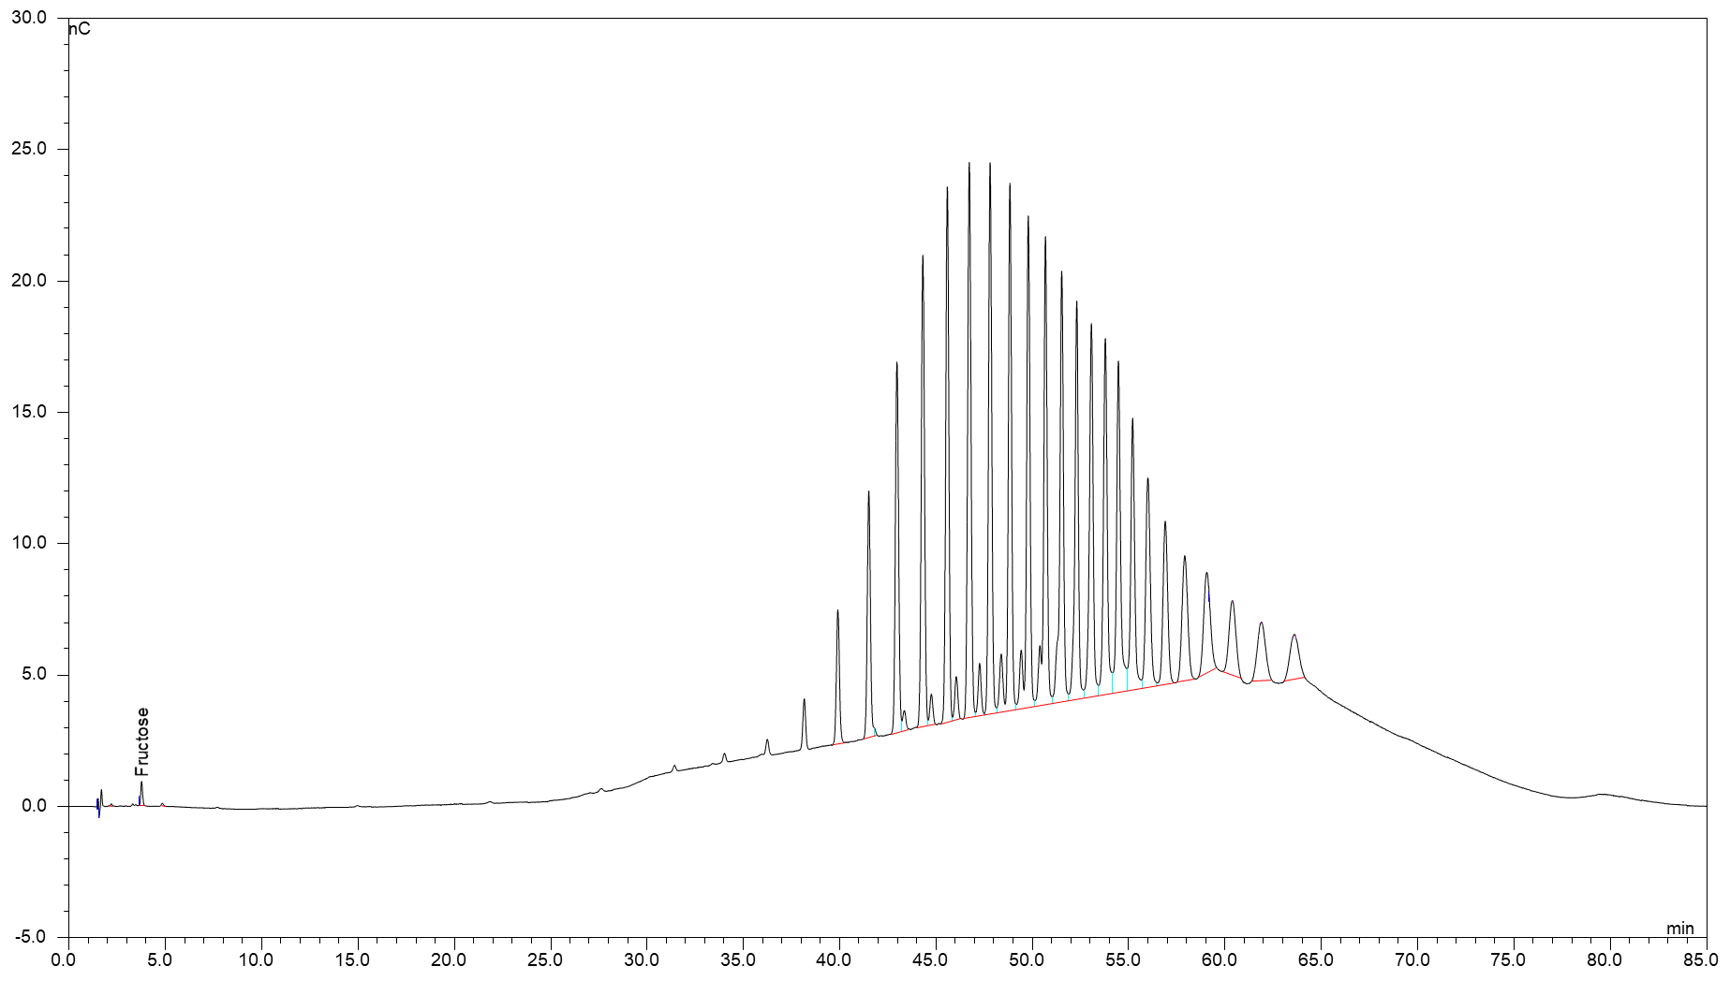
High-performance anion exchange chromatography with pulsed amperometric detection (HPAEC-PAD) chromatogram of chicory inulin

