Figure S1. Circos plots showing representative annotation of mtDNA for both C. nemoralis (top) and C. hortensis (bottom), also showing GC content (inner track, red line represents 50%) and read depth (middle track). The C. nemoralis assembly has a duplicated tRNA-Val region, though the depth of sequence reads indicates further repeats. The C. hortensis assembly has a single copy of the tRNA-thr region, though the depth of sequence reads indicates both tRNA-thr and COX3 are likely repeated.

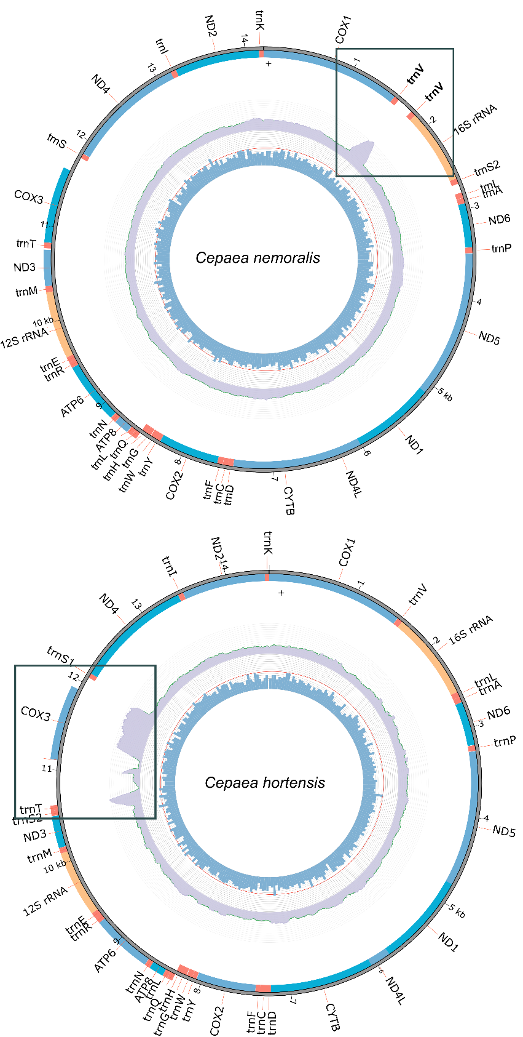

Figure S2. The mtDNA to nuclear genome copy number ratio versus number of heteroplasmic sites (using bam-readcount, 0.05% filter) using individuals from a) the C. nemoralis matriline b) wild C. nemoralis and c) wild C. hortensis.

