Supplemental Material Figure 1
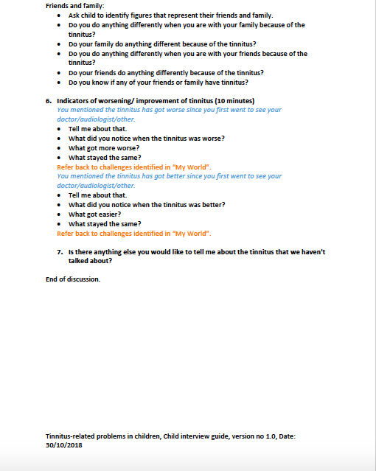
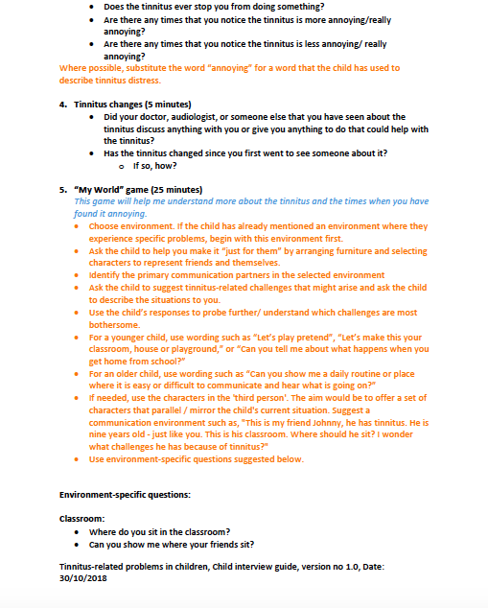
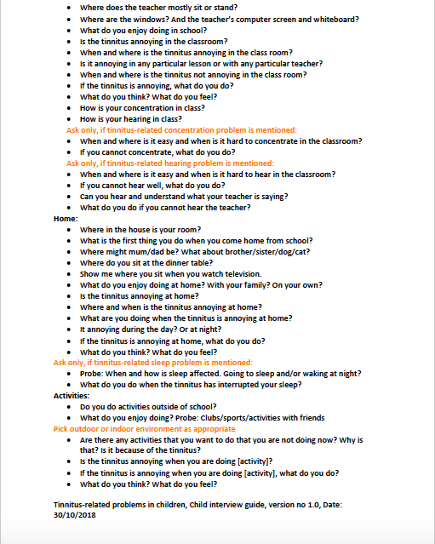
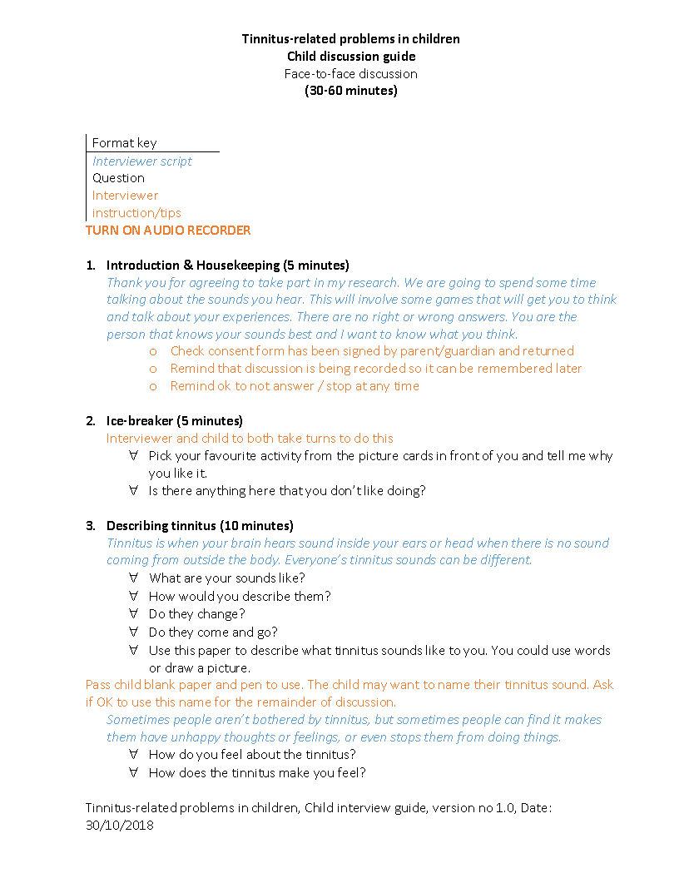
Child individual interview semi-structured guide
Supplemental Material Figure 2
Child group interview semi-structured guide
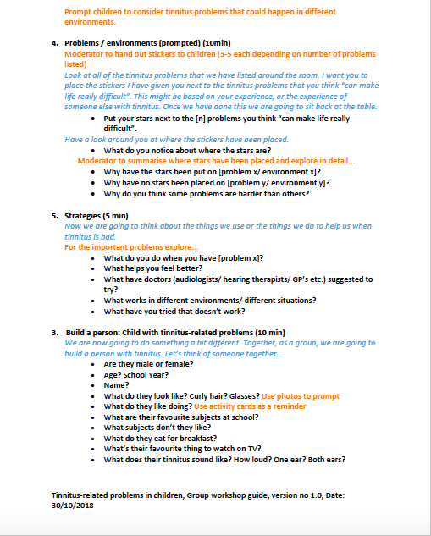
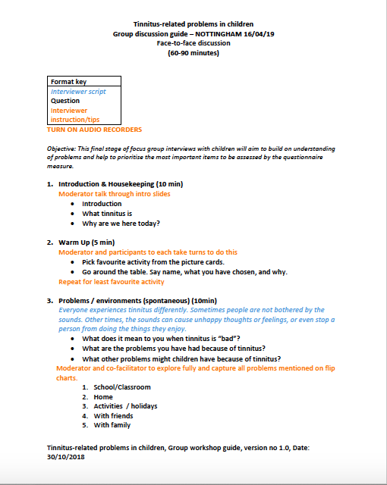

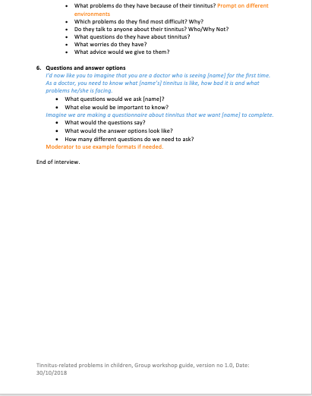

Supplemental Material Figure 3
Parent interview semi-structured guide
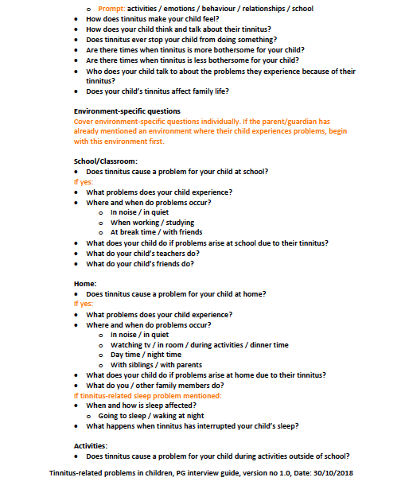
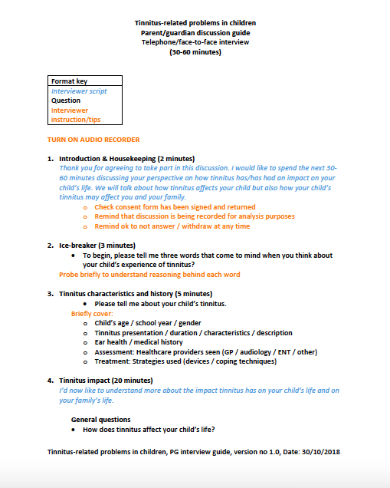

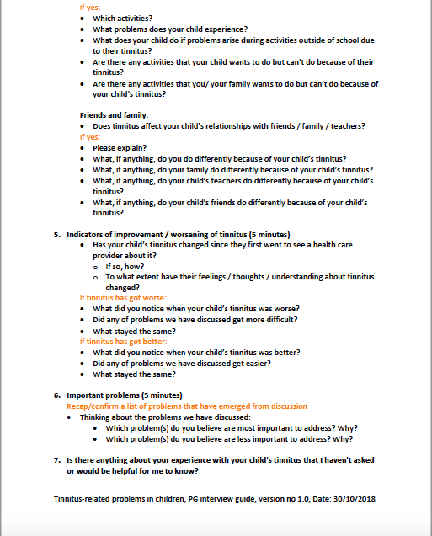

Supplemental Material Figure 4
Clinician interview semi-structured guide
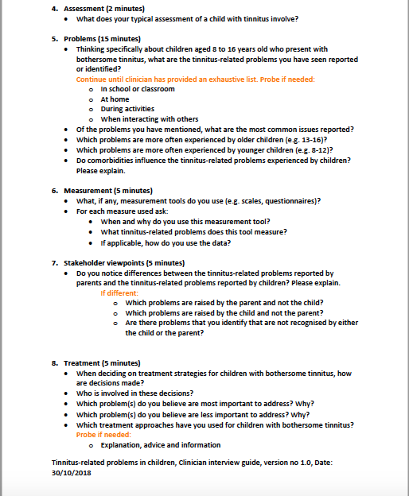
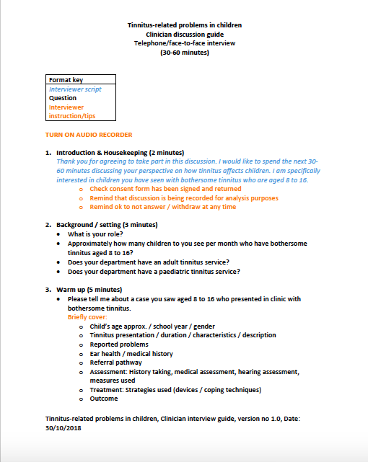

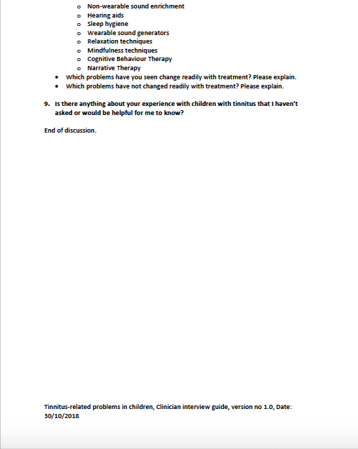

Supplemental Material Table 1
Saturation Table
 | Interviews
Codes and categories | 1,2,3 | 4,5,6 | 7&8*, 9 | 10,11,12 | 13,14,15 | 16,17,18 | 19,20,21 | 22,23,24
Sleep
- Difficulty getting to sleep | X
- General sleep disruption | X
- Notice at night | X
- Wake up at night | X
Physical health
- Ear pain | X
- Headache |  |  | X
- Tired/ fatigue | X
School/ Learning
- School (general) | X
- Affects concentration | X
- Affects school performance |  | X
- Behaviour (school) |  |  |  |  | X
- Exams or assessments | X
- Hearing or listening (school) | X
- Interferes with work | X
- Loud environments | X
- Missing school |  |  | X
- Particular lessons | X
- Quiet environments | X
- Teachers lack awareness |  |  |  |  | X
- Worry about getting into trouble | X
Cognitive impact
- Concentration | X
- Confusion |  | X
- Difficult to ignore | X
- Distracting | X
Hearing and listening
- Hearing and listening (general) | X
- Altered perception of sound | X
- Difficulty hearing speech in noise | X
Activities
- Activities (general) | X
- Avoidance of quiet or loud sound | X
- Computer or tv | X
- Family or Home life |  |  |  | X
- Games and sports | X
- Hearing tests |  | X
- Homework |  | X
- Music or loud events | X
- Need to remain close to home | X
- Social events | X
- Swimming | X
- Using the telephone |  |  |  | X
Emotions
- Anger |  | X
- Anguish |  | X
- Annoying (general) | X
- Annoying when going to sleep | X
- Being bothered by tinnitus | X
- Anxious | X
- Depressed |  |  |  |  |  |  | X
- Embarrassed |  |  |  |  | X
- Frustration | X
- Grumpy | X
- Hopelessness |  |  |  |  | X
- Insecure |  |  | X
- Lack of enjoyment |  |  |  |  |  | X
- Less tolerant |  |  |  |  | X
- Mood |  |  |  |  |  |  | X
- Negative thoughts feelings |  | X
- Hates life |  |  |  |  | X
- Thinking - 'why me' or it's unfair |  |  | X
- Unable to control or can’t find things to help |  | X
- Unable to relax |  | X
- Wanting tinnitus to go away |  |  | X
- Nervous |  | X
- Overwhelmed | X
- Panic |  |  | X
- Sad | X
- Scared | X
- Stressed or distressing | X
- Unsettling |  | X
- Upsetting |  |  |  | X
- Worried | X
- Wound up |  |  |  |  | X
Concerns and questions
- Concerns and questions (general) |  |  |  | X
- Concerns for the future | X
- Fear you won’t be believed |  |  | X
- Feeling to blame for the tinnitus |  |  |  | X
- Hoping tinnitus will go away |  |  |  | X
- It won’t go away |  |  | X
- Tinnitus is something serious |  | X
- Why me, not others |  |  | X
- Worry about getting teased or bullied |  |  |  | X
- Worry about sleep |  | X
- Worry about tinnitus difficulties |  | X
- Worry about school | X
- Worry tinnitus will get worse | X
Behaviour
- Behaviour (general) |  |  | X
- Don't want to be alone |  |  |  |  |  |  | X
- Lack of confidence |  |  |  |  | X
- Looking for an external noise |  |  |  | X
- Over-alertness |  |  |  |  |  |  | X
Negative coping
- Bottling up difficulties |  |  | X
- Over-attending to the sound |  |  |  |  |  |  | X
- Physical response | X
- Talking to distract self |  | X
- Thinking or talking about tinnitus a lot |  |  | X
- Try to get rid of it | X
Social impact
- Affects conversations | X
- Being singled out or bullied |  |  |  |  | X
- Don’t want to draw attention to it |  |  | X
- Family relationships |  |  | X
- Feeling different isolated or lonely | X
- Hard to talk to others |  | X
- Social impact – general |  | X
- Weird |  |  |  |  | X
- Withdrawn |  |  |  |  | X
- Social impact
Perception of others
- Don’t believe you |  |  | X
- Lack awareness, understanding, forget | X
- Lack of support | X
- Parental anxiety |  |  |  | X
Knowledge and resources
- Lack of health care services |  |  |  |  | X
- Not knowing what tinnitus is | X
Exacerbating Factors
- Accumulates over time |  |  |  | X
- Cold weather |  | X
- Difficult situations | X
- Having a cold |  | X
- Lifestyle change |  |  |  |  |  | X
- Loud noises | X
- Notice in quiet | X
- Speaking and thinking about it |  | X
- Specific noises |  |  |  | X
- Transition from loud to quiet |  |  |  | X
- When or after seeing a health care professional |  | X
- When at home or in evenings |  |  |  |  | X
- When in situation cannot control |  |  | X
- When not engaged in situation |  |  |  | X
- When stressed | X
- When tired | X
Note. *Group interview

Supplemental Material Figure 5
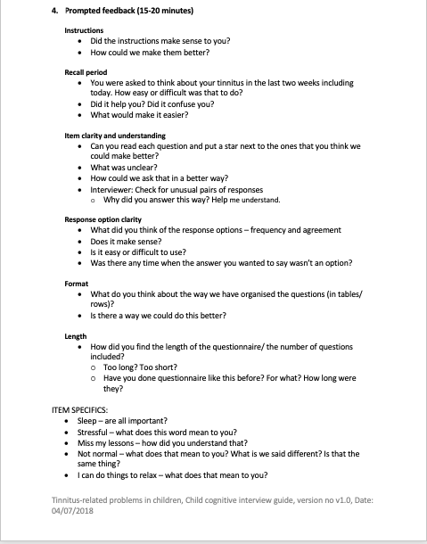
Cognitive interview semi-structured guide
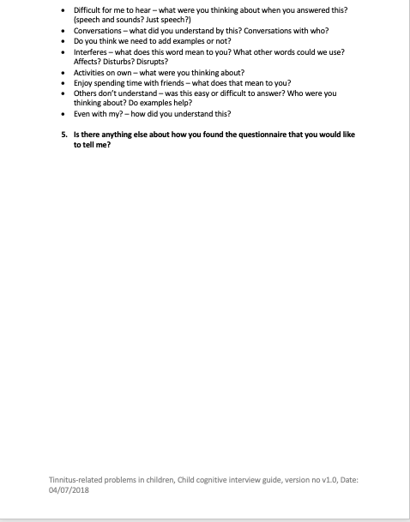
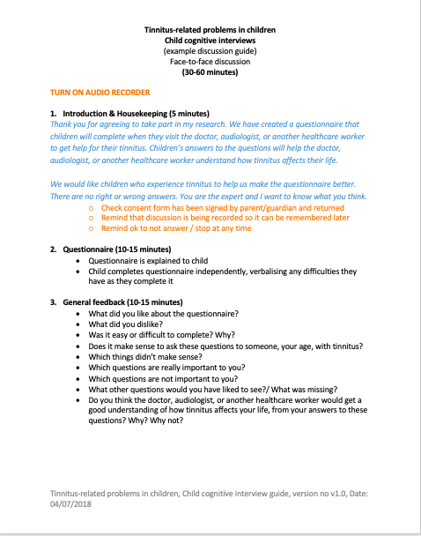

Supplemental Material Figure 6
Clinician survey outline
- Where is your department based? (NHS Trust)
- How many people in your department (including you) have reviewed the questionnaire and provided feedback for this survey?
- Is the instruction text suitable? (Suitable/ Mixed Views/ Not Suitable)
  - Please explain your answer.
- Is the recall period (last TWO weeks) suitable? (Suitable/ Mixed Views/ Not Suitable)
  - Please explain your answer.
- The questionnaire uses the following response scale throughout: Are the response scale options suitable? (Suitable/ Mixed Views/ Not Suitable)
  - Never
    - Please explain your answer.
  - A little of the time
    - Please explain your answer
  - Some of the time
    - Please explain your answer.
  - A lot of the time
    - Please explain your answer.
  - All of the time
    - Please explain your answer.
- Asked for each item:
  - Is the item suitable? (Suitable/ Mixed Views/ Not Suitable)
    - Please explain your answer.
- Asked for each subscale:
  - Is the response scale (Never, A little of the time, Some of the time, A lot of the time, All of the time) suitable for these items? (Suitable/ Mixed Views/ Not Suitable)
- Were there any questions missing?
- If you have any other general feedback about the questionnaire please include it here.

Supplemental Table 2
Domains and subdomains of the conceptual framework, alongside supporting quotes from interviews with children and parents and the 38 items from the iTICQ pilot version
Conceptual Framework |  | Example quote from interviews | Pilot questionnaire item
Domains | Subdomains
Sleep & Feeling Tired | General sleep problems | “I won’t be able to go to sleep. Some nights I can and it’s fine and I’m straight to bed, but other nights it just gets quite bad and I'm rolling on both my sides trying to get to sleep. All I can hear is this really frustrating noise.” CH9F16 | My tinnitus stops me from sleeping well  Even with my tinnitus, I sleep well
 | Difficulty getting to sleep | “I’ll get to bed and lie down. I’ll turn off my light…and it will be okay for a while…it will be there quietly…but then it will get really loud when I am trying to fall asleep. I don’t know why.” CH16F12 | My tinnitus makes it difficult for me to get to sleep
 | Waking up in the night | “In the morning, a few hours before I normally wake up, I just wake up and I can't get back to sleep. Or I go to the toilet, and I can't get back to sleep because I can just hear it all the time.” CH4F11 | My tinnitus makes me wake up during the night
 | Tired/ fatigue | “I'm tired so it gets harder to concentrate in lessons and I think it just kind of spirals...” CH16F12 | I feel tired because of my tinnitus
 | Don’t want to go to bed | “Sleep tends to be the most common one. So, they have trouble getting to sleep, or they don’t want to go to bed, or they don’t like going to bed.” CN6 | I don't like going to bed because of my tinnitus
 | Worrying about not sleeping because of tinnitus | “Children are worried that it is stopping them from going to sleep and the effects it has on them.” CN3 | I worry that my tinnitus will stop me from sleeping
Learning | School performance | “Last year he didn’t have a very good year at school. He spent a lot of time outside of the classroom because his tinnitus was so bad…that really affected his school year and he didn’t perform as well as expected.”P1M11 | Even with my tinnitus, I am able to do my schoolwork
 | General concentration and attention difficulties | “It’s kind of annoying. Like it’s hard to concentrate…in lessons, trying to concentrate and listen to the teacher. I can just hear it sometimes…and then I try to block it out, but it’s hard to block out. So I'm losing more concentration on my work at the same time.” CH4F11 | My tinnitus makes it difficult for me to concentrate
 | Exams, assessments, or tests | “It was quite frustrating because during my GCSEs, obviously no one knew there was an issue and it was really overpowering. I think stress triggers it because I was obviously quite stressed out and also if the room is quite quiet, it can get louder. So, I was in the exam hall and all I could hear was this really high pitch… I couldn’t concentrate.” CH9F16 | My tinnitus makes tests, assessments, or exams more difficult to do
 | Finding school stressful | “It’s mostly stress when you get stressed a lot it comes and it really bothers you. You might be thinking about that too much and mess up the test.” CH1M13 (Group) | I find school stressful because of my tinnitus
 | Missing school/lessons | “I don’t always feel like I want to go and do [the lesson], I’m like, ‘can I go somewhere else?’ I’ve got one lesson where I know it’s going to be bad. It’s just tiring.” CH12F13 | Because of my tinnitus, I miss my lessons
 | Getting into trouble at school | “…if you don’t make yourself different, you don’t show any signs of anything then the teacher’s not going to get frustrated, you’re not going to be told you’re going to be kept in.” P3M9 | I get into trouble at school because of my tinnitus
Emotional Health | Worried/ scared | “If my tinnitus was quite bad [in the future] how would it affect me then? Or even if I got an apprenticeship or into the world of work, that it’s not like school where I can say, my tinnitus is bad, or I'm stressed out, can I leave?…you're an adult then, so you have to try and cope. What if my tinnitus was quite overpowering? Especially if it was in a university room…what if I can't hear the lecturer? Then there’s no point in me even being there really…” CH9F16 | My tinnitus makes me feel worried
 | Panic/Stressed | “I didn’t know what it was but I remember it distressing me quite a lot and I was asking my parents what it was, but they said that it wasn’t a big deal…” CH14F12 | My tinnitus makes me feel stressed
 | Sad/ bad mood/ depressed | “He’s got really bad tinnitus this morning and was crying. He didn’t sleep very well last night. He gets really upset, saying that we don’t understand what it’s like for him… He has said to me before that he hates his life.” P4M12 | Even with my tinnitus, I feel happy  My tinnitus puts me in a bad mood
 | Feeling different/ embarrassed | “No, he doesn’t [talk to his friends about tinnitus]. He said he’s embarrassed by it. He thinks it’s a sign he’s a bit weird.” P4M12 | My tinnitus makes me feel like I am not normal
 | Lonely | “It obviously wasn’t nice knowing that [another child at school had tinnitus]but it was like…I’m not the only one who has it.” CH9F16 | My tinnitus makes me feel lonely
 | Anger | “She goes into her own world. You can actually see it in her face that she’s just somewhere else. She gets quite frustrated. She tends to shout at us, and she actually takes it out on her big sister and it’s like ‘why’s it always me that’s got to have this?’…it’s just horrible to see.” P5F12 | My tinnitus makes me feel angry
 | Helpless/ can’t cope | “He feels hopeless, that nothing is helping.”P4M12 | There are things that I can do that help me cope with my tinnitus
 | Overwhelmed | “The sound doesn’t change, but how I can handle it, or if it is overpowering, that kind of changes.” CH9F16 | I struggle with how tinnitus makes me feel
 | Tense/ can’t relax | “I’m like really annoyed that it would be something which I couldn’t stop and I’d be trying to relax and it made me more annoyed.” CH3F14 | Even with my tinnitus, I can do things to relax
Hearing & Listening | Difficult to hear | “Yes, it makes it difficult to hear teachers talking because I was trying to focus on the teacher and get rid of it at the same time, which doesn’t work.” CH12F13 | My tinnitus makes it difficult for me to hear
 | Makes things sound different | “…after the alarm is turned off I can keep hearing the alarm, sort of, type thing...” CH5M12 | Because of my tinnitus, things don't sound like they should
 | Makes conversations difficult | “In the canteen when it’s really loud. It gets hard. The booming comes in really loud, over the top of everyone else and it drowns out everyone else and just makes it like that noise is all I can hear…it gets a bit annoying, because I can't actually hear what other people are saying.” CH16F12 | My tinnitus makes it difficult to take part in conversations
 | Worry about not being able to hear | “Once I had a sleepover at my friend’s house and my tinnitus was so bad. I was getting so worried that I wasn’t going to get to sleep that I actually couldn’t hear him when he was talking to me.” CH1M11(Group) | I worry about not being able to hear properly because of my tinnitus
Taking Part | Affects activities with others | “Sometimes when it gets really noisy when I go to football, my tinnitus starts.” CH1M11(Group) | My tinnitus interferes with the activities I do with others (e.g. friends, family)
 | Affects activities I do on my own | “Sometimes, if I’m watching something on my laptop, and I’ve got headphones on that fill my whole ear, it makes the tinnitus really loud. It’s not distressing, it’s just unsettling when it’s really loud, and I’m trying to do other things.” CH14F12 | My tinnitus interferes with the activities I do on my own
 | Stops activities | “There are certain activities that he wouldn’t go to. For example, there was a birthday party at the weekend. He didn’t want to go to that because it would be noisy and would make it worse.” P4M12 | Because of my tinnitus, I have stopped doing the activities I used to do
 | Avoid loud or quiet places | “Friday lunchtime in the common room is like hell, it’s so busy. There’s so many people and I try and avoid that. I’d rather go with one or two friends to the shop or something like that… because I know that my tinnitus will be really bad in situations like that, I just won’t be able to hear what people are saying...” CH9F16 | Because of my tinnitus, I avoid certain places
 | Dislike being far from home | “Parties aren’t so bad because…I can just ring my mum or my dad and one of them will pick me up. Whereas festivals would stress me our because it is a further distance away.”CH9F16 | Because of my tinnitus, I don't like being far from home
 | Dislike being alone | “They can withdraw. They can be clingy. So they don’t want to be on their own….because that can be when it is worse.”CN8 | Because of my tinnitus, I don't like being on my own
Relationships | Affects friendships | “They would make fun of her because she was hearing noises in her ear and then she wasn’t able to concentrate and then they were starting to call her names.” P5F12 | Even with my tinnitus, I enjoy spending time with friends
 | Affects family relationships | “He’s quite good at keeping it in when he’s in public or when he’s at school, and so then we as a family get the brunt of it when it’s been a bad day, because he can't always express verbally how he’s feeling, so then that will come out in a bit of an outburst. Angry, shouting and cross. But it’s because he can't handle what’s happening inside.” P1M11 | Even with my tinnitus, I get on well with my family (e.g. my parents, brothers, sisters)
 | Others don’t understand | “School is a nightmare for him. It’s an old school so that doesn’t help….He has teachers that don’t want to understand.”P3M9 | Other people don't understand how tinnitus affects me (e.g. teachers, friends, family)
 | Lack of support | “The boarding house were banning phones at night…he explained to the housemaster ‘I need my phone to help me get to sleep because I’ve got tinnitus’ and he said, ‘well you’ll need a medical letter’.” P2M15 | I feel like I get enough support for my tinnitus
 | Hard to talk to others | “They don’t know about it. I never really complain about it to the teacher, or anything, because there’s not anything they can do. But I also don’t really like talking about it to people, so I wouldn’t want to tell my teacher anyway.” CH14F12 | I find it hard to talk to other people about my tinnitus
Note. Respondent ID format: CH9F16 refers to child number 9, female, aged 16. P3M9 refers to parent number three, male child, aged 9. Code CN6 refers to clinician number 6.

Supplemental Material Table 3.
Amendments to the tinnitus definition, instructions, and question text.
 | Pilot v1.0 text | Pilot v1.5 text | Rationale for change
Tinnitus definition | Tinnitus is the name for hearing sounds in the ears or head when there is no sound coming from outside the body. | Tinnitus is hearing sounds in the ears or head when there is no sound coming from outside the body.  Tinnitus is sometimes called “ear noises” or “ringing’ or ‘buzzing’ in the ears. | Removed redundant text and added child-friendly examples.^{v1.3}
Instructions | This questionnaire will ask you about how your tinnitus has been in the last TWO WEEKS (including today). For each row, please tick (🗹) the box/click the answer that matches your experience or feelings. There are no right or wrong answers.  Please ask for help if there is something you are not sure about. | These questions will ask you about how your tinnitus has been in the last TWO WEEKS.  For each row, please [tick (🗹) the box/ click the answer] that matches you. There are no right or wrong answers.  Please ask for help if there is something you are not sure about. | Simplified text. Removed more complex three and four-syllable words ‘questionnaire’ and ‘experience.’ ^{v1.4}
Question text | Thinking about how your tinnitus has been in the last TWO weeks, how much does this sound like you? | Thinking about how your tinnitus has been in the last TWO weeks… | Removed ‘how much does this sound like you’ as phrase highlighted as confusing in cognitive interview/ was no longer logical to include following removal of agreement scale. ^{v1.1}
Note. Green text highlights new or updated text. Superscript text indicates the pilot version where the change was made (as shown in Figure 1).

Supplemental Material Table 3.
Amendments to the response scale.
 | Pilot v1.0 text | Pilot v1.5 text | Rationale for change
Scene-setting items | Frequency scale: Never, A little of the time, Some of the time, A lot of the time, All of the time | Frequency scale:  None of the time, A little of the time, Some of the time, A lot of the time, All of the time. | Replaced ‘Never’ with ‘None of the time’ for parity with the latter end of the scale. ^{v1.2}
Subscale items | Agreement scale: Strongly disagree, Disagree, I don’t agree or disagree, Agree, Strongly Agree | Frequency scale:  None of the time, A little of the time, Some of the time, A lot of the time, All of the time | To address inconsistent use of agreement scale. ^{v1.1}
Note. Green text highlights new or updated text. Superscript text indicates the pilot version where the change was made (as shown in Figure 1).

Supplemental Material Table 4
Amendments to the questionnaire items.
Section/  Subscale | Pilot item v1.0 | Pilot v1.5 text | Rationale for change
Scene-setting items | How much have you noticed your tinnitus? | How much have you noticed your tinnitus? | No change
 | How much have you felt annoyed by your tinnitus? | How much have you felt annoyed by your tinnitus?
 | How much has your tinnitus made it difficult to do things? | How much has your tinnitus made it hard to do things? | Substituted a simpler, single-syllable word^{. v1.4}
Sleep and feeling tired | My tinnitus stops me from sleeping well | REMOVED | Covered by other items in sleep subscale^{. v1.4}
 | Even with my tinnitus, I sleep well | Even with my tinnitus, I sleep well | No change
 | My tinnitus makes it difficult for me to get to sleep | My tinnitus makes it hard for me to get to sleep | Substituted a simpler, single-syllable word. ^{v1.4}
 | My tinnitus makes me wake up during the night | My tinnitus makes me wake up during the night | No change
 | I feel tired because of my tinnitus | I feel tired because of my tinnitus
 | I don't like going to bed because of my tinnitus | I don't like going to bed because of my tinnitus
 | I worry that my tinnitus will stop me from sleeping | I worry that my tinnitus will stop me from sleeping
Learning | Even with my tinnitus, I am able to do my schoolwork | Even with my tinnitus, I am able to do my schoolwork | No change
 | My tinnitus makes it difficult for me to concentrate | My tinnitus makes it hard for me to focus or concentrate | Substituted a simpler, single-syllable word.^{v1.4}  Added ‘focus’ as an alternative common word for ‘concentrate’. ^{v1.4}
 | My tinnitus makes tests, assessments, or exams more difficult to do | My tinnitus makes tests or exams harder to do | Removed redundant word ‘assessments’. ^{v1.1}  Substituted a simpler word. ^{v1.4}
 | I find school stressful because of my tinnitus | I find school stressful because of my tinnitus | No change
 | Because of my tinnitus, I miss my lessons | I miss my lessons because of my tinnitus | Aligned structure with other items for parity. ^{v1.2}
 | I get into trouble at school because of my tinnitus | I get into trouble at school because of my tinnitus | No change
Emotional Health | My tinnitus makes me feel worried | I worry about my tinnitus | Amended to cover children’s common experience of worrying about tinnitus. ^{v1.2}
 |  | NEW ITEM:  My tinnitus makes me feel scared | New ‘scared’ item added as widely reported and not sufficiently covered by other items. ^{v1.3}
 | My tinnitus makes me feel stressed | My tinnitus makes me feel stressed | No change
 | Even with my tinnitus, I feel happy | Even with my tinnitus, I feel happy
 | My tinnitus puts me in a bad mood | My tinnitus puts me in a bad mood
 | My tinnitus makes me feel like I am not normal | My tinnitus makes me feel like I am not normal
 | My tinnitus makes me feel lonely | REMOVED | Scores showed a possible floor effect. Lacked relevance for children and mainly parent-reported in previous interview study. ^{v1.4}
 | My tinnitus makes me feel angry | REMOVED | Feedback suggested anger was covered by ‘bad mood’ item. ^{v1.2}
 |  | NEW ITEM:  My tinnitus makes me feel sad | ‘Sad’ item by clinicians not covered by other items.^{v1.2}
 | There are things that I can do that help me cope with my tinnitus | There are things that I can do that help me cope with my tinnitus | No change
 | I struggle with how tinnitus makes me feel | REMOVED | Not well understood by children. Abstract concept.^{v1.4}
 | Even with my tinnitus, I can do things to relax | Even with my tinnitus, I can do things to relax | No change
Hearing and listening | My tinnitus makes it difficult for me to hear | My tinnitus makes it hard for me to hear | Substituted a simpler, single-syllable word.^{v1.4}
 | Because of my tinnitus, things don't sound like they should | REMOVED | Not well understood. Lacked relevance to children.^{v1.4}
 | My tinnitus makes it difficult to take part in conversations | My tinnitus makes it hard to take part in conversations | Substituted a simpler, single-syllable word. ^{v1.4}
 | I worry about not being able to hear properly because of my tinnitus | I worry about not being able to hear because of my tinnitus | ‘Properly’ removed as considered redundant. ^{v1.2}
Taking part | My tinnitus interferes with the activities I do with others (e.g., friends, family) | My tinnitus gets in the way of things I do with friends or family | Substituted a simpler words/ phrases. ^{v1.4}
 | My tinnitus interferes with the activities I do on my own | My tinnitus gets in the way of things I do on my own | Substituted a simpler words/ phrases.^{v1.4}
 | Because of my tinnitus, I have stopped doing the activities I used to do | My tinnitus stops me from doing the things I used to do | Substituted a simpler words/ phrases.^{v1.1 and v1.4}
 | Because of my tinnitus, I avoid certain places | There are places I avoid because of my tinnitus | Initial decision to substitute ‘avoid’ to ‘do not go to’ however decision later reversed to maintain simplicity and meaning. ^{v1.4 and v1.5}
 | Because of my tinnitus, I don't like being far from home | REMOVED | Children said item lacked relevance as they are not often away from home. Scores suggested floor effect.^{v1.4}
 | Because of my tinnitus, I don't like being on my own | REMOVED | Not well understood. Item with response scale considered complex. Scores suggested floor effect.^{v1.4}
 |  | NEW ITEM:  I prefer to spend time on my own because of my tinnitus | Item suggested by clinicians not felt to be covered by original items.^{v1.2}
Relationships | Even with my tinnitus, I enjoy spending time with friends | Even with my tinnitus, I enjoy spending time with friends | No change
 | Even with my tinnitus, I get on well with my family (e.g., my parents, brothers, sisters) | Even with my tinnitus, I get on well with my family (e.g., my parents, brothers, sisters)
 | Other people don't understand how tinnitus affects me (e.g., teachers, friends, family) | REMOVED | Not well understood. Found complex due to inclusion of three diverse example groups. Felt covered by ‘support/help’ item.^{v1.4}
 | I feel like I get enough support for my tinnitus | I feel like I get enough help for my tinnitus | Substituted a simpler, child-friendly word.^{v1.4}
 | I find it hard to talk to other people about my tinnitus | I find it hard to talk to other people about my tinnitus | No change
Note. Green text highlights new or updated text. Superscript text indicates the pilot version where the change was made (as shown in Figure 1).

