***Journal of Biogeography***

**Article type: Original Article**

**Running head: Testing Holocene landscape openness in Tasmania**

**TITLE: How old is the Tasmanian cultural landscape? A test of landscape openness using quantitative land cover reconstructions.**

Authors: Mariani M.1, Connor, S.E.1,2, Fletcher, M.-S.1, Theuerkauf, M.3, Kuneš P.4, Jacobsen G.5, Saunders, K.M.5, Zawadzki, A.5

1School of Geography, University of Melbourne, Melbourne, Victoria, Australia

2Centro de Investigação Marinha e Ambiental (CIMA), University of the Algarve, Faro 8005-139, Portugal

3Institute for Geography and Geology, Ernst-Moritz-Arndt-University Greifswald, Greisfwald, Germany

4Department of Botany, Faculty of Science, Charles University, 128 43 Prague, Czech Republic

5Australian Nuclear Science and Technology Organisation, Lucas Heights, New South Wales, Australia

Correspondence to: MICHELA MARIANI, School of Geography, University of Melbourne, Victoria, Australia; [mmariani@student.unimelb.edu.au](mailto:mmariani@student.unimelb.edu.au)

WORD COUNT:7107

**Abstract**

**Aim** To test competing hypotheses about the timing and extent of Holocene landscape opening using pollen-based quantitative land-cover estimates.

**Location** Dove Lake, Tasmanian Wilderness World Heritage Area, Australia.

**Methods** Fossil pollen data were incorporated into pollen dispersal models and corrected for differences in pollen productivity among key plant taxa. Mechanistic models (REVEALS - Regional Estimates of VEgetation Abundance from Large Sites) employing different models for pollen dispersal (Gaussian plume and Lagrangian stochastic models) were evaluated and applied in the Southern Hemisphere for the first time.

**Results** Validation of the REVEALS model with vegetation cover data suggests an overall better performance of the Lagrangian stochastic model. Regional land-cover estimates for forest and non-forest plant taxa show persistent landscape openness throughout the Holocene (average landscape openness ~50%). *Gymnoschoenus sphaerocephalus*, an indicator of moorland vegetation, shows higher values during the early Holocene (11.7-9 ka) and declines slightly through the mid-Holocene (9-4.5 ka) during a phase of partial landscape afforestation. Rain forest cover reduced (from ~40% to ~20%) during the period between 4.2 – 3.5 ka.

**Main conclusions** Pollen percentages severely under-represent landscape openness in western Tasmania and this bias has fostered an over-estimation of Holocene forest cover from pollen data. Treeless vegetation dominated Holocene landscapes of the Dove Lake area, allowing us to reject models of landscape evolution that invoke late-Holocene replacement of a rain forest-dominated landscape by moorland. Instead, we confirm a model of Late Pleistocene inheritance of open vegetation. Rapid forest decline occurred after ca. 4 ka, likely in response to regional moisture decline.

**Keywords**

Australia, cultural landscape, dispersal models, fire, Holocene, moorland, rain forest, REVEALS, Tasmania, vegetation reconstruction

1. **Introduction**

The ability to accurately model and predict Earth system behaviour is crucial for developing effective management strategies for our future environment (e.g. Anderson *et al.*, 2006; Dearing *et al.*, 2010; Gaillard *et al.*, 2010). Recognition of the reciprocal relationship between vegetation cover and climate via biogeochemical and biogeophysical processes/feedbacks (e.g. Foley *et al.*, 2003) has fostered development of coupled dynamic vegetation and climate models (e.g. Smith *et al.*, 2011). A critical point is the scarce information on past land cover currently incorporated into such models (e.g. Kaplan *et al.*, 2002; Sitch *et al.*, 2003; Smith *et al.*, 2011). Quantitative estimates of past plant cover are rare (e.g. Trondman *et al*., 2015), with the Southern Hemisphere particularly under-represented. Here we apply, for the first time in the Southern Hemisphere, mechanistic models for regional vegetation reconstruction to quantify landscape changes in western Tasmania, Australia. These reconstructions allow us to address biogeographical and methodological debates over a) the efficiency of mechanistic models in landscapes dominated by both wind- and animal- pollinated plants; and b) the timing and extent of long-term vegetation changes in western Tasmania.

Fire is considered the most critical non-climatic factor controlling land cover changes on Earth (Bond *et al.*, 2005). Fire and vegetation are strongly linked in Australia (Bradstock *et al.*, 2002), with, for example, the distribution of fire-sensitive rain forest among flammable sclerophyll vegetation considered to be a result of the past fire history (Bowman, 1998; Bowman, 2000). Tasmania (Fig. 1) is an exemplar of the role of fire in decoupling vegetation from climate, with large areas in which rain forest is the potential vegetation currently occupied by fire-promoted vegetation (Jackson, 1968; Brown & Podger, 1982a; Wood & Bowman, 2011). Indeed, the juxtaposition of fire-sensitive rain forest against pyrogenic species (e.g. *Eucalyptus*) in Tasmania has puzzled ecologists for decades (Bowman & Jackson, 1981; Brown & Podger, 1982b; Yospin *et al.*, 2015) and the origin and evolution of the present-day dominance of pyrogenic moorland is the subject of long-standing debate (see Colhoun, 1996a; Fletcher & Thomas, 2010a; Macphail, 2010 and references therein). This debate is split between those that argue for late Holocene replacement of a forested landscape by open vegetation (Macphail, 1979; Colhoun, 1996b), while others argue an open landscape persisted throughout the Holocene (Thomas, 1995a; Fletcher & Thomas, 2010a).

Proponents of the former model interpret the region-wide dominance of rain forest pollen types as indicating a climate-driven expansion of rain forest from the Late Pleistocene to the mid-Holocene (e.g. Macphail, 1979; Colhoun, 1996). In contrast, Fletcher & Thomas (2007a, b; 2010a, b) highlight the bias in the pollen record toward plants that produce large amounts of well-dispersed pollen (i.e. rain forest species in Tasmania), and use modern pollen spectra to infer the persistence of open vegetation across western Tasmania for the last ca. 12,000 years (12 kyrs). They note a departure between Holocene and previous interglacial floras and charcoal sequences, citing human arrival during the last glacial cycle (~35 kyrs) as the probable cause for this, thus concluding that western Tasmania represents an ancient cultural landscape. Macphail (2010) has critiqued their model, arguing that the nature of pollen deposition at many of the mires studied by Fletcher and Thomas (2010) biases pollen records toward local bog vegetation, which is palynologically similar to pyrogenic moorland. Thus, the debate over the origin and development of the modern treeless and pyrogenic vegetation landscape of western Tasmania centres on how pollen production and deposition biases are resolved.

Here, we produce quantitative land cover estimates to understand vegetation change and test competing models of landscape evolution in western Tasmania. We employ recently reported pollen productivity estimates (PPEs) for this region (Mariani *et al.*, 2016) to develop quantitative land cover estimates using the REVEALS (Sugita, 2007b) approach.

**1.1 Quantitative reconstruction of land cover from pollen data**

Quantitative reconstruction of past vegetation cover has long been a major objective of palynology (e.g. Sugita, 1993; Gaillard *et al.*, 1998; Broström *et al.*, 2004). Numerous factors influence the over- or under-representation of vegetation in pollen spectra (e.g. taphonomy, pollen productivity, dispersal capabilities) (Fletcher & Thomas, 2007b; de Nascimento *et al.*, 2015). Recent advances enable effective modelling of pollen productivity and dispersal (Sugita, 2007a, b; Gaillard *et al.*, 2010), improving understanding of past vegetation dynamics and providing quantitative land-cover data to landscape management and palaeoclimate modelling. Emerging from these efforts is the landscape reconstruction algorithm (LRA: Sugita 2007a,b) for estimating vegetation abundance on regional (104-105 km2 –*REVEALS* model) and local (<1 km2 up to 5 km2 –*LOVE* model) scales. These mechanistic models employ pollen productivity estimates (PPEs) to correct productivity bias, and models of dispersal and deposition of small particles in the air, to correct differences in pollen dispersion.

The main assumption behind REVEALS, supported by simulations and empirical studies, is that pollen deposited in large sites (>50-100 ha) originate from a larger source-area (Jacobson & Bradshaw, 1981), and can be used to estimate regional vegetation cover (Sugita, 2007b; Hellman *et al.*, 2008). A critical choice is the pollen dispersal model. The most commonly employed dispersal model in the REVEALS approach is the Gaussian plume model (REVEALS-GPM) (Prentice, 1985; Sugita, 1993; Sugita, 1994; Sugita, 2007a), while the emerging Lagrangian stochastic model (REVEALS-LSM) has only been employed in Germany thus far (Kuparinen *et al*., 2007; Theuerkauf *et al*., 2013). The GPM uses Sutton's air pollutant plume dispersion equation (Sutton, 1953) and describes the concentration of particles downwind from a point source as spreading outward from the centreline of the plume following a normal distribution. This model may be less reliable for particle dispersal over longer distances, due to the influence of vertical airflows and turbulence (Kuparinen *et al.*, 2007). The LSM is fully mechanistic dispersal model that more realistically describes pollen dispersal and deposition in lakes (Theuerkauf *et al.*, 2013). Both models were previously employed in Tasmania to derive pollen productivity estimates; LSM was found to perform more realistically (Mariani *et al.*, 2016).

Quantifying landscape openness from palynological data is a long-awaited goal (Faegri & Iversen, 1989). In Europe, the ratio between Arboreal Pollen (AP) and Non-Arboreal Pollen (NAP) has traditionally been used to qualitatively describe human impact on landscapes. However, pollen percentages and AP:NAP relationships are not linearly related to vegetation composition and landscape patterns (e.g. Sugita *et al.*, 1999; Hellman *et al.*, 2008) and the proportion of unforested land is strongly underestimated by NAP data (Hellman *et al.*, 2008; Kuneš *et al.*, 2011; Kuneš *et al.*, 2015). An attempt to correct for this bias in southern Sweden revised NAP-based estimates of 30-40% open vegetation to 60-80% using REVEALS (Hellman *et al.*, 2008; Gaillard *et al.*, 2010).

REVEALS development and validation have mainly occurred in the Northern Hemisphere (e.g. Hellman *et al.*, 2008; Sugita *et al.*, 2010; Abraham & Kozáková, 2012; Mazier *et al.*, 2012; Hultberg *et al.*, 2015; Trondman *et al.*, 2015), where most plant species are wind-pollinated and the goal has been quantifying human impact on vegetation. To date, no attempt has been made to quantitatively reconstruct land cover changes in the Southern Hemisphere using pollen dispersal models, nor in vegetation with numerous animal-pollinated plants (e.g. *Eucalyptus*), such as in Tasmania. In this paper, we apply and validate REVEALS-LSM and REVEALS-GPM to reconstruct Holocene vegetation/land cover in the Southern Hemisphere for the first time.

1. **Methods**

**2.1 Study area**

Tasmania is a cool temperate island located around 300 km south of mainland Australia. The island is bisected by a north-west/south-east trending mountain range, which produces a steep orographic precipitation gradient with a wet west and dry east (Gentilli, 1972; Sturman & Tapper, 2006). Mean annual temperature in the west varies from 5-7°C (winter) to 14-16°C (summer) and precipitation values exceed 3000 mm (Australian Bureau of Meteorology, <http://www.bom.gov.au/>). Presently, western Tasmania is dominated by treeless pyrogenic vegetation (moorland), whereas rain forest communities are restricted by topography and fire protection (Wood *et al*., 2011a). The main component of current moorland vegetation in western Tasmania is buttongrass (*Gymnoschoenus sphaerocephalus* Brown/Hooker (Cyperaceae)).

Dove Lake (41°39'34.27"S, 145°57'35.14"E; *Wee bone ne tinker* in the local indigenous language) lies beneath the iconic Cradle Mountain (*War loun dig er ler*) within the World Heritage-listed Cradle Mountain-Lake St. Clair National Park. Humans settled here >35 kyrs ago (Cosgrove, 1999) and Cradle Mountain was the last place in Tasmania’s west occupied by Tasmanian Aborigines prior to their exile in the 19th century (Plomley, 1966). Dove Lake is medium-sized (90 ha), subalpine lake (940 m a.s.l.) of glacial origin (Fig. 1, S1) and surrounded by steep topography (Fig. S1). Dove is one of the largest natural lakes in western Tasmania; its size makes it suitable for regional vegetation reconstruction using REVEALS (e.g. Sugita, 2007b; Hellman *et al.*, 2008). Mean annual rainfall at the nearest meteorological station (Cradle Valley; 41°38'24.23"S, 145°56'24.28"E; 903 m a.s.l.) is 2698 mm (Fig. 1).

The vegetation around Dove Lake is dominated by sclerophyllous heath and *Eucalyptus* woodlands on the eastern and western flanks; moorland is found at the northern edge and rain forest only occupies the south-west corner (Fig. 1b). Dominant species in the modern landscape are *Eucalyptus coccifera* Hook., *Lophozonia cunninghamii* Hook. (syn. *Nothofagus cunninghamii*), *Gymnoschenous sphaerocephalus* and various ericaceous shrubs. Typical montane rain forest trees are also found, such as *Fuscospora gunnii* Hook. *(*syn. *Nothofagus gunnii)*, *Athrotaxis selaginoies* D.Donand *A. cupressoides* D.Don (Cupressaceae)*.* In this paper the genus name *Nothofagus* will be used when referring to *Lophozonia* and *Fuscospora* in order to maintain consistency with fossil records (Hill *et al.*, 2015).

**2.2 Pollen and charcoal analysis**

Pollen, spore and microscopic charcoal sample preparation followed standard protocols (Faegri & Iversen, 1989) at 1-cm intervals. Relative pollen data were calculated from a pollen sum of at least 300 terrestrial pollen grains per sample (excluding wetland taxa and ferns). Microscopic charcoal was counted on the microscope slides during pollen counting. Macroscopic charcoal was analysed at 5 mm-resolution to reconstruct local fire history. A set amount of sediment (1.25 cm3) per sample was digested in 5% Sodium Hypoclorite (bleach) for at least two weeks and sieved using 125-μm and 250-μm diameter meshes (Whitlock & Larsen, 2001). To account for variations in sediment deposition, charcoal counts were converted into Charcoal Accumulation Rates (CHAR, particles cm-2 yr-1).

**2.3 Quantitative vegetation reconstruction and model validation**

The choice of dispersal model in REVEALS is crucial (Theuerkauf *et al*., 2013). The Gaussian plume model (Prentice, 1985; Sugita, 1993; Sugita, 1994) and the Lagrangian stochastic model (Kuparinen *et al*., 2007) are the two models currently implemented in PPE calculations and REVEALS runs (REVEALS-GPM and REVEALS-LSM). Compared to the GPM, the LSM gives greater importance to pollen arriving from longer distances (Kuparinen *et al*., 2007; Theuerkauf *et al.*, 2013). Pollen fall speed (terminal velocity) also has a large effect on predicted dispersal in the GPM, yet a small effect in the LSM (Theuerkauf *et al*., 2013).

We validated the models’ vegetation estimates from two surface sediment samples from large lakes (Dove Lake and Lake St Clair – Hopf *et al*., 2001) against the actual vegetation cover around the same lakes and pollen data (see Hellman *et al*. 2008) using principal component analysis (PCA; Jolliffe, 2002). Lake St Clair (Fig.1) is the largest natural lake (4500 ha) in western Tasmania and expected to register regional vegetation information. REVEALS modelling employed recently published PPEs and fall speeds for thirteen key pollen taxa in western Tasmania (Mariani *et al*. 2016). In addition to the regional average wind speed of 6.5 m/s, we calculated additional GPM-based PPEs for a wind speed of 3 m/s to compare with published estimates. For the LSM, we calculated PPEs with parameters for windy conditions (see Kuparinen *et al*., 2007) to compare with the published LSM-based PPEs calculated with parameters for unstable conditions (see Mariani *et al*., 2016). Thus we assess four modelled atmospheric scenarios: GPM 3 m/s, GPM 6.5 m/s, LSM unstable and LSM windy unstable.

All model runs were performed in the ‘disqover’ package (Theuerkauf *et al.*, 2016) for R v.3.3.1 (The R foundation for Statistical Computing, 2016). Plant cover percentages around the target lakes were calculated for a 50 km-radius (approximately the area covered by the REVEALS reconstruction) using the vegetation map, TasVeg 3.0 (Government of Tasmania, 2013) in ArcMap 10.2 (ESRI - Environmental Systems Resource Institute, 2009, Redlands, California) and plant survey data (Mariani *et al*. 2016). Validation employed principal component analysis (PCA) in pc-ord for Windows 4.27 (McCune & Mefford, 1999). Detrended Correspondence Analysis (DCA) was performed in the R package ‘vegan’ (Oksanen *et al*., 2015) to confirm that PCA was appropriate (Birks *et al*., 2012). Pollen percentages from the two surface samples were also added to the analysis to gauge model improvement. Mean deviation from actual plant cover (%) was also calculated for each taxon.

For REVEALS application to the Dove Lake fossil record, all taxa from Mariani *et al*. (2016) were used (excluding infrequent <1% taxa: *Monotoca*, *Sprengelia* and *Eucryphia*), accounting for at least 80% of the terrestrial pollen counts per sample. To assess the performance of REVEALS under different atmospheric scenarios, REVEALS was applied to the Holocene pollen data from Dove Lake using the four model settings mentioned above. Plant taxa were grouped into forest and non-forest categories based on structure (Table 1).

1. **Results**

**3.1 Pollen and charcoal analysis**

Pollen, spores and microscopic charcoal were analysed in 109 samples. A reduced pollen diagram showing only key taxa for vegetation reconstruction appears in Fig. 2. For comparison with REVEALS results, key taxa were re-scaled to 100%. The full, non-rescaled pollen diagram with pollen zone descriptions appears in Fig. S3 and S4.

Pollen abundances of montane rain forest indicators (Cupressaceae and *Nothofagus gunnii*) show a persistent decline from early to late Holocene. Pollen of the main rain forest component today, *Nothofagus cunninghamii*, shows high values (~50%), until ca. 4 ka, and then declines to 25%. Pollen of *Phyllocladus aspleniifolius* Hooker increases from the early to mid-Holocene, with an evident decline since ca. 5 ka. *Eucalyptus* pollen is relatively abundant throughout the sequence, with a stepwise increase at around ca. 5 ka. Pollen percentages of non-forest taxa are consistently low (<20%): Poaceae and *Bauera rubioides* increase after ca. 5 ka, together with pollen of *Gymnoschoenus sphaerocephalus*. *G. sphaerocephalus* pollen is most abundant during the early Holocene (~8%), somewhat rarer throughout the mid-Holocene, and again more abundant after ca. 5 ka. Total forest pollen increases from early to mid-Holocene, reaching 85% of the total terrestrial pollen spectrum. During the late Holocene, rain forest pollen declines substantially to 40-60%.

Macroscopic CHAR values are generally low throughout the core, with substantial peaks at 3.7, 4.5 ka and relatively high macroscopic charcoal influx between 6.5 and 7.5 ka (Fig. 2). Micro-CHAR peaks are mainly synchronous with macro-CHAR peaks, both showing a sharp increase during the last 160 years preceded by periods of high microscopic charcoal influx between 3.4-4 ka, 5.8-6.3 ka and peaks at 7.2 ka and 10.8 ka (Fig. 2).

**3.3 REVEALS validation**

PPEs calculations under atmospheric settings different from the published material (Table 1) appear in Table S3. Differences between REVEALS estimates and predicted vegetation cover (%) are presented in Fig. S4 and S5. PPEs calculated with GPM 3 m/s and GPM 6.5 m/s show large differences, whereas PPEs from LSM under unstable and windy conditions are quite similar. Vegetation cover errors (%) are generally smaller for the REVEALS-LSM runs, compared to REVEALS-GPM (Fig. S4 and S5).

REVEALS validation appears in Fig. 3. PCA axis 1 clearly isolates pollen percentages, modern plant cover and REVEALS results for GPMs and LSMs. *Gymnoscheonus sphaerocephalus* and *Eucalyptus* show the strongest correlations with Axis 1, *r*=0.98 and *r*=-0.89 respectively, whereas Ericaceae and *Nothofagus cunninghamii* are correlated with Axis 2, *r*=0.85 and *r*=-0.71 respectively. The majority of pollen taxa align along Axis 2, clearly separating anemophilous (skewed towards *N. cunninghamii*) and zoophilous taxa (skewed towards Ericaceae). Zoophilous taxa are positioned close to results for REVEALS-LSM and REVEALS-GPM 6.5 m/s and modern plant cover, whereas wind-pollinated taxa are skewed towards pollen percentages. REVEALS-LSM (both unstable and windy conditions) and REVEALS-GPM (6.5 m/s) estimates for Lake St. Clair are close to the actual plant cover extracted from a 50-km buffer from this site. The PCA biplot shows REVEALS GPM performs better using 6.5 m/s wind speed than 3 m/s. Current plant cover around Dove Lake and Lake St Clair is more closely related with REVEALS-LSM results than REVEALS-GPM results on Axis 1, suggesting an overall better performance of LSM. Interestingly, the two runs for REVEALS-LSM are virtually identical, whereas the REVEALS-GPM runs are separated on the PCA biplot.

* 1. **REVEALS application**

Figure 4 summarises pollen percentages and REVEALS estimates obtained using GPM and LSM for forest and non-forest taxa. REVEALS estimates for single taxa are presented in Fig. S6 and S7, alongside effects of different atmospheric parameters (Fig. S8). REVEALS-LSM provides more coherent cover estimates than REVEALS-GPM (Fig. S8). Given the validation results, we focus on the results of REVEALS-GPM (6.5 m/s) and REVEALS-LSM (unstable) to address long-term landscape dynamics at Dove Lake.

GPM estimates show high land-cover for *G. sphaerocephalus* (solid red, Fig. 4)*,* a moorland indicator, reaching more than 60%. Rain forest cover (light green, Fig. 4) is relatively low, accounting for less than 40% throughout the Holocene. *Eucalyptus* (dark green, Fig. 4), an indicator of sclerophyll forests, covers less than 5% throughout the reconstruction period. LSM dispersal simulations produce markedly different results: *G. sphaerocephalus* covers up to 45% of total reconstructed land cover, forest cover varies between ~20% and ~40% and *Eucalyptus* cover is fairly constant between 5 and 10% throughout the reconstruction period. Both model runs show maximum forest cover between 10 ka and 4 ka. After ~4 ka, a sharp decrease in forest cover (from ~40% to ~20%) is observed, corresponding to a 50% decline of tree cover.

1. **Discussion**
   1. **REVEALS model performance in western Tasmania**

REVEALS corrects for dispersal and productivity biases in pollen data, hence the choice of the dispersal model alters the reconstructions. Application of REVEALS-GPM and REVEALS-LSM produced considerably better results than the raw percentages of key pollen taxa (Fig. 3, Fig.4). The PCA biplot (Fig. 3) shows the LSM outperformed the more commonly used GPM. Improvement is more evident for Dove Lake, likely due to its small size (~90 ha) relative to Lake St. Clair (4500 ha). REVEALS-LSM results for unstable and windy unstable conditions are very consistent, whereas REVEALS-GPM results are more sensitive to wind parameters (Fig. 3). REVEALS-LSM estimates for Dove Lake are close to actual plant cover, and, thus, appear realistic. REVEALS-GPM performs similarly with high wind speed, however, PPEs calculated with the GPM are unrealistic (Mariani *et al*., 2016). Our results suggest that LSM is a better model for pollen dispersal and deposition in western Tasmania.

Pollen dispersal over long distances - the most important for pollen deposition in larger lakes - is mainly carried by turbulent flows and updrafts (Jackson & Lyford, 1999). GPMs do not describe such asymmetric airflows and therefore appear only suited to predict short-distance dispersal (Theuerkauf *et al*., 2016). The Lagrangian stochastic model simulates updrafts and may be more suitable to model pollen deposition in lakes (Theuerkauf *et al*., 2013). Updraft velocities are typically much higher than the fall speed of pollen, which explains the greater difference between estimates produced by REVEALS-GPM and REVEALS-LSM for taxa characterized by very large pollen grains, such as *N. cunninghamii* and *G. sphaerocephalus* (Fig.S7 and S8).

We conclude that the REVEALS model can be successfully applied to Holocene fossil pollen records in western Tasmania. This represents an important advance in Southern Hemisphere palaeoecology and for systems in which animal-pollination is common. A critical limitation of model application in our study region is the scarcity of large (>1 km2) natural lakes. However, model applicability can be tested by substituting single large lakes with multiple small sites, as proposed in southern Sweden (Trondman *et al*., 2015) or using other simulation-based reconstruction approaches (Bunting & Middleton, 2009; Mrotzek *et al.,* 2017).

**4.2 Holocene land cover changes in western Tasmania**

Our land cover estimates reveal a landscape dominated by open vegetation through the entire Holocene (Fig. 5). Early Holocene forest cover was approximately 40%, increasing towards a rain forest maximum in the mid-Holocene, a period when forest and non-forest equally shared 50% of the landscape. This vegetation mix corresponds with peak rain forest pollen content in pollen records from western Tasmania (e.g. Macphail, 1979; Markgraf *et al.*, 1986; Colhoun, 1996a; Fletcher & Moreno, 2012) and a minimum in regional fire activity (Fig. 5; Fletcher and Moreno, 2012; Fletcher *et al*., 2015). This period is synchronous with a phase (9.2 - 5 ka) of surplus moisture promoting speleothem growth in Lynds Cave (Xia *et al.*, 2001), approximately 25 km NNW of Dove Lake. Wetter conditions in Tasmania during this phase are linked to an enhancement and/or northward-displacement of the prevailing mid-latitude Southern Westerly Winds (SWW) (Fletcher & Moreno, 2011; 2012), which drove lake level fluctuations in southern Australia and hydroclimatic change across the Southern Hemisphere mid-latitudes (Fletcher & Moreno, 2012; Wilkins *et al.*, 2013).

A late-Holocene rain forest decline around Dove Lake occurred in response to decreased moisture availability and a concomitant increase in fire activity across western Tasmania (Fletcher and Moreno, 2012; Fletcher *et al*., 2014, 2015; Rees et al, 2015; Beck *et al*., 2017). These changes are linked to increasingly frequent El Niño events in the tropical Pacific (McGlone *et al.*, 1992; Moy *et al.*, 2002; Donders *et al.*, 2008), which are associated with drier conditions and increased fire activity in south-east Australia today (Nicholls & Lucas, 2007; Mariani & Fletcher, 2016b). The sharp decline in forest cover at 4.1 ± 0.1 ka is, considering age uncertainties, virtually synchronous with an increase in fire activity observed across western Tasmania at 4.0 ka (Fletcher, *et al*., 2015; Fig. 5e). While it is impossible to distinguish between anthropogenic and climatic drivers of this fire activity, historical ignitions in Tasmania are almost entirely of human origin (Bowman and Brown, 1986). The long occupation (>35 kyrs) and people’s historically documented use of fire to manage landscapes (Plomley, 1966; Thomas, 1995b) argues strongly for a climatically-modulated fire regime in which humans were the primary ignition source.

Comparison with another record from a small site (0.51 ha) near Dove Lake, Wombat Pool (~1.5 km north-west of Dove Lake) (Stahle *et al.*, 2016) offers insights into local fire and vegetation dynamics. A peak in macroscopic charcoal is recorded at Wombat Pool and Dove Lake at 3.7 ka, indicating enhanced local fire activity. Paradoxically, this peak in local fire activity occurs after the main vegetation change around Dove Lake (Fig. 5). Regional vegetation change therefore occurred prior the local increase in fire activity surrounding Dove Lake, likely in response to regional hydroclimatic and fire regime change. The close match between regional vegetation shifts at Dove Lake and regional charcoal influx from western Tasmania (Fig. 5e) suggests the Dove Lake land cover record reflects climate-vegetation dynamics that were mediated by humans and fire activity.

**4.3. Did moorland dominate Holocene landscapes of western Tasmania?**

Our land-cover estimates prove the persistence of treeless vegetation through the entire Holocene, with *G. sphaerocephalus* accounting for 15-45% (REVEALS-LSM) of land cover throughout the reconstruction period (Fig. 5). Pollen percentages for this taxon vary between 2 and 8% (Fig. 2), highlighting severe under-representation (Fletcher & Thomas, 2007). Tasmanian moorland vegetation, although dominated by *G. sphaerocephalus* (Jarman *et al*., 1988)*,* includes other taxa, including *Leptospermum*, Poaceae, Restionaceae, *Melaleuca*, *Sprengelia* and *Gleichenia* (Jarman, 1988). Most of these are also found within other vegetation formations (e.g. heath, *Eucalyptus* woodlands, sclerophyll forests), making them less reliable indicators of moorland. Hence, our moorland abundance reconstructions based on *G. sphaerocephalus* must be considered as absolute minimum values for western Tasmania moorlands. Other approaches, such as the Multiple Scenario Approach (Bunting & Middleton, 2009), should be implemented in future to test the possible range of abundances of these communities.

The landscape-scale decoupling of vegetation and climate in western Tasmania has intrigued ecologists and archaeologists for decades (Jackson, 1968; Thomas, 1993, 1995a,b; Cosgrove, 1995; Colhoun, 1996; Fletcher and Thomas, 2007; 2010; Macphail, 2010; Colhoun and Shimeld, 2012). We find no evidence for rain forest (the climatic climax vegetation) dominance in the landscape at any time through the Holocene around Dove Lake, enabling us to reject models that invoke late Holocene replacement of a rain forest-dominated landscape by moorland (Macphail, 1979; Colhoun, 1996). Instead, we support the inheritance of Late Pleistocene landscape openness through the Holocene to the present (Fletcher & Thomas, 2010a). This model contends that the people’s arrival to a largely treeless landscape during the Last Glacial Cycle (ca. 35 ka) and their subsequent manipulation of fire regimes restricted Holocene expansion of typical interglacial vegetation (i.e. rain forest) (Colhoun & van der Geer, 1998) to areas protected from fire. Instead, plants tolerant of frequent burning and an interglacial climate (i.e. moorland and associated sclerophyllous species) expanded at the Pleistocene—Holocene transition and remained dominant through the Holocene. Indeed, *G. sphaerocephalus* is absent from pre-Holocene interglacial pollen spectra (Colhoun and van der Geer, 1998; Colhoun *et al*., 1999), and Holocene sequences have significantly more charcoal than pre-Holocene interglacials (Fletcher and Thomas, 2010a). Thus, we provide empirical support for the Late Pleistocene inheritance model and the notion that western Tasmania constitutes an ancient cultural landscape (Fletcher and Thomas, 2010a).

1. **Conclusion**

Statistical analysis of modern pollen and plant cover estimates in western Tasmania shows a more realistic performance of REVEALS estimates based on the Lagrangian stochastic model (LSM) when compared to widely-used Gaussian plume model. REVEALS-LSM effectively corrects for biases of productivity and dispersal, allowing better quantification of palynologically-underrepresented plant taxa. Our reconstruction quantifies change in landscape openness in a defined geographic area for the first time in the Southern Hemisphere. Results indicate a landscape dominated by treeless vegetation throughout the last 12 kyrs. We identify a regional shift in regional vegetation at ca. 4 ka, manifest as a rapid halving of rain forest cover from 40% to 20% landscape cover. This phase likely reflects a modulation of the effects of regional-scale anthropogenic burning in response to regional climatic change. Finally, evidence for a persistently open landscape supports the notion that this region represents an ancient cultural landscape resulting from the influence of anthropogenic burning through the last glacial cycle and its influence over post-glacial vegetation development.

**Acknowledgements**

Research was supported by Australian Research Council grants DI110100019 and IN140100050 and an AINSE AWARD (ALNGRA16024). MM was also supported by an AINSE PGRA scholarship (#12039) and the John and Allan Gilmour Science Award (Faculty of Science, University of Melbourne). We acknowledge that our work was conducted on Tasmanian Aboriginal lands and thank the Tasmanian Aboriginal community for their support. We thank Michael Comfort from the Department of Primary Industries, Parks, Water & Environment (DPIPWE) for granting the permit to core Dove Lake. Thanks to Felicitas Hopf for providing surface sample pollen data for Lake St. Clair, and to Kristen Beck, Valentina Vanghi, Anthony Romano and Coralie Tate for assistance in the field.

**REFERENCES**

Abraham, V. & Kozáková, R. (2012) Relative pollen productivity estimates in the modern agricultural landscape of Central Bohemia (Czech Republic). *Review of Palaeobotany and Palynology*, **179**, 1-12.

Anderson, N.J., Bugmann, H., Dearing, J.A. & Gaillard, M.-J. (2006) Linking palaeoenvironmental data and models to understand the past and to predict the future. *Trends in Ecology & Evolution*, **21**, 696-704.

Beck, K.K., Fletcher, M.-S., Gadd, P., Heijnis, H. & Jacobsen, G. (2017) An early onset of ENSO influence in the extra-tropics of the southwest Pacific inferred from a 14, 600 year high resolution multi-proxy record from Paddy's Lake, northwest Tasmania. *Quaternary Science Reviews, 157*, 164-175..

Birks, J.B., Lotter, A.F., Juggins, S. & Smol, J.P. (2012) *Tracking environmental change using lake sediments: data handling and numerical techniques*. Springer, Dordrecht.

Bond, W.J., Woodward, F.I. & Midgley, G.F. (2005) The global distribution of ecosystems in a world without fire. *New Phytologist*, **165**, 525-537.

Bowman, D. & Brown, M. (1986) Bushfires in Tasmania: a botanical approach to anthropological questions. *Archaeology in Oceania*, **21**, 166-171.

Bowman, D.M. (1998) The impact of Aboriginal landscape burning on the Australian biota. *New Phytologist*, **140**, 385-410.

Bowman, D.M.J.S. (2000) *Australian rainforests: islands of green in a land of fire*, First edn. Cambridge University Press, Cambridge.

Bowman, D.M.J.S. & Jackson, W.D. (1981) Vegetation succession in southwest Tasmania. *Search*, **12**, 358-362.

Bradstock, R.A., Williams, J.E. & Gill, M.A. (2002) *Flammable Australia: the fire regimes and biodiversity of a continent*. Cambridge University Press.

Brown, M.J. & Podger, F.D. (1982a) Floristics and fire regimes of a vegetation sequence from sedgeland-heath to rainforest at Bathurst Harbour, Tasmania. *Australian Journal of Botany*, **30**, 659-676.

Brown, M.J. & Podger, F. (1982b) On the apparent anomaly between observed and predicted percentages of vegetation types in south-west Tasmania. *Australian Journal of Ecology*, **7**, 203-295.

Bunting, M. & Middleton, R. (2009) Equifinality and uncertainty in the interpretation of pollen data: the Multiple Scenario Approach to reconstruction of past vegetation mosaics. *The Holocene*, **19**, 799-803.

Colhoun, E.A. (1996a) Application of Iversen's glacial–interglacial cycle to interpretation of the Last Glacial and Holocene vegetation of western Tasmania. *Quaternary Science Reviews*, **15**, 557-580.

Colhoun, E.A. (1996b) Application of Iversen's glacial-interglacial cycle to interpretation of the late last glacial and Holocene vegetation history of western Tasmania. *Quaternary Science Reviews*, **15**, 557-580.

Colhoun, E.A. & van der Geer, G. (1998) Pollen analysis of 0-20m at Darwin Crater, western Tasmania, Australia. *International Project of Paleolimnology and Late Cenozoic Climate*, **11**, 68-89.

Colhoun, E.A., Pola, J.S., Barton, C.E. & Heijnis, H. (1999) Late Pleistocene vegetation and climate history of Lake Selina, western Tasmania. *Quaternary International*, **57-58**, 5-23.

Colhoun, E.A. & Shimeld, P.W. (2012) Late-Quaternary vegetation history of Tasmania from pollen records. *Peopled Landscapes: Archaeological and Biogeographic Approaches to Landscapes. Terra Australis*, **34**, 29.

Cosgrove, R. (1995) Late Pleistocene behavioral variation and time trends: the case from Tasmania. *Archaeology in Oceania*, **30**, 83 - 104.

Cosgrove, R. (1999) Forty-two degrees south: the archaeology of Late Pleistocene Tasmania. *Journal of World Prehistory*, **13**, 357-402.

de Nascimento, L., Nogué, S., Fernández-Lugo, S., Méndez, J., Otto, R., Whittaker, R.J., Willis, K.J. & Fernández-Palacios, J.M. (2015) Modern pollen rain in Canary Island ecosystems and its implications for the interpretation of fossil records. *Review of Palaeobotany and Palynology*, **214**, 27-39.

Dearing, J.A., Braimoh, A.K., Reenberg, A., Turner, B.L. & van der Leeuw, S. (2010) Complex land systems: the need for long time perspectives to assess their future. *Ecology and Society*, **15**, 21.

Donders, T.H., Wagner-Cremer, F. & Visscher, H. (2008) Integration of proxy data and model scenarios for the mid-Holocene onset of modern ENSO variability. *Quaternary Science Reviews*, **27**, 571-579.

Donders, T.H., Haberle, S., Hope, G., Wagner, F. & Visscher, H. (2007) Pollen evidence for the transition of the Eastern Australian climate system from the post-glacial to the present-day ENSO mode. *Quaternary Science Reviews*, **26**, 1621-1637.

Faegri, K. & Iversen, J. (1989) *Textbook of pollen analysis*. Wiley, New York.

Fletcher, M.-S. & Thomas, I. (2007a) Holocene vegetation and climate change from near Lake Pedder, south-west Tasmania, Australia. *Journal of Biogeography*, **34**, 665-677.

Fletcher, M.-S. & Thomas, I. (2007b) Modern pollen–vegetation relationships in western Tasmania, Australia. *Review of Palaeobotany and Palynology*, **146**, 146-168.

Fletcher, M.-S. & Thomas, I. (2010a) The origin and temporal development of an ancient cultural landscape. *Journal of Biogeography*, **37**, 2183–2196.

Fletcher, M.-S. & Thomas, I. (2010b) A Holocene record of sea level, vegetation, people and fire from western Tasmania, Australia. *The Holocene*, **20**, 351-361.

Fletcher, M.-S. & Moreno, P.I. (2011) Zonally symmetric changes in the strength and position of the Southern Westerlies drove atmospheric CO2 variations over the past 14 k.y. *Geology*, **39**, 419-422.

Fletcher, M.-S. & Moreno, P.I. (2012) Have the Southern Westerlies changed in a zonally symmetric manner over the last 14,000 years? A hemisphere-wide take on a controversial problem. *Quaternary International*, **253**, 32–46.

Fletcher, M.-S., Wood, S.W. & Haberle, S.G. (2014a) A fire-driven shift from forest to non-forest: evidence for alternative stable states? *Ecology*, **95**, 2504-2513.

Fletcher, M.-S., Benson, A., Heijnis, H., Gadd, P.S., Cwynar, L.C. & Rees, A.B.H. (2015) Changes in biomass burning mark the onset an ENSO-influenced climate regime at 42°S in southwest Tasmania, Australia. *Quaternary Science Reviews*, **122**, 222-232.

Fletcher, M.-S., Wolfe, B.B., Whitlock, C., Pompeani, D.P., Heijnis, H., Haberle, S.G., Gadd, P.S. & Bowman, D.M.J.S. (2014b) The legacy of mid-Holocene fire on a Tasmanian montane landscape. *Journal of Biogeography*, **41**, 476-488.

Foley, J.A., Costa, M.H., Delire, C., Ramankutty, N. & Snyder, P. (2003) Green surprise? How terrestrial ecosystems could affect earth’s climate. *Frontiers in Ecology and the Environment*, **1**, 38-44.

Gaillard, M.-J., Birks, H.J.B., Ihse, M. & Runborg, S. (1998) Pollen/landscape calibrations based on modern pollen assemblages from surface-sediment samples and landscape mapping-a pilot study in South Sweden. *Palaeoclimate Research*, **27**, 31-52.

Gaillard, M.-J., Sugita, S., Mazier, F., Trondman, A.-K., Brostrom, A., Hickler, T., Kaplan, J.O., Kjellström, E., Kokfelt, U. & Kunes, P. (2010) Holocene land-cover reconstructions for studies on land cover-climate feedbacks. *Climate of the Past*, **6**, 483-499.

Gentilli, J. (1972) *Australian climate patterns*. The Griffin Press, Adelaide.

Hellman, S., Gaillard, M.J., Broström, A. & Sugita, S. (2008) The REVEALS model, a new tool to estimate past regional plant abundance from pollen data in large lakes: validation in southern Sweden. *Journal of Quaternary Science*, **23**, 21-42.

Hopf, F.V.L., Colhoun, E.A. & Barton, C.E. (2000) Late-glacial and Holocene record of vegetation and climate from Cynthia bay, Lake StClair, Tasmania. *Journal of Quaternary Science*, **15**, 725-732.

Hultberg, T., Gaillard, M.-J., Grundmann, B. & Lindbladh, M. (2015) Reconstruction of past landscape openness using the Landscape Reconstruction Algorithm (LRA) applied on three local pollen sites in a southern Swedish biodiversity hotspot. *Vegetation History and Archaeobotany*, 24, 253-266.

Jackson, S.T. & Lyford, M.E. (1999) Pollen dispersal models in Quaternary plant ecology: assumptions, parameters, and prescriptions. *The Botanical Review*, **65**, 39-75.

Jackson, W.D. (1968) Fire, air, water and earth – an elemental ecology of Tasmania. *Proceedings of the Ecological Society of Australia*, **3**, 9-16.

Jacobson, G.L. & Bradshaw, R.H.W. (1981) The selection of sites for paleovegetational studies. *Quaternary Research*, **16**, 80-96.

Jarman, S.J., Kantivalis, G. & Brown, M.J. (1988) *Buttongrass moorlands in Tasmania. Tasmanian Forest Research Council Research Report No. 3*. Tasmanian Forest Research Council, Hobart.

Jolliffe, I. (2002) *Principal component analysis*. Wiley Online Library.

Kaplan, J.O., Prentice, I.C., Knorr, W. & Valdes, P.J. (2002) Modeling the dynamics of terrestrial carbon storage since the Last Glacial Maximum. *Geophysical Research Letters*, **29, 22**

Kirkpatrick, J.A. & Dickinson, K.J.M. (1984) The impact of fire on Tasmanian vegetation and soils. *Australian Journal of Botany*, **32**, 613-629.

Kuneš, P., Odgaard, B.V. & Gaillard, M.J. (2011) Soil phosphorus as a control of productivity and openness in temperate interglacial forest ecosystems. *Journal of Biogeography*, **38**, 2150-2164.

Kuneš, P., Svobodová-Svitavská, H., Kolář, J., Hajnalová, M., Abraham, V., Macek, M., Tkáč, P. & Szabó, P. (2015) The origin of grasslands in the temperate forest zone of east-central Europe: long-term legacy of climate and human impact. *Quaternary Science Reviews*, **116**, 15-27.

Kuparinen, A., Markkanen, T., Riikonen, H. & Vesala, T. (2007) Modeling air-mediated dispersal of spores, pollen and seeds in forested areas. *Ecological modelling*, **208**, 177-188.

Macphail, M. (2010) The burning question: Claims and counter claims on the origin and extent of buttongrass moorland (blanket moor) in southwest Tasmania during the present glacialinterglacial. *Terra Australis*, **32**, 323-339.

Macphail, M.K. (1979) Vegetation and climates in southern Tasmania since the last glaciation. *Quaternary Research*, **11**, 306-341.

Mariani, M. & Fletcher, M.S. (2016) The Southern Annular Mode determines inter‐annual and centennial‐scale fire activity in temperate southwest Tasmania, Australia. *Geophysical Research Letters*, **43**,  1702–1709.

Mariani, M., Connor, S., Theuerkauf, M., Kuneš, P. & Fletcher, M.-S. (2016) Testing quantitative pollen dispersal models in animal-pollinated vegetation mosaics: An example from temperate Tasmania, Australia. *Quaternary Science Reviews*, **154**, 214-225.

Markgraf, V., Bradbury, J.P. & Busby, J.R. (1986) Palaeoclimates in southwestern Tasmania during the last 13,000 years. *Palios*, **1**, 368-380.

Mazier, F., Gaillard, M.-J., Kuneš, P., Sugita, S., Trondman, A.-K. & Broström, A. (2012) Testing the effect of site selection and parameter setting on REVEALS-model estimates of plant abundance using the Czech Quaternary Palynological Database. *Review of Palaeobotany and Palynology*, **187**, 38-49.

McCune, B. & Mefford, M.J. (1999) *PC-Ord for Windows*. MjM Software, Gleneden Beach.

McGlone, M.S., Kershaw, P. & Markgraf, V. (1992) El Nino/Southern Oscillation climatic variability in Australasian and South American paleoenvironmental records. *El Nino: historical and paleoclimatic aspects of the southern oscillation* (ed. by H.F. Diaz and V. Markgraf). Cambridge University Press, Cambridge, 435-462.

Moy, C.M., Seltzer, G.O., Rodbell, D.T. & Anderson, D.M. (2002) Variability of El Nino/Southern Oscillation activity at millennial timescales during the Holocene. *Nature*, **420**, 162-165.

Nicholls, N. & Lucas, C. (2007) Interannual variations of area burnt in Tasmanian bushfires: relationships with climate and predictability. *International Journal of Wildland Fire*, **16**, 540-546.

Oksanen, J., Kindt, R., Legendre, P., O’Hara, B., Stevens, M., Oksanen, M. & Suggests, M. (2015) Vegan community ecology package: ordination methods, diversity analysis and other functions for community and vegetation ecologists. Version 2.3-1.

Plomley, N.J.B. (1966) *Friendly Mission: The Tasmanian Journals and Papers of George Augustus Robinson* 1829-1834 (Kingsgrove: Tasmanian Historial Research Association).

Prentice, I.C. (1985) Pollen Representation, Source Area, and Basin Size: Toward a Unified Theory of Pollen Analysis. *Quaternary Research*, **23**, 76-86.

Sitch, S., Smith, B., Prentice, I.C., Arneth, A., Bondeau, A., Cramer, W., Kaplan, J., Levis, S., Lucht, W. & Sykes, M.T. (2003) Evaluation of ecosystem dynamics, plant geography and terrestrial carbon cycling in the LPJ dynamic global vegetation model. *Global Change Biology*, **9**, 161-185.

Smith, B., Samuelsson, P., Wramneby, A. & Rummukainen, M. (2011) A model of the coupled dynamics of climate, vegetation and terrestrial ecosystem biogeochemistry for regional applications. *Tellus A*, **63**, 87-106.

Stahle, L.N., Whitlock, C. & Haberle, S.G. (2016) A 17,000-year-long record of vegetation and fire from Cradle Mountain National Park, Tasmania. *Frontiers in Ecology and Evolution*, **4**, 82.

Strandberg, G., Kjellström, E., Poska, A., Wagner, S., Gaillard, M.-J., Trondman, A.-K., Mauri, A., Kaplan, J., Birks, H. & Bjune, A. (2014) Regional climate model simulations for Europe at 6 and 0.2 k BP: sensitivity to changes in anthropogenic deforestation. *Climate of the Past*, **10**, 661-680.

Sturman, A.P. & Tapper, N.J. (2006) *The weather and climate of Australia and New Zealand*. Oxford University Press.

Sugita, S. (1993) A model of pollen source area for an entire lake surface. *Quaternary Research*, **39**, 239-244.

Sugita, S. (1994) Pollen representation of vegetation in Quaternary sediments: theory and method in patchy vegetation. *Journal of Ecology*, **1** ,881-897.

Sugita, S. (2007a) Theory of quantitative reconstruction of vegetation II: all you need is LOVE. *The Holocene*, **17**, 243-257.

Sugita, S. (2007b) Theory of quantitative reconstruction of vegetation I: pollen from large sites REVEALS regional vegetation composition. *The Holocene*, **17**, 229-241.

Sugita, S., Gaillard, M.-J. & Brostrom, A. (1999) Landscape openness and pollen records: a simulation approach. *The Holocene*, **9**, 409-421.

Sugita, S., Parshall, T., Calcote, R. & Walker, K. (2010) Testing the Landscape Reconstruction Algorithm for spatially explicit reconstruction of vegetation in northern Michigan and Wisconsin. *Quaternary Research*, **74**, 289-300.

Sutton, O. (1953) Micrometeorology. McGraw-Hill, New York

Theuerkauf, M., Kuparinen, A. & Joosten, H. (2013) Pollen productivity estimates strongly depend on assumed pollen dispersal. *The Holocene*, ***23*(**1), 14-24

Theuerkauf, M., Couwenberg, J., Kuparinen, A. & Liebscher, V. (2016) A matter of dispersal: REVEALSinR introduces state-of-the-art dispersal models to quantitative vegetation reconstruction. *Vegetation History and Archaeobotany*, ***25***(6), 541-553.

Thomas, I. (1993) Late Pleistocene Environments and Aboriginal Settlement Patterns in Tasmania. *Australian Archaeology*, **36**, 1-11.

Thomas, I. (1995a) "Where have all the forests gone?" New pollen evidence from Melaleuca Inlet in Southwestern Tasmania. *IAG 1993 Conference Proceedings* (ed by G. Dixon and D. Aitkin), pp. 295-301. Melbourne.

Thomas, I. (1995b) *Ethnohistoric sources for the use of fire by Tasmanian Aborigines: a preliminary compilation and investigation of the evidence*. Dept. of Geography and Environmental Studies, University of Melbourne.

Trondman, A.K., Gaillard, M.J., Mazier, F., Sugita, S., Fyfe, R., Nielsen, A.B., Twiddle, C., Barratt, P., Birks, H.J.B. & Bjune, A.E. (2015) Pollen‐based quantitative reconstructions of Holocene regional vegetation cover (plant‐functional types and land‐cover types) in Europe suitable for climate modelling. *Global change biology*, **21**, 676-697.

Whitlock, C. & Larsen, C. (2001) Charcoal as a fire proxy. Smol, JP, Birks, HJB and Last, WM (eds.) Tracking environmental change using lake sediments Vol. 3, Terrestrial, algal, and Siliceous Indicators: 75-97. In. Kluwer Academic Publishers

Wilkins, D., Gouramanis, C., De Deckker, P., Fifield, L.K. & Olley, J. (2013) Holocene lake-level fluctuations in Lakes Keilambete and Gnotuk, southwestern Victoria, Australia. *The Holocene*,***23*(**6), 784-795..

Wood, S.W. & Bowman, D.M.J.S. (2011) Alternative stable states and the role of fire–vegetation–soil feedbacks in the temperate wilderness of southwest Tasmania. *Landscape Ecology*, 1-16.

Wood, S.W., Hua, Q. & Bowman, D.M.J.S. (2011a) Fire-patterned vegetation and the development of organic soils in the lowland vegetation mosaics of south-west Tasmania. *Australian Journal of Botany*, **59**, 126-136.

Xia, Y., Zhao, J. & Collerson, K.D. (2001) Early-Mid Holocene climatic variations in Tasmania, Australia: multi-proxy records in a stalagmite from Lynds Cave. *Earth and Planetary Science Letters*, **194**, 177-187.

Yospin, G.I., Wood, S.W., Holz, A., Bowman, D.M., Keane, R.E. & Whitlock, C. (2015) Modeling vegetation mosaics in sub-alpine Tasmania under various fire regimes. *Modeling Earth Systems and Environment*, **1**, 1-10.

**SUPPORTING INFORMATION**  
Additional Supporting Information may be found in the online version of this article:

Appendix S1. Topography of the study area.

Appendix S2 Core extraction and chronology information.

Appendix S3. Extended pollen diagram from Dove Lake.

Appendix S4. Pollen zones descriptions for Dove Lake.

Appendix S5. Further calculations of PPEs.

Appendix S6. Further statistics supporting the REVEALS validation.

Appendix S7. Additional REVEALS model runs and taxon-specific estimates.

**DATA ACCESSIBILITY:** Data produced in the present work are available upon request to [mmariani@student.unimelb.edu.au](mailto:mmariani@student.unimelb.edu.au)

**BIOSKETCH**

**Michela Mariani** is interested in reconstructing past climate and vegetation dynamics to uncover present and future scenarios. Her research is especially focused on fire, human and climate-driven changes of terrestrial ecosystems throughout the Holocene and Late Pleistocene in the Southern Hemipshere.

Author contributions: M.M. collected and analysed the data and led the manuscript writing; S.E.C. conceived ideas, data analysis support and manuscript editing; M.-S.F. conceived ideas, fieldwork support and manuscript editing; M.T. methodology support and manuscript editing; P.K. methodology support and manuscript editing; J.G. radiocarbon dating support; K.M.S. analytical support and manuscript editing; A.Z. lead-210 dating support.

**Figures list:**

**Fig. 1** Location map of the study site (Dove Lake, Tasmania – TAS1507SC2, red star). The green star indicates the validation site (Lake St Clair). Black box represents the vegetation extent reconstructed by the REVEALS model (100 x 100 km). Red (green) circle is the 50 km buffer around Dove Lake (Lake St Clair) used to extract modern plant cover from the TasVeg 3.0 vegetation maps (Government of Tasmania, 2013) for the REVEALS validation process (see Methods). Polygons in the right panel represent vegetation formations. Lake area is shown as shades of blue representing bathymetry in metres.

**Table 1 -** Table showing fall speeds and pollen productivity estimates for the ten key pollen taxa used for the vegetation reconstruction (data from Mariani *et al*., 2016). GPM= Gaussian plume model; LSM= Lagrangian stochastic model.

**Fig. 2** Diagram showing pollen % of key taxa used for the vegetation reconstruction. Macro- and micro- charcoal accumulation rates (particles/cm2 yr-1) are also shown. Colours represent the grouping of the taxa according to vegetation structure: green is used for taxa generally occurring within forests; red is used for plant taxa commonly found in non-forested environments. Dashed lines indicate statistically determined pollen zones (see Appendix S4 for zones’ description).

**Fig. 3** Plot of the REVEALS validation PCA. REVEALS vegetation estimates from the surface samples of Dove Lake and Lake St. Clair (Tasmania) were compared to the actual modern plant cover around 50 km from each lake. REVEALS results from four model runs (REVEALS-GPM3m/s, REVEALS-GPM6.5m/s, REVEALS-LSM and REVEALS-LSM windy) are shown. Axis 1 represents 68.5% of the variance, whereas Axis 2 represents the 16.5%. Grey arrows highlight taxa with a correlation with the PCA Axes larger than r=0.5. Filled symbols indicate data from Lake St. Clair, hollow symbols represent Dove Lake. **Fig. 4** Comparison of pollen data and quantitative reconstruction results: summary diagram showing a) pollen percentages; b) REVEALS vegetation estimates using the Gaussian plume model (REVEALS-GPM); c) REVEALS vegetation estimates using the Lagrangian stochastic model (REVEALS-LSM). Dashed lines indicate statistically determined pollen zones (same as Fig. 2).

**Fig. 5** Summary figure showing major palaeoenvironmental trends, including a) reconstructed plant cover for *Gymnoscheonus sphaerocephalus* (%); b) reconstructed total rainforest cover (%); c) Reconstructed *Eucalyptus* plant cover; d) Macroscopic CHAR record; e) Fire activity based on charcoal influx from two alpine sites in western Tasmania (Fletcher et al., 2015). Orange-yellow shading highlights periods of relatively low moisture, enhanced fire activity and low forest cover. Green shading identifies the period with maximum forest cover and low fire activity, suggesting wetter conditions.

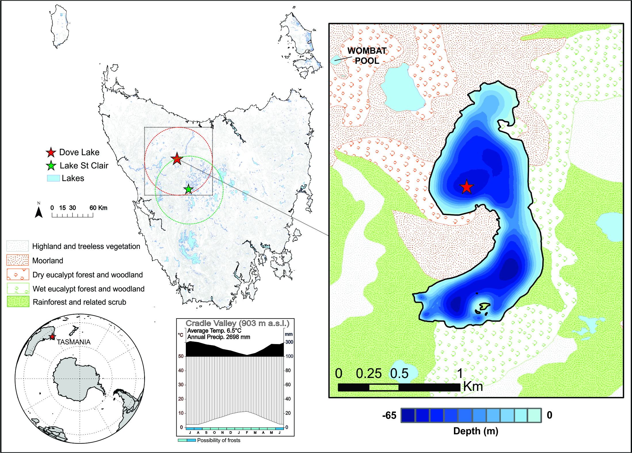

**Fig. 1** Location map of the study site (Dove Lake, Tasmania – TAS1507SC2, red star). The green star indicates the validation site (Lake St Clair). Black box represents the vegetation extent reconstructed by the REVEALS model (100 x 100 km). Red (green) circle is the 50 km buffer around Dove Lake (Lake St Clair) used to extract modern plant cover from the TasVeg 3.0 vegetation maps (Government of Tasmania, 2013) for the REVEALS validation process (see Methods). Polygons in the right panel represent vegetation formations. Lake area is shown as shades of blue representing bathymetry in metres.

**Table 1 -** Table showing fall speeds and PPEs for the ten key pollen taxa used for the vegetation reconstruction from Dove Lake (data from Mariani *et al*., 2016). GPM= Gaussian plume model; LSM= Lagrangian stochastic model. Superscripts *f* and *nf* are used to differentiate forest and non-forest plant taxa.



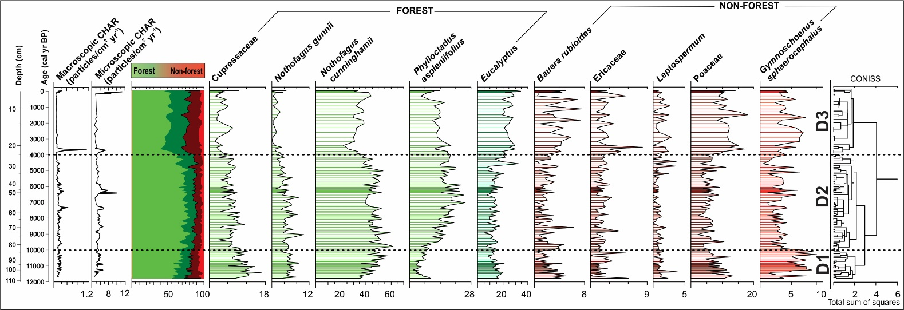

**Fig. 2** Diagram showing pollen % of key taxa used for the vegetation reconstruction. Macro- and micro- charcoal accumulation rates (particles/cm2 yr-1) are also shown. Colours represent the grouping of the taxa according to vegetation structure: green is used for taxa generally occurring within forests; red is used for plant taxa commonly found in non-forested environments. Dashed lines indicate statistically determined pollen zones (see Appendix S4 for zones’ description).

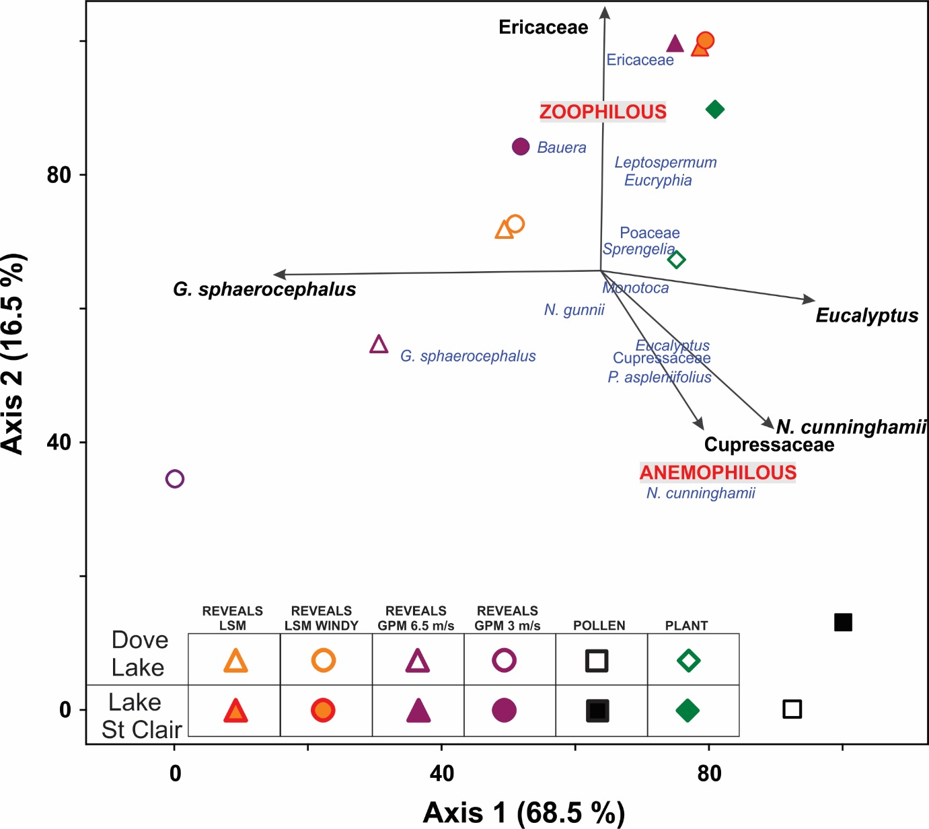

**Fig. 3** Plot of the REVEALS validation PCA. REVEALS vegetation estimates from the surface samples of Dove Lake and Lake St. Clair (Tasmania) were compared to the actual modern plant cover around 50 km from each lake. REVEALS results from four model runs (REVEALS-GPM3m/s, REVEALS-GPM6.5m/s, REVEALS-LSM and REVEALS-LSM windy) are shown. Axis 1 represents 68.5% of the variance, whereas Axis 2 represents the 16.5%. Grey arrows highlight taxa with a correlation with the PCA Axes larger than r=0.5. Filled symbols indicate data from Lake St. Clair, hollow symbols represent Dove Lake.

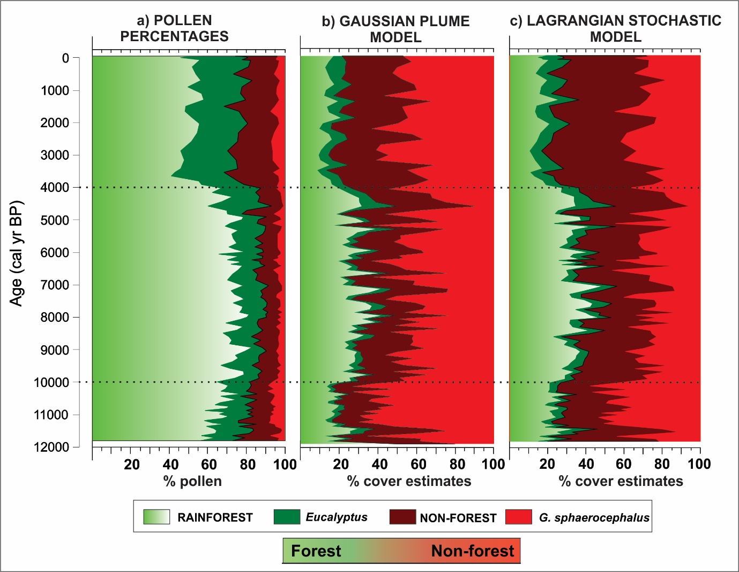

**Fig. 4** Comparison of pollen data and quantitative reconstruction results: summary diagram showing a) pollen percentages; b) REVEALS vegetation estimates using the Gaussian plume model under neutral conditions (REVEALS-GPM); c) REVEALS vegetation estimates using the Lagrangian stochastic model (REVEALS-LSM). Dashed lines indicate statistically determined pollen zones (same as Fig. 2).

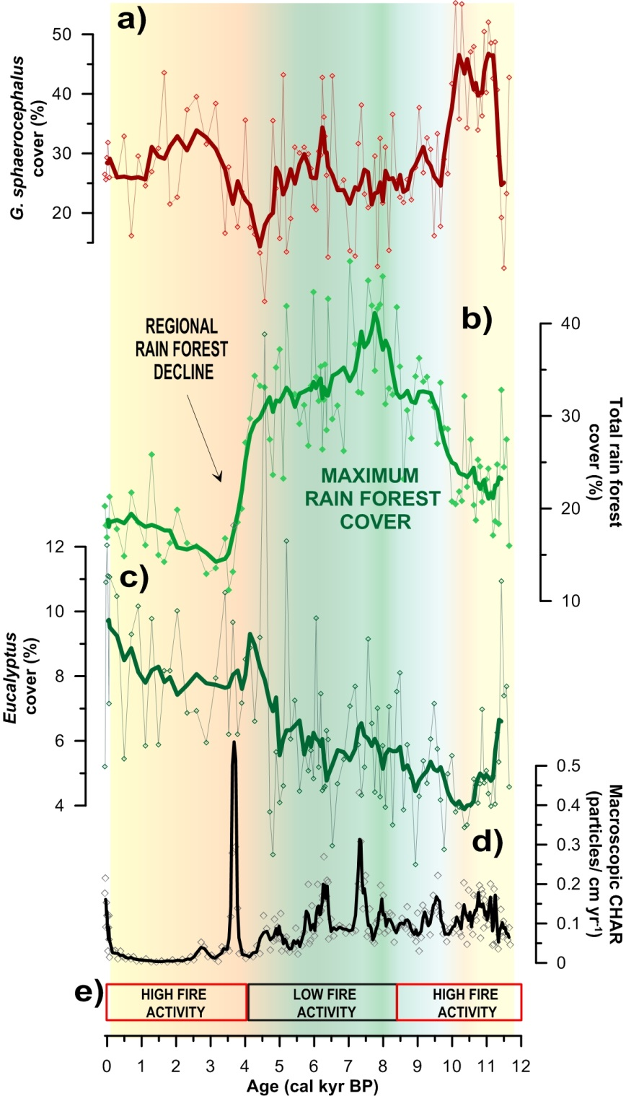

**Fig. 5 –** Summary figure showing major palaeoenvironmental trends, including a) reconstructed plant cover for *Gymnoscheonus sphaerocephalus* (%); b) reconstructed total rainforest cover (%); c) Reconstructed *Eucalyptus* plant cover; d) Macroscopic CHAR record; e) Fire activity based on charcoal influx from two alpine sites in western Tasmania (Fletcher *et al*., 2015). Orange-yellow shading highlights periods of relatively low moisture, enhanced fire activity and low forest cover. Green shading identifies the period with maximum forest cover and low fire activity, suggesting wetter conditions.