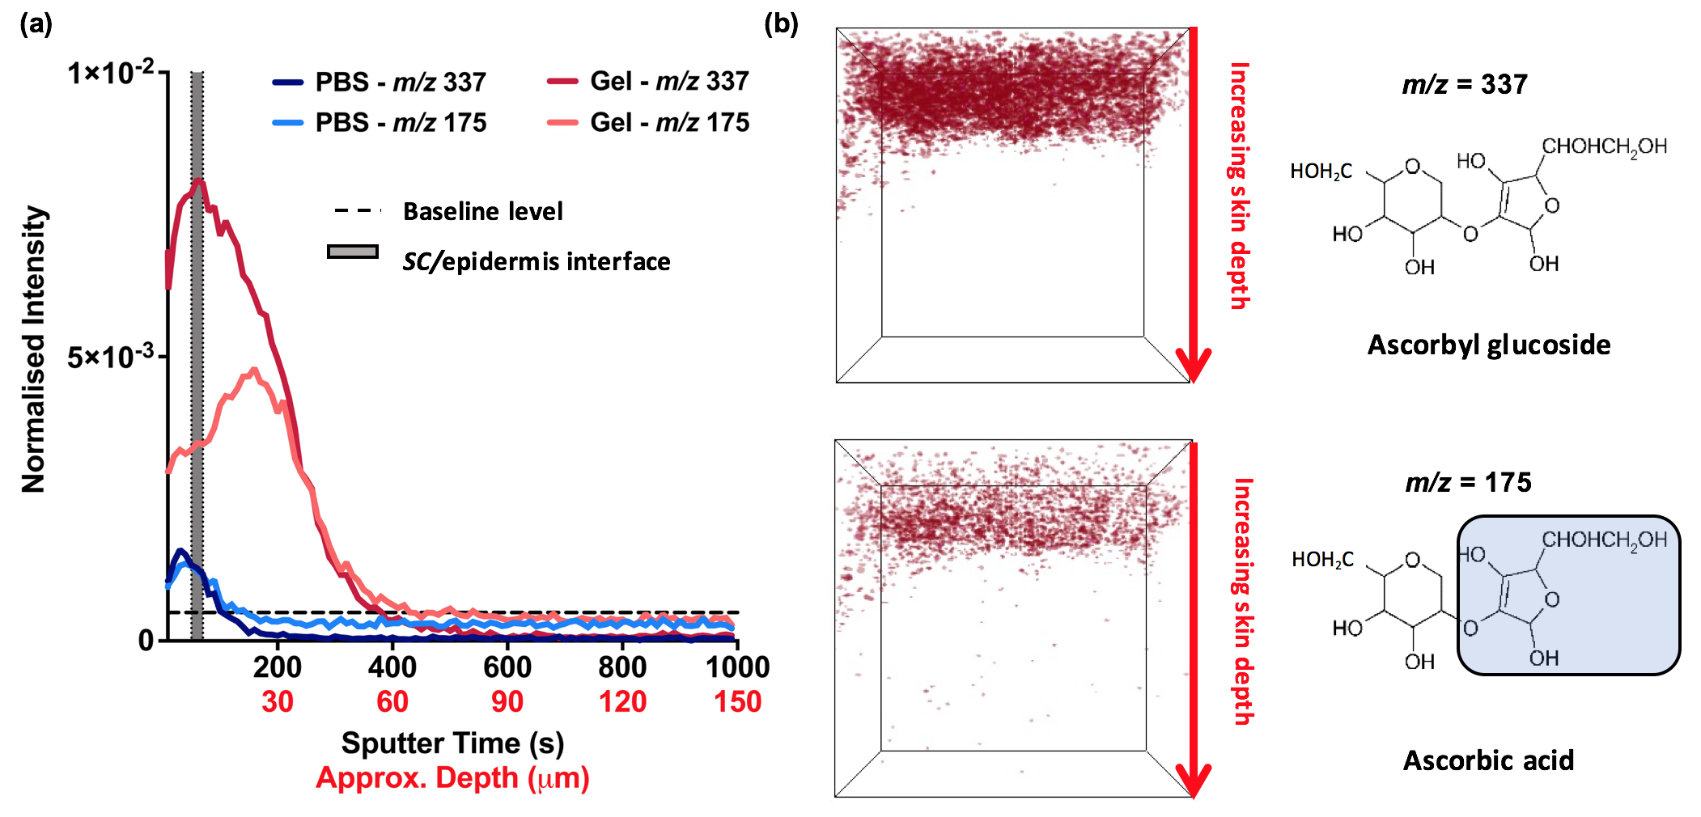

Figure 4. ToF-SIMS depth profile analysis of ex vivo skin samples treated with ascorbyl glucoside. (a) A depth profile graph showing the intensity of both the ascorbyl glucoside (m/z = 337) and ascorbic acid (m/z = 175) ions following application of ascorbyl glucoside as both a PBS and hydrogel formulation and (b) 3D ion maps of ascorbyl glucoside and ascorbic acid from a sample applied with the ascorbyl glucoside hydrogel formulation.

