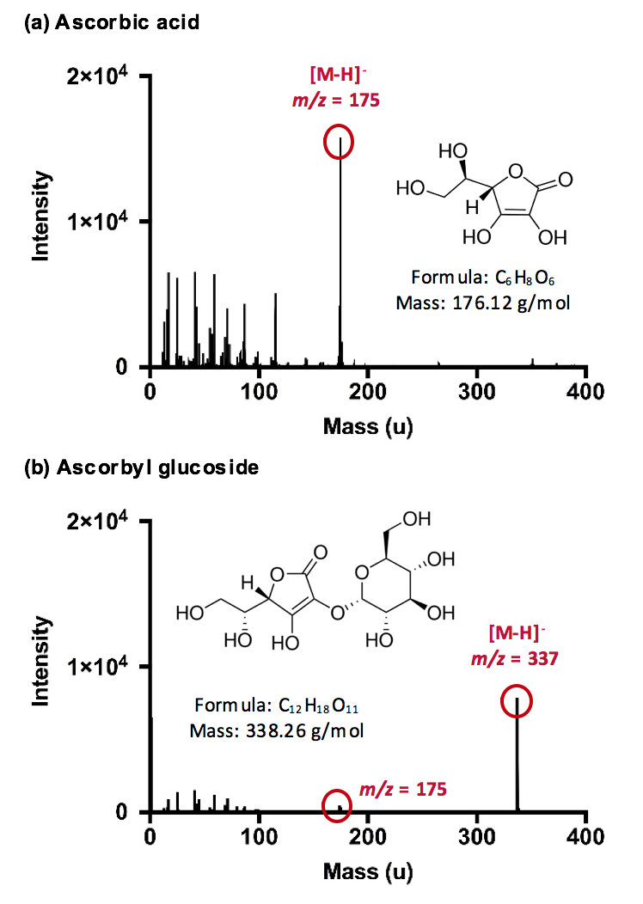

Figure 2. ToF-SIMS reference spectra. The identity and mass of the molecular ion peak and any significant fragments are highlighted for (a) ascorbic acid and (b) ascorbyl glucoside.

