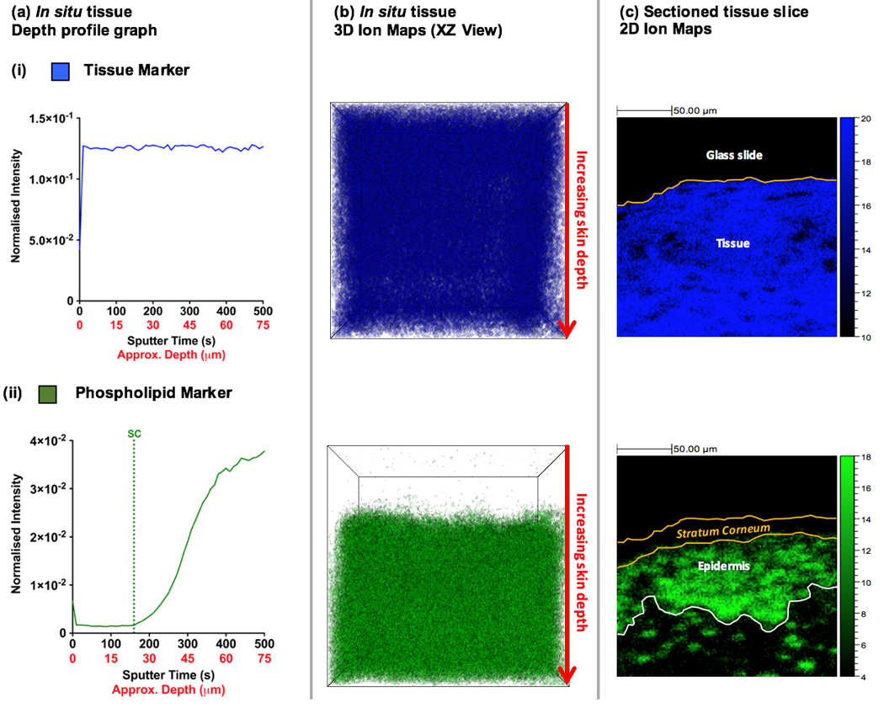

**Figure 1. ToF-SIMS analysis of native porcine skin tissue.** The ion intensity of (i) a generic tissue marker (CN-) and (ii) a phospholipid marker (PO3-) is shown. Depth profile analysis elucidates ion intensity as a function of sample depth. The depth profile data is presented as both (a) a depth profile graph and (b) a 3D ion map (presented as an isosurface with a maximum opacity of 10%). (c) 2D ion maps from surface analysis of a cross-sectioned skin tissue slice.