SUPPORTING INFORMATION

**Enhanced vitamin C skin permeation from supramolecular hydrogels, illustrated using *in situ* ToF-SIMS 3D chemical profiling**

Nichola J. Starra, Khuriah Abdul Hamida†, Judata Wibawab, Ian Marlowb, Mike Bellb, Luïsa Pérez-Garcíaa, David A. Barretta, David J. Scurra*

a Advanced Materials and Healthcare Technologies, School of Pharmacy, University of Nottingham, NG7 2RD, UK.

b Walgreens Boots Alliance, Nottingham, NG90 1BS, UK

† Permanent address: Faculty of Pharmacy, Department of Pharmaceutics, Universiti Teknologi MARA Selangor, 42300 Puncak Alam, Malaysia.

* Corresponding Author: David.Scurr@nottingham.ac.uk

**(a) Optical Images**

**(b) Optical profilometry images**

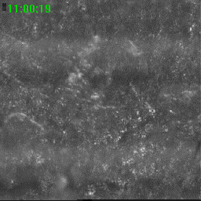

**Pre-sputter photo**

**(b) Post-sputter photo**

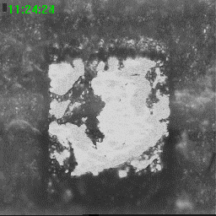

**Post-sputter photo**

**(b) Post-sputter photo**

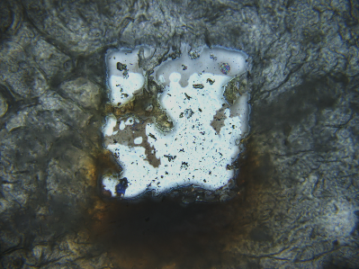

**FoV: 1169 x 876 µm**

**FoV: 1169 x 876 µm**

**2D Image**

**(b) Post-sputter photo**

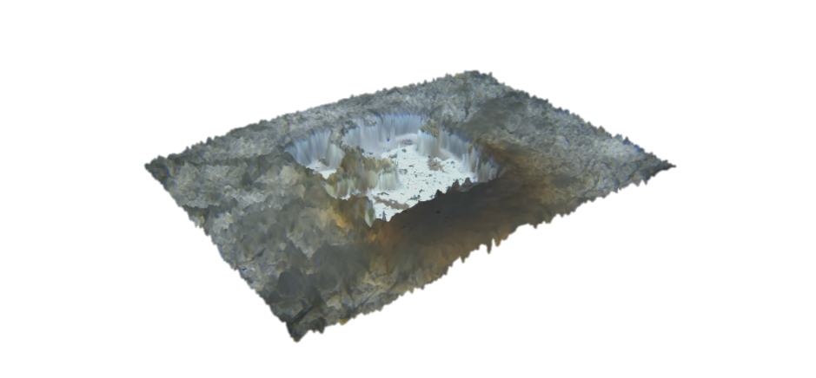

**FoV: 1169 x 876 µm**

**FoV: 1169 x 876 µm**

**3D Image**

**(b) Post-sputter photo**

**Figure S1.** (a) Optical images and (b) optical profilometry images confirming the creation of a sputter crater, following depth profile analysis of porcine skin tissue. Samples were imaged using a Zeta-20 optical microscope (Zeta Instruments, CA, U.S.A). Skin sections adhered to silicon wafers were gently compressed between two glass slides and imaged with the *stratum corneum* side facing upwards. Images were collected at × 20 magnification, which equated to a working distance of 3.1 mm and an XY resolution of 0.45 μm. The sample was vertically scanned at regular depth intervals between user-defined upper and lower reference surfaces. The maximum Z resolution achievable for these samples was approximately 0.25 μm.

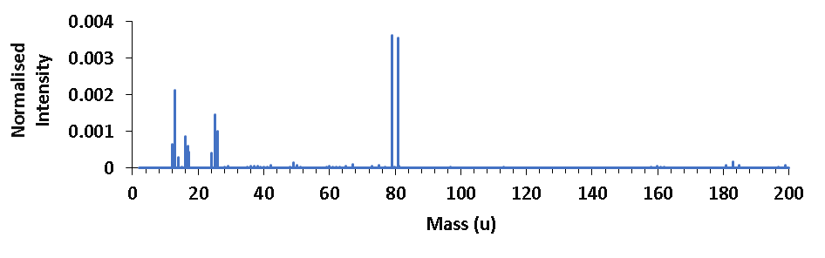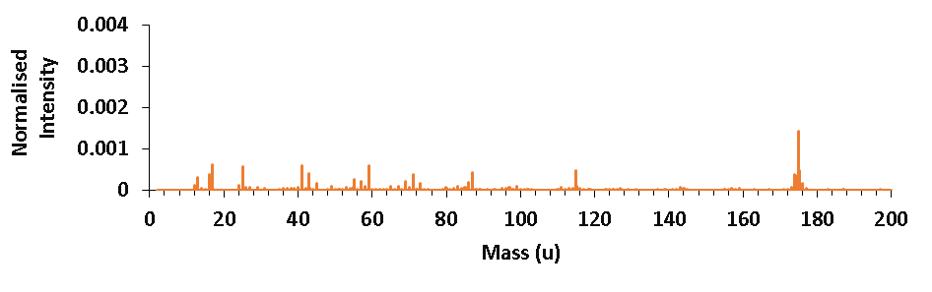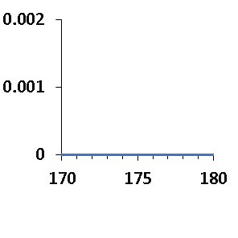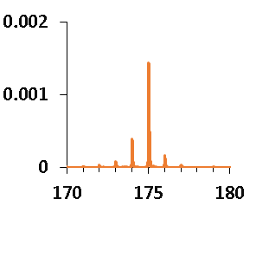

**Gelator**

**Ascorbic acid**

**[M-H]-**

**(a)**

**[M-H]-**

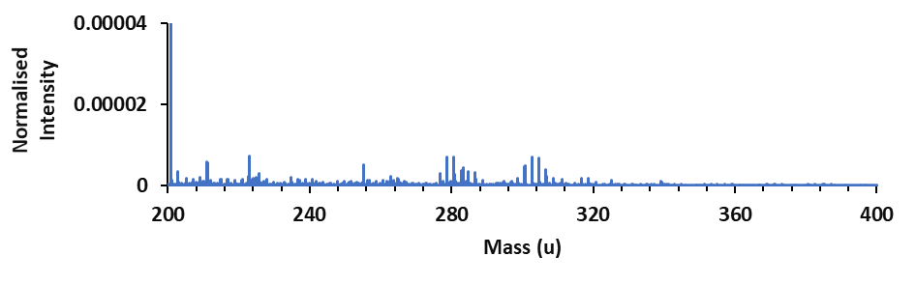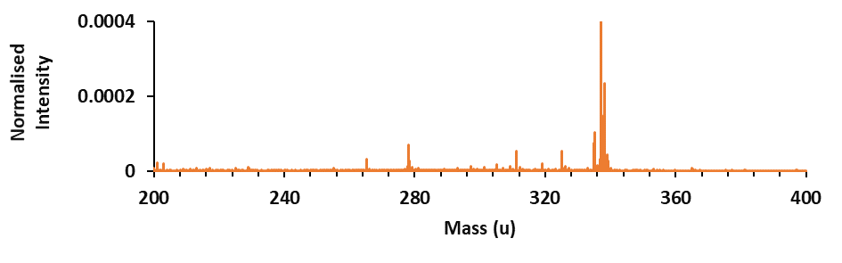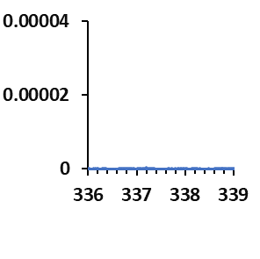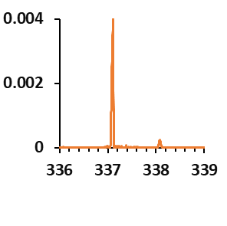

**[M-H]-**

**[M-H]-**

**Gelator**

**Ascorbyl glucoside**

**(b)**

**Figure S2.** ToF-SIMS reference spectra.A comparison between the reference spectra of the gelator compound and (a) ascorbic acid (b) ascorbyl glucoside, confirming that there are no gelator peaks overlapping the molecular ion peaks of these two compounds.

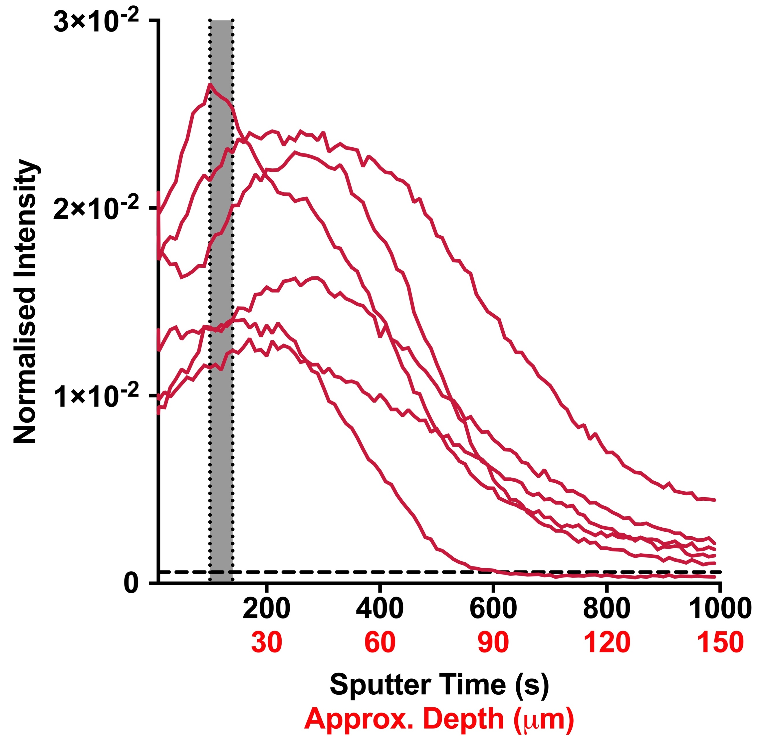

**(a)**

**Ascorbic acid**

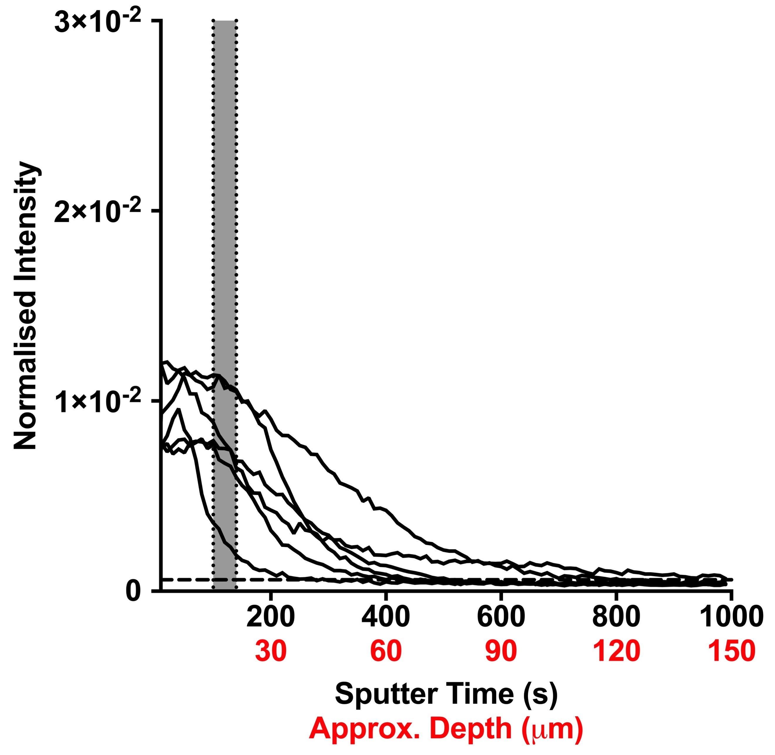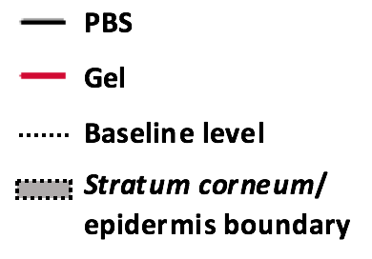

**(b)**

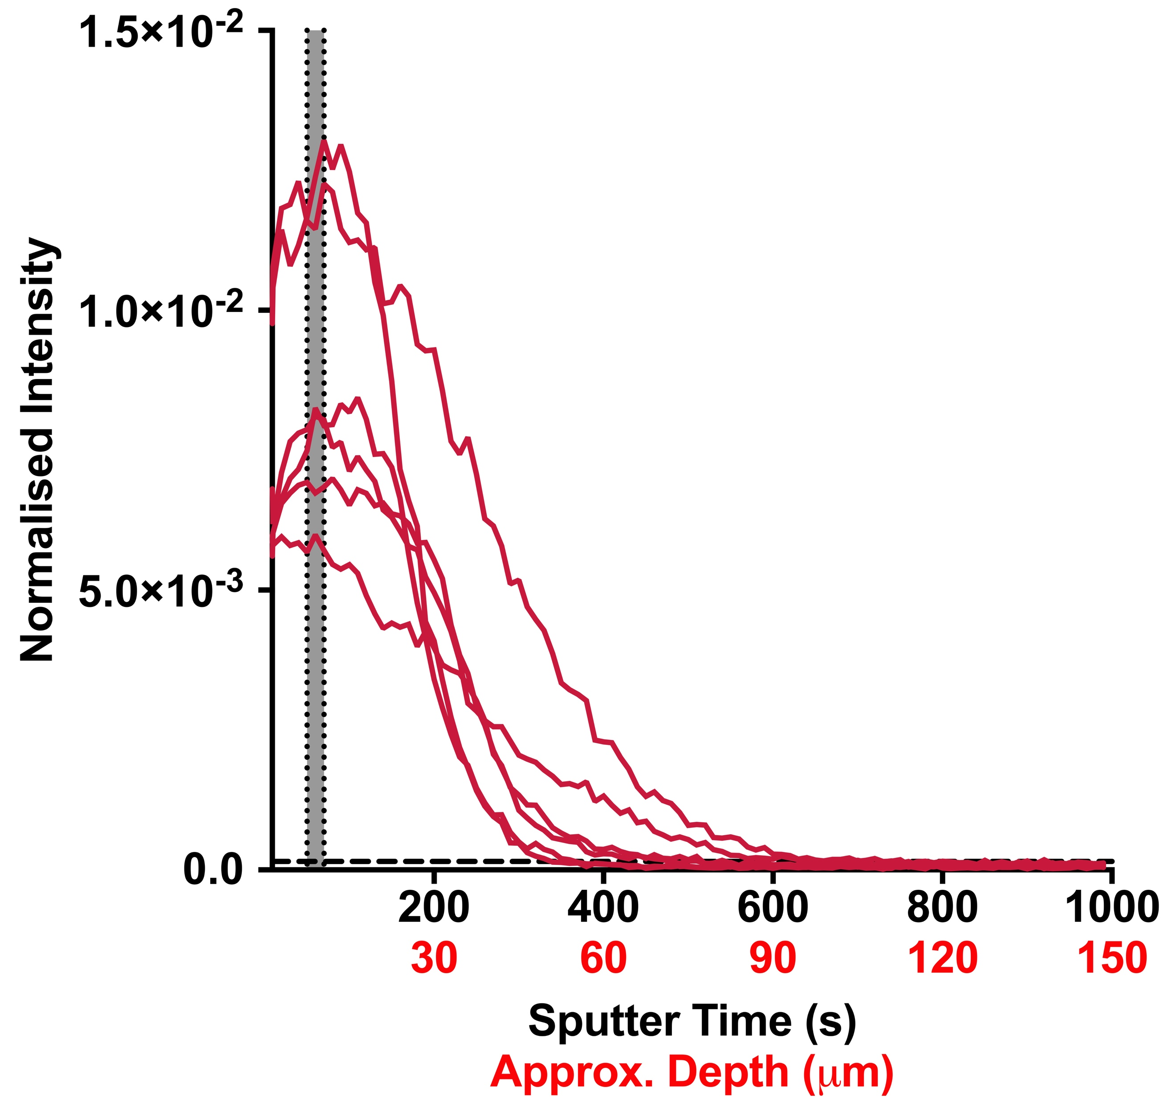

**Ascorbyl glucoside**

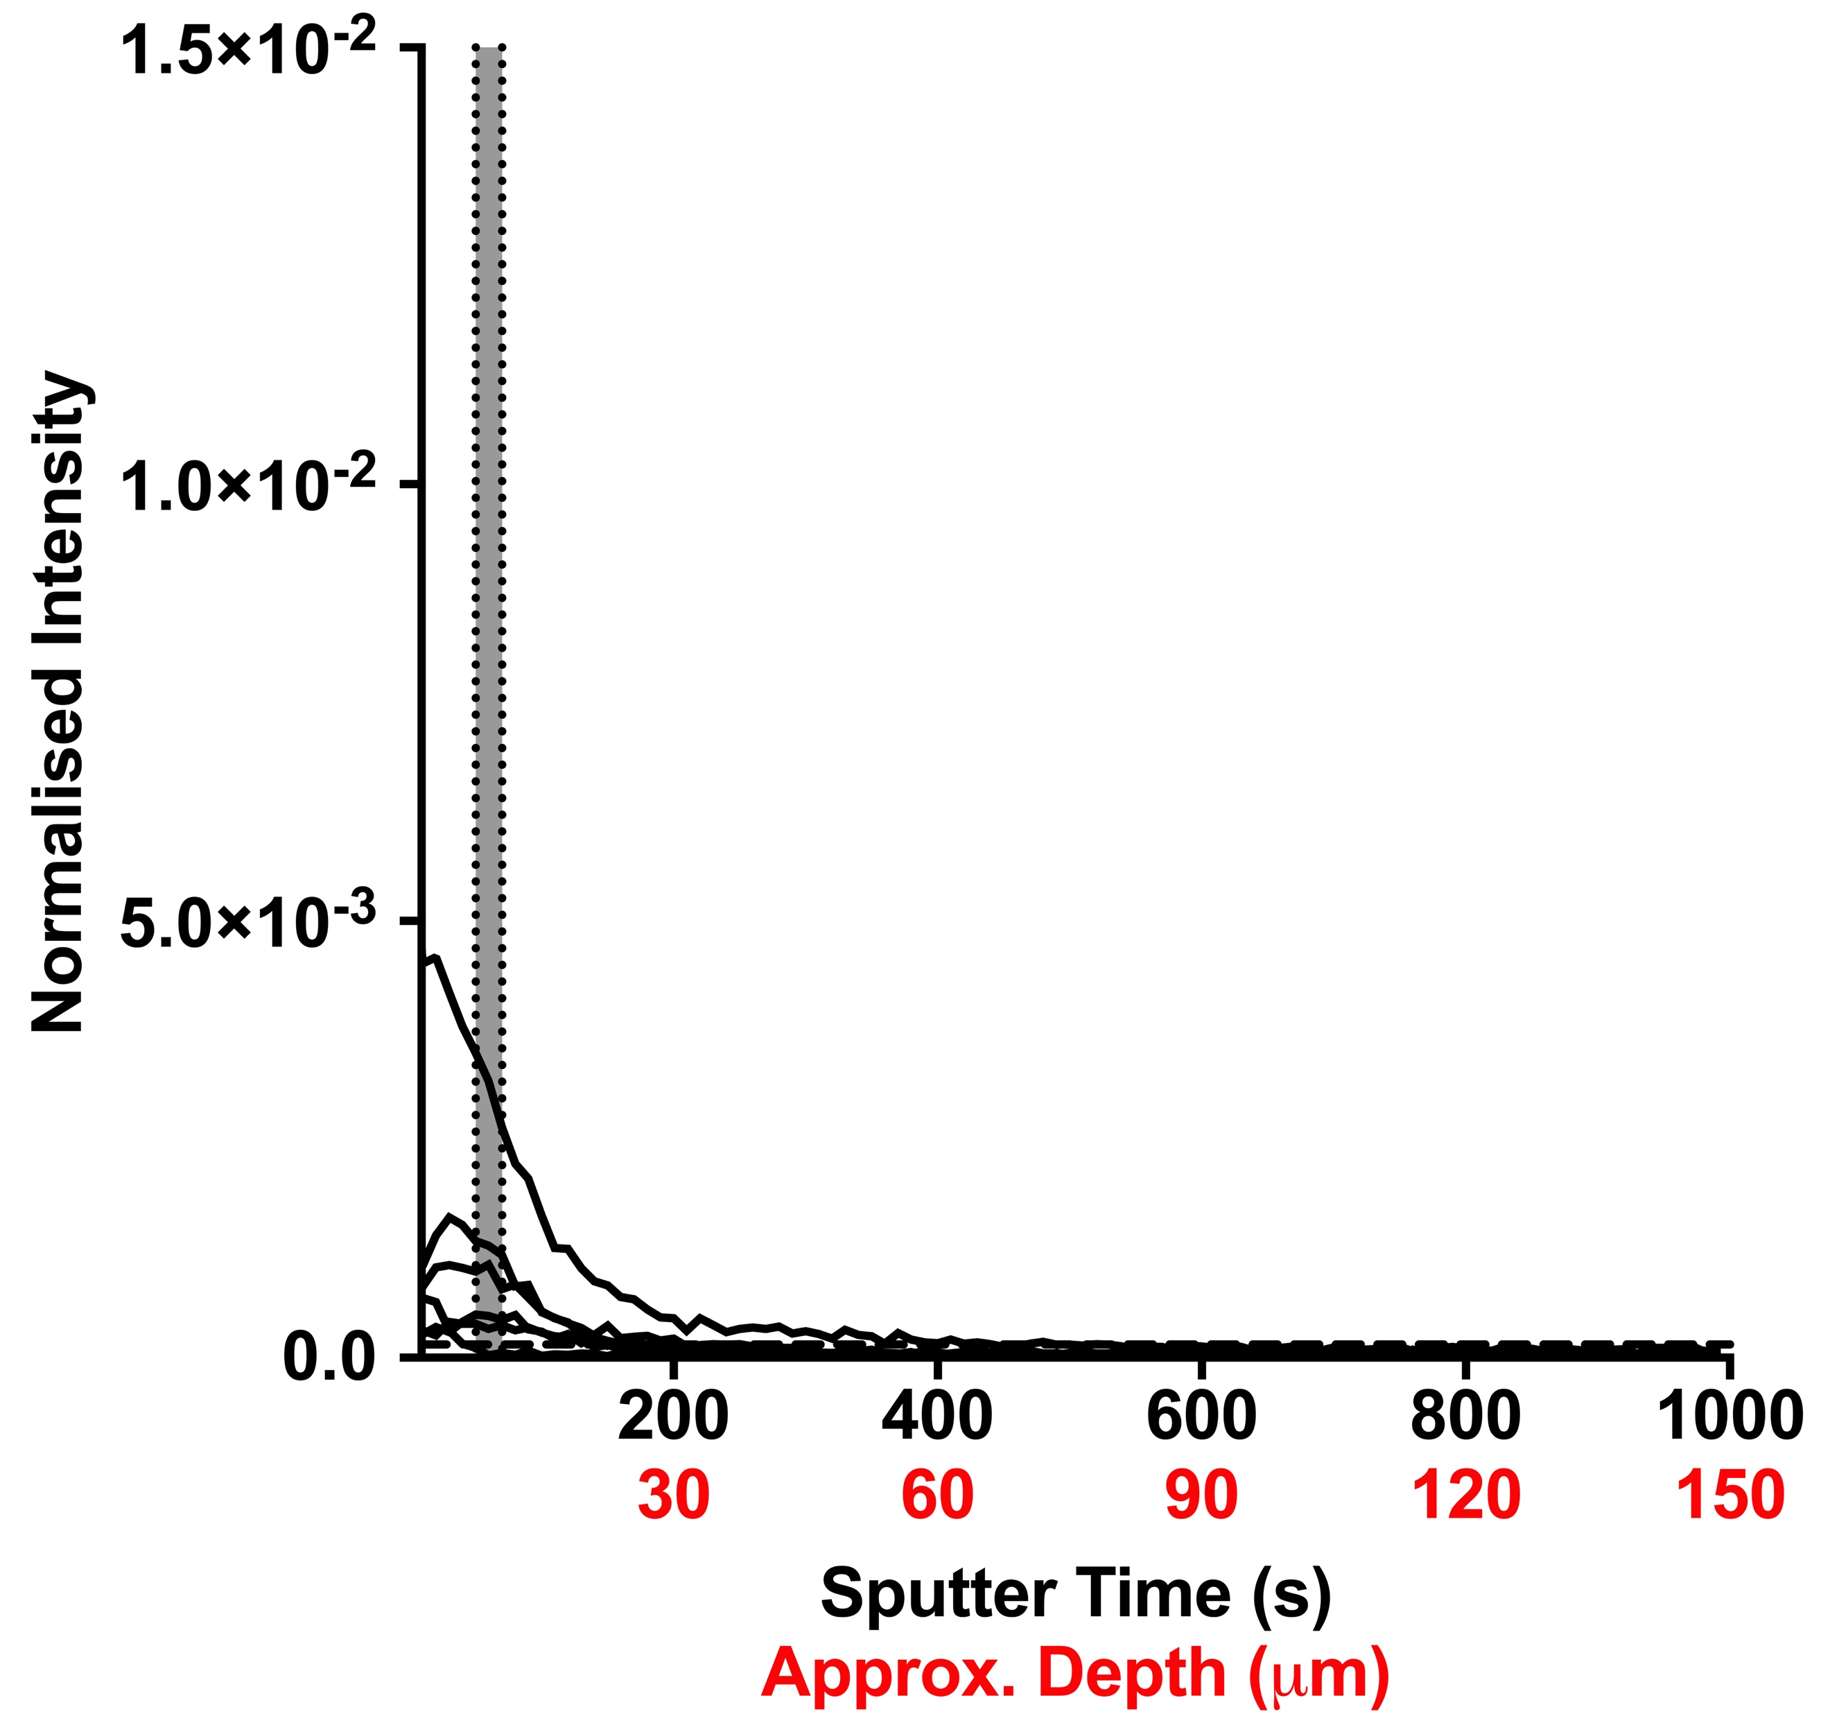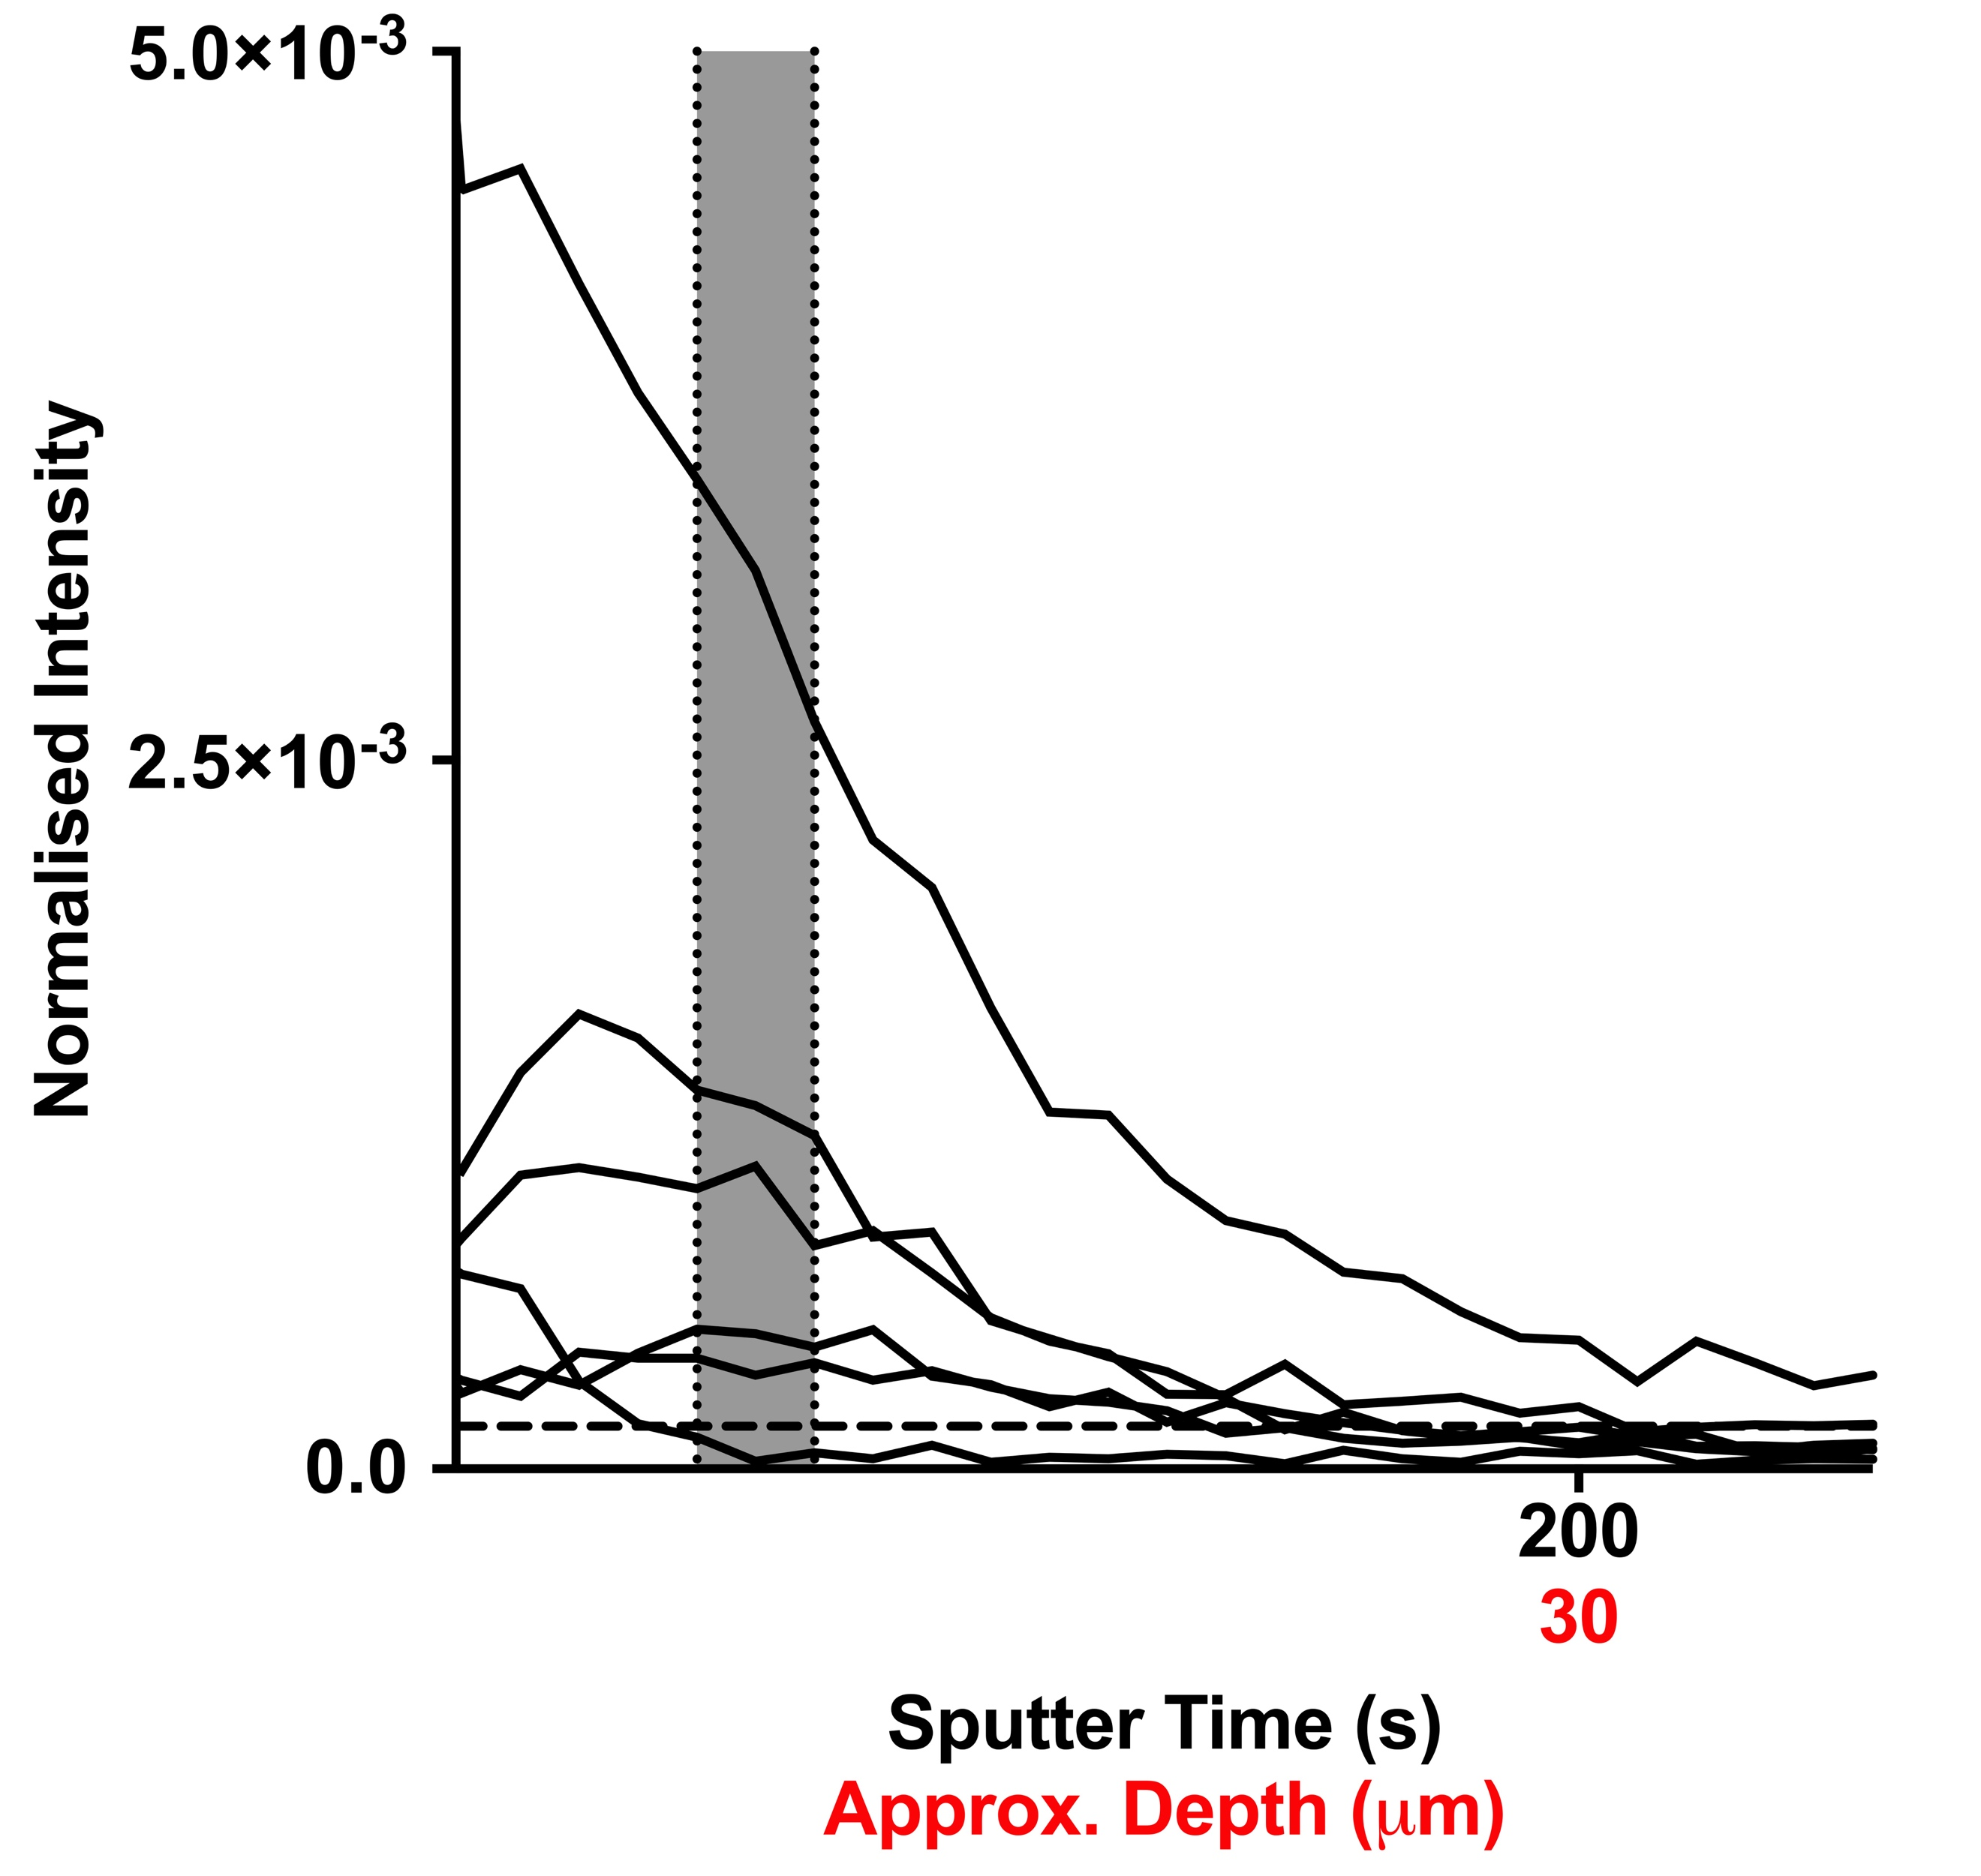

**Figure S3.** ToF-SIMS depth profile analysis of *ex vivo* skin samples following compound application (n=5, all repeats shown). Samples treated with (a) ascorbic acid and (b) ascorbyl glucoside in a Franz cell set-up, applied as both PBS solutions (black data) and hydrogel formulations (red data). The data is presented as depth profile graphs, showing the intensity of the respective molecular ions as a function of sputter time and approximate skin depth.

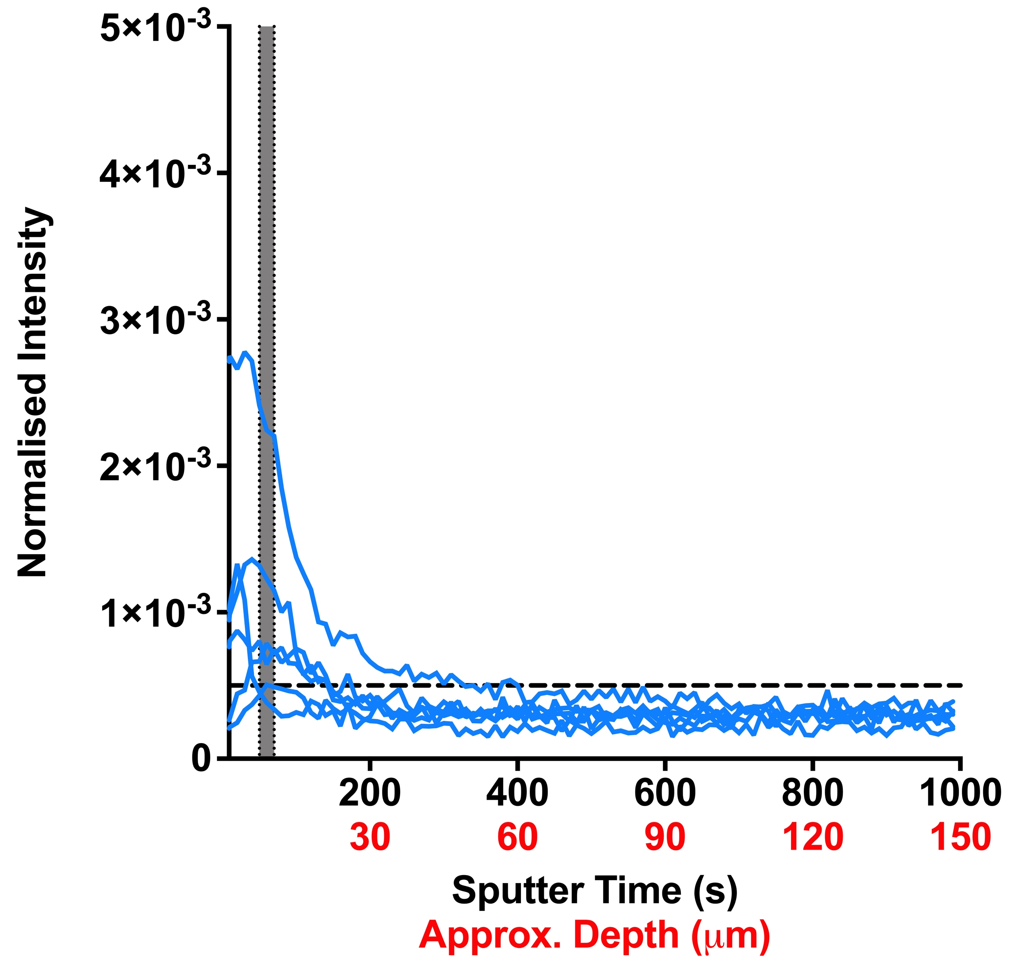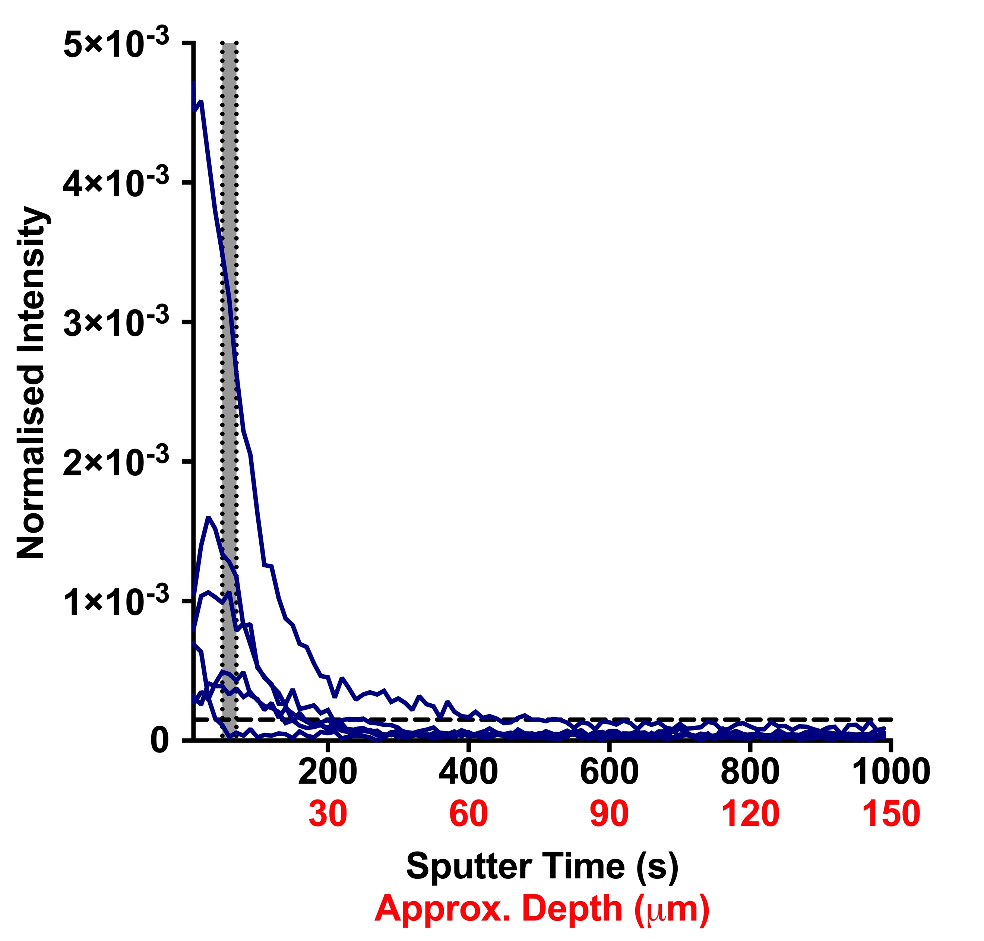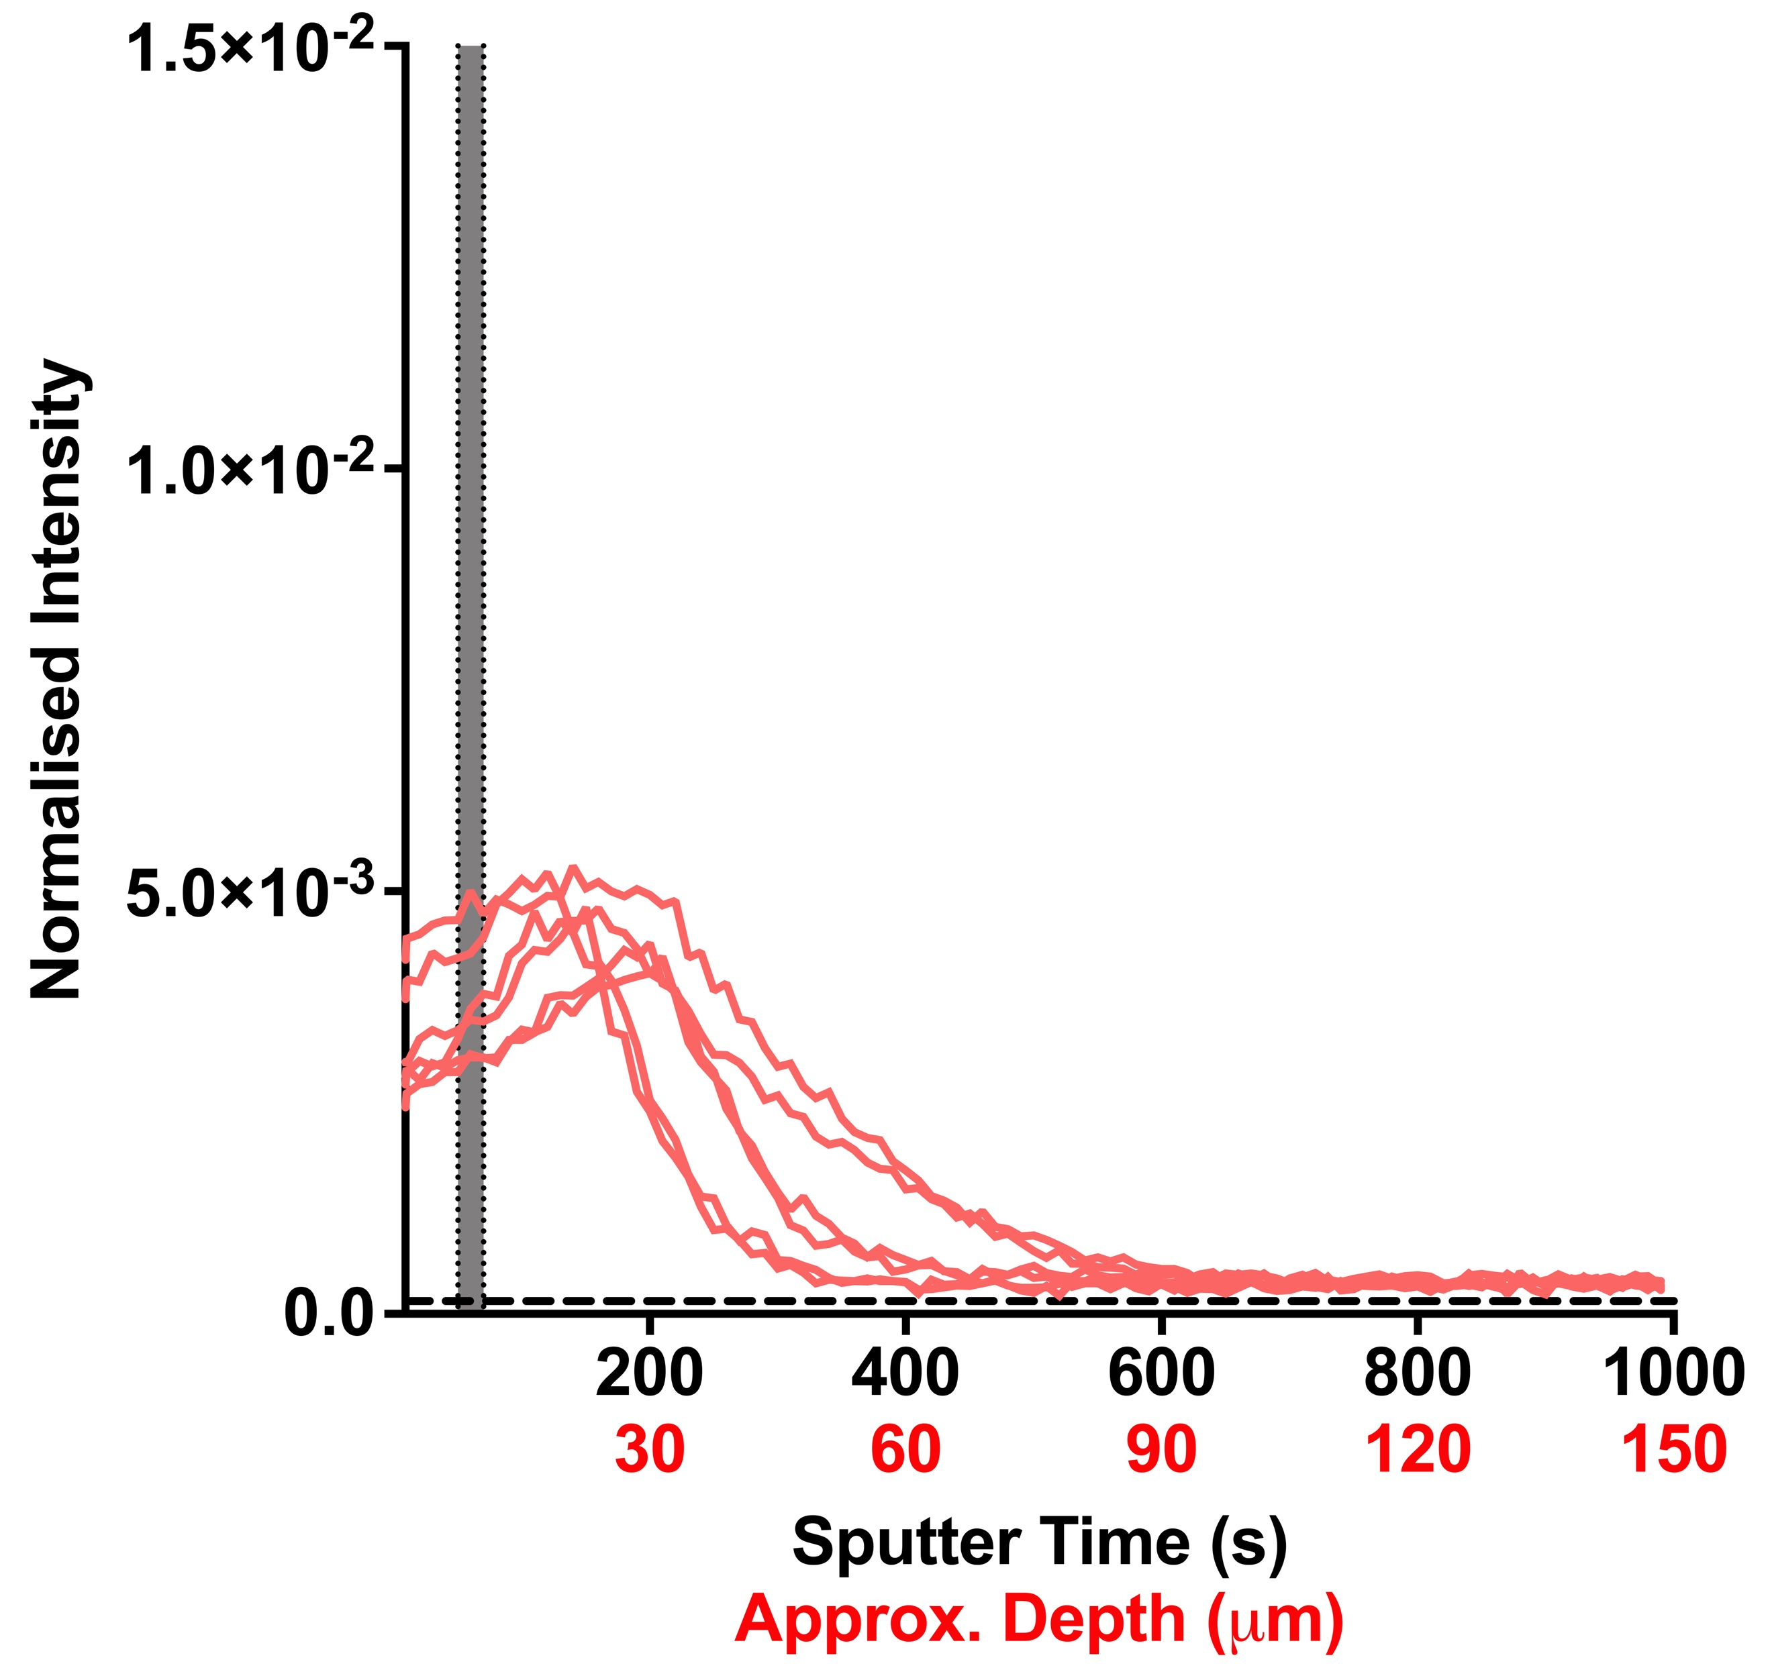

**(a)**

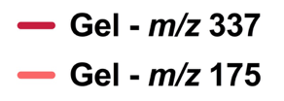

**(b)**

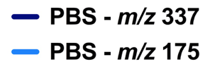

**Figure S4.** ToF-SIMS depth profile analysis of *ex vivo* skin samples treated with ascorbyl glucoside (n=5, full repeats shown). The data is displayed as depth profile graphs showing the ion intensity of both (a-b) the ascorbyl glucoside ion (*m/z* = 337) and (c-d) the ascorbic acid ion (*m/z* = 175) following application of ascorbyl glucoside as both a hydrogel (red data) and PBS (blue data) formulation.

|  |  |  |  |  |  |  |  |
| --- | --- | --- | --- | --- | --- | --- | --- |
| Formulation Type | Ascorbic acid  (mg) | Ascorbyl glucoside (mg) | Phosphate buffered saline (mL) | Gelator*  (mg) | Ethanol  (μL) | Distilled water (μL) | % of active (w/v) in total volume |
| 5% AA in PBS | 50 | 0 | 1 | 0 | 0 | 0 | 5 |
| 5% AG in PBS | 0 | 50 | 1 | 0 | 0 | 0 | 5 |
| 5% AA in Gel | 50 | 0 | 0 | 5 | 400 | 600 | 5 |
| 5% AG in Gel | 0 | 50 | 0 | 5 | 400 | 600 | 5 |

**\* Gelator is 1,3-bis[(3-octadecyl-1-imidazolio)methyl]benzene dibromide. AA = ascorbic acid; AG = Ascorbyl glucoside**

**Table S1.** A table detailing the composition of the four different formulations tested.