## Abstract

Element cycling in the terrestrial environment is heavily reliant upon processes that occur in soil solution. Here we present the first application of microdialysis to sample iodine from soil solution. In comparison to conventional soil solution extraction methods such as Rhizon™ samplers, centrifugation, and high-pressure squeezing, microdialysis can passively sample dissolved compounds from soil solution without altering the *in-situ* speciation of trace elements at realistic soil moisture conditions. In order to assess the suitability of microdialysis for sampling iodine, the permeability factors and effect of perfusion flowrate on I– and IO3– recovery was examined in stirred solutions. Furthermore, microdialysis was used to sample native soluble iodine at a range of water contents and iodine-enriched soils to investigate iodine soil dynamics. Total iodine concentrations were measured using ICP-MS. Inorganic species and the molecular weight distribution of organically bound iodine were determined by anion exchange and size exclusion chromatography (SEC) coupled to an ICP-MS, respectively. The most effective recovery rates in stirred solution were observed with the slowest perfusion flowrate yielding 66.2 ± 7.1 and 70.5 ± 7.1% for I– and IO3–, respectively. Microdialysis was proven to be capable of sampling dissolved iodine from the soil solution, which accounted for <2.5% of the total soil iodine and speciation followed the sequence: organic-I > I– > IO3–. The use of SEC coupled to (i) UV and (ii) ICP-MS analysis provided detail regarding the molecular weight distribution of dissolved org-I compounds. Dissolved org-I was detected with approximate molecular weights between 0.1 - 4.5 kDa. The results in this study show that microdialysis is a suitable technique for sampling dissolved iodine species from soils maintained at realistic moisture contents. In addition, inorganic iodine added to soils was predominately bound with relatively low molecular weight (<4.5 kDa) soluble organic matter.

## Introduction

Iodine is an essential micronutrient involved in the synthesis of the thyroid hormones thyroxine and triiodothyronine (Zimmermann et al., 2008). Approximately 2 billion people are at risk of insufficient iodine intake, which causes a spectrum of clinical and social issues. These include, but are not limited to: stillbirth; decreased IQ; goitre; and congenital hypothyroidism, collectively theyare known as iodine deficiency disorders (IDD) (Fuge & Johnson, 2015; Zimmermann et al., 2015). When access to iodine-rich food (e.g. seafood, fortified salt) is limited, iodine intake depends on the transfer of iodine from soil-to-crops, which may lead to insufficient dietary intake (Watts et al., 2015). As such, a greater understanding of iodine reaction mechanisms in soils and subsequent plant availability and uptake is required.

Assessing mass flow and diffusive processes in soils including: chemical reactions, biotic transformations and plant uptake is reliant upon understanding the interactions and activity of ions that occur in soil solution. The majority of soil iodine exists bound to the solid soil phase; adsorbed to metal oxides or irreversibly bound to natural organic matter, particularly humus, which is the primary reservoir of iodine in soil (Shetaya et al., 2012). During iodine addition events such as rainfall, irrigation or fertilisation, inorganic iodine entering the soil can react in a number of ways, including: (1) adsorption by variable-charge oxides, such as Fe/Al/Mn oxides, (2) methylation by the soil microbial community, and (3) iodination of phenolic moieties and amines (Humphrey et al., 2018; Schlegel et al., 2006; Shetaya et al., 2012). Consequently, the concentration of iodine in the soil solution of most natural soils is very low; ranging from <0.1-9.2% of the total soil iodine (Hansen et al., 2011; Hong et al., 2008; Schmitz & Aumann, 1995; Takeda et al., 2016). Assessing the *in-situ* concentration and speciation of iodine in soil solution presents significant difficulties due to the limited sample volume and potential changes in iodine speciation as a result of fluctuating soil conditions imposed during sample extractions.

Microdialysis is a passive sampling technique that has been applied to investigate the mobility and bioavailability of nutrients and metal ions in soils (Brackin et al., 2015; Buckley et al., 2017; Cocovi-Solberg et al., 2014; Miró et al., 2005a; Miró et al., 2005b; Rosende et al., 2013; Torto et al., 2002). The passive diffusion, driven by the concentration gradient between the perfusate and soil solution, enables the sampling of dissolved compounds whilst maintaining their *in-situ* chemical characteristics (Brackin et al., 2017; Inselsbacher & Näsholm, 2012; Miró et al., 2010). Therefore, it is possible to examine the effect of environmental conditions on nutrient mobility

Size exclusion chromatography (SEC) separates chemical species in aqueous samples according to molecular size. When coupled to a UV-Vis molecular absorption detector and an element-specific detector, SEC provides an effective analytical tool for identifying org-I species in environmental or biological samples (Humphrey et al., 2018). However, the application of SEC to investigate soluble iodine dynamics in soil is limited. Rädlinger and Heumann (1997) described a fast and sensitive method using SEC-ICP-MS for characterising halogen-humic substance species in groundwater, seepage water from soil, brown water and sewage effluent. They observed the formation of organically bound species using labelled 129I–, resulting in the finding that specific humic substance fractions are preferentially iodinated. Andersen et al. (2009) coupled SEC with UV-Vis analysis and the Ce/As method for iodine analysis to investigate the speciation of iodine in groundwater. There was a strong correlation between total iodine in groundwater and organic matter with the chromatograph highlighting an org-I peak, with a molecular weight (MW) of ~5 kDa and the presence of I- and very low MW substances, with org-I accounting for 8-70% of the total iodine present in the sample. The transformation from inorganic iodine to org-I plays a vital role in iodine immobilisation and plant availability.

The aim of this research was to investigate iodine dynamics in soil solution. Objectives were to (i) develop a method capable of sampling iodine from soil solution using microdialysis and (ii) identify different species of iodine present in the soil solution using SEC coupled to UV-vis molecular absorption analysis and ICP-MS.

## Materials and Methods

### Soil collection and storage

Three soil samples were collected from arable, grassland and woodland sites in South Nottinghamshire, UK where the monthly average temperature is between +3.6 °C and +16.4 °C and average annual rainfall is 652 mm. Shallow soil samples were collected (0–10 cm), after removal of surface litter, and retained for further processing. Soils were sieved using a nylon mesh to <2 mm, homogenised and air-dried. Soil pH was determined using an Orion pH meter after equilibrating 5 g of soil in 12.5 mL of 0.01 M CaCl2 solution for 30 min. The water holding capacity (WHC), of each soil was determined gravimetrically in triplicate. Loss-on-ignition (LOI) at 450 °C was used to estimate the organic matter content of the soils for the arable, grassland and woodland soils. Total soil iodine was extracted with tetramethylammonium hydroxide (TMAH) according to the method developed by Watts and Mitchell (2009). Soil texture was classified after laser granulometer particle size measurement as outlined by Rawlins et al. (2013).

### Microdialysis

Whilst this application of microdialysis is novel, the principles are well understood. The mass transfer through the semi-permeable microdialysis membrane is subject to Fick’s law of membrane properties, hydrodynamics variables and the diffusivity of the target compound (Miró et al., 2010). Bungay et al. (1990) outlined the mathematical framework for *in-vivo* quantitative microdialysis of solutes. The recovery of a solute (Ed) is defined as a function of multiple resistances to solute movement imposed by: the external environment (Rext); the microdialysis membrane (Rm); the dialysate (Rd); and the perfusate flow rate (Qd) (Buckley et al., 2017; Bungay et al., 1990):

$E_{d} =1-\exp\left(-\frac{1}{Q_{d}\left(R_{ext} {+ R}_{m} +{ R}_{d}\right)}\right)$ (1)

Where:

$R_{ext}=\frac{1}{2πD_{ef} \sqrt{2r_{o}{ L}_{ef}}}$ (2)

$R_{m}=\frac{ln⁡(r_{o}/r_{i})}{2πL_{ef}D_{m}∅_{m}}$ (3)

$R_{d}=\frac{13}{15}\left[\frac{r_{i}-r_{o}}{2πL_{ef}r_{i}D_{d}}\right]$ (4)

As seen in equations 1-4, microdialysis sampling is controlled by specific membrane properties such as the effective diffusion coefficient (Def) in the surrounding medium, the effective dialysis length (Lef), outer and inner radius (ro and ri,respectively), the accessible volume fraction for analyte (∅m), diffusive transport of the target analyte through the membrane (Dm), and the diffusion coefficient through the dialysate (Dd) (Buckley et al., 2017; Bungay et al., 1990; Miró et al., 2010; Torto et al., 1998; Torto & Mogopodi, 2004).

The order of most resistance to solute recovery for microdialysis sampling in soils is as follows: Rext > Rm > Rd. The most significant factors impacting Rext include impedances to solute movement by the soil solid phase, microbial immobilisation and mineralisation (Schimel & Bennett, 2004; Tinker & Nye, 2000). Resistances associated with Rm include the physical attributes of the membrane such as length, inner and outer radii of the probe and porosity. The resistances to Rd include viscosity, temperature and solutes already present in the perfusate (Miró et al., 2010), however, these generally have minor effects on recovery (Bungay et al., 1990). The most effective means of improving recovery is to either decrease these resistances or reduce the flow rate, however, these measures can increase cost and sampling times (Buckley et al., 2017; Inselsbacher et al., 2011).

In this study, the microdialysis system consisted of a KD Scientific Legato 200 Series syringe pump, equipped with four syringes (BD Plastipak; 20 mL) used to deliver the perfusate solution. The syringes were attached, using adaptors, to a microdialysis probe (CMA 20/ Microdialysis AB, Stockholm, Sweden) with a polyethersulfone (PES) membrane (10 mm long, 500 µm outer diameter) with a 100 kDa molecular weight cut-off (MWCO). The probes were then attached to 0.5 mL vials for dialysate collection (Eppendorf, Hamburg, Germany). A schematic demonstrating the microdialysis setup used in this paper is provided in the supplementary data (Figure 3S. 1).

### Microdialysis sampling

### Microdialysis in stirred solutions

The transport characteristics and recovery of I- and IO3- through the microdialysis membranes were first calculated in solution. Microdialysis probes were attached to the syringe pump and positioned in a glass beaker (100 mL) with a solution comprising 100 µg L-1 I- or IO3-, kept at a constant temperature of 20 °C and mixed with a magnetic stirrer throughout the sampling period; the beaker was covered with Parafilm® to avoid evaporative losses. The probes were perfused with high-purity deionised (Milli-Q) water (⩾18.2 MΩ cm at 25 °C) at flow rates of 1, 3, 5, 7.5 and 10 µL min-1, respectively. A total of eight dialysis samples were collected for each flow rate. Samples were then frozen at −20 °C, freezing did not alter the speciation of iodine in the samples, as confirmed in preliminary tests. Samples were defrosted immediately before analysis of total iodine and inorganic iodine concentrations using liquid chromatography (LC) coupled to ICP-MS.

### Microdialysis in soils

Microdialysis was used to sample dissolved iodine in the soil solution of three experimental soils in two separate experiments. The first experiment was designed to investigate changes in iodine mobility and speciation as a function of wetting; in the second experiment, microdialysis and SEC-UV-ICP-MS were used to investigate iodine dynamics in soil solution.

### Iodine mobility and speciation as a function of soil moisture

Approximately 25 g (dry weight) of the arable, grassland and woodland soils were packed into 50 mL polypropylene self-standing centrifuge tubes modified with a hole drilled into the lid to allow gas exchange. The air-dried soils with approximately 0% WHC were adjusted to 60, 70, 80, 90, 100 and 110% of their WHC, using Milli-Q water, and equilibrated for 10 days at 4 °C prior to sampling, each moisture treatment was replicated three times. Prior to use, probes were soaked in a Milli-Q for 5 min for cleansing. Insertion holes were made in the soils using a needle and a probe was inserted into each individual microcosm. After an initial probe purging period of 5 min, the probes were perfused with Milli-Q water at 2.5 µL min-1 for 4 hours, to ensure an adequate volume of solution for analysis. Dialysate solutions were collected, in 0.5 mL safe-lock Eppendorf vials and frozen at −20 °C until analysis for total iodine and inorganic iodine speciation by LC-ICP-MS.

### Iodine dynamics in soil solution

Air-dried soils with approximately 0% WHC were adjusted to 80% WHC, using Milli-Q water, and spiked with an additional 200 mg kg-1 I- or IO3- and equilibrated for 10 days at 4 °C prior to microdialysis sampling, each treatment was replicated three times. To investigate iodine speciation in the artificially spiked soils the probes were perfused with Milli-Q water at 5 µL min-1 for 2.5 hours, after an initial purging period of 5 min. Dialysate solutions were collected, in 0.5 mL safe-lock Eppendorf vials and frozen at −20 °C until analysis for total, inorganic iodine speciation and SEC analysis.

### Calculation of relative recovery, diffusive flux and permeability factors

### Relative recovery

The relative recovery (RR) is the percentage of the concentration (µg L-1) of analyte in the dialysate (Cdialysis) over the external concentration (µg L-1) in the sample medium (Cmedium), (Equation 5), and is the same for solutions and solid media (Inselsbacher et al., 2011; Miró et al., 2010; Mosetlha et al., 2006; Torto et al., 2002; Zhou et al., 2008).

$RR (\%)=\left(C_{dialysis}/C_{medium}\right)×100$ (5)

### Diffusive flux

The diffusive flux (DF) (µg cm-2 h-1) represents the rate at which target compounds diffuse across the membrane, accounting for the total surface area of the membrane and sampling time (Leitner et al., 2017; Oyewole et al., 2014) (Equation 6):

$DF=(C_{dialysis}×V_{pump})/(A_{m} ×time$) (6)

Where Vpump is the volume (µL) sampled at each individual pump flow rate, Am is the surface area of the membrane (0.159 cm2), and time (hours) is the sampling time.

Permeability factors

Permeability factors (*PF*) are used as an indicator of membrane resistance to solute movement (Torto et al., 1998), and defined by equation (7) (Bungay et al., 1990):

*PF* = 1/ (*Rd +* *Rm* + *Rext*) (7)

In the stirred solutions, *Rext*= 0 (Bungay et al., 1990), and in aqueous solutions *Rm* > *Rd*. Therefore, in the stirred I- and IO3- solutions the *PF* is defined by equation (8):

*PF* = 1/ *Rm* (8)

*PF* for I- and IO3- in stirred solutions were derived by linearising equation (1), and taking the gradient of the plot of −ln(1−*RR*/100) vs. 1/*Qd*, (Buckley et al., 2017; Bungay et al., 1990; Torto et al., 1998).

### Iodine analysis

### Total Iodine analysis

Total 127I concentrations were determined in single MS, no-gas mode (Agilent 8900 ICP-QQQ-MS, Agilent Technologies). A calibration curve for iodine was prepared using aqueous standards with concentrations of 0.5, 1, 10, 25, 50 and 100 µg L-1 for 127I. Drift correction standards were employed, as were in-house reference materials for quality control checks throughout the analytical run. The limit of detection (LOD) (3SD blanks) was 0.42 µg L-1 for 127I analysis in solution. An internal standard of Te (m/z = 125) in 0.5% TMAH was mixed with the sample solution, via a t-piece, to monitor instrument stability.

### Iodine speciation analysis using LC-ICP-MS

### Inorganic iodine analysis

The concentrations of inorganic iodine, 127I- and 127IO3-, were determined using ion chromatography (IC), consisting of an Agilent 1260 Infinity Bio-inert Quaternary LC Pump and an Agilent 1260 Infinity Bio-inert High Performance Auto sampler coupled to an Agilent 8900 ICP-MS. Samples (10 μL) were injected onto an anion exchange column (Hamilton PRP X-100, 250 mm × 4.6 mm, 5 μm) and separated according to their affinity for the column and mobile phase. The mobile phase consisted of isocratic elution using 100 mM NH4NO3, adjusted to pH 9.5 with TMAH (25%) and a flow rate of 1.5 mL min-1. The eluent from the column was directly aspirated into the ICP-MS, which monitored the m/z ratio of 127I. The LODs were 0.25 and 0.30 µg L-1 respectively for 127I- and 127IO3- in solution. An in-house reference material was measured giving iodine concentrations of 5 µg L-1 (recovery 92%; n = 12) for 127IO3– and 127I–.

### Iodine molecular weight distribution analysis using SEC-UV-ICP-MS

Size exclusion chromatography (SEC-UV-ICP-MS) analysis was performed using an Agilent 1260 Infinity Bio-inert Quaternary LC Pump and an Agilent 1260 Infinity Bio-inert High Performance Autosampler. The SEC column was an AdvanceBio SEC 130Å (4.6 x 300 mm column, packed with 3-µm particles, Agilent), with a MWCO of 100 kDa. The mobile phase consisted of isocratic elution of 150 mM sodium phosphate buffer, pH 7.0 at a flow rate of 0.35 mL min-1. The UV detector was set to 220 nm, to measure protein standards, and 254 nm to detect dissolved organic carbon as UV absorption at 254 nm occurs due to organic substances with aromatic and other mesomeric π electron systems (Rädlinger & Heumann, 1997; Rädlinger & Heumann, 2000; Shah et al., 2005; Shimamoto et al., 2011; Takeda et al., 2009; Yamada et al., 2002). Total 127I concentrations were simultaneously determined in single MS, no-gas mode using ICP-MS (Agilent 8900). Due to the lack of commercially available calibration standards for humic substances (Conte & Piccolo, 1999), protein standards of known MW: Ovalbumin (45000 Da); Myoglobin (17000 Da); Aprotinin (6700 Da); Neurotensin (1700 Da); and Angiotensin II (1000 Da) (AdvanceBio SEC 130Å protein standard, Agilent) were used to calibrate the size-exclusion column with nominal molecular-weight ranges. Figure 3. 1 shows the calibration for SEC analysis. An inorganic iodine speciation chromatogram can be found in the supplementary data (Figure 3S. 2), highlighting the clear peak separation.

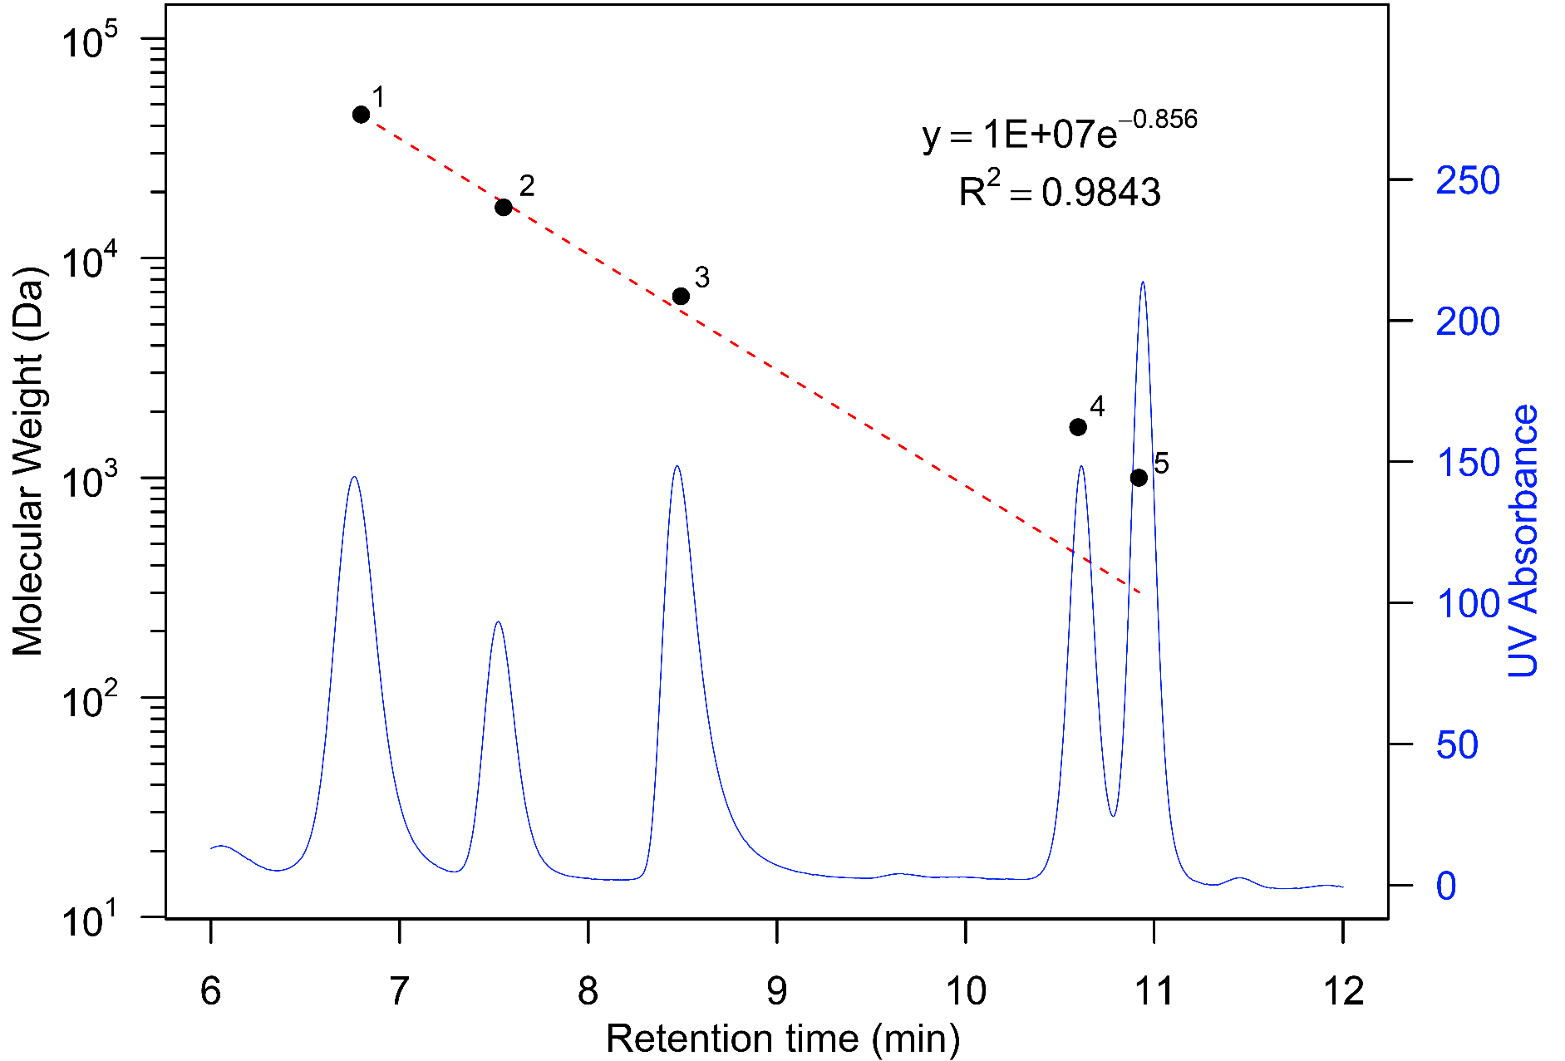

**Figure 3. 1.** Molecular weight calibration curve (note log10 scale) and chromatogram separation (secondary axis) for AdvanceBio SEC 130Å protein standard mixture (log10 scale). Size-exclusion chromatography fractionation (black circles): 1- Ovalbumin (45000 Da); 2- Myoglobin (17000 Da); 3- Aprotinin (6700 Da); 4- Neurotensin (1700 Da); and 5- Angiotensin II (1000 Da), UV detection at 220 nm.

### Statistical analysis

Statistical analysis was performed in R version 3.3.2 (R Core Team, 2016). Non-linear regression curve fitting was calculated in R and data was analysed using one-way and multi-factorial ANOVA followed by Tukey's HSD post-hoc test. Statistical significance was placed at *p*≤0.05.

## Results and discussion

### Soil characteristics

The physiochemical characteristics of the experimental soils are summarised in Table 3. 1. The experimental soils had a range of physiochemical properties; soil pH for the arable and grassland was much higher compared to the woodland soil, whilst the opposite trend was observed for both organic matter concentration and total 127I concentrations, which were much lower in the arable and grassland soils compared to the woodland soil.

**Table 3. 1.** Soil physiochemical characteristics. Values for 127I expressed as mean ± standard error (SE) (n=3).

|  |  |  |  |  |
| --- | --- | --- | --- | --- |
|  | Units | Arable | Grassland | Woodland |
| Location |  | 52.9001, -1.0884 | 52.8890, -1.0877 | 52.8986, -1.0744 |
| pH (CaCl2) |  | 6.9 | 5.9 | 3.6 |
| Organic matter | % | 5.1 | 7.0 | 50.6 |
| WHC | % | 36.8 | 41.5 | 70.8 |
| 127I | mg kg-1 | 3.38 ± 0.05 | 3.63 ± 0.05 | 12.99 ± 0.10 |
| Classification |  | clay | sandy loam | clay loam |

### Relative recovery and diffusive fluxes of iodine in solution

The RR of I– and IO3– decreased non-linearly, following exponential functions with increasing flowrate (Figure 3. 2 and Table 3. 2). Relative recoveries are highly dependent on perfusate flowrate. The average RR for I– at the lowest flow rate (1 µL min-1 )was 66.2 ± 7.1% which decreased to 35.4 ± 2.3% at the highest flow rate (10 µL min-1); the average RR forIO3– at 1 µL min-1 was 70.5 ± 7.1% and decreased to 20.8 ± 58% at 10 µL min-1. In general, the standard deviation of RR also decreased with higher flow rates for both I– and IO3–.

The opposite trend was observed for the DF which increased with flow rate from 6.94 ± 0.72 and 8.43 ± 3.00 µg cm-2 h-1 of I at 1 µL min-1 to 37.09 ± 2.42 and 21.80 ± 6.12 µg cm-2 h-1 of I at 10 µL min-1 for I– and IO3– respectively. Furthermore, the standard deviation of the DF increased with higher flow rates for both I– and IO3–. In addition to the RR and DF the PF for I– and IO3– were calculated in the stirred solution (Table 3. 2). The PF provides a relative measure of individual solute permeability for each membrane in solution (Buckley et al., 2017; Bungay et al., 1990; Torto et al., 1998).

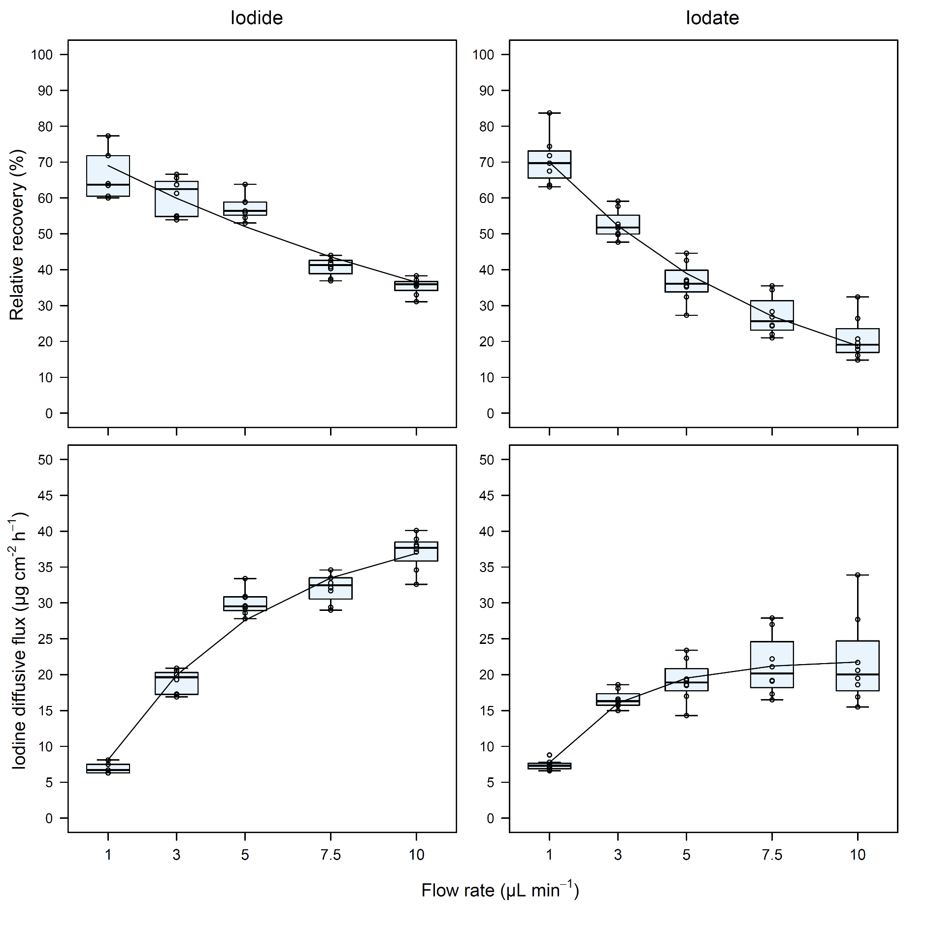

**Figure 3. 2.** The effect of perfusion flow rate (µL min-1) on (a) the relative recovery (%) of I- and IO3– and (b) the diffusive fluxes (µg cm-2 h-1) of I– and IO3– (n = 8 at each concentration). Equations for regression curves of relative recoveries and diffusive fluxes are given in Table 3. 2.

**Table 3. 2.** Exponential functions of relative recoveries (%) and diffusive fluxes (µg cm-2 h-1) of I– and IO3– by microdialysis probes inserted into a stirred standard solution (100 µg L-1). Equations are expressed as functions of flow rate (µL min-1) (Qd). Permeability factors (PF) are given for each membrane and compound. Functions were calculated from the data shown in Figure 3. 1.

|  |  |  |  |  |  |
| --- | --- | --- | --- | --- | --- |
|  | Relative recovery | R2 | Diffusive fluxes | R2 | PF |
| IO3– |  | 0.88 |  | 0.78 | 0.76 |
| I– | $RR=75.30×\exp\left(-0.08×Q_{d}\right)$ | 0.87 | $D=41.64×(1-\exp{(-0.22×Q_{d}}$) | 0.94 | 0.82 |

A non-linear decrease of RR with increasing flow rate was observed, this has previously been reported for Cd, Cu, Ni, Pb (Miró et al., 2010), organic and inorganic nitrogen ions (Inselsbacher et al., 2011), and phosphate (Demand et al., 2017) due to rate-limited diffusive transport driven by a concentration gradient into the probe to obtain equilibrium between the external medium and dialysate. From these results it is possible to conclude that the PES membrane, with a 100 kDa MWCO, is suitable for sampling inorganic iodine species. Iodine, present as I– or IO3–, successfully passed through the microdialysis probe without being adsorbed onto the probe or tubing or having its speciation altered. Within this experiment there was evidence of intra-probe variability on RR, as seen in Figure 3. 2. This variability has previously been attributed to manufacturing and is thought to have a greater impact on low-mobility ions (Demand et al., 2017; Torto et al., 2002).

### Iodine mobility and speciation as a function of soil moisture

The primary objective of this experiment was to assess the viability and practicality of sampling dissolved iodine in soil solution by using microdialysis. Table 3. 3 shows the DF of total iodine sampled from three different soils equilibrated at a range of moisture contents, over 4 hours with a dialysate flow rate of 2.5 µL min-1; Figure 3. 3 shows the proportion of IO3-, I- and org-I (total I minus the sum of inorganic species) present in the dialysate (concentrations presented in Table 3S. 1).

**Table 3. 3.** Diffusive flux (µg cm-2 h-1) of total native iodine sampled from arable, grassland and woodland soils equilibrated at different water holding capacities (n = 3 ± SD). Microdialysis had a perfusate flow of 2.5 µL min-1, the dialysate was collected for 4 hours

|  |  |  |  |  |  |  |
| --- | --- | --- | --- | --- | --- | --- |
|  | Iodine diffusive flux (µg cm-2 h-1) | | | | | |
|  | 60% WHC | 70% WHC | 80% WHC | 90% WHC | 100% WHC | 110% WHC |
| Arable | 2.40 ± 0.59 | 1.84 ± 0.26 | 1.85 ± 0.49 | 2.69 ± 0.69 | 2.60 ± 0.16 | 2.45 ± 0.08 |
| Grassland | 3.61 ± 0.88 | 3.32 ± 1.64 | 5.48 ± 1.27 | 3.40 ± 1.39 | 3.02 ± 0.72 | 4.69 ± 2.90 |
| Woodland | 2.11 ± 0.70 | 2.58 ± 1.06 | 2.09 ± 0.10 | 3.76 ± 2.12 | 2.21 ± 0.52 | 7.17 ± 6 .60 |

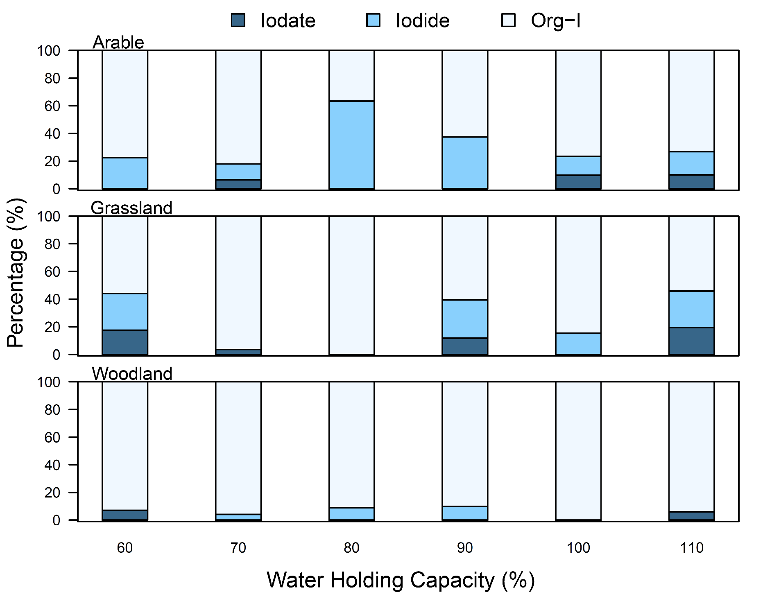

**Figure 3. 3.** Stacked bar plot showing the average proportion of IO3-, I- and org-I species concentration at different water holding capacities. Microdialysis had a perfusate flow of 2.5 µL min-1, the dialysate was collected for 4 hours.

Despite the differences in total soil iodine (Table 3. 1), there was little variation in the DF of iodine sampled from the arable, grassland and woodland soils with average fluxes of 2.3 ± 0.37, 3.9 ± 0.96 and 3.3 ± 1.99 µgcm-2 h-1, respectively. The arable soil consistently had the lowest DF for iodine. On average, the highest DF occurred in the grassland soils whilst the woodland soil had the highest individual DF in the soil equilibrated at 110% WHC. Table 3. 3 indicates that moisture content did not influence the DF of iodine sampled in the arable soil, however, it appears that in the grassland and woodland soils equilibrated at 110% WHC iodine mobility did increase.

Table 3. 3 demonstrates that microdialysis is a suitable method for sampling iodine in soil solution, at naturally occurring trace concentrations. Comparisons between common soil solution extraction techniques including, Rhizon™ samplers, high-speed centrifugation-filtration, and high-pressure soil squeezing have previously been assessed for extracting trace elements (Di Bonito, 2005). All of the aforementioned techniques have specific limitations with regards to extracting soil solution; (i) Rhizon samplers are only suitable for use in soils with a high moisture content (>100% WHC; often requiring additional wetting), (ii) centrifugation, whilst applicable for bulk solution studies, is not suitable for consecutive extractions and (iii) soil squeezing can induce anaerobism, which could alter the chemical composition and speciation of trace elements in soil solution (Di Bonito, 2005). In comparison, microdialysis was shown to be capable of working at an extended range of soil moisture contents, as low as 60% of the WHC. As such, microdialysis has the ability to sample dissolved compounds from soil solution at realistic moisture contents for aerobic soils which allows us to collect data to inform more representative predictions with regards to the soil iodine dynamics. In addition, due to the non-invasive nature of microdialysis, it would be possible to consecutively sample the soil solution in order to assess short-term iodine interactions, as many of these interactions occur over hours-days (Shetaya et al., 2012).

Figure 3. 3 shows the proportions of IO3-, I- and org-I within the dialysate sampled from the soils equilibrated at different WHC for 10 days. Native iodine in soil solution was generally present as org-I > I– > IO3–, with many of the IO3– concentrations falling below the detection limit. The average proportion of iodine species in the arable soil for IO3–: I–: Org-I was 4: 28: 68, whereas the grassland and woodland composition was 9: 16: 75 and 2: 4: 94, respectively. Soil physicochemical properties can influence the speciation of iodine found in soils. We found the highest proportion of inorganic species (predominantly iodide) in the arable and grassland soils, which have relatively low organic matter contents (≤7%) and pH ≥5.9, whilst in the organic-rich woodland soil >94% of the iodine was present as org-I. Within the literature there are differences in observations of the speciation of iodine in soil solution. Sheppard et al. (1995) showed that the iodine speciation within the soil solution of an acidic organic soil was primarily found as org-I, whilst Takeda et al. (2016) reported that I– was the dominant species in soil solution accounting for 27-63% of the total iodine in solution. In the current study, and the findings reported by Takeda et al. (2016), IO3– concentrations often fell below the LOD. Shimamoto et al. (2011) reported that soluble org-I accounted for 50-60% of the total iodine present in soil solution, the results in the current study suggest that org-I accounted for >65% of the total iodine in soil solution. Iodine associated with organic matter is relatively unavailable for plant uptake (Keppler et al., 2003; Xu et al., 2011b), the large proportion of soluble org-I found here could be a contributing factor to low iodine uptake observed by plants.

### Speciation of exogenous iodine in soil solution

In order to assess the speciation and fate of exogenous iodine, the total and inorganic iodine concentrations were measured on the microdialysis solutions sampled from soils spiked with an additional 200 mg kg-1 I– or IO3–. The DF of iodine species present in soil solution are shown in Figure 3. 4.

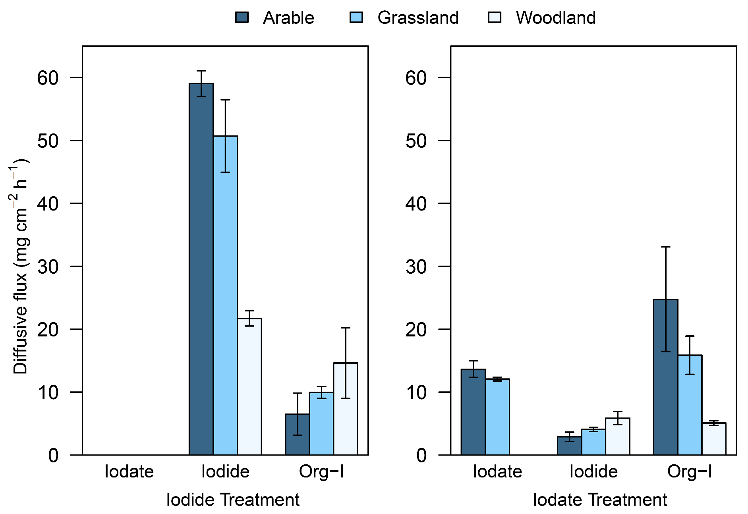

**Figure 3. 4.** Diffusive fluxes (mg cm-2 h-1) of IO3-, I-, org-I sampled using microdialysis probes from soils (arable, grassland and woodland) artificially spiked with an additional 200 mg kg-1 I- or IO3- at 80% of WHC. Microdialysis had a perfusate flow of 5 µL min-1, the dialysate was collected for 2.5 hours (n = 3 ± SD).

Figure 3. 4 illustrates the DF of IO3-, I- and org-I in the arable, grassland and woodland soils sampled over 2.5 h with a flowrate of 5 µL min-1, the concentrations (mg L-1) can be found in the supplementary data (Table 3S. 2). Microdialysis is far more suitable for sampling dissolved compounds present in the soil solution, maintaining the integrity of the sample without introducing potential speciation altering conditions induced by other pore water extraction techniques. The total iodine concentration measured in the microdialysis dialysate (Table 3S. 2) was equal to 1 - 2.5% of the total iodine present in the spiked soil systems. These results fall within a range of previously published data which have demonstrated that only a small proportion of the naturally occurring iodine in the soils is soluble. Whitehead (1973b) reported the average proportion of extractable iodine in 0.01 M CaCl2, a reagent with a similar ionic concentration of soil solution, was 1.6% for 23 UK soils. The rapid removal of the spiked iodine from the soil solution demonstrates the difficulties in assessing the fate, mobility and availability of native iodine to plants due to the rapid complex reactions that occur when iodine is added to soils.

The results in Figure 3. 4 show that IO3- and I- have different interactions and fates when added to soils. Soils spiked with I– had significantly higher (*p*<0.01) concentrations of total iodine in the soil solution compared to the soils spiked with IO3–, indicating that I– has slower reaction mechanisms within soils and remains more mobile in the terrestrial environment. The concentration of I- in these soils followed the sequence arable > grassland > woodland, the reverse trend was observed for org-I formation. Soils spiked with I- displayed no evidence of IO3- formation. Whilst IO3- was detected in the arable and grassland soils spiked with IO3-, it was not present in the woodland soil indicating it had been completely adsorbed or had its speciation altered. Figure 3. 4 provides evidence that the IO3– was reduced to I- in all of the soils, with the highest concentration of I- forming in the woodland soil. Although there were significantly higher (*p*<0.01) concentrations of soluble org-I in the arable and grassland soils spiked with IO3-, compared to I-, we found significantly lower (*p*<0.05) concentrations of org-I in the woodland soil spiked with IO3- compared to I-.

Previous studies investigating the sorption of inorganic iodine by soils, or materials representing specific soil components in microcosms or aqueous suspensions, have indicated a range of specific sorption or retention processes (Bowley et al., 2016; Shetaya et al., 2012; Whitehead, 1984). When I- is added to soils it displays much greater longevity in soil solution compared to IO3-, with sorption being highly dependent upon soil organic matter concentration and hydrous oxides at lower pH values (Whitehead, 1973b). This same trend was observed by Yoshida et al. (1992) when less I– (~50% of spike) was sorbed compared to IO3– (~90% of spike), it was noted that the sorption of I– increased with decreasing pH. The results presented in Figure 3. 4, are consistent with previous findings where we observed the greatest I- sorption in the woodland soils, which has the lowest pH and highest organic matter concentration and the lowest I- sorption occurred in the arable soil, which had the highest pH >6.5 and lowest organic matter concentration. Figure 3. 4 shows no measurable concentrations of IO3– in the soils spiked with I-. Whilst I- can be oxidised to IO3– in the presence of δ-MnO2, via an intermediate species (I2), I2 is rapidly converted to org-I in the presence of organic matter, hence why no IO3– was detected in the I– spiked soils (Gallard et al., 2009).

A number of studies investigating the fate of inorganic iodine added to soils have reported that the reduction of IO3- by soil organic matter may precede the conversion of inorganic iodine into organic forms (Fukui et al., 1996; Steinberg et al., 2008a; Whitehead, 1974a). The reduction of IO3-, to reactive intermediate products, I2 or HOI, then rapid incorporation with organic matter has also been observed (Francois, 1987). Figure 3. 4 shows that IO3- added to soils was sorbed or transformed to I– or org-I, particularly in the woodland soil where no IO3– was detected. The woodland soil has the highest concentration of organic matter and also the highest concentration of I–, providing further evidence that the reduction of IO3- is influenced by soil organic matter. Interestingly, the woodland soil has the lowest concentration of soluble org-I, it is likely that the IO3- was removed from the soil solution and incorporated into soil organic matter. Substantial evidence suggests that hydrous oxides adsorb IO3- more strongly than I- (Kodama et al., 2006; Whitehead, 1974b), the relatively high concentrations of IO3- and org-I present in the arable soils spiked with IO3- could have initially been adsorbed by hydrous oxides prior to being incorporated by soluble organic matter forming org-I.

### Molecular size distribution of dissolved organic iodine in soil solution

In addition to total iodine analysis and inorganic speciation analysis on the dialysate solutions described in Figure 3. 4, SEC coupled to UV absorbance and ICP-MS analysis was used to investigate the molecular size distribution of soluble org-I and its association with dissolved organic matter. The UV absorbance (mAU) and SEC-signal intensity (counts per second) chromatograms for the arable, grassland and woodland soils are shown in Figure 3. 5.

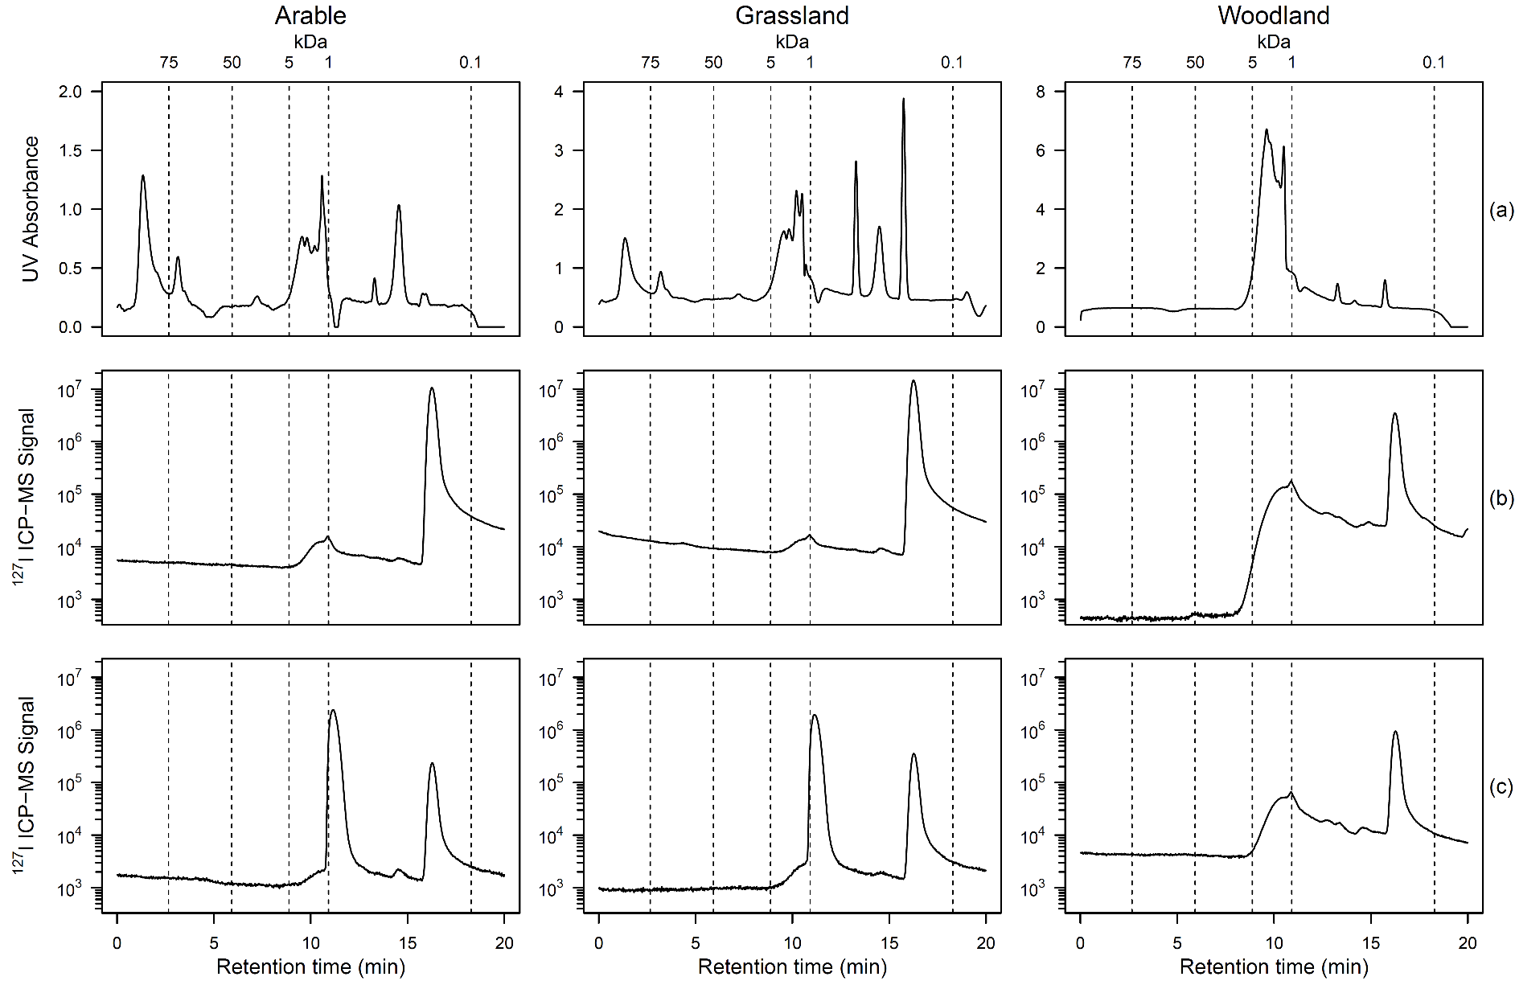

**Figure 3. 5.** Size exclusion chromatograms for arable, grassland and woodland soils: (a) UV absorbance (measured at 254 nm), (b) ICP-MS chromatograms for soils spiked with 200 mg kg-1 I- and (c) ICP-MS chromatograms for soils spiked with 200 mg kg-1 IO3-.

The results of the UV absorbance, measured at 254 nm, in soil solution are shown in Figure 3. 5a. Dissolved organic matter was detected in all three soils; total absorbance followed the sequence woodland > grassland > arable. In the arable and grassland soils two defined, and one less defined peak were observed between retention times of 1 - 2, 3 - 3.5 and 6.5 - 7.5 min (Figure 3. 5a), which correspond to MWs of approximately >85 kDa, >70 kDa and >21 kDa. In addition, the arable and grassland UV absorbance chromatogram show an additional four peaks between 9 - 11.5 min, with an approximate MW of 4.5 - 0.5 kDa. Three further peaks eluted between 13 - 16 min, corresponding to MWs of <0.5 kDa. The woodland soil had no peaks eluting before 8 min, however, similar peaks were observed matching the arable and grassland soil suggesting that the dissolved organic matter in the woodland soil is lower in molecular size compared to the arable and grassland soils.

In addition to UV absorbance the ICP-MS signal intensities (counts per second) are shown in Figure 3. 5 for soils spiked with I- (b) and IO3- (c). In all of the soils an I- peak was detected at 16 - 18 min, whilst the IO3- peak, detected at 10.8 minutes, was only present in the arable and grassland soils spiked with IO3-, consistent with the results in Figure 3. 4. The SEC-ICP-MS data confirms that the amount of iodine present in the soil solution spiked with IO3- was much lower than those spiked with I-. Despite the presence of large dissolved organic compounds (>70 kDa) present in the arable and grassland soils there were no corresponding peaks in the iodine intensity data, suggesting that soluble inorganic iodine interacts with smaller organic substances. A large soluble org-I peak was eluted at ~9 min in all of the soil samples, regardless of the initial spike speciation. The org-I peak corresponds to the smaller weight dissolved organic matter with a MW between 4.5 - 0.5 kDa, suggesting that iodine had been incorporated by this size fraction. There was also evidence of smaller org-I compounds present between 12 - 15 minutes, with a defined peak at 14.5 min in all of the different soils, this was also associated with organic matter detected by the SEC-UV analysis.

There are very few previous investigations assessing the chemistry of soluble org-I in soil solution using SEC. Bowley et al. (2016) investigated specific iodine binding sites in purified soluble humic systems, reporting that whilst iodine is capable of binding with both high and low MW fractions, there is a preference to bind to lower MW fractions. The results obtained in this study support this observation; Figure 3. 5 indicates a preferential binding to lower MW organic compounds (<4.5 kDa). Xu et al. (2011a) conducted soil resuspension experiments with 0.1 μM I- and IO3- to investigate the distribution and speciation of 129I and 127I at a contaminated site. They showed that on average 78% of the newly introduced inorganic iodine species were irreversibly removed from solution by the organic-rich soil, while the remaining soluble iodine was transformed into colloidal and dissolved org-I. Within the persistent soluble fraction 4.5% of the iodine was found with a molecular size of 3 - 45 kDa, the remaining final 18% of added iodine was associated with the molecular size fraction <3 kDa. The results in this study agree with the finding presented by Xu et al. (2011a) and indicate that low-molecular-weight organic matter is mainly responsible for the soluble inorganic iodine species, after addition to soils rather than the high-molecular-weight organic matter.

## Conclusions

This study is the first application of microdialysis to sample iodine from solution and soils. The initial solution based experiments, designed to assess the practicality of using microdialysis to sample iodine, were successful, with similar recovery rates to previously published results. We provide further evidence that microdialysis is a robust *in-situ* soil solution sampling method, with a greater capacity for sampling soils with a low moisture content in comparison to more conventional methods such as Rhizon™ samplers, centrifugation, and high-pressure squeezing. Often the conventional methods require additional wetting, which potentially alters the redox conditions in soil solution, microdialysis avoids this maintaining the *in-situ* integrity of the sample. Within this paper, the mobility and speciation of iodine in soil solution were investigated in arable, grassland and woodland soils. The speciation of iodine present in soil solution was determined using LC-ICP-MS and was predominately found as org-I > I– > IO3–, with many IO3- concentrations falling below the LOD. We observed that the total iodine concentration in soil solution accounted for 1-2.5% of the total iodine (mg kg-1) in the soil systems. The majority of iodine added to soils was removed, presumably bound to soil organic matter or metal hydrous oxides. The inorganic iodine added to the soils, which remained in solution, was transformed to soluble organically bound species. Through the use of SEC, we demonstrated that these inorganic species became bound with low MW dissolved organic compounds <4.5 kDa. The use of microdialysis and SEC-UV-ICP-MS could be used in conjunction with isotopically labelled iodine to further investigate the effects of soil physicochemical properties on short-term iodine dynamics.

## Supplementary Data

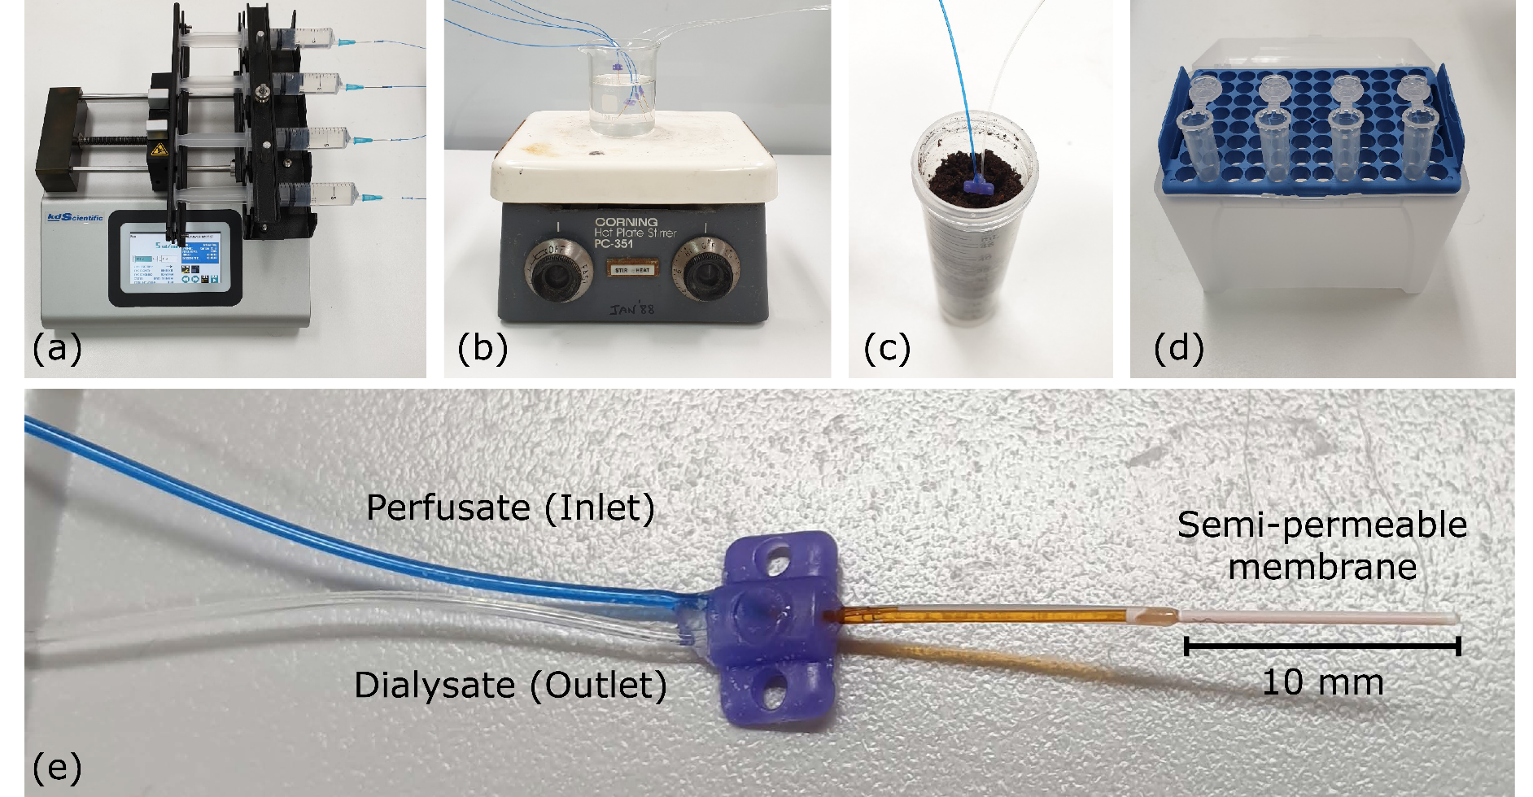

**Figure 3S. 1** Schematic experimental setup of microdialysis system used in solution and soil experiments. Consisting of (a) KD Scientific Legato 200 Series syringe pump, (b) microdialysis probe in a stirred solution, (c) microdialysis probe in a soil sample, (d) Eppendorfs used to collect sampled dialysate solutions, and (e) microdialysis probe (CMA 20) with a polyethersulfone (PES) membrane (10 mm long, 500 µm outer diameter) with a 100 kDa molecular weight cut-off.

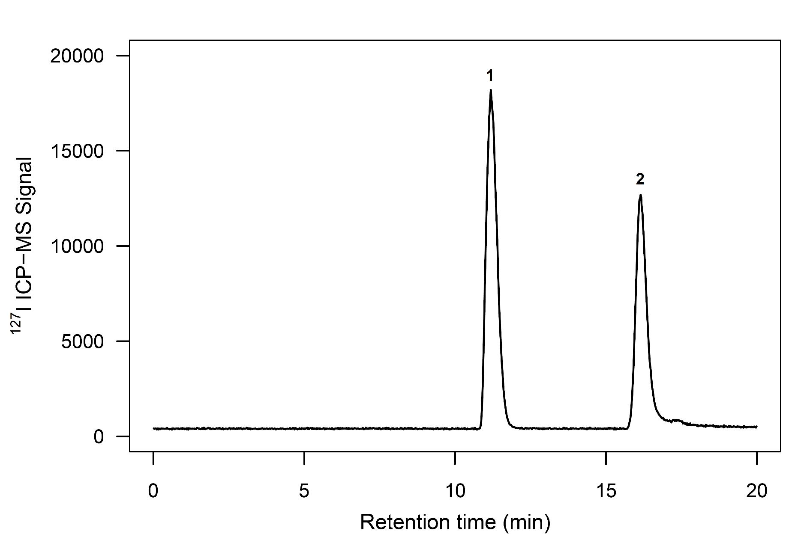

**Figure 3S. 2** SEC-ICP-MS chromatogram of inorganic iodine standards (10 µg L-1): 1, IO3-; 2, I–

**Table 3S. 1.** Average concentration (µg L-1) of total iodine, IO3-, I-, org-I extracted using microdialysis probes from soils (arable, grassland and woodland) equilibrated at different water holding capacities. Microdialysis dialysate was extracted at 2.5 µL min-1 for 4 hours.

|  |  |  |  |  |
| --- | --- | --- | --- | --- |
|  | Concentration (µg L-1 ) | | | |
| Soil | Total Iodine | IO3– | I– | Org-I |
| Arable 60 % WHC | 0.611 | < DL | 0.137 | 0.474 |
| Arable 70 % WHC | 0.469 | 0.031 | 0.053 | 0.385 |
| Arable 80 % WHC | 0.470 | < DL | 0.298 | 0.172 |
| Arable 90 % WHC | 0.684 | < DL | 0.256 | 0.428 |
| Arable 100 % WHC | 0.662 | 0.065 | 0.089 | 0.507 |
| Arable 110 % WHC | 0.623 | 0.063 | 0.104 | 0.456 |
| Grassland 60 % WHC | 0.919 | 0.161 | 0.244 | 0.513 |
| Grassland 70 % WHC | 0.844 | 0.030 | < DL | 0.814 |
| Grassland 80 % WHC | 1.395 | < DL | < DL | 1.395 |
| Grassland 90 % WHC | 0.964 | 0.114 | 0.266 | 0.584 |
| Grassland 100 % WHC | 0.769 | < DL | 0.119 | 0.650 |
| Grassland 110 % WHC | 0.333 | 0.065 | 0.087 | 0.180 |
| Woodland 60 % WHC | 0.638 | 0.045 | < DL | 0.593 |
| Woodland 70 % WHC | 0.791 | < DL | 0.032 | 0.759 |
| Woodland 80 % WHC | 0.528 | < DL | 0.048 | 0.480 |
| Woodland 90 % WHC | 1.034 | < DL | 0.103 | 0.931 |
| Woodland 100 % WHC | 0.562 | < DL | < DL | 0.562 |
| Woodland 110 % WHC | 2.574 | 0.157 | < DL | 2.417 |

**Table 3S. 2.** Total concentration (mg L-1) for IO3-, I-, org-I extracted using microdialysis probes from soils (arable, grassland and woodland) artificially spiked with 200 mg kg-1 I- or IO3-. Microdialysis dialysate was extracted at 5 µL min-1 for 2.5 hours (n=3 ± SD).

|  |  |  |  |
| --- | --- | --- | --- |
| Concentration (mg L-1 ) | | | |
| Soil | IO3– | I– | Org-I |
| Arable + I– spike | < LOD | 4.693 ± 0.163 | 0.517 ± 0.267 |
| Grassland + I– spike | 0.001 ± 0.001 | 4.032 ± 0.458 | 0.790 ± 0.075 |
| Woodland + I– spike | 0.001 ± 0.001 | 1.726 ± 0.097 | 1.162 ± 0.445 |
| Arable + IO3– spike | 1.085 ± 0.105 | 0.231 ± 0.058 | 1.967 ± 0.662 |
| Grassland + IO3– spike | 0.960 ± 0.024 | 0.325 ± 0.027 | 1.262 ± 0.242 |
| Woodland + IO3– spike | < LOD | 0.468 ± 0.082 | 0.405 ± 0.030 |

# Chapter 4. Short-term soil solution iodine dynamics

Paper as submitted to *Environmental Science and Technology*

## Author list

Humphrey OS, Young SD, Crout NMJ, Bailey EH, Ander EL and Watts MJ

## Author contribution

Study conceived by all authors

Experiments and analysis performed by OSH

All figures produced by OSH

Model conceived by OSH and NMJC

Construction of the paper by OSH

All authors were involved in the study and manuscript development

## Abstract

Assessing the dynamic reactions of iodine (I) in soil is critical to evaluating radioiodine exposure and understanding soil-to-crop transfer rates. Our mechanistic understanding has been constrained by method limitations in measuring soil solution-solid phase over short-periods (hours). We use microdialysis to passively extract soil solution spiked with radioiodine (129I– and 129IO3–), to monitor short-term (≤40 hours) *in-situ* fixation and speciation changes. We observed greater instantaneous adsorption of 129IO3– compared to 129I– in all soils and the complete reduction of 129IO3– to 129I– within 5 hours of application. Soluble organically bound iodine (org-129I) was formed in the low molecular weight (MW) range (<5 kDa). A slower (20 to 40 hours) time-dependent formation of larger MW org-I compounds (12-18 kDa) occurred in some samples, possibly a result of the binding of smaller iodinated compounds. Modelling revealed the removal of soluble I from soil solution to have an average half-life of <2 hours. This implies a very short window of availability in which I from rainfall or irrigation is available to crops, thus presenting challenges to phytofortification strategies in soil-based production systems.

## Introduction

Iodine (I) is an essential micronutrient for mammalian life, required for the synthesis of thyroid hormones, approximately 1.9 billion people worldwide are estimated to be at risk of developing an iodine deficiency disorder (WHO et al., 2007; Zimmermann et al., 2008). Radioiodine (129I; half-life 1.57 x 107 yr and 131I; half-life 8.02 d) released as a consequence of anthropogenic activities poses a major ecological and health concern due to its biophilic properties and relatively high environmental mobility (Xu et al., 2011a). Once 129I enters the environment, it behaves similarly to 127I, capable of bioaccumulating through the food chain and subsequently in the thyroid where it can induce tumors (Shetaya et al., 2012; Takeda et al., 2016; Yamaguchi et al., 2010). Understanding the biogeochemical processes and mechanisms that affect I cycling in the terrestrial environment is critical to evaluating the cause of I deficiency and potentially harmful exposure to radioiodine isotopes.

Soil properties including pH, redox potential, concentration of soil organic matter (SOM) and Fe/Al/Mn hydrous oxides affect I fixation, mobility and speciation (Bowley et al., 2016; Humphrey et al., 2018; Shetaya et al., 2012; Shimamoto et al., 2011; Whitehead, 1973b; Yamada et al., 1999). Following natural and anthropogenic I addition events (e.g. rainfall, irrigation, nuclear weapons testing), soluble inorganic-I species, iodide (I-) and iodate (IO3-), can be converted to soluble organic compounds (org-I) and/or incorporated into the solid soil phase, bound to SOM or adsorbed to metal oxides (Bowley et al., 2016; Schwehr et al., 2009; Shetaya et al., 2012; Shimamoto et al., 2011; Yamaguchi et al., 2010). In soil solution the transformation of inorganic-I into org-I occurs rapidly, with I– being lost more rapidly (minutes-hours) than IO3– (hours–days) (Shetaya et al., 2012). It was demonstrated previously that IO3– and org-I are less mobile and have a greater affinity for solid-soil components compared to I– (Kodama et al., 2006; Schwehr et al., 2009; Shimamoto et al., 2010). Metal hydrous oxides such as manganese oxide birnessite (δ-MnO2) can oxidize I– to IO3–, however, in the presence of organic matter (OM) (pH <7.0) δ-MnO2 catalyzes the oxidation of I– to I2 which is then incorporated into OM, following the same mechanism as iodination of phenols, through reaction with I2 (Warner et al., 2000). Whilst the pH and redox potential of soils affects I speciation and mobility, SOM appears to be the dominant factor controlling I retention in soils (Kaplan, 2003; Schwehr et al., 2009; Xu et al., 2011b).

Microdialysis is an established method for pharmacokinetics and has been used to investigate the mobility and bioavailability of macro-nutrients and metal ions in soil (Brackin et al., 2015; Buckley et al., 2017; Demand et al., 2017; Miró et al., 2005b); its applicability for following I reaction dynamics was previously evaluated by the authors (Humphrey et al., Pending). The passive sampling conditions of microdialysis enable the extraction of the soil solution phase with high temporal resolution and minimal disturbance to the soil structure. Unlike conventional soil solution sampling methods which are destructive (e.g. centrifugation, high-pressure squeezing) or require soil to be close to saturation (e.g. Rhizon™ samplers), microdialysis can perform continuous extractions of the soil solution at a wide range of water contents (as low as ~50% water holding capacity (WHC)). Evaluating soluble I without disturbing the ambient soil conditions, which could result in changes in I speciation, is vital for more detailed understanding of I biogeochemistry in soil.

In this study, we investigated short-term soil soluble I dynamics in three soils with contrasting physicochemical properties. Microdialysis was used to extract an isotopic I tracer (129I) under ambient soil conditions to monitor changes in concentration and speciation at 2.5 hour (hr) intervals over a 40 hr period. Iodine in the extracted pore water was analysed and speciated to determine: (i) the rate at which inorganic-I is removed from soil solution and adsorbed to the soil solid phase; and, (ii) the molecular weight (MW) range of soluble org-I compounds which are formed.

## Materials and Methods

### Soil sampling and physiochemical characteristics

Three topsoils (0 – 10 cm), from adjoining arable, grassland and woodland sites, were collected from a location in Nottinghamshire, UK. The soils were sieved to <2 mm, homogenized and air-dried. Soil pH was determined using an Orion pH meter after equilibrating 5 g of soil in 12.5 mL of 0.01 M CaCl2 for 30 min. Loss-on-ignition (LOI), as an estimate of SOM content, was determined after heating in a muffle furnace at 450 °C for 16 hr, after an initial drying period. The water holding capacity (WHC) of the soil was determined gravimetrically in triplicate according to Grace et al. (2006). Total soil 127I was extracted with 5% tetramethylammonium hydroxide (TMAH) at 70 °C for 3 hr (with shaking after 1.5 hr); once cooled, 5 mL of Milli-Q water was added and the bottles were centrifuged (20 min at 3500 rpm) and the supernatant solutions retained for analysis by ICP-MS (Watts & Mitchell, 2009). To determine the concentrations of reactive iron, aluminium, and manganese hydrous oxides, soils were extracted with dithionite-citrate-bicarbonate (DCB) solution, centrifuged (20 min at 2500 rpm), filtered (<0.22 µm) and the supernatant solutions retained for analysis by ICP-MS (Mehra & Jackson, 1960). Particle size analysis was determined using the method described in Rawlins et al. (2013), using a laser diffraction particle size analyzer.

### Soil incubation and microdialysis extractions

The radioiodine tracer (129I) was obtained from the American National Institute of Standards as NaI (NIST, Gaithersburg, Maryland, USA; CRM 4949C, 0.004 mol L-1 Na129I, 3451 Bq mL-1). The primary stock (129I-) was made up to 100 mL with 0.01 M NaOH, as recommended by the suppliers. Iodate (129IO3-) was prepared from the 129I- stock by oxidation, using a method adapted from Yntema and Fleming (1939). To 50 mL of the 129I- stock, 5 mL of 0.1 M HCl was added in an initial neutralization step, followed immediately by 5 mL of 0.2 M sodium chlorite for oxidation. Successful oxidation to 129IO3– was confirmed by anion exchange HPLC-ICP-QQQ-MS (Figure 4S. 1). The water content of the air-dried soils (~90 g dry weight (dw)) was raised to 50% of WHC with Milli-Q water (18.2 MΩ cm; Millipore) and allowed to equilibrate for 10 days at 20 ± 0.5 °C in the dark. The moist soils were then homogenized with equivalent volumes of 129I- or 129IO3- in solution to bring the soils to 80% WHC with a final 129I concentration of 0.2 mg kg-1 (dw basis). The soils were then distributed between triplicate 50 mL Corning® polypropylene centrifuge tubes (~30 g dw of soil per replicate).

The microdialysis system consisted of a syringe pump (KD Scientific Legato 200 Series), equipped with plastic syringes (BD Plastipak; 20 mL) used to deliver the perfusate solution. Syringes were attached to microdialysis probes CMA 20 (10 mm length, 500 mm outer and 400 mm inner diameter) with a polyethersulfone (PES) membrane (100 kDa molecular weight cut-off (MWCO). Within two minutes of 129I addition to soil, incision holes were made, using an introducing needle, and the microdialysis probes were inserted ~1.5 cm beneath the soil surface. Probes were perfused with Milli-Q water at a flow rate of 5 µL min–1 and dialysate solutions collected at 2.5 hr intervals in 300 µL glass vials over a 40 hr extraction period. Samples were initially stored in the refrigerated micro-fraction collector (6 °C; CMA 470) before freezing at −20 °C until defrosting immediately before analysis. Throughout the extraction, soils were kept in the dark at a constant temperature of 20 ± 0.5 °C. The probes and micro-fraction collector were from CMA Microdialysis AB (Kista, Sweden).

### Total iodine analysis

All 129I concentrations were measured using an ICP-QQQ-MS (Agilent 8900, Agilent Technologies). Analysis was conducted using both quadrupoles and the reaction cell, to remove isobaric and polyatomic interferences, a full description of 129I analysis can be found in Humphrey et al. (2019). Due to the small sample volume (~300 µL), we used an Agilent 1260 Infinity Bio-inert Quaternary LC pump and high performance autosampler to act as a low volume autosampler: vials were also equipped with flat bottomed glass inserts to further reduce the sample volume requirement. Throughout the analytical run, an in-house quality control sample with a known concentration of 5 µg L-1 129I was measured with an average recovery of 101% (*n =28*) and a limit of detection (LOD) (3 x SD blanks) of 0.0075 µg L-1 for 129I.

### Iodine speciation analysis

Inorganic-I (129I- and 129IO3-) concentrations were measured by ICP-QQQ-MS following on-line chromatographic separation in isocratic mode using a Hamilton PRP X-100, anion exchange column (250 mm × 4.6 mm, 5 μm) and a samples injection volume of 25 μL. The mobile phase was 100 mM NH4NO3, adjusted to pH 9.5 with TMAH (25%), at a flow rate of 1.5 mL min-1. Quality control samples with a known I concentration of 5 µg L-1, 129I- and 129IO3-, were measured with an average recovery of 97% and 96% (*n =22*), respectively. The LOD for 129I- and 129IO3- was 0.007 and 0.006 µg L-1 of I respectively.

The MW distribution of soluble org-I was determined using size exclusion chromatography (SEC) hyphenated with UV absorbance detection and ICP-QQQ-MS. An Agilent 1260 Infinity Bio-inert Quaternary LC pump and high performance autosampler in isocratic mode with an AdvanceBio SEC 130 Å (4.6 x 300 mm column, packed with 3-µm particles, MWCO of 100 kDa, Agilent) was used as the sample introduction system. Samples (10 μL) were injected onto the column with a mobile phase (flow rate of 0.35 mL min-1) consisting of 150 mM sodium phosphate buffer, pH 7.0. Platinum tip sampler and skimmer cones were used on the ICP-QQQ-MS due to the high sodium concentration in the mobile phase. The UV detector scanned at 220 nm to measure the calibration protein standards, and 254 nm to detect dissolved organic carbon (Rädlinger & Heumann, 1997; Rädlinger & Heumann, 2000; Shah et al., 2005; Shimamoto et al., 2011; Takeda et al., 2009; Yamada et al., 2002). Protein standards of known MWs: Ovalbumin (45 kDa); Myoglobin (17 kDa); Aprotinin (6.7 kDa); Neurotensin (1.7 kDa); and Angiotensin II (1 kDa) (AdvanceBio SEC 130Å protein standard, Agilent) were used to calibrate the column.

### Kinetic modeling

The dynamic interactions of the inorganic-129I were modeled as simultaneous ordinary differential equations for soluble 129I and absorbed 129I (Equations 1 and 2) with instantaneous partitioning between soluble org-I and inorganic-I described by a distribution coefficient Kd (Equations 3 and 4). The initial conditions of the model at t(hr)=0 allowed for a proportion of the spiked 129I to be instantly sequestered from solution and absorbed. The model is shown schematically in Figure 4. 1.

$\frac{\text{d}\left[\text{S}\right]}{\text{dt}}\text{ = -k}\text{1}\text{ * [S]}$ (1)

$\frac{\text{d}\left[\text{A}\right]}{\text{dt}}\text{ = k}\text{1}\text{ * [S]}$ (2)

$\text{S}\text{Inorg} \text{ = }\frac{1}{K\text{d}+1}\text{ * S}$ (3)

$\text{S}\text{Org} \text{ = }\frac{K\text{d}}{1+K\text{d}}\text{ * S}$ (4)

Equations (1) and (2) require initial values S(t=0)=IS(1-F0) and A(t=0)=IS*F0 respectively. The variable S is the concentration of soluble 129I, K1 is the adsorption rate coefficient (hr-1), IS defined as the initial spike concentration, F0 is the proportion of I immediately adsorbed, A is the concentration of adsorbed I (µg L-1), SInorg is the concentration of soluble inorganic-129I (µg L-1), SOrg is the concentration of soluble organic-129I (µg L-1), and Kd is the partition coefficient between org-I and inorganic-I.

The unknown parameters: k1 (hr-1), F0 and Kd were estimated by fitting the model to the observed concentrations of inorganic-129I and org-129I. The differential equations were solved using 4th order Runge-Kutta and fitting was performed using a Metropolis-Hastings procedure (Press et al., 2007) to minimize the residual sum of squares between modeled and observed values. Conventional (destructive) soil solution sampling extracts a sample representative of soil conditions at a specific time point; however, microdialysis passively extracts the soil solution phase over a predetermined period. The concentration of the target compound within the sampled dialysate is an integrated measurement of the concentration over the period between measurements; therefore, cumulative values of SInorg and SOrg were used to model soluble I dynamics.

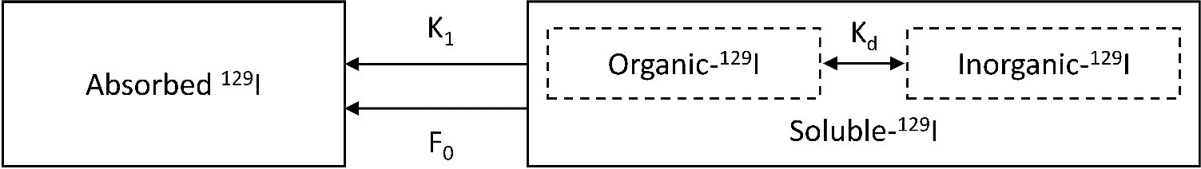

**Figure 4. 1.** Conceptual model describing 129I dynamics in soil solution phase

## Results and Discussion

### Soil characteristics

The soil physiochemical characteristics in Table 4. 1 reflect their land use. Compared to the arable and grassland soils the acidic woodland soil had a much greater LOI, extractable Fe/Al/Mn hydrous oxide content and total I concentration. Given that all three soils are from the same general location the greater I concentration in the woodland soil may reflect a greater ability to retain I from precipitation and the absence of annual crop removal.

**Table 4. 1.** Summary of soil physiochemical characteristics. Values expressed as mean ± standard error (SE) (n=3)

|  |  |  |  |  |
| --- | --- | --- | --- | --- |
|  | Units | Arable | Grassland | Woodland |
| Location (long, lat decimal degrees) |  | 52.9001, -1.0884 | 52.8890, -1.0877 | 52.8986, -1.0744 |
| Elevation | m | 95 | 83 | 121 |
| pH (CaCl2) |  | 6.9 | 5.9 | 3.6 |
| LOI | % | 5.1 | 7.0 | 50.6 |
| WHC | % | 36.8 | 41.5 | 70.8 |
| 127I | mg kg-1 | 3.38 ± 0.05 | 3.63 ± 0.05 | 12.9 ± 0.10 |
| 129I | µg kg-1 | <DL | <DL | <DL |
| Fe2O3 | % | 0.180 ± 0.02 | 0.0131 ± 0.001 | 0.696 ± 0.06 |
| Al(OH)3 | % | 0.0379 ± 0.003 | 0.0523 ± 0.007 | 0.925 ± 0.05 |
| MnO2 | % | 0.0594 ± 0.005 | 0.0226 ± 0.003 | 0.622 ± 0.07 |
| Texture (clay/silt/sand) | % mass | 41/41/18 | 17/19/64 | 24/35/41 |
| Texture classification |  | Clay | Sandy Loam | Clay Loam |

### Soluble soil 129I dynamics

Total concentrations of soluble 129I extracted from the soils spiked with 129I– or 129IO3– are shown in Figure 4. 2 alongside cumulative relative recovery of the extracted soluble 129I on the secondary y-axis.

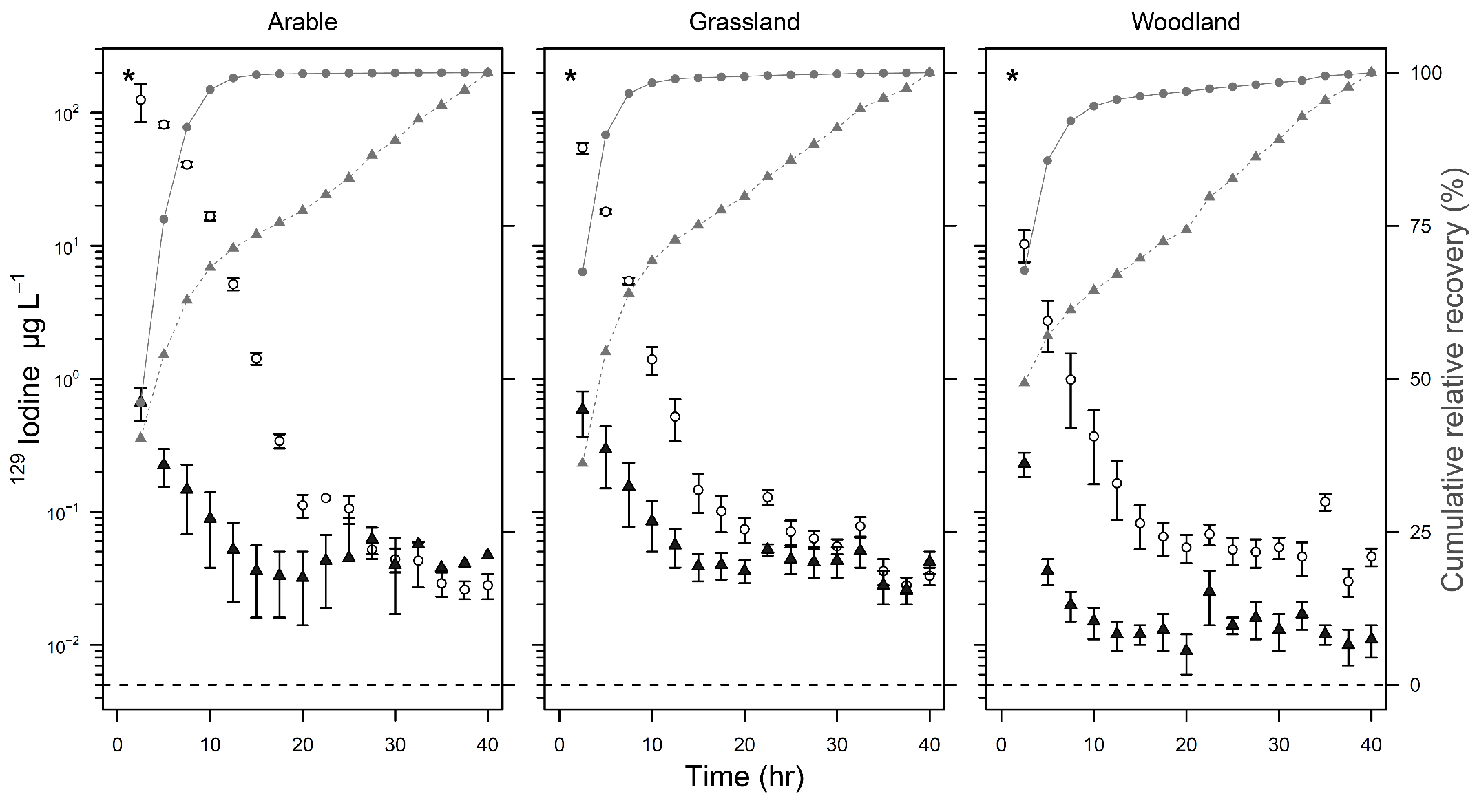

**Figure 4. 2.** Total soluble 129I (µg L-1) extracted from arable, grassland and woodland soils at 2.5 hour intervals over 40 hours. Symbols represent mean values obtained in triplicate, error bars indicate ±S.E. An asterisk at the top left of each chart denotes the initial spike concentration; white circles represent soils spiked with 129I–; black triangles represent soils spiked with 129IO3–. Note the log scale on the primary Y-axis. The secondary Y-axis shows the cumulative mean relative recovery of measured soil solution I: grey circles represent soils spiked with 129I–; grey triangles represent soils spiked with 129IO3–. The dashed line indicates the detection limit. Each microdialysis dialysate sample was extracted at 5 µL min-1 for 2.5 hours.

Losses of 129I from soil solution were observed in all the soils within 2.5 hr, irrespective of the initial spike speciation (129I– or 129IO3–); the magnitude of the losses differed between soils. The concentration of 129I in the first dialysate (0-2.5 hr) was equivalent to 63, 27 and 5% of the initial iodide (129I-) spike added to the arable, grassland and woodland soils, respectively; equivalent values for the soils treated with 129IO3– were 0.3, 0.3 and 0.1%. The rate of removal from the soil solution phase in all soils was therefore much greater for 129IO3– than for 129I-. Following a rapid decline in the concentration of soil soluble 129I in the first 10 hr, a more gradual decline was observed over the following 30 hr period. In the final sample collection, the concentration of 129I was <0.02% of the initial spike concentration in all soils treated with both I species.

The rapid initial loss of 129IO3– from solution observed in this study may be a combination of adsorption on inorganic soil phases or, rapid immobilization within SOM (Shetaya et al., 2012). Volatilization has previously been reported to occur from soils, but is suppressed by the presence of SOM (Yamaguchi et al., 2010) and the likelihood of it meaningfully contributing to total loss rates is low (Sheppard et al., 1994). Therefore, adsorption onto inorganic soil phases and rapid immobilization by SOM are far more likely reasons for the losses of 129Ifrom soil solution; both of these processes are pH-dependent. When soil pH <6.0 IO3–, sorption is predominantly influenced by specific adsorption to iron and aluminum oxides (Whitehead, 1974a; Yoshida et al., 1992). By contrast, when soil pH >6.0, IO3– is incorporated with organic compounds via a reduction to electrophilic intermediate species, such as HOI or I2 (Francois, 1987; Schlegel et al., 2006; Shetaya et al., 2012; Steinberg et al., 2008b; Warner et al., 2000). Soil solution I– can also be sorbed onto clays, hydrous oxides and SOM; where sorption generally increases with decreasing pH, as observed in this study (Kaplan et al., 2000; Mackowiak et al., 2005; Whitehead, 1984). The faster immediate sorption of 129IO3– compared to 129I– highlights the different adsorption mechanisms of inorganic-I in soils.

The cumulative mean recovery shows the percentage of 129I sampled at each time point, relative to the total concentration of 129I extracted from the soils. From soils spiked with 129I–, on average, >60% of the total 129I was collected in the first fraction compared to 42% for soils spiked with 129IO3–. By 20 hr >98% and >77% of the total extracted 129I had been extracted from the soils spiked with 129I– and 129IO3–, respectively. Despite the significant differences in total 129I concentrations present in the soil solution after the first sample, similar concentrations were determined in the soil solution 40 hr after 129I addition. In batch sorption experiments Muramatsu et al. (1990) found that sorption of both radiolabelled I– and IO3– in soils was >90% after 1 day and practically complete after ~3 days. By comparison, Shetaya et al. (2012) reported that the loss of I− from solution was extremely rapid, reaching completion over minutes–hours, whereas IO3- loss from solution was slower, typically occurring over hours–days, which is consistent with the current study. However, microdialysis has enabled much greater resolution at time intervals within a similar range to the reaction times reported Shetaya et al. (2012), and shown that adsorption and losses occur more rapidly than previously observed using batch experiment approaches.

### Soil soluble iodine speciation

The concentrations of soluble inorganic (129I- + 129IO­­3-) and organic (total I minus the sum of inorganic species) 129I in the three soils spiked with either 129I– or 129IO3– are shown in Figure 4. 3. A combined inorganic fraction was calculated due to the concentrations of 129IO3– present in the soils treated with either 129I– or 129IO3– falling below the LOD (shown in Figure 4S. 2).

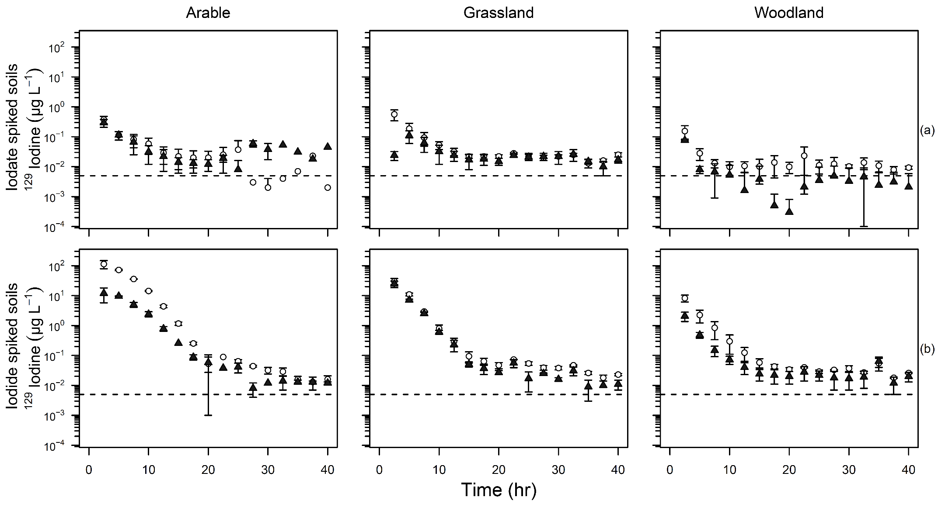

**Figure 4. 3.** Soluble 129I speciation of (a) iodate and (b) iodide spiked arable, grassland and woodland soils over 40 hours. Symbols represent the mean values obtained in triplicate, bars indicate ±SE. White circles represent inorganic-129I concentrations; black triangles represent soluble org-129I concentrations. Note the log scale on the primary Y-axis. The dashed line indicates the detection limit. Microdialysis dialysate was extracted at 5 µL min-1 for 2.5 hours.

In general, the proportion of inorganic-129I in the soil solution phase was greater than that of org-129I. An exception to this occurred in the arable soil spiked with 129IO3–, where the org-129I became the dominant fraction in samples after 25 hr, when inorganic-129I concentrations were below the LOD. In contrast, in woodland soil spiked with 129IO3– the soluble org-129I fraction was below the LOD 10 hr after addition, and only inorganic species were detected.

The speciation of stable and radioiodine present in soil systems has been the focus of several studies (Muramatsu et al., 1989; Shimamoto et al., 2011; Yamada et al., 1996; Yoshida et al., 2007) with I– and org-I identified as the dominant species present. When 129IO3- was added to the soils we observed an immediate reduction to 129I– in soil solution, with very low concentrations of 129IO3- remaining in soil solution beyond 2.5 hrs (Figure 4S. 2, d). Reduction of IO3– to I– in soils has previously been observed (Muramatsu et al., 1990; Zhang et al., 2011) and may arise from biotic processes. However, it seems more likely that reduction is caused by abiotic interactions with solid or dissolved OM as the reaction rates appear to be too rapid for biological processes (Shetaya et al., 2012). In contrast, when soils were spiked with 129I-, a very low concentration of 129IO3– was detected in the arable and grassland soils within 7.5 hr, indicating that limited 129I– oxidation to 129IO3– had occurred (Figure 4S. 2). We only observed I– oxidation in the arable and grassland soils; there was no evidence for oxidation in the organic-rich acidic woodland soil (Figure 4S. 2), the oxidized 129IO3– was subsequently reduced or absorbed by the solid soil phase.

Factors controlling 129I– oxidation in soil remain unclear (Amachi, 2008). The conversion of I– to org-I requires I– to be initially oxidized to an intermediate such as I2 or HOI (Schlegel et al., 2006; Warner et al., 2000). Iodide-oxidizing bacteria in soils have previously been observed to influence I– sorption/incorporation into SOM and oxidation to IO3– and to produce volatile org-I compounds such as CH3I (Amachi et al., 2003; Seki et al., 2012). In addition, metal oxides (Al, Fe, Mn) and humic substances can act as oxidizing agents. In batch kinetic experiments, pH and metal oxide concentrations significantly influence reaction rates, with faster oxidation occurring at lower pH and greater metal oxide concentrations (Allard et al., 2009; Fox et al., 2009). However, in our *in-situ* experiments we did not observe I– oxidation in the acidic, Fe/Al/Mn rich woodland soil. Figure 4. 3 shows that the greatest initial loss of I– occurred in the woodland soil, which had the largest metal oxide concentrations, an order of magnitude higher than the arable and grassland soils, highest organic matter and the lowest pH. Previously the rapid loss of I– from solution in organic-rich soils was described as a first-order reaction (Sheppard & Thibault, 1992). Whilst I- may be initially bound by weak electrostatic attraction to solid soil media, it can be easily desorbed, attesting to an easily exchangeable form of I in the soil rather than organic or inorganic complexation, nevertheless a gradual transfer to organic forms does occur, as seen in Figure 4. 3.

### Modeling short-term iodine geodynamics

Due to the (apparent) immediate reduction of 129IO3– to 129I- (Figure 4S. 2), only soils spiked with 129I- were modeled (Figure 4. 1). The fitted model predictions and observed data are presented in Figure 4. 4, which highlight the rapid losses of soluble 129I in all soils, with the rate of these reactions influenced by soil properties. The predicted rate coefficients are provided in Table 4. 2.

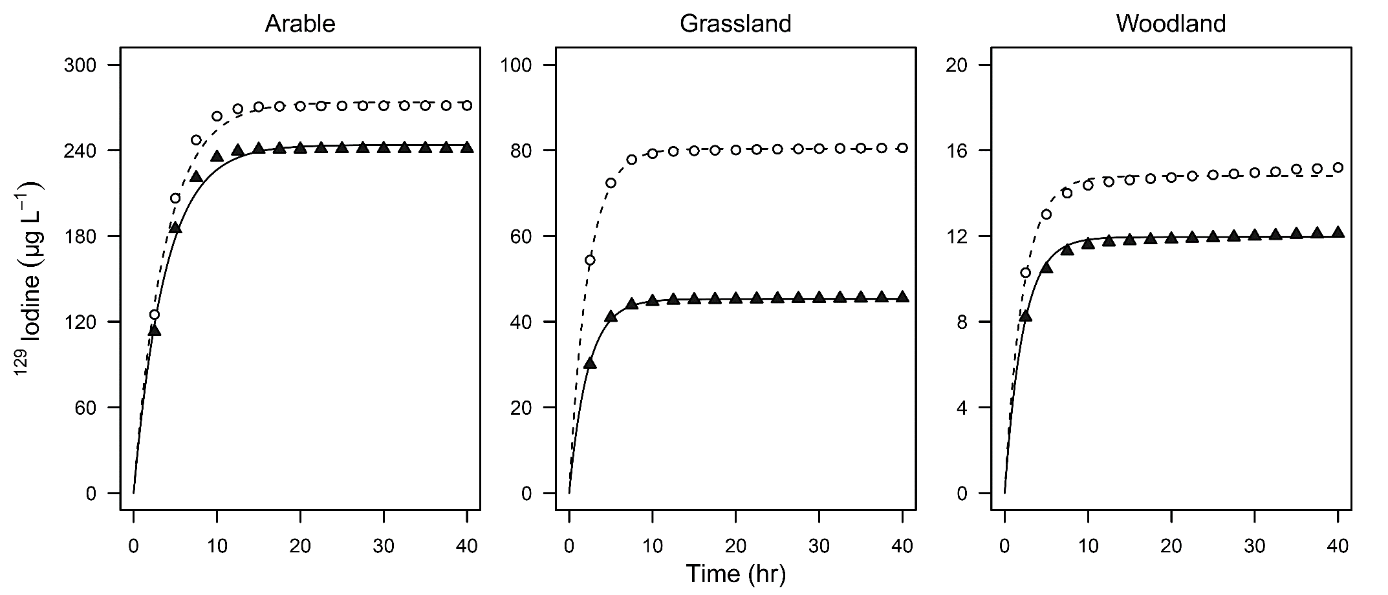

**Figure 4. 4.** Modelled and observed cumulative extracted 129I (µg L-1) in arable, grassland and woodland soils over 40 hours. White circles represent observed total-129I; the dashed line represents modeled total-129I; black triangles represent soluble inorganic-129I; the black line represents modeled soluble inorganic-129I.

**Table 4. 2.** Summary of model parameters in arable, grassland and woodland soils. Values expressed as mean ± SE. F0 is the proportion of I immediately adsorbed, K1 is the adsorption rate and Kd is the partition coefficient between org-I and inorganic-I.

|  |  |  |  |
| --- | --- | --- | --- |
| Coefficients | Arable | Grassland | Woodland |
| F0 | 0.638 ± 0.004 | 0.821 ± 0.0002 | 0.966 ± 0.0004 |
| k1 (hr-1) | 0.264 ± 0.003 | 0.446 ± 0.0006 | 0.454 ± 0.006 |
| Kd | 0.123 ± 0.006 | 0.775 ± 0.002 | 0.238 ± 0.009 |

We found that initial conditions required the instantaneous partitioning of the 129I spike between solution and absorbed I via a parameter F0 representing the proportion of added I which was immediately absorbed. The remaining total soluble I fraction had half-lives of 2.62, 1.55 and 1.52 hr in the arable, grassland and woodland soils, respectively. Figure 4. 4 and Table 4. 2 show how the instantaneous adsorption capacity increases with SOM (woodland > grassland > arable) and decreasing pH. Santschi et al. (2016) highlighted that OM is largely responsible for controlling the biogeochemistry of radioiodine, even when present at very low concentrations. Our results indicate that even in the arable soil, with a relatively low concentration of SOM, a large proportion of 129I- is instantly sorbed and removed from the soil solution. These results support previous findings which have demonstrated that although organic-rich soils may contain higher concentrations of I, much of that I may not be accessible to plants (Bowley et al., 2016). Whilst the woodland soil had the largest concentration of 127I, our model and observations of the dynamic interactions that occur during I addition events indicate rapid removal from solution.

### Molecular weight distribution of soluble organic iodine

The presence of org-129I was confirmed using SEC-ICP-QQQ-MS; the presence of multiple peaks indicates that soluble org-I exists at a range of MWs. Time-dependent changes in speciation and molecular weight of 129I in the soil solution phase are shown in Figure 4. 5.

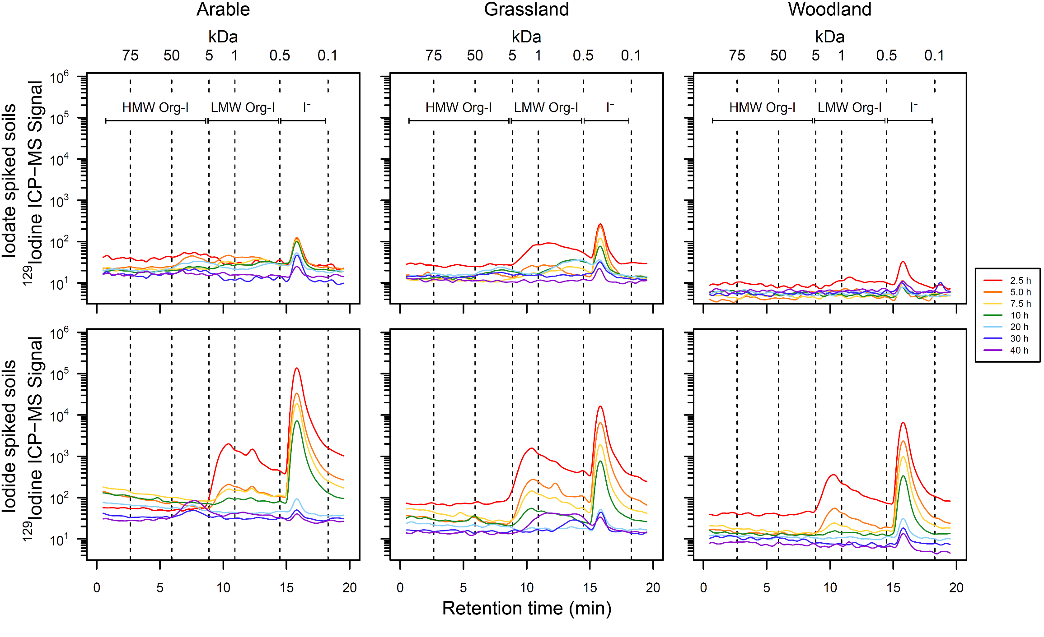

**Figure 4. 5.** Molecular weight distribution of soluble isotopically labeled 129I in arable, grassland and woodland soils spiked with 129IO3–or 129I- extracted over 40 hours, separated by size exclusion chromatography. Note the log Y-axis. High molecular weight organically bound I (HMW org-I), low molecular weight organically bound I (LMW org-I) and 129I– retention times labelled.

Within all three experimental soils, for addition of both 129I- and 129IO3-, chromatographic peaks were observed for 129I– between 15 and 18 min that decreased over the 40 hr extraction period. The intensity of the 129I– peak was considerably less in the 129IO3– treated soils due to the higher rates of instantaneous adsorption on inorganic soil phases and rapid immobilization by SOM. All soils spiked with 129I–, had a broad peak representing LMW org-129I between 9 and 15 min; the overall intensity of the org-I peak decreased over the 40 hr sampling period. There was a shift in the MW distribution in the arable soil spiked with 129I– between 20 and 40 hr when the signal intensity of the LMW org-I peak decreased and a HMW org-I peak, with a retention time between 5 and 10 min emerged. In contrast, within the grassland soil spiked with 129I-,dissolved org-129I had a lower MW distribution; no org-I compounds >5 kDa were present throughout the sampling period. The emergence and rapid decline of LMW org-129I between 0.5–5 kDa in the woodland soil further illustrates how quickly initially soluble I is removed from solution in organic rich soils. However, within the arable and grassland soils the MW distribution of the org-I underwent various changes within the 40 hr sampling period. The UV absorbance results confirmed that soluble organic compounds had a broad MW range (Figure 4S. 3).

The transport behavior of inorganic-I in soils may be significantly impacted by the fixation of dissolved I into macromolecular humic substances, however, many of the mechanisms controlling the rate of fixation remain unknown (Hu et al., 2012; Rädlinger & Heumann, 2000; Steinberg et al., 2008b; Tikhomirov et al., 1980). Xu et al. (2011a) demonstrated that higher proportions of 125I– and 125IO3– were associated with organic compounds <3 kDa, 16 and 20% compared to 6 and 3% in the >3 kDa fraction, respectively. In addition, they found that binding sites became saturated and less available when the treatment concentration increased (Xu et al., 2011a). In resuspension experiments, Xu et al. (2011b) found that mobile 129I was associated with amphiphilic organic compounds with an average MW between 13.5 and 15 kDa. Figure 4. 5 shows that higher proportions of soluble inorganic-I were incorporated into organic compounds with a low MW (<5 kDa). However, there was evidence of larger dissolved org-I compounds with a MW between 12 and 18 kDa 20 hr after 129I addition, in agreement with Xu et al. (2011a).

The time-dependent formation of these larger dissolved org-I compounds could be due to smaller dissolved compounds binding together via weak chemical forces or the influence of microbial activity. The iodination of SOM in acidic conditions was shown to be predominantly an abiotic process, however, in less acidic conditions (pH ≥5), microbial assisted iodination of SOM was observed (Xu et al., 2011a). Whilst microbial activity is generally not deemed essential for the transformation of IO3– into org-I (which seems to be primarily controlled by abiotic processes (Yamaguchi et al., 2010)), microbial laccases have been shown to enhance I– sorption in soils (Seki et al., 2012). Microbiological activities have previously been reported to incorporate I– with humic acids and soils with a relatively HMW and low mobility (Rädlinger & Heumann, 2000). Heumann et al. (2000) identified that in the presence of microorganisms the production HMW org-I compounds significantly increased over an 8 week period; in contrast Figure 4. 5 demonstrates that formation of relatively HMW compounds occurred in 20-40 hr.

It has previously been suggested that the rapid rate of reaction of I with SOM could be beneficial, as humus may act as a natural barrier, accumulating any radioiodine released from nuclear waste repositories as immobile org-I compounds (Xu et al., 2011b). Following a radioiodine contamination event limited soil-to-crop transfer would be beneficial for reducing the risk and duration of potentially harmful exposure (Keppler et al., 2003; Xu et al., 2011b; Xu et al., 2012). The short-term experiments presented in this paper show that inorganic-129I is rapidly incorporated into LMW organic compounds (<2.5 hr) which, over time, can be sorbed to the solid soil phase or bind together to form HWM organic compounds (~30 hr).

Evaluating the short-term transport, speciation and fate of I in soil is critical to assess the environmental mobility and plant availability, as 127I is an essential micronutrient for which dietary intake often depends on the transfer of I from soil-to-crops (Watts et al., 2015). Volatilized I from seawater, which undergoes photolysis, aerosol formation and deposition inland, is the main source of I in soil (Humphrey et al., 2018). Specific soil and rainfall properties influence the concentration of I present in rainfall and the volume retained by soils which would be accessible for plant uptake (Shetaya et al., 2012). Passive uptake is the predominant pathway for I absorption in plants (Humphrey et al., 2019), as such, plant uptake is highly dependent upon the concentration in the soil solution phase. By using 129I as a proxy for 127I, it is possible to predict how much soluble I is available for plant uptake after deposition, which we demonstrate only remains in the soil solution phase for a very limited period, with an average half-life of <2 hr, before being sorbed on to inorganic soil phases or immobilized by SOM. Consequently, there is a severely limited window of opportunity for plants to absorb I from the soil solution and subsequent transfer of I to animal and human diets. Considering that there are an estimated 1.9 billion people at risk of I deficiency worldwide (Zimmermann et al., 2015), the findings in this paper may contribute to better understanding of the efficacy of phytofortification strategies.

## Supporting Information

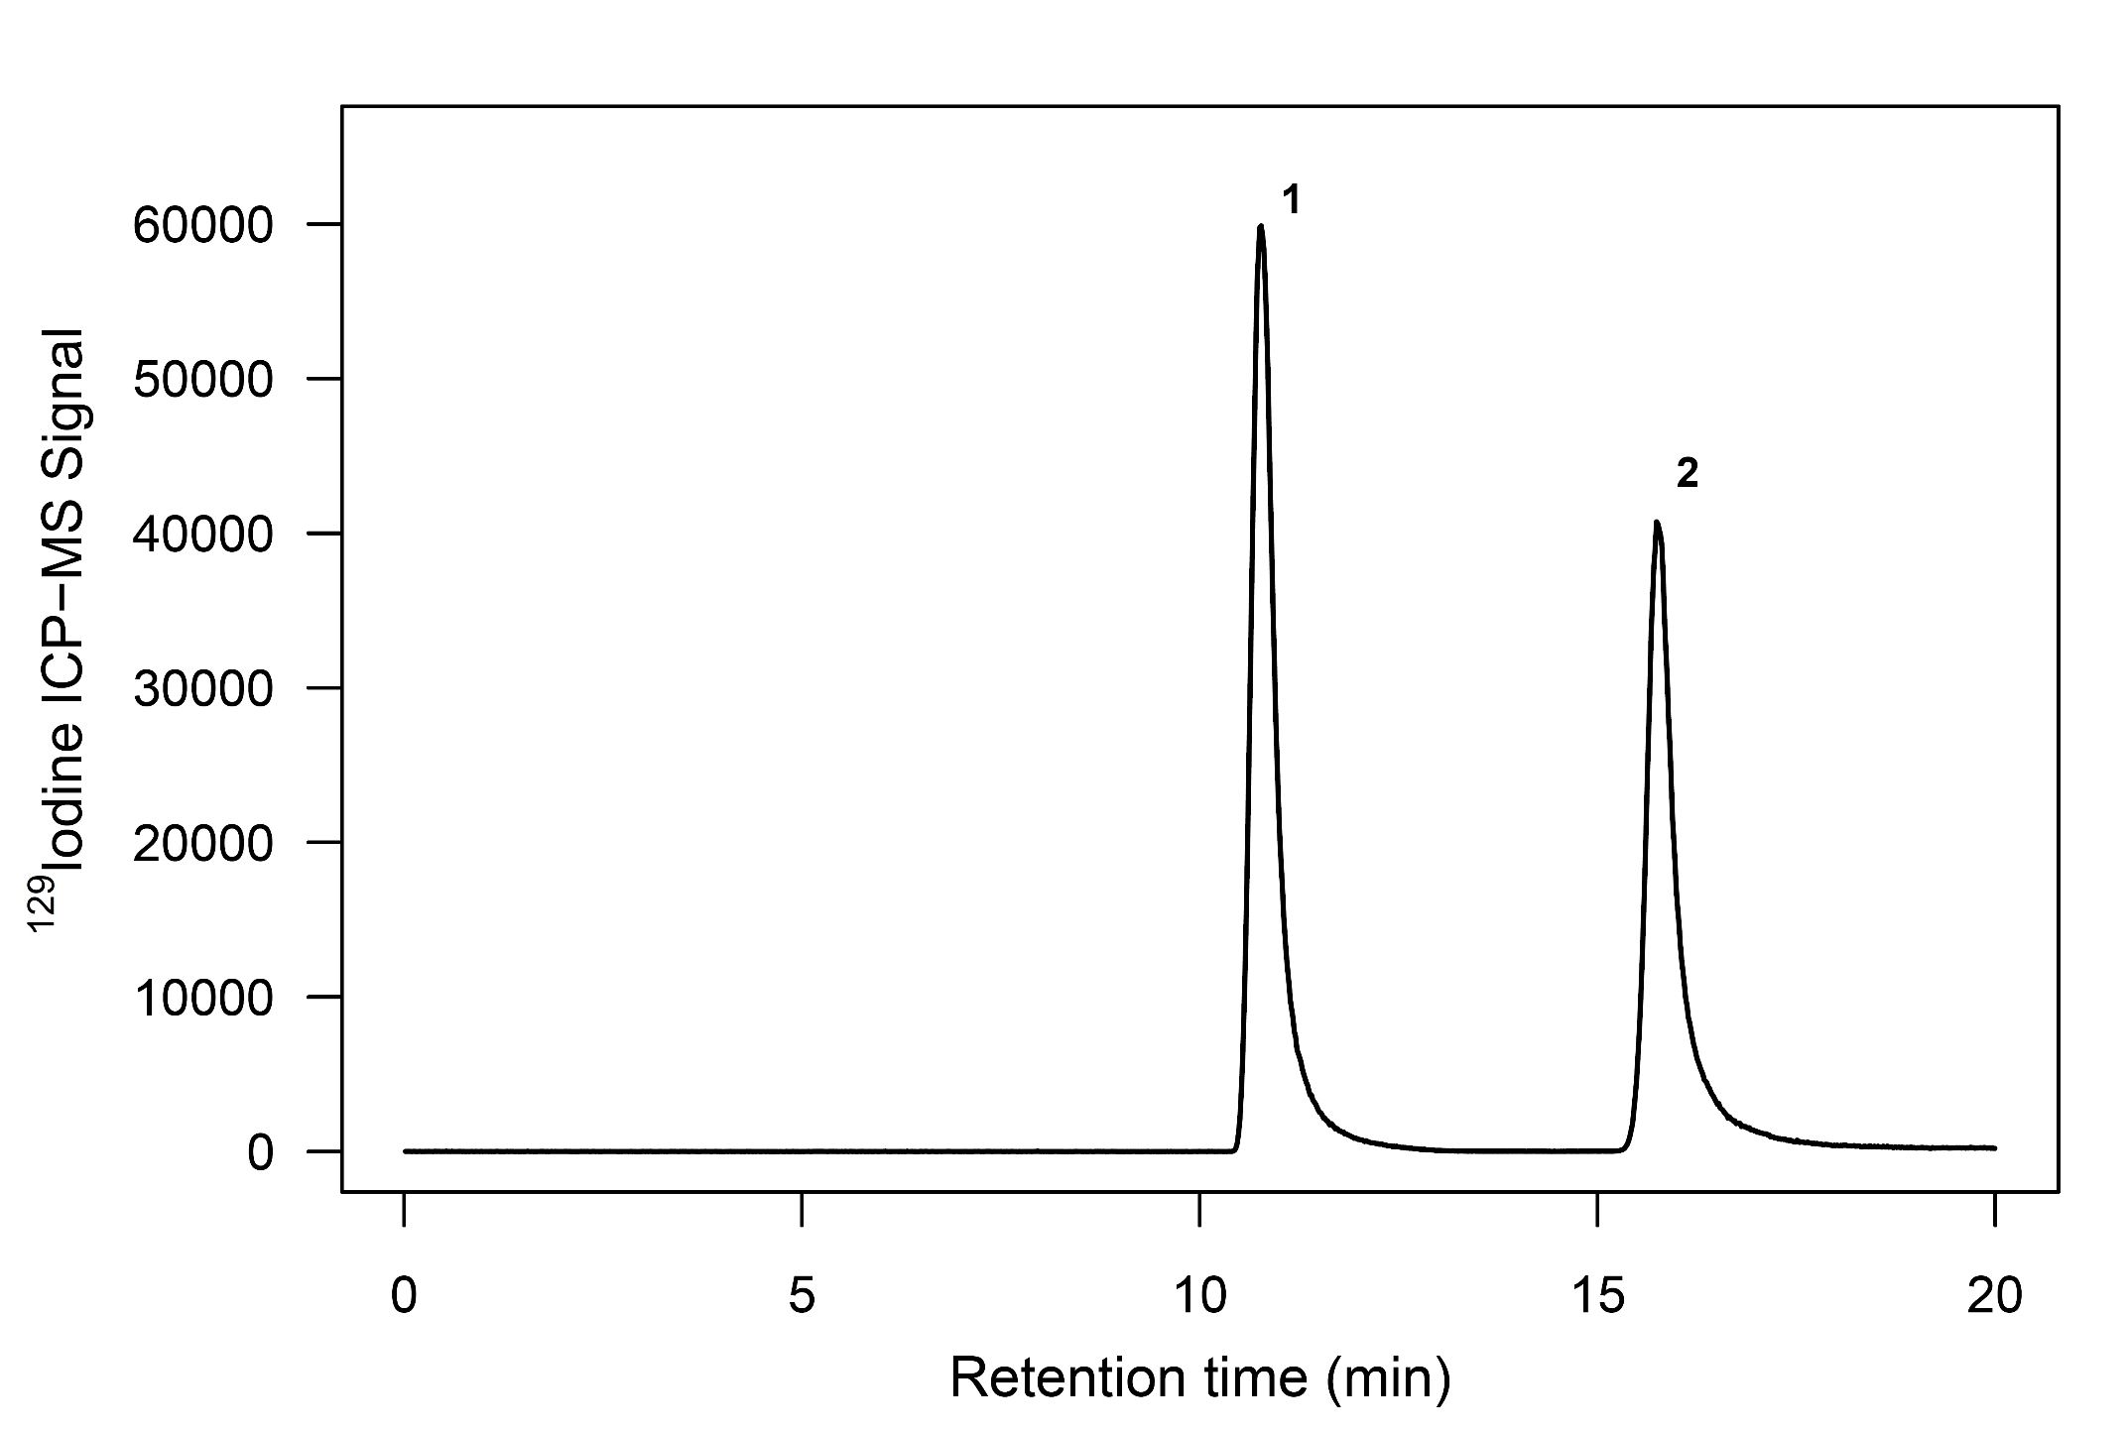

**Figure 4S. 1.** SEC-ICP-MS chromatogram of mixed inorganic-129I standards (50 µg L-1): 1, IO3-; 2, I–

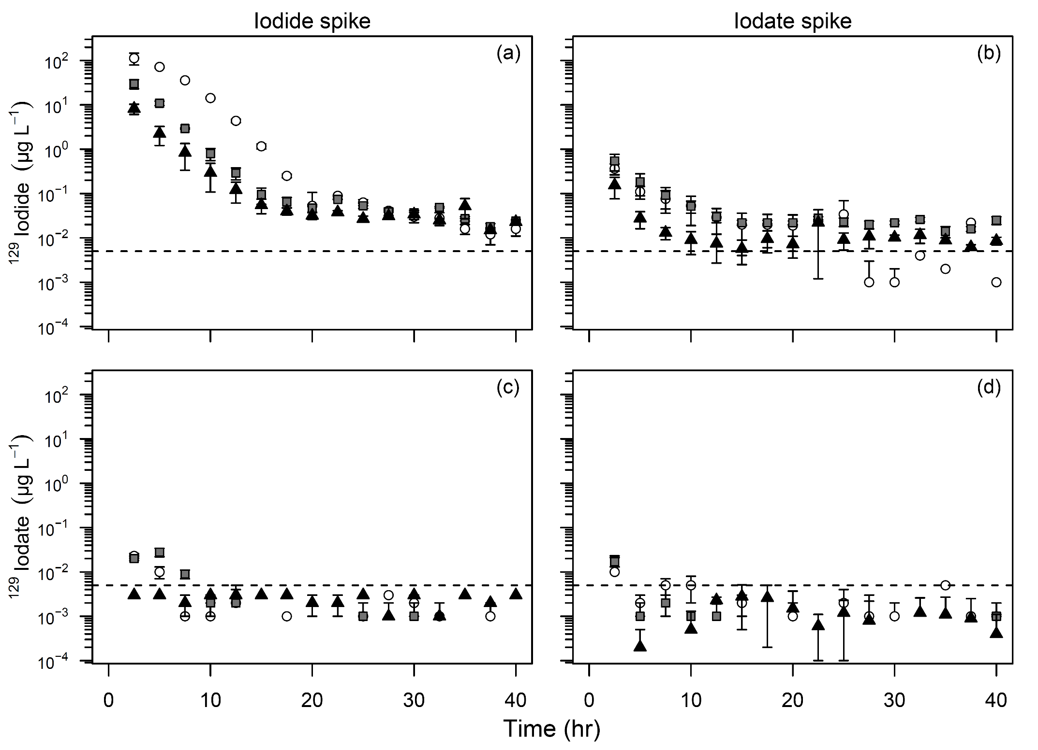

**Figure 4S. 2.** Inorganic-I (129I- and 129IO3-) concentration in the soil solution phase (µg L-1 ) in soils spiked with either 129I- and 129IO3- over 40 hours. Symbols represent the mean values obtained in triplicate, bars indicate SE. White circles represent arable soils; grey squares represent grassland soils; black triangles represent woodland soils. Note the log scale on primary Y-axis. The dashed line indicates the detection limit. Microdialysis dialysate was extracted at 5 µL min-1for 2.5 hours.

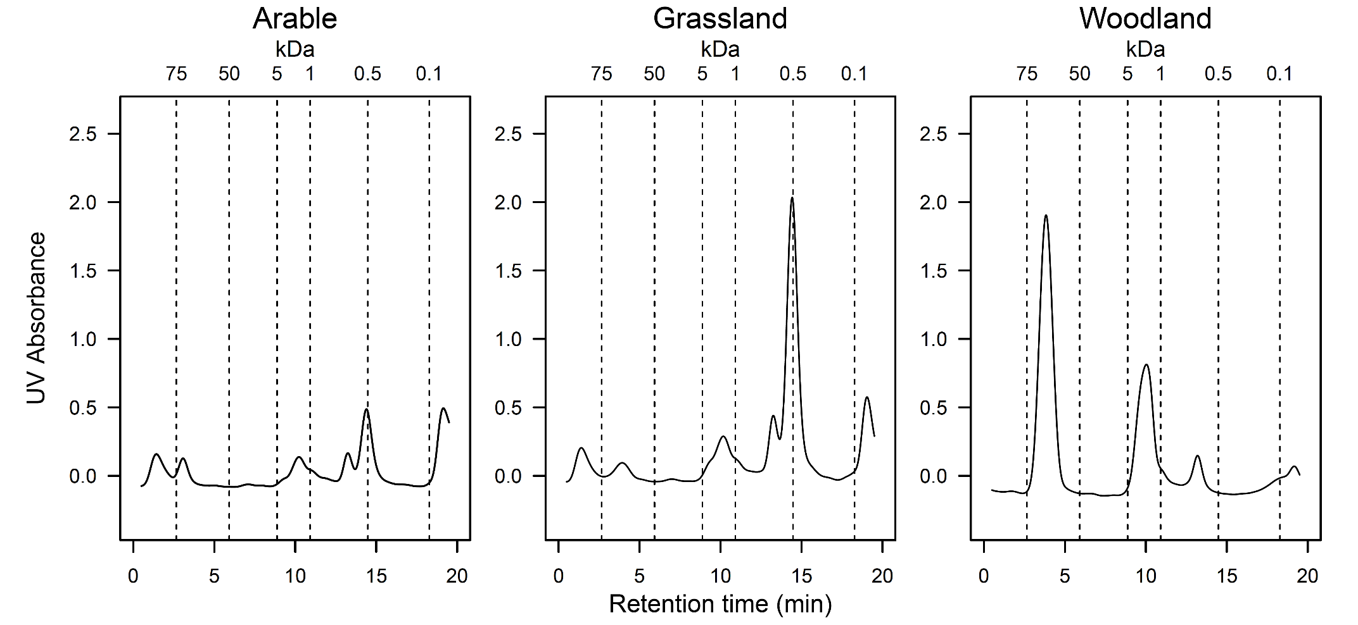

**Figure 4S. 3.** UV absorbance measurements separated by size exclusion showing molecular weight distribution of dissolved organic compounds in soil solution for arable, grassland and woodland soils (UV absorbance measured at 254 nm).