Electronic supplementary information

for

Metal-Organic Frameworks Constructed from Group 1 Metals (Li, Na) and Silicon-Centered Linkers

David Pugh,ª Emma Ashworth,ª Karen Robertson,ª Luke C. Delmas,ª Andrew J. P. White,ª Peter N. Horton,^{b} Graham J. Tizzard,^{b} Simon J. Coles,^{b} Paul D. Lickiss,*ª and Robert P. Davies*ª

a: Molecular Sciences Research Hub, Imperial College London, 80 Wood Lane, London, W12 0BZ, UK
b: National Crystallography Service, Chemistry, University of Southampton, Highfield, Southampton, SO17 1BJ, UK
Tel.: +44 (0) 20 7594 5761; e-mail p.lickiss@imperial.ac.uk (PDL)
Tel.: +44 (0)20 7594 5754; e-mail r.davies@imperial.ac.uk (RPD)

Contents
- Notes on the X-ray crystal structure of IMP-22 02
- Notes on the X-ray crystal structure of IMP-23 03
- Notes on the X-ray crystal structure of IMP-24 04
- Notes on the X-ray crystal structure of IMP-25 06
- Notes on the X-ray crystal structure of IMP-26 09
- Notes on the X-ray crystal structures of IMP-27Li and IMP-27Na 11
- Powder X-ray diffraction traces 14
- TGA traces 16
- BET trace of IMP27-Li 18
- References 19

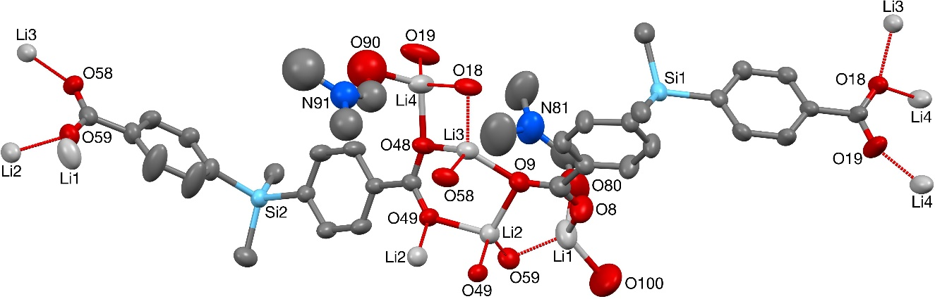
- Notes on the X-ray crystal structure of IMP-22

Figure S1: ORTEP diagram of the asymmetric unit of IMP-22 with thermal ellipsoids at 50% probability. Hydrogen atoms and solvent molecules (bar coordinating oxygens) omitted for clarity.

The O80- and O90-based coordinated DMF solvent molecules in the structure of IMP-22 were both found to be disordered, with two orientations of approximately 66 and 34% occupancy being identified for the former, whilst for the latter three orientations of approximately 43, 30, and 27% occupancy were identified. The geometries of both sets of orientations were optimized, the thermal parameters of adjacent atoms were restrained to be similar, and only the non-hydrogen atoms of the major occupancy orientation of the O80-based molecule were refined anisotropically (those of the minor occupancy orientation of the O80-molecule, and all three orientations of the O90-based molecule, were refined isotropically). The hydrogen atoms of the presumed O100-based coordinated water molecule could not be located and so the atom list for the asymmetric unit is low by 2H (and that for the unit cell low by 32H).
The included solvent was found to be highly disordered, and the best approach to handling this diffuse electron density was found to be the SQUEEZE routine of PLATON.^{S1} This suggested a total of 1614 electrons per unit cell, equivalent to 100.9 electrons per asymmetric unit. Before the use of SQUEEZE the solvent clearly resembled DMF (C₃H₇NO, 40 electrons), and 2.5 DMF molecules corresponds to 100 electrons, so this was used as the solvent present. As a result, and combined with the “missing” H₂O hydrogen atoms on O100, the atom list for the asymmetric unit is low by 2.5(C₃H₇NO) + 2H = C_{7.5}H₁₉N_{2.5}O_{2.5} (and that for the unit cell low by C₁₂₀H₃₁₂N₄₀O₄₀) compared to what is presumed to be present.

- Notes on the X-ray crystal structure of IMP-23
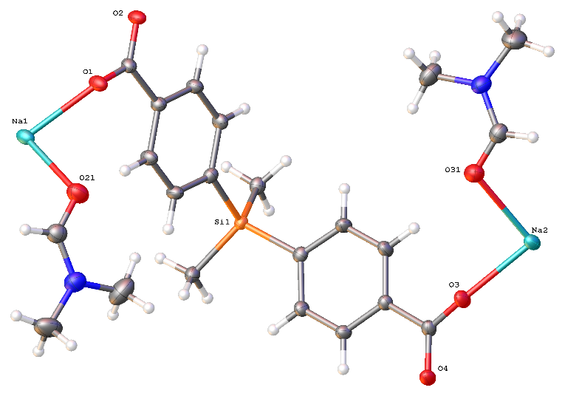

Figure S2: ORTEP diagram of the asymmetric unit of IMP-23 with thermal ellipsoids at 50% probability. Hydrogen atoms and solvent molecules (bar coordinating oxygens) omitted for clarity.

The structure was solved in the space group I4₁/a (#88) by Intrinsic Phasing using the ShelXT structure solution program and refined by Least Squares using version 2014/7 of ShelXL.^{S2} All non-hydrogen atoms were refined anisotropically. Hydrogen atom positions were calculated geometrically and refined using the riding model.
There are four cavities containing highly disordered solvent (assumed to be DMF) for which solvent masking was used (Table S1). Electron density corresponding to 244 electrons was masked, which is a good fit for 1.5 DMF molecules per cavity (C₃H₇NO requires 40 electrons).
No | x | y | z | V | e | Content
1 | 0.000 | 0.250 | 0.401 | 467 | 61
2 | 0.000 | 0.750 | 0.539 | 467 | 61
3 | 0.500 | 0.250 | 0.189 | 467 | 61
4 | 0.500 | 0.750 | 0.786 | 467 | 61

Table S1: details regarding the solvent masking for IMP-23.

- Notes on the X-ray crystal structure of IMP-24
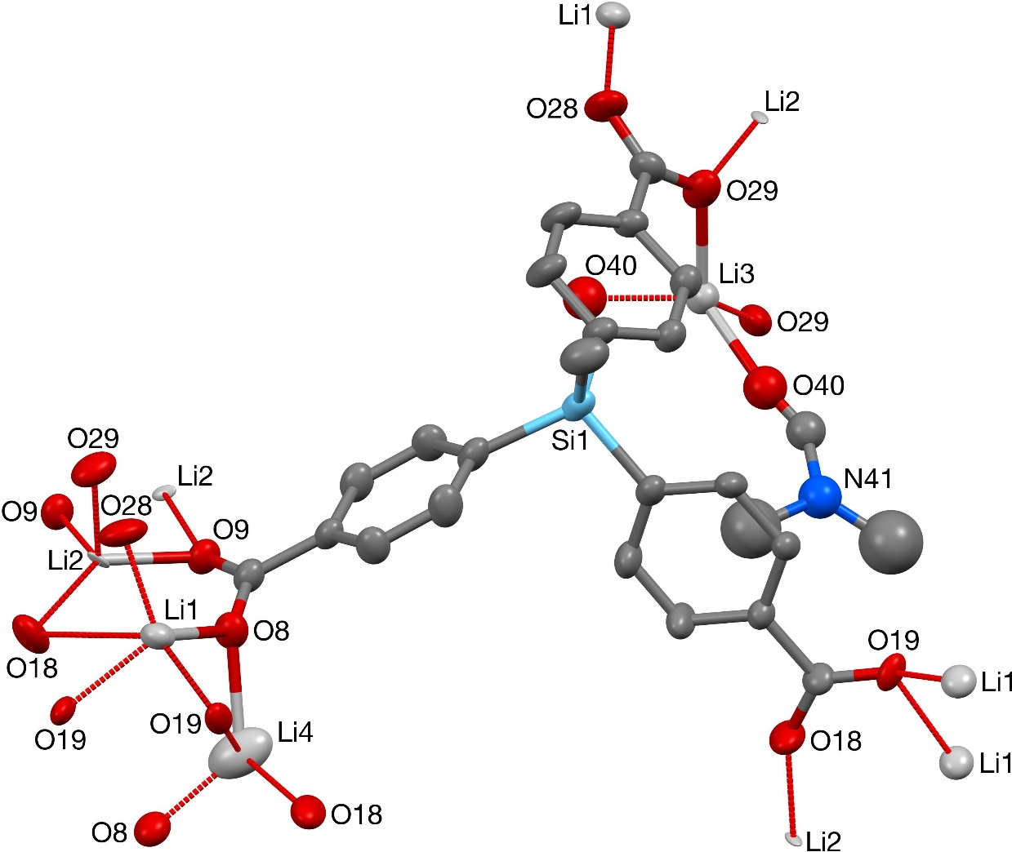

Figure S3: ORTEP diagram of the asymmetric unit of IMP-24 with thermal ellipsoids at 50% probability. Hydrogen atoms and solvent molecules (bar coordinating oxygens) omitted for clarity.

Li1, Li2, and Li3 all appear to be in a 4-coordinate distorted tetrahedral geometry, but Li4 is seemingly in a 2-coordinate bent geometry on the edge of a pore. This is likely a result of unresolved donor solvents: the SQUEEZE algorithm was used to remove highly disordered DMF which was bound to Li4. Additional disorder was found within the C1-based benzoate moiety, the C17-based carboxylate group, and the O40-based coordinated DMF solvent molecule. For the C1-based benzoate moiety and the C17-based carboxylate group, two orientations were identified of approximately 78:22 and 69:31 occupancy respectively. For the O40-based DMF molecule three orientations of approximately 38, 35, and 27% occupancy were identified. The geometries of each set of orientations were optimized, the thermal parameters of adjacent atoms were restrained to be similar, and only the non-hydrogen atoms of the major occupancy orientations of the C1-based benzoate moiety and the C17-based carboxylate group were refined anisotropically (those of the minor occupancy orientations of the C1-based benzoate moiety and the C17-based carboxylate group, and all three orientations of the O40-based DMF molecule, were refined isotropically). The Li4 center was found to be disordered across two C₂-related positions ca. 1.49 Å apart, and so was refined at 50% occupancy.
Diffuse electron density was found near to the disordered Li4 center and extending away from it, and though no sensible model could be constructed it seems probable that it is a coordinated solvent molecule disordered across the adjacent C₂ axis. The best approach to handling this diffuse electron density was found to be the SQUEEZE routine of PLATON.^{S1} In order to allow SQUEEZE to remove all of the electron density (including that within bonding distance), the Li4 center was temporarily removed from the structure before running SQUEEZE, and added back afterwards. SQUEEZE suggested a total of 93 electrons per unit cell, equivalent to 15.5 electrons per asymmetric unit. By analogy with the O40-based DMF (C₃H₇NO, 40 electrons) molecule bonded to Li3, this electron density was presumed to be due to a dimethylformamide molecule coordinated to Li4. 0.4 DMF molecules corresponds to 16 electrons, so this was used as the solvent present. As a result the atom list for the asymmetric unit is low by 0.4(C₃H₇NO) = C_{1.2}H_{2.8}N_{0.4}O_{0.4} (and that for the unit cell low by C_{7.2}H_{16.8}N_{2.4}O_{2.4}) compared to what is presumed to be present.
Despite the apparent trigonal nature of the unit cell, a hemispherical data set was collected, giving a redundancy of approximately 5.7. The experiment was designed to collect approximately 99.5% complete data to a resolution of 0.74 Å with a target I/σ of 20, and ran for 38 hours. Combined with the very nice peak shapes, there is every reason to consider this a high quality data set. Unfortunately, quite apart from the disorder handling detailed above, the final structure has a couple of serious problems with two of the lithium centers, Li2 and Li4. The Li2 center, which sits in a general position, refines to a thermal parameter that is both far too low and sufficiently anisotropic that it requires a strong restraint to stop from going non-positive definite. The obvious solution to both these issues is to model this center as a distinctly heavier atom, but there is little it could plausibly be from a chemical standpoint. The best and most obvious alternative would be sodium, but whilst modelling this site as mixed Li/Na in a ca. 86:14 ratio addresses the electron density issue, it has its own problems with unrealistically short Na–O bond lengths, and so presents little overall improvement. Being only approximately 1.50 Å away from its C₂-related counterpart, the Li4 center can only have a maximum occupancy of 0.5, but even when refined at 50% occupancy its thermal parameter is still noticeably high compared to the adjacent atoms. However, lowering the occupancy to improve the thermal parameter leads to both charge balance problems and occasional voids in the structure. These two centers, therefore, are subject to distinct uncertainty and so whilst the overall pattern of the MOF is clear, the exact nature of the metal nodes is not. (It is worthy of note that solving and refining the structure using the lower symmetry space group P3₁ does not resolve any of the issues.)
Because of these uncertainties, a second data set was collected using a new crystal from the same batch. As with the original crystal, the diffraction patterns looked very nice, but this time trigonal symmetry was assumed, leading to a much lower redundancy in the data of approximately 3.3. This second experiment was designed to collect approximately 99.5% complete data to a resolution of 0.80 Å with a target I/σ of 25, and ran for 64 hours. Once again this looks to be a very nice high quality data set, and yet exactly the same problems in the final structural model are observed. This suggests that the problems may well be in the model rather than in the data as had initially been thought (and is often the case for MOF materials), though we have not been able to identify a chemically sensible alternative model.

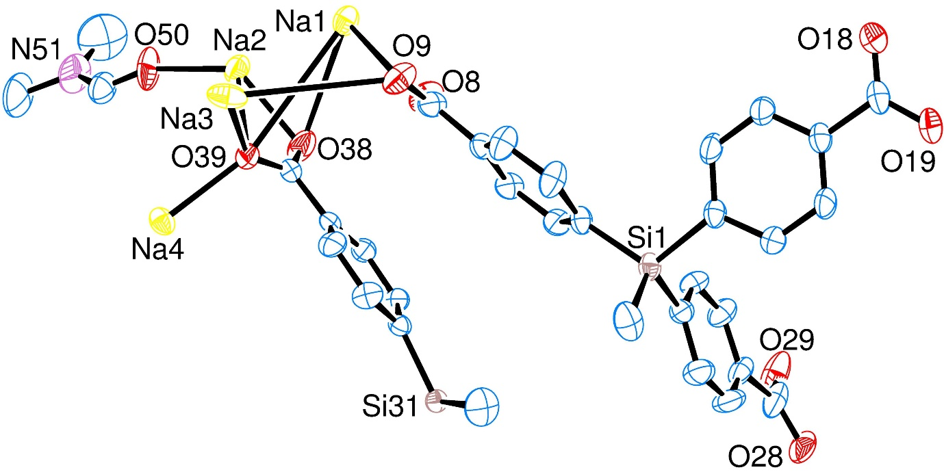
- Notes on the X-ray crystal structure of IMP-25

Figure S4: ORTEP diagram of the asymmetric unit of IMP-25 with thermal ellipsoids at 50% probability. Hydrogen atoms and solvent molecules (bar coordinating oxygens) omitted for clarity.

The O50-based coordinated dimethylformamide solvent molecule in the structure of IMP-25 was found to be disordered. Two orientations were identified of ~57 and 43% occupancy, their geometries were optimised, the thermal parameters of adjacent atoms were restrained to be similar, and only the non-hydrogen atoms of the major occupancy orientation were refined anisotropically (those of the minor occupancy orientation were refined isotropically).
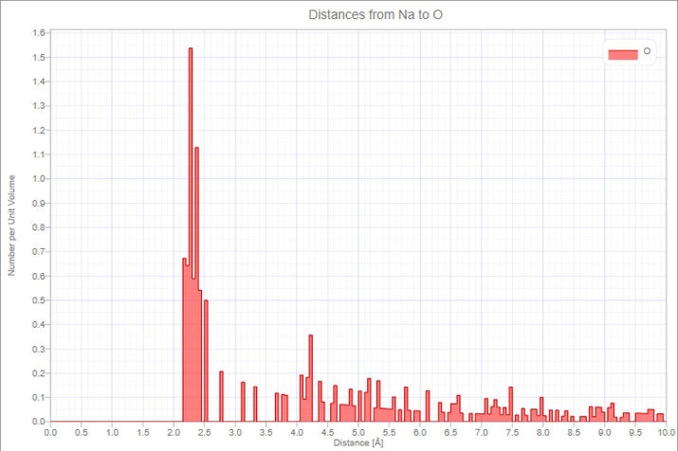

Figure S5: histogram showing the distribution of Na–O distances within IMP-25.
When analysing the structure of IMP-25, the question of how close two atoms have to be in order to constitute a significant bond is key. The majority of the Na–O distances in IMP-25 are within the range 2.1–2.5 Å (Figure S5). This is broadly consistent with literature examples of ‘ionic’ Na–O bonds (albeit with some covalent character e.g. NaOMe) where the sum of ionic radii for Na⁺ and “O–” is between 2.3–2.5 Å. Here it should be noted that this value is highly dependent on the coordination environment at each atom.^{S3} Nonetheless, this cluster of Na–O distances clearly constitutes a set of Na–O bonds.
The sum of van der Waals radii for Na and O is 4.00 Å,^{S4} so any Na–O distances longer than this are not bonds. This leaves a handful of intermediate distances which may or may not constitute a bond. If the intermediate distances are all discounted then the structure of IMP-25 is a series of overlapping helical nodes which run parallel to the [001] direction, but importantly are not bound to each other (Figure S6). This is similar to the structure of IMP-24 indicating that the ligand is favouring the formation of helical nodes.
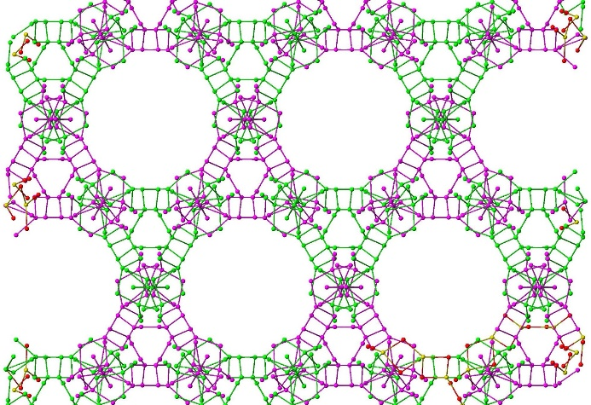

Figure S6: Diagram showing the series of helical metal nodes in IMP-25 which run parallel to the c axis if the Na–O bond lengths are restricted to 2.53 Å. The purple and green nodes appear to overlap but in fact are entirely separate entities.

The key Na–O distance is the one at ~2.7 Å. If this is considered to be a genuine bond, the helical nodes are all joined together to form one 3D metal node (cf. main text, Figure 6). Including the other intermediate Na–O distances strengthens the degree of bonding between the nodes but does not further change the connectivity. In view of the fact that this key distance is ~1.3 Å shorter than the sum of van der Waals radii for Na and O, it is hard to justify excluding it from the list of genuine Na–O bonds. Hence, we assign the structure of IMP-25 as a single 3D metal node rather than a series of parallel but unconnected helices (Figure S7).

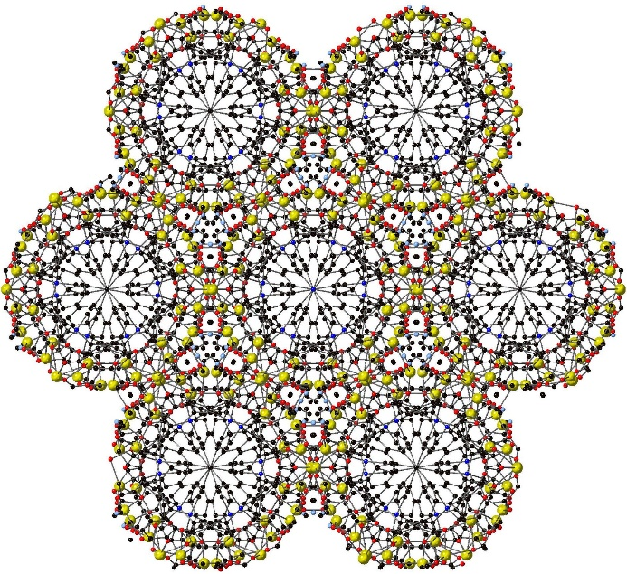

Figure S7: View down [001] of IMP-25 showing the large channels filled by the ‘organic’ component of L2, and the small channels filled by DMF solvent molecules. Element colors: C = black; O = red; Na = yellow; Si = blue.

Each of the four crystallographically distinct Na⁺ cations make an important contribution to the gross structure of the 3D node. The cations labelled Na1 (Figure 6a) and Na3 (Figure 6c) are found in the middle of the channel walls. The former is in a 5-coordinate environment with one κ²-carboxylate and three κ¹-carboxylate anions comprising the coordination sphere, whereas the latter is in a 4-coordinate environment surrounded by four κ¹-carboxylate anions. The geometry at both cations is distorted away from ideal, with the τ’₄ parameter^{S5} of 0.63 indicating severe distortion away from ideal tetrahedral for Na3. The τ⁵ parameter^{S6} of 0.16 indicates mild distortion away from ideal square based pyramidal for Na1, but this underestimates the distortion caused by the acute chelate angle from the κ²-carboxylate anion.
The Na⁺ cation labelled Na2 (Figure 6b) is located on the outer edge of the tube, facing the small channel filled by coordinated DMF solvent molecules. This is also in a 5-coordinate environment with one κ²-carboxylate, two κ¹-carboxylate anions, and one (disordered) DMF molecule comprising the coordination sphere. The τ₅ parameter of 0.06 reflects minimal distortion away from ideal square-based pyramidal geometry, where the apical ligand is DMF. The Na⁺ cation facing the center of the tube is Na4 (Figure 6d) which is also in a 5-coordinate environment bound to one κ²-carboxylate and three κ¹-carboxylate anions. The τ₅ parameter of 0.02 suggests almost ideal square-based pyramidal geometry, but as in the case for Na1, this underestimates the distortion from the κ²-carboxylate.

- Notes on the X-ray crystal structure of IMP-26
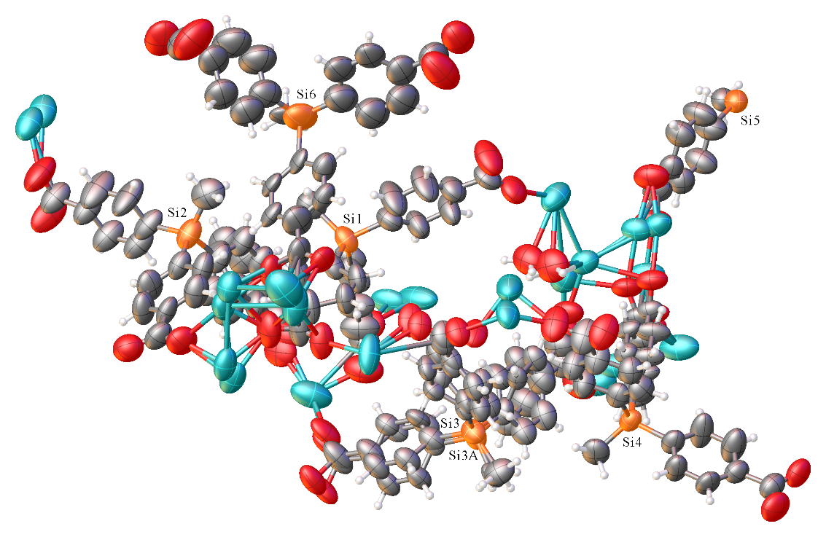

Figure S8: ORTEP diagram of the asymmetric unit of IMP-26 with thermal ellipsoids at 50% probability. Hydrogen atoms and solvent molecules (bar coordinating oxygens) omitted for clarity.

The structure was solved in the space group R3 (#146) by Intrinsic Phasing using the ShelXT structure solution program and refined by Least Squares using version 2014/7 of ShelXL.^{S2} All non-hydrogen atoms were refined anisotropically. Hydrogen atom positions were calculated geometrically and refined using the riding model.
There is disorder of some of the silane ligands and sodium cations. As such various restraints (DFIX, SADI, DELU, SIMU, RIGU, and FLAT) have been applied. Solvent masking using SQUEEZE was also carried out to remove highly disordered DMF solvents (Table S2). This corresponded to 2206 electrons, which is approximately 55 molecules of DMF removed from the unit cell. To provide a comparison, the related structure IMP-25 contains 36 modelled molecules of DMF (coordinated to the Na⁺ cations) and six molecules of disordered DMF were removed by SQUEEZE, making 42 in total. The cell volume of IMP-26 is ~2300 Å³ bigger than IMP-25, and whilst some of this volume increase can be accounted for by the presence of water (there is none in IMP-25) the increase in cell volume is still sufficiently large to accommodate 55 molecules of DMF, hence this is considered a realistic account of the electron density within IMP-26.
No | x | y | z | V | e | Content
1 | -0.921 | -0.802 | -0.876 | 10517.4 | 2206.1 | ?

Table S2: details regarding the solvent masking for IMP-26.

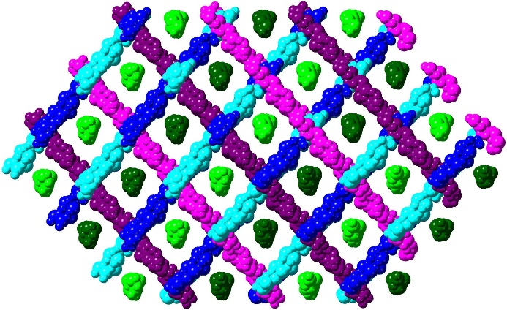

Figure S9: Diagram showing the parallel columns in IMP-26. Dark/light green columns are parallel, as are dark/light blue and pink/purple.

MOF IMP-26 is formed of interpenetrating columns of Na⁺ cations which run in three different directions. When the structure is viewed down the c axis, the columns overlap giving the impression of a single 3D metal node, but the columns are separate entities which are not directly bonded to each other. In order to aid visualization of the structure, the parallel columns have been color coded (Figure S9). The MOF is oriented to look down the columns coloured green which are all mutually parallel. The dark/light shading is used to distinguish between alternate columns but they are otherwise identical. The other two directions are indicated by columns colored blue and purple, with similar dark/light alternating shading being used to distinguish alternate columns for ease of visualization. None of the columns are interconnected, instead they form a complex three-dimensional interlaced lattice which looks remarkably similar to the MOF IMP-25 when viewed down the c axis.
TGA of a combined sample (Figure S20) showed a single mass loss between 100 and 260 °C corresponding to 11.5% of the sample mass. There is no non-coordinated solvent in IMP-25 so it is reasonable to assume that this mass loss came entirely from IMP-26. The SQUEEZE algorithm calculated 55 molecules of DMF per unit cell of IMP-26, or 16.6% by mass. This implies that the as-synthesized sample contains IMP-25 and IMP-26 in a 1:2 ratio, assuming all the non-coordinating solvent from IMP-26 is lost under TGA conditions.

- Notes on the X-ray crystal structure of IMP-27Li and IMP-27Na

Figure S10: ORTEP diagram of the asymmetric unit of IMP-27Na with thermal ellipsoids at 50% probability. Hydrogen atoms and solvent molecules (bar coordinating oxygens) omitted for clarity.

Despite repeated attempts, all crystals of IMP-27Li that we grew were found to be twinned. The best dataset was of sufficient quality to unambiguously assign the atoms making up the MOF, but this did not lead to a satisfactory solution with R values remaining stubbornly high, even when synchrotron radiation was used. This was partly caused by the presence of solvent molecules (DMF) within the pores which were severely disordered. Normally these would have been removed using SQUEEZE^{S1} but this is not possible with twinned crystals. We have therefore included the structure only as a comparison point to the literature data and to IMP-27Na.
Each ligand arm of IMP-27 (both Li and Na) is deprotonated and unique hence there are four crystallographically distinct carboxylate groups linking three separate chains. Within these chains there are four crystallographically distinct metal atoms. Whilst these chains have very similar overall arrangements, due to the difference in coordination number there is enough variation in the connectivity of the atoms to warrant separate descriptions.
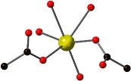
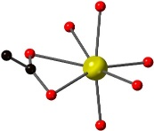
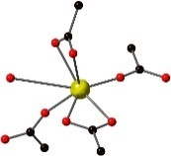
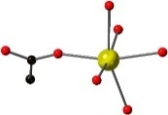

Figure S11: views of the coordination environment around (a) Na1; (b) Na2; (c) Na3; (d) Na4 in IMP-27Na.
In IMP-27Li there are two μ⁴–carboxylate groups each containing two μ–O atoms. There is one μ³–carboxylate group with one μ–O (O8) bridging Li1 and Li4, and one monodentate O atom (O7) coordinating to Li2. The fourth crystallographically distinct carboxylate group coordinates in a dimonodentate form to Li1 and Li2. These result in a full complement of tetrahedral coordination positions for Li1 and Li2, but Li3 requires one H₂O and one DMF molecule, and Li4 coordinates to one H₂O molecule to fulfil the expected tetrahedral coordination for Li. Each lithium cation is 4-coordinate with τ’₄ values between 0.78 and 0.89, indicating some distortion away from ideal tetrahedral geometry is present.
IMP-27Na has, as expected, a more complex coordination environment. It has only three carboxylate groups bonding to the metal chains, the fourth (O11 and O12) hydrogen bonds to five H₂O molecules, four of which are crystallographically distinct. The three coordinating carboxylate groups each coordinate in a different manner. O21 and O22 comprise a μ³ bridge between Na1, Na2 and Na4 with additional chelation of Na2. O31 and O32 complete a μ⁴ bridge between Na1, Na1A, Na2, and Na3 with O32 providing a μ³ bridge; this carboxylate group also chelates to Na1. O41 and O42 are a μ–O bridge between Na1 and Na3, and also chelate to Na1. Further bridging between Na centers is performed by solvent molecules (both H₂O and, uncommonly, DMF) with the coordination environment at each Na center completed by monodentate solvent molecules. In addition, there is one non-coordinating DMF molecule per unit cell.
Due to the slight distortion of frameworks relative to one another the void space of IMP-27Li and IMP-27Na differ. For both MOFs the void space is interconnected but this interconnection is 3D in IMP-27Li and only 2D in IMP-27Na. In addition, this calculated void space is only present in IMP-27Na when all coordinated DMF molecules have been removed, whereas the void space of IMP-27Li is present even with coordinated solvent. Removal of coordinated DMF increases the void space. The largest channel in IMP-27Na runs parallel to the [110] direction and measures 5 × 6 Å².
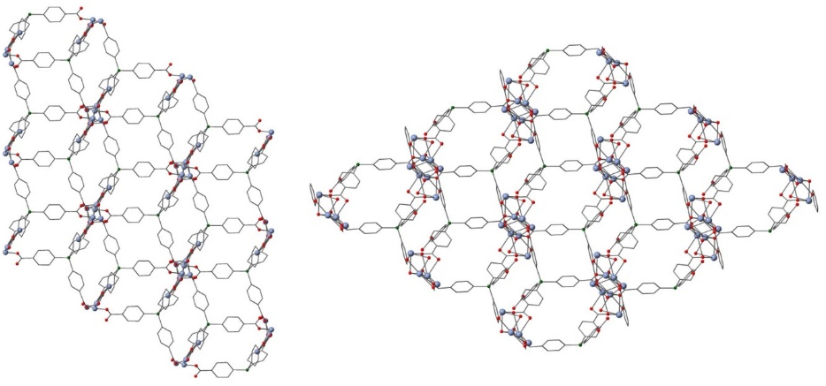
An examination of both structures shows the topology to be identical (Figure S12). The metal cations in each structure form chains which run perpendicular to the plane of the paper and each chain is connected to six ligand environments in a distorted hexagonal arrangement. Each ligand connects three neighbouring chains, but the major difference between the structures is that for IMP-27Li the ligand connects to one chain using two arms, whereas for IMP-27Na all three chains are only connected using one arm, with the fourth arm dangling free.

Figure S12: a comparison of the structure topologies for IMP-27Li (left) and IMP-27Na (right). Atom colors: C = gray, O = red, Si = green, metal = blue.
Each chain is surrounded by six ligand environments in a roughly hexagonal array with L3 bridging three of the chains. The major difference between the structures is that for IMP-27Li all four carboxylate arms are directly bound to M⁺ chains (one chain is bound by two arms from the same ligand) whereas for IMP-27Na only three of the arms are directly bound to chains, with the fourth arm hydrogen bonding to the coordinated water which bridges the Na⁺ cations (Figure S13). Further details regarding the structures of IMP-27Li and IMP-27Na can be found in the ESI.
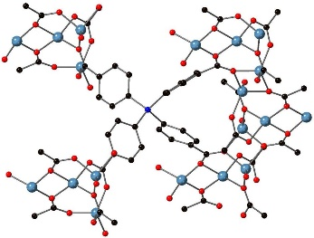
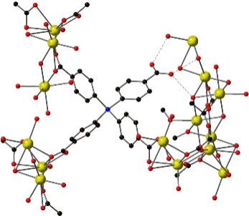

(a, b)

Figure S13: view of the connectivity of L3 in (a) IMP-27Li and (b) IMP-27Na. The mono-coordinated carboxylates are located in the top left and bottom left, and the chain with two carboxylate groups attached is on the right. Hydrogen bonding from the unbound carboxylate to the Na⁺ node is shown as a dotted line. Element colors: C = black; O = red; Li = blue; Na = yellow.

- Powder X-ray diffraction traces

Figure S14: PXRD traces of the simulated pattern from the single crystal data of IMP-22 (light brown, bottom); as-synthesized (teal, middle) and after drying (dark brown, top).

Figure S15: PXRD traces of IMP-23 as synthesized (blue, bottom) and the simulated pattern from the single crystal data (red-brown, top).

Figure S16: PXRD traces of as-synthesized IMP-25 + IMP-26 (orange, bottom) and the simulated pattern from the single crystal data of IMP-25 (crimson, middle) and IMP-26 (purple, top).

Figure S17: PXRD traces of the simulated pattern from the single crystal data of IMP-27Li (light brown, bottom); as synthesized (teal, middle); after drying (dark brown, top).

- TGA traces
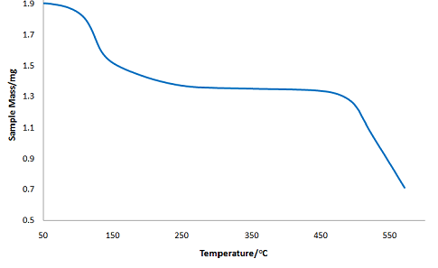

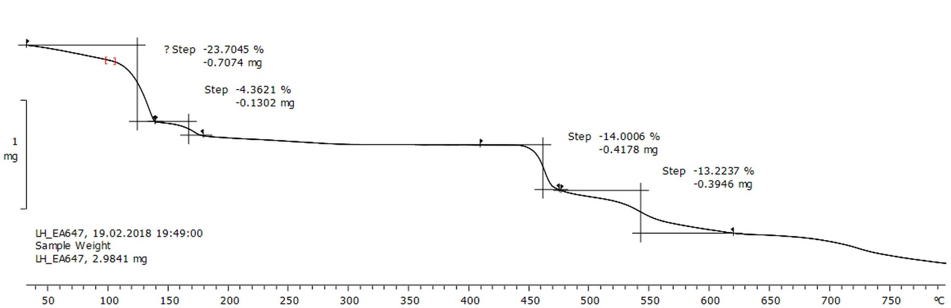
Figure S18: TGA trace of IMP-22. Conditions: 50 °C to 600 °C at 10 °C/minute under a constant flow of N₂. The mass loss between 50 °C and 230 °C corresponds to 36.1% loss (calculated mass loss of all DMF molecules = 36.3%). The onset of decomposition was observed around 485 °C.

Figure S19: TGA trace of IMP-23. Conditions: 50 °C to 800 °C at 10 °C/minute under a constant flow of N₂. The two-step mass loss between 50 °C and 180 °C corresponds to 28.1% loss (calculated mass loss of all coordinated DMF molecules = 28.2%).

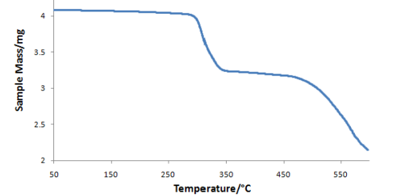

Figure S20: TGA trace of IMP-24. Conditions: 50 °C to 600 °C at 10 °C/minute under a constant flow of N₂. The mass loss between 260 °C and 330 °C corresponds to 16.3% loss (calculated mass loss of all DMF molecules = 16.7%). The onset of decomposition was observed around 470 °C.
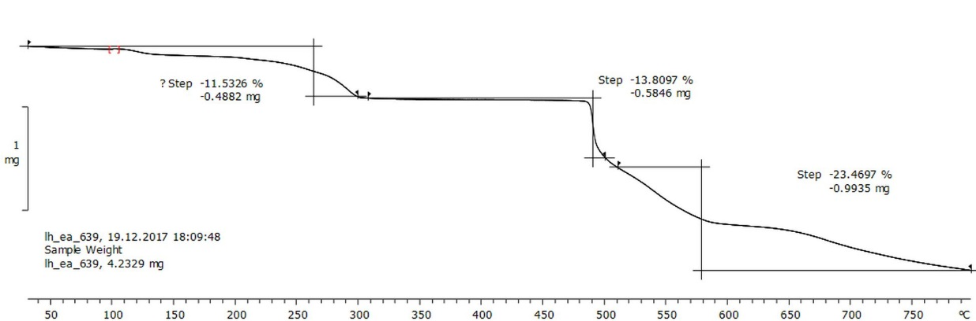

Figure S21: TGA trace of a mixture of IMP-25 and IMP-26. Conditions: 50 °C to 800 °C at 10 °C/minute under a constant flow of N₂. The mass loss between 100 °C and 260 °C corresponds to 28.1% loss (calculated mass loss of all coordinated DMF molecules = 28.2%).

- BET trace of IMP-27Li

Figure S22: BET trace of IMP-27Li.

- References
S1) Spek, A. L. Single-crystal structure validation with the program PLATON. J. Appl. Cryst., 2003, 36, 7.
S2) Sheldrick, G. M. A short history of SHELX. Acta Crystallogr. Sect. A, 2008, 64, 112.
S3) Shannon, R. D. Revised effective ionic radii and systematic studies of interatomic distances in halides and chalcogenides. Acta Crystallogr. Sect. A, 1976, 32, 751.
S4) Alvarez, S. A cartography of the van der Waals territories. Dalton Trans., 2013, 42, 8617.
S5) Okuniewski, A.; Rosiak, D.; Chojnacki, K.; Becker, B. Coordination polymers and molecular structures among complexes of mercury(II) halides with selected 1-benzoylthioureas. Polyhedron, 2015, 90, 47.
S6) Addison, A. W.; Rao, T. N.; Reedijk, J.; van Rijn, J.; Verschoor, G. C. Synthesis, structure, and spectroscopic properties of copper(II) compounds containing nitrogen–sulphur donor ligands; the crystal and molecular structure of aqua[1,7-bis(N-methylbenzimidazol-2′-yl)-2,6-dithiaheptane]copper(II) perchlorate. J. Chem. Soc., Dalton Trans., 1984, 1349.

