**How significant is atmospheric metal contamination from mining activity adjacent to the** **Tasmanian Wilderness World Heritage Area? A spatial analysis of metal concentrations using HYSPLIT Modelling.**

Authors: Larissa Schneider1, Michela Mariani2, Krystyna M. Saunders3, William A. Maher4; Jennifer J. Harrison2, Michael-Shawn Fletcher2, Atun Zawadzki3, Henk Heijnis3, Simon G. Haberle1

1 Archaeology and Natural History. School of Culture, History and Language. Australian National University. Coombs Bld. 9. 2600 Canberra, ACT. Australia.

2 School of Geography, University of Melbourne, Parkville, Victoria, Australia

3 Australian Nuclear Science and Technology Organisation, New Illawarra Road, Lucas Heights, 2234, NSW. Australia.

4 Institute for Applied Ecology. University of Canberra, Bruce, Canberra, Australia.

**Corresponding Author:** Larissa Schneider. Archaeology and Natural History. School of Culture, History and Language. Australian National University. Coombs Bld. 9. 2600 Canberra, ACT. Australia. Larissa.Schneider@anu.edu.au.

**Keywords:** HYSPLIT, lake, metal concentration , metal contamination, metal spatial distribution, enrichment factor, extremely severe enrichment

**Abstract:**

This paper investigated metal contamination from historical mining in lakes in the Tasmanian Wilderness World Heritage Area (TWWHA) and surrounding region. The largest increase in sedimentation and metal contamination occurred ca. 1930 when open-cut mining commenced and new mining technology was introduced into the region. The geochemical signal of lake sediments changed from reflecting the underlying geology and lithology to that reflecting mining activities. Lake metal concentrations since mining activities commenced are in the order: Owen Tarn > Basin Lake > Perched Lake> Lake Dove > Lake Dobson > Lake Cygnus. The HYSPLIT air particle trajectory model explains metal distribution in these lakes, and why the northwest region has the highest metal contamination. Enrichment factors (EF) for Pb, Cu, As and Cd are > 1 for all lakes, with Owen Tarn and Basin Lake having very high EFs for Cu and Pb (98 and 91 respectively). Pb, Cu, As and Cd concentrations in lake sediments are above the Australia/New Zealand lower sediment guidelines, with Pb, Cu and As above the upper guidelines. This study demonstrated the legacy of metal contamination in the TWWHA by mining activities and the consequences of lack of execution of environmental regulations by past governments in Tasmania.

1. **Introduction**

Mining has been a key factor in the economic development of Tasmania, Australia, with numerous abandoned mine sites that are still contaminating soils, rivers, lakes and estuaries (Augustinus et al., 2010). This is of environmental concern in a wide geographical area beyond the immediate vicinity mine sites, as particulate emissions released to the atmosphere by mining operations can be transported over long distances by atmospheric circulation (Suvarapu and Baek, 2017). Here, we use computer modelling of air particle trajectories and lake sediment contamination measurements to develop and test a model of airborne contamination transport from historic mining activities in western Tasmania, Australia.

Mining has been a key factor in the economic development of Tasmania, with numerous abandoned mine sites that are still contaminating soils, rivers, lakes and estuaries (Augustinus et al., 2010). The West Coast of Tasmania is characterised by folded and faulted geology containing several ore bodies that were exploited when the British arrived in Australia in the late 1700s. Principal among these are the major mining centres developed around the closely spaced Mt Lyell and Mt Read ore deposits, Queenstown and Rosebery, respectively.

Analysis of sediment and water from Macquarie Harbour, downstream from Queenstown region, indicates a dramatic increase in metal and metalloid concentrations (hereafter collectively referred as metals) in the harbour resulting from contamination of the Queen and King Rivers by the Mt Lyell mine in Queenstown (Augustinus et al., 2010; Carpenter et al., 1991; Eriksen et al., 2001; Stauber et al., 2000; Teasdale et al., 2003). Further afield, an increase in metals in isolated catchments downwind from both Queenstown and Roseberry reveal the same trends in metal contaminants through the period of intensive mining and smelting operations, suggesting transportation of metal contaminants by wind from mining centres (Harle et al., 2002).

While the effects of mining on the environment around the Queenstown-Rosebery region of western Tasmania are relatively well recognised, through localised deforestation around mining sites and some downstream impact of aquatic ecosystems (De Blas, 1994; Harle et al., 2002; Hodgson et al., 2000; Kozlov and Zvereva, 2006), there has been no attempt to understand the spatial distribution of airborne metal contaminants from Queenstown and Rosebery. This is important because the western boundary of the Tasmanian Wilderness World Heritage Area (TWWHA) lies just 11 and 12 km from both Queenstown and Rosebery, respectively, in the prevailing wind direction.

The atmospheric distribution of metal contaminants involves a complex interplay of environmental factors, climate and local meteorological characteristics. The principal environmental factors affecting atmospheric transport of metals include, but are not limited to, precipitation, temperature, air movement and pressure (Fang et al., 2005; Pacyna et al., 2009; Suvarapu and Baek, 2017). All of these must be taken into consideration when assessing atmospheric metal distribution and deposition into the environment.

A useful tool to understand this interplay of climate factors on metal distribution is The Hybrid Single Particle Lagrangian Integrated Trajectory Model (HYSPLIT) model (NOAA, 2018). HYSPLIT produces back trajectories that, when combined with satellite images (from NASA's MODIS satellites), can calculate air particle trajectories and, thus, the direction atmospheric contamination has travelled (Kusumaningtyas and Aldrian, 2016). Despite its apparent usefulness, this model has never been applied to assess airborne contamination from historical mining sites in Tasmania to understand the potential effects of airborne contamination on environmental systems.

In this study, we assess the extent of metal contamination in the TWWHA and surrounding areas using sediment cores from six freshwater lakes. In particular, we applied the HYSPLIT model and statistical analyses to establish the main chemical and physical factors affecting the airborne distribution of metals in these lakes. Furthermore, we compared lake sediment metal concentrations with the ANZECC/ARMCANZ (2000) sediment guidelines values to assess the past and current health of the local environment. Ultimately, the study was undertaken to inform the scientific community and the public about the legacy of metal contamination within the TWWHA to support government initiatives in establishing appropriate regulations and policies to protect the environmental values of this wilderness area.

1. **Material and Methods**
   1. **Regional description**

Western Tasmania is a mountainous area underlain predominantly by intensely folded and faulted Cambrian and pre-Cambrian quartzite rocks and conglomerate units that are intersected with highly mineralised volcanic belts (Corbett and Solomon, 1989). The area includes more than 4,000 lakes and tarns, mostly of glacial origin, ranging from highly acid, dystrophic lakes to ultra-oligotrophic clear water lakes (Hodgson et al., 2000). The west coast receives high orographic rainfall produced by air masses rising over mountains (Gentilli et al., 1972; Sturman and Tapper, 2006). The rainfall reaches a maximum of 3,400 mm and there is an annual temperature range of 3 – 21 °C, with a mean annual temperature of 11 °C at sea level, and 6°C at 1000 m altitude (Langford, 1965). The climate is dominated by the prevailing zonal westerlies that latitudinally migrate through the seasonal cycle, with west to south-westerly airflow dominant in the austral winter and west to north westerly airflow dominant in the austral summer.

* 1. **Historical setting**

Tasmania has been occupied by humans for ca. 40,000 years (Cosgrove, 1999), with Tasmanian Aborigines responsible for maintaining an essentially open landscape through the use of fire (e.g. Mariani et al., 2017). Despite an initial invasion of Tasmania by the British in the late 1700s, it wasn't until the late 19th century with the arrival of mineral prospectors that the west of Tasmania was exposed to exploitation for deposits of gold, silver, lead, zinc and copper. Subsequently, major mining and smelting operations were stablished and concentrated at several centres around Queenstown and Rosebery (Figure 1).

Discharge of tailings, slag, toxic metals and acid drainage into the Queen River that rungs through Queenstown, and downstream to the King River and ultimately into Macquarie Harbour, has eliminated all but the most robust forms of aquatic life in these waterways (Hodgson et al, 2000). Today, these towns are located along the boundary with the TWWHA, thus, there is a high probability that areas within the TWWHA have experienced some degree of long-range metal contamination and ecological change from historic mining activities (Harle et al., 2002; Hodgson et al., 2000).

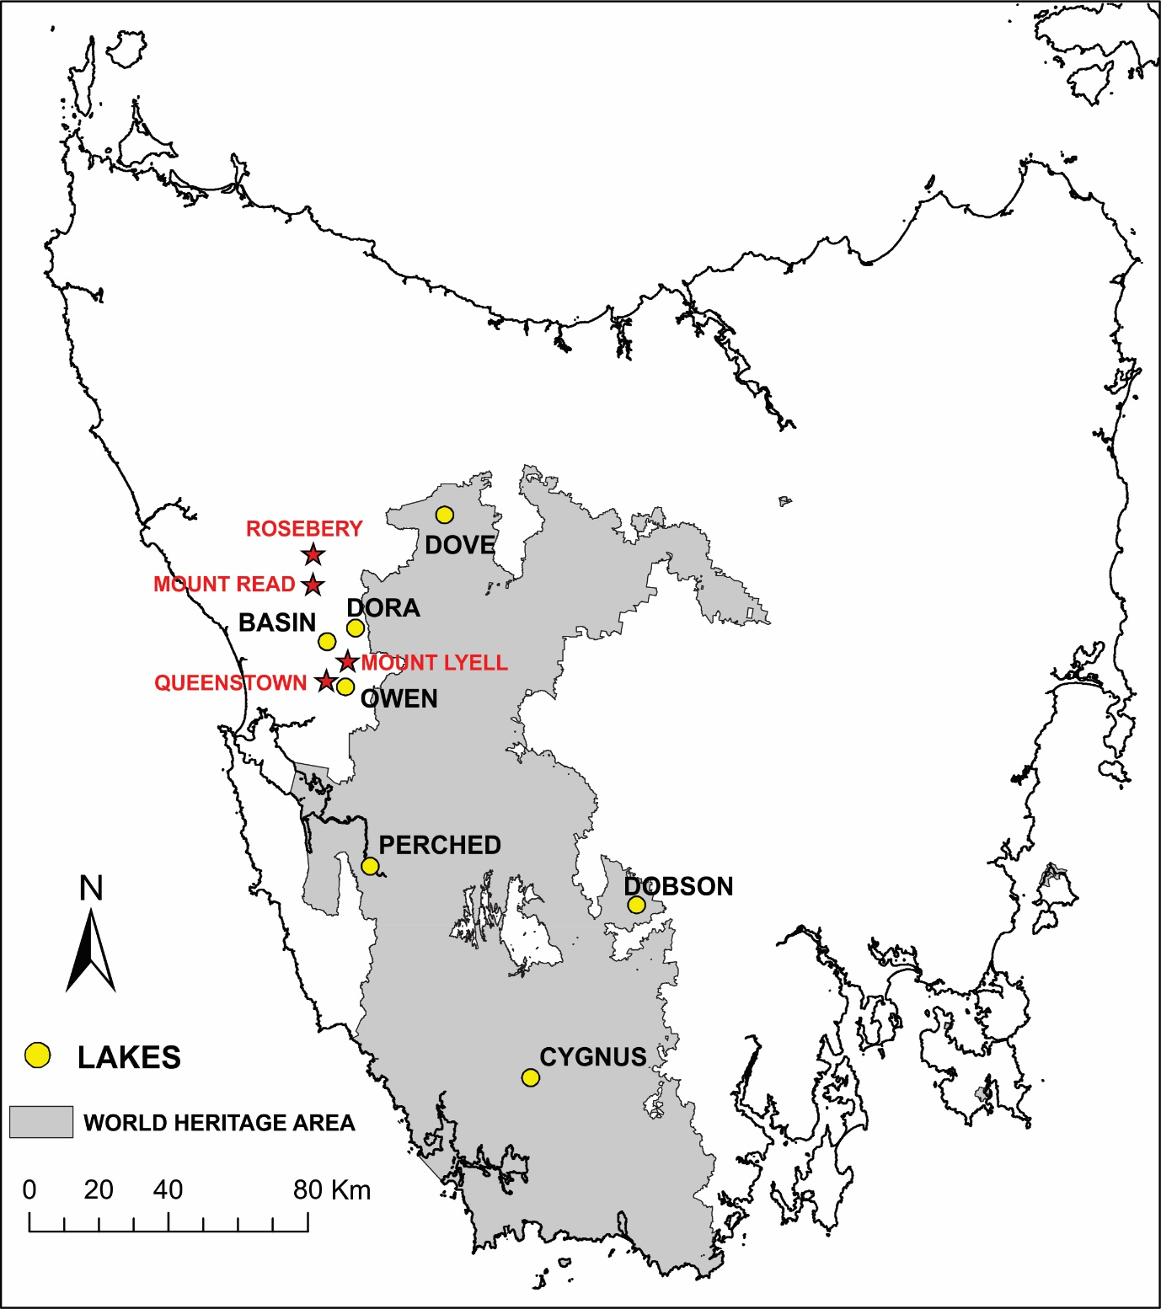

**Figure 1 – Map of Tasmania, Australia with the Tasmanian World Wilderness Heritage Area (TWWHA) in grey. The yellow circles indicate the six lakes where sediment cores were collected. The red stars indicate the three mining centres in the area: Queenstown, Mount Lyell and Rosebery**.

Mineral exploration commenced in the 1880s however, it wasn’t until the end of 1920s, with the advent of automation and changed work practices, that mining activities expanded from underground to open-cut. This was attributed to favourable copper prices and advances in transport (Rae, 1994).

The mining boom in Queenstown-Rosebery saw a downturn in the 1980s and activities were reduced to two mining companies: Copper Mines of Tasmania (CMT) in Queenstown which has been active for 100 years, and MMG Rosebery, active in Rosebery since 1936.

* 1. **Site selection and sediment collection**

Sites were chosen to provide an adequate spatial coverage to characterize the aerial transport of metals from mining sites and to document spatial differences in the deposition of metals within the TWWHA. Given the aim of assessing atmospheric transport of particles and metal deposition in lakes, we targeted lakes with small catchments to avoid major geochemical influence from the drainage basins (Figure 1). A total of six lakes were identified as suitable for these analyses. A 25m-resolution digital elevation model (DEM) was used to analyse lake catchment morphologies from where the catchment area for each lake was derived using the suite of Hydrology Tools (Arc Hydro) in ArcGIS 10.3 (ESRI, 2015). This approach allowed us to map flow direction and stream paths based on aspect and slope for each cell of the DEM. The catchment boundaries were delineated, and the surface was calculated using the same program.

Sediment collection were conducted in two periods:

Collection 1: sediment samples from Dove Lake, Lake Cygnus, Lake Dobson and Perched Lake were collected in 2000 using a gravity corer and hammer driven piston corer (Neale and Walker, 1996).

Collection 2: Sediment samples from Lake Basin and Owen Tarn were collected in 2011 and 2015 respectively again using a Universal Corer.

* 1. **Sediment dating**

Lead-210 (210Pb) samples were processed at the Australian Nuclear Science and Technology Organisation (ANSTO) using alpha spectrometry and following methods described by Harrison et al. (2003). The alpha spectrometry method was chosen. Each dried sediment sample (2g) was spiked with Polonium-209 (209Po) and Barium-133 (133Ba) tracers. Each sample was then leached with hot nitric and hydrochloric acids to release polonium and radium. Polonium was autoplated onto silver disks after adding the reducing agent hydroxylammonium chloride. Radium and barium were isolated by co-precipitation and collected as colloidal micro-precipitates of barium sulphate on fine membrane filter papers. The activities of 210Po on the silver disks and 226Ra on the membrane filters were determined by alpha spectrometry. Each membrane filter was also counted by gamma spectrometry to measure the 133Ba tracer activity. Chemical yield recoveries of 210Po and 226Ra were calculated using the recoveries of 209Po and 133Ba tracers, respectively. Unsupported 210Pb activity for each sample was calculated from the activity of 210Po (the proxy for total 210Pb) minus the 226Ra activity (the proxy for supported 210Pb).

The 210Pb dating models Constant Initial Concentration (CIC) (Pennington et al., 1976; Robbins and Edgington, 1975) and Constant Rate of Supply (CRS) (Appleby and Oldfield, 1978) were used to determine sediment ages and mass accumulation rates for sediment cores with dry bulk density data available. A modified CIC 210Pb dating model as described by Brugan (1978) was used to determine CIC ages and sedimentation rates for those sediment cores where dry bulk density data were not available.

* 1. **Geochemical analyses**

Samples from collection 1 (Lake Dove, Perched Lake, Lake Dobson and Lake Cygnus) were transported to the ANSTO and stored at 4º C before being oven dried at 40°C until they were a constant mass. Metal concentrations in sediments were measured by inductively coupled plasma mass spectrometer (ICP-MS) and inductively coupled plasma atomic emission spectrometer (ICP-AES). Approximately 0.5 g of oven dried sediment was weighed into a tetrafluormethaxil (TFM) closed digestion vessel (Ethos Milestone) and 3 mL sub-boiled nitric acid, 1 mL of sub-boiled hydrochloric acid, 0.1 mL of 50% w/v high purity hydrofluoric acid (Merck, Suprapur) and 3 mL of deonised water added. Each vessel was capped and placed in a Milestone MLS 1200 Mega microwave cavity, heated to 180°C for 25 mins, and then held at 180°C temperature for 15 mins before being cooled to room temperature and diluted with 30 mL of deonised water. One mL of the digest was transferred to an 8 mL centrifuge tube and 4 mL of ICP-MS internal standard added (6Li, 45Sc, 89Y, 103Rh, 115In, 185Re, and 209Bi). Mixed standard working solutions in the 500 to 0.001 μg/ml range and continuous calibration verification solutions were measured at the same time as samples. Internal standard and suppression solutions (In, Rh, Rb) were prepared and added to the sample via on-line addition.

Certified reference materials, National Research Council of Canada (NRCC) marine sediment SRMS MESS-3 and PACS-1 were also analysed and measured values were in agreement with certified values (Supplementary Table 1).

Sediment samples from collection 2 (Owen Tarn and Basin Lake) were freeze dried for 72 hours and homogenized by intensive manual mixing of sediments. Approximately 1 g of freeze-dried material was weighed into a 60 mL polytetrafluoroacetate (PFA) closed digestion vessel (Mars Express) and 2 mL of concentrated nitric acid (Aristar, BDH, Australia) and 1 mL of 30% concentrated hydrochloric acid (Merck Suprapur, Germany) added (Telford et al., 2008). Each PFA vessel was then capped, placed into an 800W microwave oven (CEM model MDS-81, Indian Trail, NC, USA), and samples heated at 120º C for 15 mins. The digests were cooled to room temperature and diluted to 50 mL with deionised water (Sartorius). The tubes were then centrifuged at 5000 rpm for 10 mins. One mL of the digest was transferred into a 10-mL centrifuge tube and then diluted to 10 mL with ICP-MS internal standard (Li6, Y19, Se45, Rh103, In116, Tb159 and Ho165). Digests were stored (0-5º C) until analysis. Samples were analysed using an ICP-MS (PerkinElmer DRC-e) with an AS-90 autosampler (Maher et al., 2001). The certified reference NIST- 2710 Montana Soil was used as controls to check the quality and traceability of metals. Measured concentrations were in agreement with certified values (Supplementary Table 1).

* 1. **The Hybrid Single Particle Lagrangian Integrated Trajectory Model (HYSPLIT)**

The wind trajectories from the sites were calculated using a map of the frequencies of HYSPLIT trajectories (Stein et al., 2015). A map with the average circulation of air masses over Tasmania during the period 1961-1990 for particles released at 42°S and 145.5°E (Queenstown, Tasmania) and 41.78°S and 145.5 °E (Rosebery, Tasmania) was created using ~1 million data points corresponding to the position of hourly-resolved HYSPLIT forward-trajectories, overlayed with 10 x 10 km grid cells. Hourly-resolved meteorological data for calculating the HYSPLIT trajectories were derived from NOAA ARL NCEP/NCAR Reanalysis FTP (ftp://arlftp.arlhq.noaa.gov/pub/archives/reanalysis). The number of occurrences per grid cell was extracted in ArcMap 10.3 and relative frequencies calculated. Red indicates grid cells with a higher occurrence of air masses travelling from Queenstown/Rosebery. A directional ellipse was derived using the ‘Directional Distribution: Standard Deviational Ellipse’ function in ArcMap 10.3. This tool creates an elliptical polygon centred on the mean for all features. The orientation of the ellipse indicates the average direction of flow during the chosen time window and spatial scale. One standard deviation was chosen to cover approximately 68% of all input feature centroids.

* 1. **Enrichment factor (EF)**

The calculation of normalized enrichment factor (EF) for metal concentrations above uncontaminated background levels enables an estimation of anthropogenic inputs of metals to sediments (Abrahim and Parker, 2007). The EF calculation seeks to reduce the variability of metal concentrations associated with fluctuations in mud/sand ratios and is a convenient tool for plotting geochemical trends across large geographic areas, which may have substantial variations in the mud sediment (i.e. clay rich) to sand ratios.

The EF method normalises the measured metal concentration with respect to a sample reference element such as iron (Fe) or aluminium (Al) (Cevik et al., 2009). In this approach the Fe or Al is considered to act as a “proxy” for the clay content. In this study, as Fe atmospheric deposition in lakes are known to have been altered by mining activities, we used Al as it was the element with least change through the profiles.

The EF was calculated using the average contamination for the years comprising the peak in mining contamination (1930 to 1980), following the equation:

EF = (*Mx*/*Alx*)/(*Mb*/*Alb*)

where *Mx* and *Alx* are the average metal and aluminium concentrations, respectively, for the mining period between 1930 to 1980. *Mb* and *Alb* are metal and aluminium background concentrations, respectively.

The lower metal concentrations in the bottom of the cores were interpreted as sediment deposited before the beginning of mining activities in 1880. From these results, natural background heavy metal values for the seven lakes was proposed based on the average of pre-mining trace element concentrations.

* 1. **Statistical analyses**

All analyses were performed with the R Statistical Software (R Development Core Team, 2008) and the respective libraries used in particular analysis are cited.

To reveal differences in the metal concentrations among lakes and mining phases, we conducted a permutational multivariate analysis of variance (PERMANOVA) based on Euclidean distances (adonis, vegan package 2.5-1 <https://cran.r-project.org/web/packages/vegan/index.html>) using the function vegdist to find the dissimilarities. Lakes and phases were included as fixed factors, and metal concentrations were given as a matrix from where vegan calculated pairwise distance to find the dissimilarities.

Principal Component Analysis (PCA) was used to explore the similarity of metal concentration in the lakes before and after mining activities in the region (dudi, ade4 package <https://cran.r-project.org/web/packages/ade4/index.html>). A multiple regression with backward-stepwise selection was performed to identify the main drivers of metal deposition in sediments of lakes within the TWWHA and the surrounding area. Metal concentrations were log transformed to comply with the assumptions of linearity, normality and homoscedasticity. Before running the multiple regression, predictor correlations were checked to avoid problems for parameter estimation and potentially leading to the wrong identification of relevant predictors of the statistical model (Dorman et al., 2013). The predictors tested were: catchment size, precipitation, atmospheric temperature, distance from the mining site and frequency of particles passing through the lakes, calculated from wind directions and speed in HYSPLIT trajectories (section 2.5). If a correlation was > 0.7, then one of the predictors was removed.

1. **Results and Discussion**
   1. **Sediment dating**

\210Pb dating results for sediments collected from the six lakes are shown in Supplementary Table 2. The CIC and CRS 210Pb dating model results were in close agreement in most lakes except for Lake Cygnus and Owen Tarn. The unsupported 210Pb activities from these cores exhibited non-monotonic profiles, thus the use of CRS age model was more appropriate. (Supplementary Table 2).

The largest variations in sedimentation rates for sediment cores closer to the mines were recorded in the 1930s (Supplementary Table 3). At this time, the open-cut mine commenced in the region and new technology such as stamper and mills arrived in the region. This change in mining methods and technology increased sedimentation rates in these lakes as a result of increased atmospheric inputs. Details on the historical changes in metal concentrations and sedimentation rates are discussed in a separate publication.

* 1. **Background metal concentrations and spatial distribution**

Patterns of metal deposition in sediments have changed dramatically since the start of mining activities (Table 1 and Supplementary Table 3). Sediment metal concentrations differed significantly between lakes (PERMANOVA: *F* model = 104.1; *r2*= 0.729; *P* < 0.001; 999 permutations) and between mining periods (PERMANOVA: *F* model = 9.5; *r2*= 0.153; *P* < 0.001; 999 permutations). PCA of metal concentrations (Figure 2 A-B) illustrates the changes in metal concentrations (Axis 1) and their dramatic change since mining activities commenced.

Metal concentrations pre-mining were in the order of: Lake Dove > Perched Lake > Basin Lake > Lake Dobson > Owen Tarn > Lake Cygnus. Metal concentrations since mining activities commenced are in the order of: Owen Tarn > Basin Lake > Perched Lake> Lake Dove > Lake Dobson > Lake Cygnus (Table 1, Supplementary Table 2). These results demonstrate that mining activities have caused a shift in the geochemical signals of sediments in the lakes, from signals reflecting the specific geology and lithology to an association with mining activities.

The PCA performed using metal concentrations measured in sediments dated from before and after the 1880s clearly indicates that the most proximal sites to the mining centres (Owen Tarn and Basin Lake) have the highest metal concentrations since mining. Lake Dove and Perched Lakes, with the highest background concentrations, decreased in the rank of metal concentrations since mining activities commenced (Figure 2 A-B).

The majority of effort in determining the impact of mining contamination on aquatic environments in western Tasmania has focussed on waterborne contamination down-stream from mines (Augustinus et al., 2010; Carpenter et al., 1991; Dawson, 1996; De Blas, 199a; Eriksen et al., 2001; McQuade et al., 1995; Stauber et al., 2000; Teasdale et al., 2003), with airborne contamination receiving comparatively little attention (Harle et al., 200b). Our study reveals that metal contamination can influence sites up to 130 km down-wind of mining sites, with Lake Cygnus in the TWWHA displaying clear evidence of contamination. These results confirm our HYSPLIT model and indicate that most of the TWWHA area has potential been impacted by airborne contamination from the Queenstown-Rosebery mines (Supplementary Figure 1). We thus urge a concerted effort to understand the environmental and ecological consequences of this contamination in the TWWHA.

**Table 1- Metal concentrations in lake sediments within the Tasmania Wilderness World Heritage Area. Metal concentrations are presented as mean concentrations per mining period.**



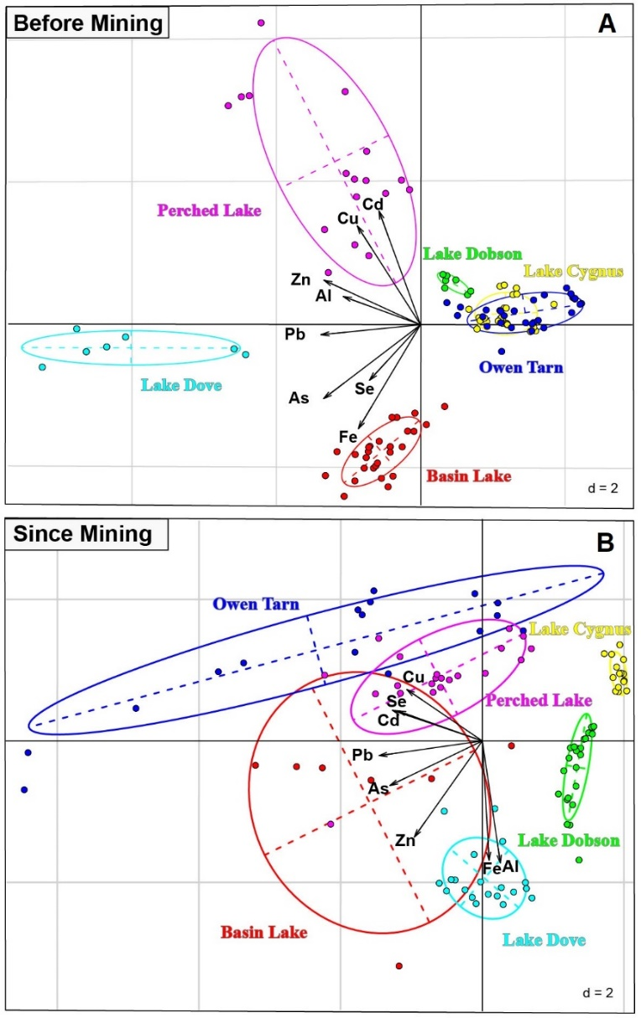

**Figure 2 – Principal Component Analyses of metal concentrations (Cu, Se, Cd, Pb, As, Zn, Fe and Al) in sediments of six lakes from the Tasmania Wilderness World Heritage Area and region (Australia) before and since mining activities commenced.**

* 1. **Drivers of metal spatial distribution**

Predictors of metal atmospheric distribution in the TWWHA are given in Table 2 and Supplementary Figures 1 and 2. Table 2 also summarises the main geographical and climatological information for each lake that were considered to be the main factors influencing metal distribution in lakes across the TWWHA.

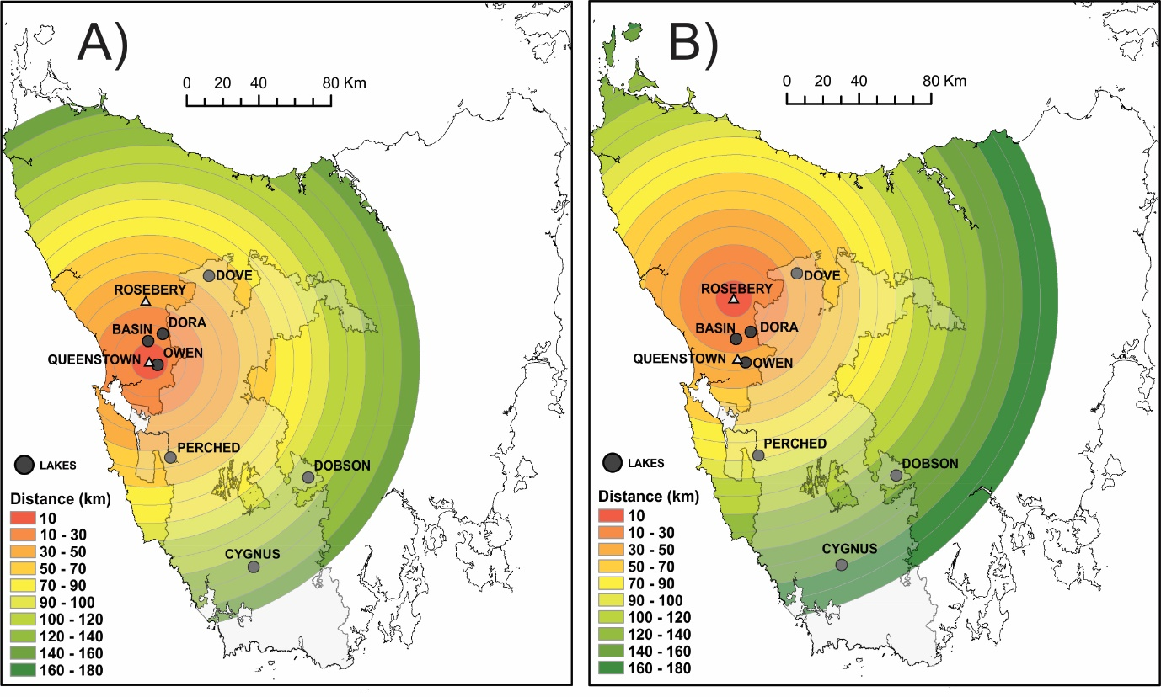

**Supplementary Figure 1 – Distance between lakes studied for metal contamination and (A) Queenstown mining site and (B) Rosebery mining site. Maps elaborated in ArcMap 10.3.**

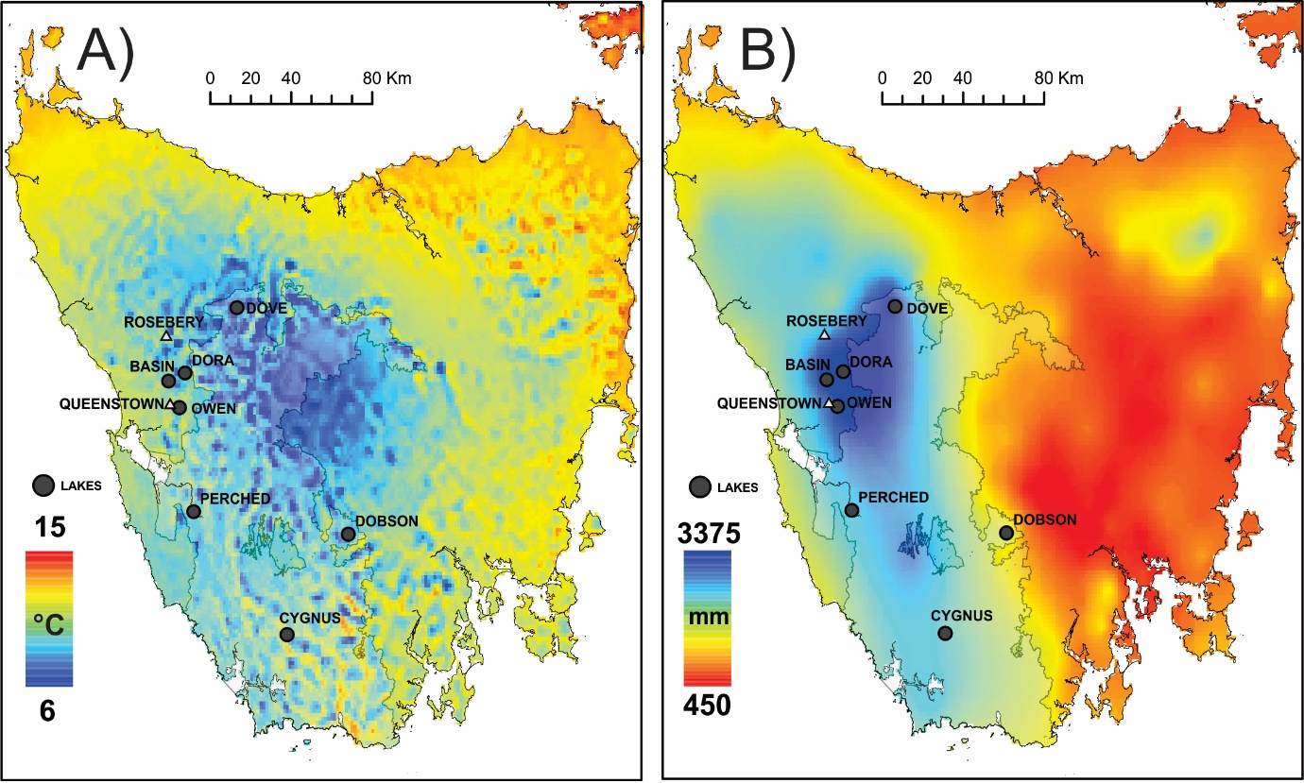

**Supplementary Figure 2 – (A) Atmospheric temperature and (B) Precipitation in the Tasmanian Wilderness World Heritage Area lakes (1961 – 1990). Data from Australian Bureau of Meteorology, maps elaborated in ArcMap 10.3.**

**Table 2: Tasmanian Wilderness World Heritage Area and surrounding lakes and their attributes: catchment size (km2), geographic coordinates, annual precipitation (mm), annual temperature (°C), and distance from the mining sites in both Queenstown and Rosebery.**



Predictors (Table 2) were checked for between-predictors correlations to select the predictors to run the statistical model. The factors distance, precipitation and frequency had a correlation > 0.7 and were, therefore, removed from the model and the HYSPLIT-derived frequency of particles was used. This decision was based on knowledge that the HYSPLIT frequency model takes into consideration environmental variables and distance in its calculation. The final list of predictors for the model was therefore: catchment size, temperature and frequency of the particles.

The HYSPLIT frequency of particles model (Figure 3) successfully explained most of the metal atmospheric transport and metal deposition into the lakes (Table 3). The significance of the HYSPLIT model on metal distribution indicates that this model provides an effective predictive tool of the spread of airborne pollutants in the landscape. The decline in metal concentration over distance is indicative of atmospheric dispersion of the particles, resulting from mining activity.

The high precipitation rate within the TWWHA area proposes that wet deposition is an important factor in metal deposition into the environment. Catchment size was a factor only significant for the major elements Fe, Al and Zn, indicating that metals deposited in these lakes were mainly a result of atmospheric metal deposition rather than catchment leaching (Table 3). Although lakes with small catchment areas were only considered in this study, deposition of major elements deposition in these lakes has been influenced by catchment leaching of major elements.

**Table 3 – Linear model results *(p* value and R2) for environmental factors influencing metal atmospheric transport and metal deposition in sediments of lakes in the Tasmania Wilderness World Heritage Area and region (Australia).**



A close up of a map

Description generated with high confidence

**Figure 3 –The Hybrid Single Particle Lagrangian Integrated Trajectory Model (HYSPLIT) back trajectories calculations demonstrating air parcel trajectories and directions of atmospheric particles and associated metals in the Tasmanian Wilderness World Heritage Area. This map represents the average circulation of air masses over Tasmania during the period 1961-1990 for particle released at 42°S and 145.5°E (Queenstown, Tasmania) and 41.78°S and 145.5 °E (Rosebery, Tasmania).**

* 1. **Enrichment Factors**

To evaluate the extent of the historical metal contamination affecting the TWWHA lake sediments, EFs were calculated for the period 1930-1980. Based on the EF values interpretation of EF < 1 = no enrichment, EF 1- 3 = minor enrichment, EF 3 - 5 = moderate enrichment, EF 5 - 10 = moderately severe enrichment, EF 10 - 25 = severe enrichment, EF 25 -50 = very severe enrichment, and EF > 50 = extremely severe enrichment (Cevik et al., 2009). All lakes had at least one of the metals with sediment concentrations showing moderate enrichment (EF > 3) since mining commenced in Tasmania (Table 3).

The EF values demonstrate significant metal contamination in the TWWHA. Mining contamination has reached distances as far as 130 km as demonstrated by the EF values > 1 for Lake Cygnus, the furthest lake from Queenstown and Rosebery in this study (Table 3, Supplementary Figure 1). The effect of metal contamination distribution in the entire TWWHA and surrounding area can be visualised in Figure 4, which demonstrates the significant increase of metal inputs since mining started.

The EF values demonstrate that, from the metals measured in this study, As, Cd, Cu, Pb and Zn are the elements of most concern in the region. Owen Tarn and Basin Lake had the most significant metal enrichment in sediments. In Owen Tarn, specifically, Cu and Pb were 90 times higher relative to the background values (Table 3). This is of major concern as Pb and Cd bioaccumulate in the bodies of aquatic and soil organisms (Cresswell et al., 2015; Lanctôt et al., 2017; Storelli, 2008; Zheng et al., 2007). Even small concentrations of these metals can affect body functions of aquatic organisms (Hodgson et al., 2000b).

The Pb and Cu EFs of 91 and 97.7, recorded in Owen Tarn are among the highest reported in the scientific literature. These results are comparable to highly contaminated places such as in the Kurang River in Pakistan, subjected to heavy metal contamination from urbanisation and discharge of untreated domestic effluents (EF Pb= 4.46, EF Cu = 12) (Zahra et al., 2014), the Shur River in Iran receiving inputs from copper mining ( EF Pb = 118.42, Cu = 264.1) (Karbassi et al., 2008), and the Lot River France receiving inputs from mining and smelting activities since the late 19th century (EF Pb = 10, EF Cu = 5) (Audry et al., 2004).

EFs for Cd and Pb in Basin Lake are also significantly higher, with values 25 times greater than background concentrations (indicating severe enrichment) (Table 3). The extreme high enrichment of these elements in the TWWHA and surrounding calls the attention of the government to investigate the effects of mining contamination in aquatic organisms in Western Tasmania, given 15,842 km2 is World Heritage Area.

**Table 3 - Enrichment factors of metals in sediments of six lakes in the Tasmanian Wilderness World Heritage Area.**



**Footnote: White = no enrichment, very light grey = minor enrichment, light grey = moderate enrichment, mid grey = moderately severe enrichment, dark grey = severe enrichment, very dark grey = very severe enrichment, and black = extremely severe enrichment.**



**A close up of a map

Description generated with high confidence**

**Figure 4 – Metal concentrations in lakes of the Tasmanian Wilderness World Heritage Area pre-mining and during mining peak.**

* 1. **Comparison of metal concentrations and ANZECC/ARMCANZ (2000) sediment quality guidelines**

The Australian and New Zealand interim sediment quality guidelines (ISQGs) (ANZECC/ARMCANZ, 2000) comprise two sediment guideline concentrations: (1) ISQG-Low concentrations and (2) ISQG-High concentrations.

ISQG-Low concentrations is used as a threshold limit to appeal for checks on possible adverse biological effects in aquatic organisms. The ISQG-High concentration is a threshold limit above which adverse biological effects are expected to occur frequently in aquatic organisms.

Table 1 shows the ratios of maximum concentration to sediment quality guideline values. These results show that Pb, Cu, As and Cd concentrations in all lakes are above the ANZECC/ARMCANZ ISQG-High threshold limit. Of concern are the Pb and As concentrations in Owen Tarn and Basin Lake, and Pb in Perched Lake sediments, which are above the ANZECC/ARMCANZ ISQG-High threshold limit.

The EF and sediment guidelines indicates that the northwest side of the TWWHA has been severely contaminated (Table 3 and 4), and most likely have generated biological adverse effects in aquatic organisms. This is of great concern considering that contamination in organisms takes place through bioaccumulation from sediment to plants (Schneider et al., 2015) and subsequent movement through trophic levels to animals and humans (Schneider et al., 2018). No study testing the health of aquatic organisms has been conducted in the area.

**Table 4 - Ratios of maximum concentration of sediments (average concentrations from 1930 to 1980) from lakes to ANZECC/ARMCANZ (2000) sediment quality guideline values. Metal concentrations highlighted in yellow indicate that the lakes metal concentrations are above guidelines values.**



Studies in other areas of West Tasmania (De Blas, 1994b; Humphrey et al., 1997; Keele, 2003; Rae, 2005) have shown metal concentrations in food web organisms above guidelines limits proposed by the World Health Organisation (WHO, 1993). In Owen Tarn, native diatom assemblages have been reported to have dramatically decreased while cosmopolitan species, indicative of lake dystrophic water and acidification have increased (Hodgson et al., 2000). It was also found that valve deformations in *Eunotia* species were a response to chemical stress (Hodgson et al., 2000). A study of metal bioaccumulation and toxicity of aquatic organisms within the TWWHA is highly recommended.

**3.6- Government Regulations and Inconsideration**

This study demonstrates the atmospheric extent of deposition of metals in the TWWHA from past mining activities. Metal contamination is likely to be causing adverse health effects to aquatic organisms and humans feeding on them. During Tasmania’s prosperous mining phase, mining companies were not subject to the same environmental regulations as the present day.

Tasmania implemented and integrated environment protection legislation in 1973, when the *Environment Protection Act 1973* (comprising air, water and noise pollution, and waste management) was put in place. Even though Tasmania was one of the first states to have environment protection legislation in place in Australia (Bingham, 1992), mining companies were allowed to operate under exemptions which were granted by the government of the day. The argument supporting exemptions was that the cost of installing equipment to comply with emission standards would be such that the mine would have to close (De Blas, 1994).

Had regulations been strictly followed, possibly the metal contamination in the TWWHA would be less severe and would have left a minor legacy of metal contamination. The high historical metal concentrations in lake sediments reported in this study leads to the question of how to and who should deal with the legacy of environmental problems arising from long running or discontinuing activities, which in earlier times had no environmental management protocols in place or lacked legal compliance to guidelines

1. **Conclusions**

This study demonstrates that historical metal concentrations in lake sediment can assist in interpreting the extent and severity of metal contamination in pristine areas. While independent studies and governmental reports have focused on the environmental effects of mining contamination in the King River and Macquarie Harbor, this study demonstrates that the atmospheric transport of metals has caused contamination to sites outside the mining catchment areas.

Atmospheric metal contaminates from mining activities in Queenstown-Rosebery in Tasmania have contaminated most of the TWWHA area and have significantly altered the natural geochemical signal of lakes. The precipitous increase in metal contamination from the 1930s, due to the start of open-cut mining and introduction of new technology, demonstrates the importance of considering historical records when interpreting metal contamination.

The HYSPLIT back trajectories particle model has been demonstrated to be a useful tool to track past metal contamination from airborne sources, explaining most of the metal atmospheric transport and metal deposition into the lakes of the TWWHA. Sediment EF values > 50 (classified as extremely severe enrichment) and metal concentrations above ISQG-High concentrations indicate that metal contamination might be posing health risks to aquatic organisms and humans feeding on them. Further investigation of metal bioaccumulation in ecosystems of the TWWHA are warranted starting in the northwest area where the metal contamination is highest.

This study is an illustration of historical contamination from mining activities that has left a legacy of metal contamination that needs to be addressed. Although mining activities have decreased significantly in the area, the metals deposited in the sediment are constantly remobilised by redox reactions, wind, catchment leaching and microorganism’s activities in the sediment. The environmental contamination in the TWWHA, therefore, is not a past issue and justifies current attention.

1. **References**

Abrahim, G.M.S., Parker, R.J., 2007. Assessment of heavy metal enrichment factors and the degree of contamination in marine sediments from Tamaki Estuary, Auckland, New Zealand. Environ. Monit. Assess. 136, 227–238. https://doi.org/10.1007/s10661-007-9678-2

Appleby, P.G., Oldfield, F., 1978. The calculation of lead-210 dates assuming a constant rate of supply of unsupported 210Pb to the sediment. CATENA 5, 1–8. https://doi.org/10.1016/S0341-8162(78)80002-2

Audry, S., Schäfer, J., Blanc, G., Jouanneau, J.-M., 2004. Fifty-year sedimentary record of heavy metal pollution (Cd, Zn, Cu, Pb) in the Lot River reservoirs (France). Environ. Pollut. 132, 413–426. https://doi.org/10.1016/j.envpol.2004.05.025

Augustinus, P., Barton, C.E., Zawadzki, A., Harle, K., 2010. Lithological and geochemical record of mining-induced changes in sediments from Macquarie Harbour, southwest Tasmania, Australia. Environ. Earth Sci. 61, 625–639. https://doi.org/10.1007/s12665-009-0377-x

Bingham, R., 1992. The Environment Protection Act. Geological Survey Bulletin 70, 20–23.

Brugam, R.B., 1978. Pollen indicators of land-use change in southern Connecticut. Quat. Res. 9, 349–362. https://doi.org/10.1016/0033-5894(78)90038-8

Carpenter, P.D., Butler, E.C.V., Higgins, H.W., Mackey, D.J., Nichols, P.D., 1991. Chemistry of trace elements, humic substances and sedimentary organic matter in Macquarie Harbour, Tasmania. Mar. Freshw. Res. 42, 625–654. https://doi.org/10.1071/mf9910625

Cevik, F., Goksu, M.Z.L., Derici, O.B., Findik, O., 2009. An assessment of metal pollution in surface sediments of Seyhan dam by using enrichment factor, geoaccumulation index and statistical analyses. Environ. Monit. Assess. 152, 309–317. https://doi.org/10.1007/s10661-008-0317-3

Corbett, K.D., Solomon, M., 1989. Cambrian Mt Read Volcanics and associated mineral deposits, in: Burrett, C.F., Martin, E.L. (Eds.), Geology and Mineral Resources of Tasmania, Special Publication. Geologial Society of Australia, Hobart, Tasmania, pp. 84–153.

Cresswell, T., Simpson, S.L., Mazumder, D., Callaghan, P.D., Nguyen, A.P., 2015. Bioaccumulation Kinetics and Organ Distribution of Cadmium and Zinc in the Freshwater Decapod Crustacean Macrobrachium australiense [WWW Document]. https://doi.org/10.1021/es505254w

Dawson, R.S., 1996. Natural colonisation and rehabilitation of a copper smelter desert, Mount Lyell, western Tasmania(Doctoral dissertation, University of Tasmania). (PhD Thesis). Hobart, Tasmania. Australia.

De Blas, A., 1994. The Environmental Effects of Mount Lyell Operations on Macquarie Harbour and Strahan (Honors Thesis). University of Technology Sydney, Sydney, NSW. Australia.

Dorman, C.F., Elith Jane, Bacher Sven, Buchmann Carsten, Carl Gudrun, Carré Gabriel, Marquéz Jaime R. García, Gruber Bernd, Lafourcade Bruno, Leitão Pedro J., Münkemüller Tamara, McClean Colin, Osborne Patrick E., Reineking Björn, Schröder Boris, Skidmore Andrew K., Zurell Damaris, Lautenbach Sven, 2013. Collinearity: a review of methods to deal with it and a simulation study evaluating their performance. Ecography 36, 27–46. https://doi.org/10.1111/j.1600-0587.2012.07348.x

Eriksen, R.S., Mackey, D.J., van Dam, R., Nowak, B., 2001. Copper speciation and toxicity in Macquarie Harbour, Tasmania: an investigation using a copper ion selective electrode. Mar. Chem. 74, 99–113. https://doi.org/10.1016/S0304-4203(00)00117-1

Fang, G.-C., Wu, Y.-S., Huang, S.-H., Rau, J.-Y., 2005. Review of atmospheric metallic elements in Asia during 2000–2004. Atmos. Environ. 39, 3003–3013. https://doi.org/10.1016/j.atmosenv.2005.01.042

Gentilli, Joseph, Gentilli, Joseph, Gentilli, J, 1972. Australian climate patterns. Melbourne : Thomas Nelson (Australia).

Harle, K.J., Britton, K., Heijnis, H., Zawadzki, A., Jenkinson, A.V., 2002. Mud, mines and rainforest: a short history of human impact in western Tasmania, using pollen, trace metals and lead-210. Aust. J. Bot. 50, 481–497. https://doi.org/10.1071/bt01028

Harrison, J., Heijnis, H., Caprarelli, G., 2003. Historical pollution variability from abandoned mine sites, Greater Blue Mountains World Heritage Area, New South Wales, Australia. Environ. Geol. 43, 680–687. https://doi.org/10.1007/s00254-002-0687-8

Hodgson, D.A., Vyverman, W., Chepstow-Lusty, A., Tyler, P.A., 2000. From rainforest to wasteland in 100 years: The limnological legacy of the Queenstown mines, Western Tasmania. Arch. Für Hydrobiol. 153–176. https://doi.org/10.1127/archiv-hydrobiol/149/2000/153

Humphrey, C., Shelley, J.M.G., Klessa, D., 1997. Mount Lyell Remediation: Evaluation of rehabilitation options for Mount Lyell using whole-effluent toxicological tests on freshwater organisms. Tasmania Department of Environment and Land Management and Supervising Scientist, Canberra, ACT. Australia.

Karbassi, A.R., Monavari, S.M., Nabi Bidhendi, G.R., Nouri, J., Nematpour, K., 2008. Metal pollution assessment of sediment and water in the Shur River. Environ. Monit. Assess. 147, 107–116. https://doi.org/10.1007/s10661-007-0102-8

Keele, S., 2003. Lunar landscapes and suphurous smogs: An environmental history of human impacts on the Queenstown region in western Tasmania c.1890-2003. University of Melbourne, Melbourne, VIC, Australia.

Kozlov, M.V., Zvereva, E.L., 2006. Industrial barrens: extreme habitats created by non-ferrous metallurgy, in: Life in Extreme Environments. Springer, Dordrecht, pp. 69–97. https://doi.org/10.1007/978-1-4020-6285-8_5

Kusumaningtyas, S.D.A., Aldrian, E., 2016. Impact of the June 2013 Riau province Sumatera smoke haze event on regional air pollution. Environ. Res. Lett. 11, 075007. https://doi.org/10.1088/1748-9326/11/7/075007

Lanctôt, C.M., Cresswell, T., Melvin, S.D., 2017. Uptake and tissue distributions of cadmium, selenium and zinc in striped marsh frog tadpoles exposed during early post-embryonic development. Ecotoxicol. Environ. Saf. 144, 291–299. https://doi.org/10.1016/j.ecoenv.2017.06.047

Langford, J., 1965. Weather and Climate, in: Davies, J. (Ed.), Atlas of Tasmania. Lands and Surveys Department, Hobart, Tasmania. Australia, p. 128.

Maher, W., Forster, S., Krikowa, F., Snitch, P., Chapple, G., Craig, P., 2001. Measurement of trace elements and phosphorus in marine animal and plant tissues by low-volume microwave digestion and ICP-MS. At. Spectrosc. 22, 361–370.

Mariani, M., Connor, S.E., Fletcher, M.-S., Theuerkauf, M., Kuneš, P., Jacobsen, G., Saunders, K.M., Zawadzki, A., 2017. How old is the Tasmanian cultural landscape? A test of landscape openness using quantitative land-cover reconstructions. J. Biogeogr. 44, 2410–2420. https://doi.org/10.1111/jbi.13040

McQuade, C.V., Johnston, J., Innes, S., 1995. Review of historical literature and data on the sources and quality of effluent from the Mount Lyell lease site. (No. 104), Mount Lyell Remediation Research and Demonstration Program. Comonwealth Department of Environment, Canberra, ACT. Australia.

Neale, J.L., Walker, D., 1996. Sampling sediment under warm deep water. Quat. Sci. Rev. 15, 581–590. https://doi.org/10.1016/0277-3791(96)00010-8

NOAA, 2018. Air Resources Laboratory - HYSPLIT - Hybrid Single Particle Lagrangian Integrated Trajectory model [WWW Document]. URL https://ready.arl.noaa.gov/HYSPLIT.php (accessed 4.27.18).

Pacyna, J.M., Pacyna, E.G., Aas, W., 2009. Changes of emissions and atmospheric deposition of mercury, lead, and cadmium. Atmos. Environ., Atmospheric Environment - Fifty Years of Endeavour 43, 117–127. https://doi.org/10.1016/j.atmosenv.2008.09.066

Pennington, W., Cambray, R.S., Eakins, J.D., Harkness, D.D., 1976. Radionuclide dating of the recent sediments of Blelham Tarn. Freshw. Biol. 6, 317–331. https://doi.org/10.1111/j.1365-2427.1976.tb01617.x

R Development Core Team, 2008. R Development Core Team (2017). R: A language and environment for statistical computing. R Foundation for Statistical Computing, Vienna, Austria. ISBN 3-900051-07-0, URL http://www.R-project.org.

Rae, L., 2005. The lost province : exploration, isolation, innovation and domination in the Mount Lyell Region 1859-1935 (PhD Thesis). University of Tasmania, Hobart, Tasmania. Australia.

Rae, L., 1994. A window on Rosebery: a pictorial review of the 100 years in and around the environs of Rosebery on Tasmania’s rugged West Coast, 1893-1993. Lou Rae, Ulverstone, Tasmania.

Robbins, J.A., Edgington, D.N., 1975. Determination of recent sedimentation rates in Lake Michigan using Pb-210 and Cs-137. Geochim. Cosmochim. Acta 39, 285–304. <https://doi.org/10.1016/0016-7037(75)90198-2>

Schneider, L., Maher, W.A., Potts, J., Taylor, A.M., Batley, G.E., Krikowa, F., Chariton, A.A., Gruber, B. 2015. Modeling food web structure and selenium biomagnification in lake macquarie, New South Wales, Australia, using stable carbon and nitrogen isotopes. Environmental Toxicology and Chemistry 3: 608–617.

Schneider, L., Maher, W.A., Potts, J., Taylor, A.M., Batley, G.E., Krikowa, F., Adamack, A., Chariton, A.A., Gruber, B. 2018. Trophic transfer of metals in a seagrass food web: bioaccumulation of essential and non-essential metals. Marine Pollution Bulletin, 131, 468-480. DOI: 10.1016/j.marpolbul.2018.04.046

Stauber, J.L., Benning, R.J., Hales, L.T., Eriksen, R., Nowak, B., 2000. Copper bioavailability and amelioration of toxicity in Macquarie Harbour, Tasmania, Australia. Mar. Freshw. Res. 51, 1. https://doi.org/10.1071/MF99010

Storelli, M.M., 2008. Potential human health risks from metals (Hg, Cd, and Pb) and polychlorinated biphenyls (PCBs) via seafood consumption: Estimation of target hazard quotients (THQs) and toxic equivalents (TEQs). Food Chem. Toxicol. 46, 2782–2788. https://doi.org/10.1016/j.fct.2008.05.011

Sturman, A., Tapper, N., 2006. The weather and climate of Australia and New Zealand, 2nd ed. Oxford University Press, New York, NY. USA.

Suvarapu, L.N., Baek, S.-O., 2017. Determination of heavy metals in the ambient atmosphere: A review. Toxicol. Ind. Health 33, 79–96. https://doi.org/10.1177/0748233716654827

Teasdale, P.R., Apte, S.C., Ford, P.W., Batley, G.E., Koehnken, L., 2003. Geochemical cycling and speciation of copper in waters and sediments of Macquarie Harbour, Western Tasmania. Estuar. Coast. Shelf Sci. 57, 475–487. https://doi.org/10.1016/S0272-7714(02)00381-5

WHL, 2018. UNESCO World Heritage Centre, World Heritage List.

WHO, 1993. World Health Organisation (WHO). Evaluation of certain food additives and contaminants. (No. 837). World Health Organization, Geneva.

Zahra, A., Hashmi, M.Z., Malik, R.N., Ahmed, Z., 2014. Enrichment and geo-accumulation of heavy metals and risk assessment of sediments of the Kurang Nallah—Feeding tributary of the Rawal Lake Reservoir, Pakistan. Sci. Total Environ. 470–471, 925–933. https://doi.org/10.1016/j.scitotenv.2013.10.017

Zheng, N., Wang, Q., Zheng, D., 2007. Health risk of Hg, Pb, Cd, Zn, and Cu to the inhabitants around Huludao Zinc Plant in China via consumption of vegetables. Sci. Total Environ. 383, 81–89. https://doi.org/10.1016/j.scitotenv.2007.05.002