Controlled functionalization of molecular vanadium oxides using a supramolecular exchange strategy
Katharina Kastner†, Johannes Forster†, Hiromichi Ida‡, Graham N. Newton‡, Hiroki Oshio‡ and Carsten Streb†*.
† Institute of Inorganic Chemistry I, Ulm University, Albert-Einstein-Allee 11, 89081 Ulm, Germany.
‡ Graduate School of Pure and Applied Sciences, University of Tsukuba, Tennodai 1-1-1, Tsukuba 305-8571, Japan.

Supporting Information Placeholder
ABSTRACT: The controlled assembly and functionalization of molecular metal oxide clusters is notoriously difficult. A new approach has been developed which allows the controlled and predetermined functionalization of vanadium oxide clusters with a range of metal centers, giving access to materials with high inherent redox-, catalytic and magnetic activity. Organic, hydrogen-bonding cations, e.g. dimethyl ammonium are used as molecular placeholders to block metal binding sites within vanadate cluster shells. Stepwise, selective replacement of the placeholder cations with metal cations gives the mono- and di-functionalized clusters. Here, the principle is used to access manganese-functionalized vanadates as C-H activation catalysts. The synthetic concept introduces fundamentally new approaches for the controlled bottom-up design of molecular metal oxides for catalysis, energy conversion and supramolecular nanostructures.
In supramolecular chemistry, the precise and predictable synthesis of a target compound is difficult to achieve as complex self-assembly mechanisms often do not allow a high degree of reaction control.¹ In inorganic supramolecular chemistry, this is particularly obvious in the field of molecular metal oxides, or polyoxometalates (POMs). POMs are anionic transition metal oxo clusters formed by the spontaneous self-assembly of simple oxometalate precursors.² In POM chemistry, variation of the reaction conditions is used to access a vast number of different cluster architectures.^{2,3} However, this synthetic approach inherently lacks the precise control required for predetermined cluster assembly, and often the resulting architectures cannot be predicted. This level of control, however, is required for the targeted synthesis of materials with specific structure and chemical reactivity.⁴
One notable exception where this approach has been realized in POM chemistry are Keggin-based lacunary clusters: these species are obtained by controlled hydrolysis of the parent anion, e.g. the Keggin anion [SiW₁₂O₄₀]⁴⁻ or the Dawson anion [P₂W₁₈O₆₂]⁶⁻. In case of the Keggin anion, lacunary clusters such as the monovacant [SiW₁₁O₃₉]⁸⁻ or the divacant [SiW₁₀O₃₄]⁸⁻ are formed^{2c} which feature one or several vacant coordination sites. These binding sites can be functionalized with metal cations, giving species such as [M(H₂O)SiW₁₁O₃₉]^{n-} and [{M(H₂O)}₂SiW₁₀O₃₈]^{n-} (M – metal cation).^{2c,5} Using this approach, functional molecular materials for energy conversion,⁶ (photo-)catalysis,⁷ molecular magnetism,⁸ supramolecular chemistry⁹ and materials science¹⁰ have been developed. However, to-date, this approach is limited to tungstate-^{2c, 3b} and molybdate-based¹¹ lacunary clusters, and no analogous strategy exists in vanadium oxide chemistry.¹²
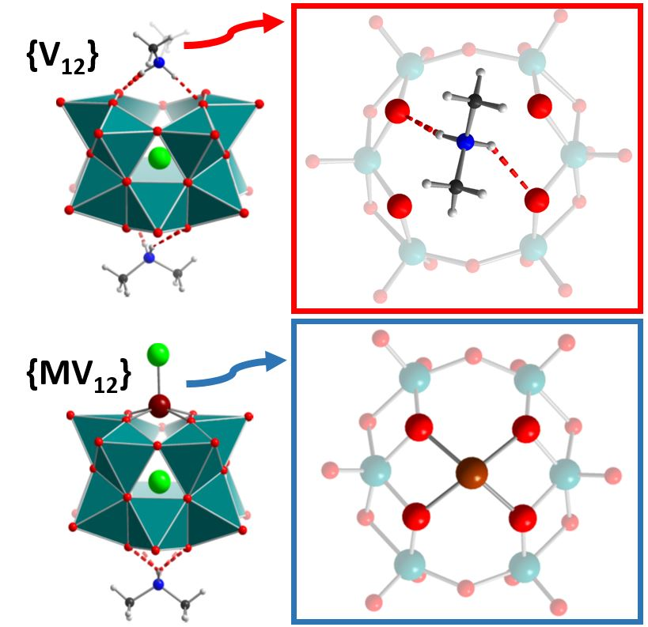
Figure 1. Top: the non-functionalized {V₁₂} featuring two DMA placeholder cations (left) and detailed illustration of the DMA-blocked binding site (right). Bottom: the mono- functionalized {MV₁₂} (here: M = Zn²⁺)¹³ and detailed illustration of the metal coordination mode highlighting the four equatorial oxo ligands (the terminal chloro ligand has been removed for clarity). Color scheme: V: teal; Cl: light green; Zn: brown; O: red, N: blue; C: grey; H: white.
We have recently taken the first steps towards controlled metal functionalization in vanadium oxide cluster chemistry: a chloride-templated dodecavanadate cluster, (DMA)₂[V₁₂O₃₂Cl]³⁻ (= {V₁₂}; DMA = dimethyl ammonium) was developed which is capable of selective metal ion binding. {V₁₂} features two hexagonal metal binding sites which are blocked by hydrogen-bonded DMA placeholder cations (Fig. 1).¹³ Reaction of {V₁₂} with transition metals allows the selective replacement of one DMA cation, giving the mono-functionalized cluster anions [M(L)V₁₂O₃₂Cl]^{n-} (= {MV₁₂}, M = Fe^{III}, Co^{II}, Cu^{II} and Zn^{II}; L = ligand, e.g. MeCN, Cl⁻), see Fig. 1. Density-functional theory calculations suggested that the second DMA cation can in principle be replaced also.¹³
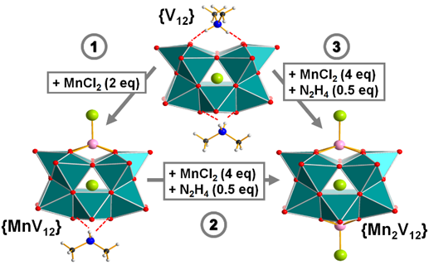
Figure 2. Top: controlled mono- and di-functionalization of {V₁₂} using stepwise ((1) and (2)) or direct (3) metal incorporation: (1) Mono-functionalization of {V₁₂} with Mn^{II} giving {MnV₁₂}. (2) Di-functionalization by reaction of {MnV₁₂} with Mn^{II}, giving {Mn₂V₁₂}. (3) Direct di-functionalization of {V₁₂} giving {Mn₂V₁₂} in a one-pot reaction. Color scheme: see Fig. 1. Bottom: overlay of the metal oxide frameworks of {V₁₂} (red), {MnV₁₂} (green) and {Mn₂V₁₂} (blue), highlighting the significant distortions observed upon metal binding.
Here, we give the first example of the versatility of this synthetic concept and show that {V₁₂} can be used as a molecular platform for the stepwise functionalization with reactive metal centers. To this end, the DMA-placeholder-blocked {V₁₂} was reacted with MnCl₂ x 4 H₂O in acetonitrile solution at room temperature. Crystallization of the mother liquor gave green block crystals and single-crystal X-ray diffraction (SC-XRD)† confirmed the formation of the mono-manganese-functionalized species (nBu₄N)₃(DMA)[(MnCl)V₁₂O₃₂Cl] x EtOAc (= (nBu₄N)₃{MnV₁₂} x EtOAc) in yields of ca. 39 %, see Fig. 2). {MnV₁₂} is virtually isostructural to the mono-functionalized {MV₁₂} species described above¹³ and also features one hydrogen-bonded DMA placeholder cation. The Mn^{II} ion is coordinated to the metal binding site by four V-O-Mn coordination bonds and long-range electrostatic interactions between the manganese and the chloride template (d(Mn…Cl) ca. 3.2-3.4 Å) are observed; the Mn coordination environment is completed by a terminal chloro ligand. Bond valence sum (BVS) calculations gave the expected oxidation states (V^{V}, Mn^{II}); no protonation of the cluster shell was found.
In the next step, we investigated whether {MnV₁₂} can be functionalized further by a second Mn^{II} center. Initial studies had suggested that the di-manganese-functionalized cluster is formed as a minor product in solution (based on ESI-mass spectrometry); however, no crystalline product was obtained. It was hypothesized that the product yield might be increased by reduction of the vanadate shell, as this should improve the electrostatic interactions between the cluster anion and the Mn^{II} cation. The viability of this reductive synthetic approach was further substantiated by electrochemical studies which had shown that {V₁₂} can be reversibly reduced by one electron (not shown).
To this end, {MnV₁₂} was reacted with MnCl₂ x 4 H₂O (4 eq.) in acetonitrile solution in the presence of the reducing agent N₂H₄ x H₂O (0.5 eq.). Diffusion of ethyl acetate into the reaction solution gave one crystalline product and SC-XRD showed that the di-functionalized species (nBu₄N)₄[(MnCl)₂V₁₂O₃₂Cl] (= {Mn₂V₁₂}) was obtained (yield ca. 40 %).† Structural analysis shows two Mn^{II} centers coordinated to the metal binding sites; their mode of coordination is virtually identical to the binding mode described above for the mono-functionalized {MnV₁₂}. Structural overlay of the metal oxide framework of {V₁₂}, {MnV₁₂} and {Mn₂V₁₂} showed that upon coordination of the Mn^{II} ions, significant changes in the vanadium oxide framework geometry are observed (Fig. 2); these were quantified by drastic changes of the O…O…O angles in the vicinity of the binding sites (see SI) and highlight the structural flexibility of the vanadate cluster shell. These data suggest that incorporation of larger cations (e.g. f-block metal cations) should be possible.
Charge balance considerations and BVS calculations indicate the presence of one delocalized V^{IV} center in {Mn₂V₁₂}; charge delocalization is not unexpected as all V centers are in identical square pyramidal [VO₅] coordination environments.¹⁴ This was further substantiated by the observation of inter-valence charge-transfer (IVCT) transitions between ʎ ca. 800-1600 nm (see SI). SQUID magnetometry confirmed the presence of one reduced V^{IV} center in {Mn₂V₁₂} and gave χ_{m}T values (at 300 K) of 9.16 emu mol⁻¹ K for {Mn₂V₁₂} and 4.4 emu mol⁻¹ K for {MnV₁₂}; the results are in line with the expected spin-only values (see SI).^{15,16} Electrochemical analyses show that both Mn-functionalized clusters feature enhanced redox-activity compared with {V₁₂}; cyclic voltammetry of {MnV₁₂} shows three quasi-reversible redox-processes while {Mn₂V₁₂} features six quasi-reversible redox-couples (see SI).
The synthetic concept was further expanded and allowed us to show that the direct di-functionalization of {V₁₂} in a one-pot reaction is also possible (Fig. 2): to this end, {V₁₂} was reacted with MnCl₂ x 4 H₂O (4 eq.) and N₂H₄ x H₂O (0.5 eq.) in acetonitrile at room temperature. Diffusion crystallization of the reaction mixture gave single crystals of {Mn₂V₁₂} in yields of ca. 49 %; product purity was confirmed by SC-XRD, EA, ICP-MS, ESI-MS, FT-IR and UV-Vis. In particular, ESI-mass spectrometry showed that both {MnV₁₂} and {Mn₂V₁₂} are stable in solution and can be transferred into the gas phase without de-metalation of the manganese ions from the cluster shell, see SI.
Based on their (electro-) chemical properties, the clusters were considered promising candidates for oxidative C-H-activation catalysis.¹⁷ Initial catalytic tests used acetonitrile solutions of the respective cluster anion (1 mol-%), the substrate 9,10-dihydroanthracene and the oxidant tBuOOH (12eq.); the reagents were combined and the reaction progress was followed using UV-Vis-spectroscopy. Both manganese-functionalized vanadates showed C-H activation reactivity and the formation of the product anthracene was observed. In detail, moderately higher zeroth order rate constants were observed for the di-functionalized species (k_{obs}({Mn₂V₁₂})= 1.2 μM h⁻¹) compared with the mono-functionalized cluster (k_{obs}({MnV₁₂}) = 1.0 µM h⁻¹). In contrast, the non-functionalized {V₁₂} showed no catalytic activity, see Fig. 3. Cluster stability under catalytic conditions was confirmed spectroscopically, see SI. The results demonstrate that metal functionalization of {V₁₂} gives access to homogeneous C-H-activation catalysts based on earth abundant materials. Detailed mechanistic studies will explore the reason for the comparable rates observed for the mono- vs di-functionalized species.
Figure 3. C-H-activation catalysis by {MnV₁₂} and {Mn₂V₁₂} illustrating the oxidation of 9,10-dihydroanthracene to anthracene in the presence of the catalyst {MnV₁₂} or {Mn₂V₁₂} (1 mol-%) and the oxidant tBuOOH (12 eq) in acetonitrile. The observed zeroth order rate constants are k_{obs},({MnV₁₂} = 1.0 μM h⁻¹ and k_{obs},({Mn₂V₁₂} = 1.2 μM h⁻¹.
In summary, we present a novel synthetic strategy which allows the stepwise functionalization of vanadium oxide clusters by incorporation of reactive metal centers. The concept gives access to a family of redox-, magnetically and catalytically active, stable functionalized molecular metal oxides. In addition, stepwise as well as direct mono- and difunctionalization are possible, making this route extremely versatile. Structural and theoretical analyses as well as preliminary experimental studies show that the binding sites should also be able to accommodate larger s-, p-, d- and f-block metal cations. In future work, the synthetic concept will be expanded to design new binding site geometries using the concepts of templated bottom-up self-assembly and supramolecular binding site blockage.
ASSOCIATED CONTENT
Supporting Information
Experimental, analytical, crystallographic and catalytic data are provided. This material is available free of charge via the Internet at http://pubs.acs.org.
AUTHOR INFORMATION
Corresponding Author
carsten.streb@uni-ulm-de.
Notes
The authors declare no competing financial interests.
†Crystallographic details: Crystallographic data and structure refinement for {MnV₁₂}: Triclinic space group, P-1, a = 19.826(4), b = 20.867(4), c = 23.792(5) Å, α = 73.94(3), β = 73.59(3), γ = 88.77(3) V = 9056 (4) Å³, Z = 4, ρ = 1.436 g cm^{–3}, μ(MoK_{α}) = 1.438 mm^{–1}, T = 150(2) K, 177676 reflections measured, 36924 unique (R_{int} = 0.0502), 2076 refined parameters, R₁ = 0.0581, wR₂ = 0.1984, GooF = 1.151. Crystallographic data and structure refinement for {Mn₂V₁₂}: Monoclinic space group, P2₁/c, a = 24.324(5), b = 16.727(3), c = 24.438(5) Å, β = 94.71(3), V = 9909(3) Å³, Z = 4, ρ = 1.535 g cm^{–3}, μ(MoK_{α}) = 1.470 mm^{–1}, T = 150(2) K, 161699 reflections measured, 20263 unique (R_{int} = 0.0796), 1134 refined parameters, R₁ = 0.0571, wR₂ = 0.1408, GooF = 1.088. The supplementary crystallographic data for {MnV₁₂} (CSD 1038467) and {Mn₂V₁₂} (CSD 1038466) can be obtained from the Cambridge Crystallographic Data Centre CCDC.
ACKNOWLEDGMENT
This work was supported through the Fonds der Chemischen Industrie (C.S.) and a doctoral fellowship by the Deutsche Bundesstiftung Umwelt (K.K.). Financial support by Deutsche Forschungsgemeinschaft DFG (grant no: STR1164/4-1), DFG Graduate School GRK 1621 “Chemical Photocatalysis” (Regensburg University), Friedrich-Alexander-University Erlangen-Nuremberg and Ulm University are gratefully acknowledged for financial support. M. Dürr and Prof. Dr. I. Ivanovic-Burmazovic are acknowledged for ESI-MS measurements.
REFERENCES
(1) (a) Lehn, J. M. Angew. Chem. Int. Ed. Engl., 1990, 29, 1304. (b) Whitesides, G. M.; Mathias, J. P.; Seto, C. T. Science, 1991, 254, 1312. (c) Philp, D.; Stoddart, J. F. Angew. Chem. Int. Ed., 1996, 35, 1155. (d) Whitesides, G. M.; Grzybowski, B. Science, 2002, 295, 2418. (e) Saalfrank, R. W.; Maid, H.; Scheurer, A. Angew. Chem. Int. Ed., 2008, 47, 8794. (f) Holliday, B. J.; Mirkin, C. A. Angew. Chem. Int. Ed., 2001, 40, 2022. (g) Müller, A.; Roy, S. Coord. Chem. Rev., 2003, 245, 153.
(2) (a) special POM issue: Hill, C. L. (guest ed.) Chem. Rev. 1998, 98, 1-300. (b) POM-themed issue: Cronin, L.; Müller, A. (guest eds.) Chem. Soc. Rev., 2012, 41, 7325. (c) Pope, M. T. Heteropoly and isopoly oxometalates, Springer-Verlag Berlin, 1983.
(3) (a) Long, D. L.;. Tsunashima R.; Cronin L. Angew. Chem. Int. Ed., 2010, 49, 1736. (b) Pope, M. T.; Müller, A. Angew. Chem. Int. Ed. Engl., 1991, 30, 34. (c) POM-themed issue: Kortz, U.; Liu, T. (guest eds.) Eur. J. Inorg. Chem., 2013, 2013, 1556.
(4) Cronin, L.; Müller, A. Chem. Soc. Rev., 2012, 41, 7333.
(5) Long, D. L.; Burkholder, E.; Cronin, L. Chem. Soc. Rev., 2007, 36, 105.
(6) (a) Yin, Q. S.; Tan, J. M.; Besson, C.; Geletii, Y. V.; Musaev, D. G.; Kuznetsov, A. E.; Luo, Z.; Hardcastle, K. I.; Hill, C. L. Science, 2010, 328, 342. (b) Sartorel, A.; Carraro, M.; Scorrano, G.; De Zorzi, R.; Geremia, S.; McDaniel, N. D.; Bernhard, S.; Bonchio, M. J. Am. Chem. Soc., 2008, 130, 5006.
(7) (a) Ben-Daniel, R.; Weiner, L.; Neumann, R. J. Am. Chem. Soc., 2002, 124, 8788. (b) Khenkin, A. M.; Efremenko, I.; Martin, J. M. L.; Neumann, R. J. Am. Chem. Soc., 2013, 135, 19304; (c) Suzuki, K.; Tang, F.; Kikukawa, Y.; Yamaguchi, K.; Mizuno, N. Angew. Chem. Int. Ed., 2014, 53, 5356. (d) Guo, W.; Luo, Z.; Lv, H.; Hill, C. L. ACS Catal., 2014, 4, 1154.
(8) (a) Ritchie, C.; Ferguson, A.; Nojiri, H.; Miras, H. N.; Song, Y.-F.; Long, D.-L.; Burkholder, E.; Murrie, M.; Kögerler, P.; Brechin, E. K., Cronin, L. Angew. Chem. Int. Ed., 2008, 47, 5609. (b) Mitchell, S. G.; Molina, P. I.; Khanra, S.; Miras, H. N.; Prescimone, A.; Cooper, G. J. T.; Winter, R. S.; Brechin, E. K.; Long, D.-L.; Cogdell, R. J.; Cronin, L. Angew. Chem. Int. Ed., 2011, 123, 9320. (c) Fang, X.; Kögerler, P.; Speldrich, M.; Schilder, H.; Luban, M. Chem. Commun., 2012, 48, 1218.
(9) (a) Sadakane, M.; Dickman, M. H.; Pope, M. T. Angew. Chem. Int. Ed., 2000, 39, 2914. (b) Bassil, B. S.; Dickman, M. H.; Römer, I.; von der Kammer, B.; Kortz, U. Angew. Chem. Int. Ed., 2007, 46, 6192.
(10) Ritchie, C.; Streb, C.; Thiel, J.; Mitchell, S. G.; Miras, H. N.; Long, D. L.; Boyd, T.; Peacock, R. D.; McGlone, T.; Cronin, L. Angew. Chem. Int. Ed., 2008, 47, 6881.
(11) (a) Combs-Walker, L. A.; Hill, C. L. Inorg. Chem., 1991, 30, 4016. (b) Khenkin, A. M.; Weiner, L.; Wang, Y.; Neumann, R. J. Am. Chem. Soc., 2001, 123, 8531.
(12) (a) Hayashi, Y. Coord. Chem. Rev., 2011, 255, 2270. (b) Inami, S.; Nishio, M.; Hayashi, Y.; Isobe, K.; Kameda, H.; Shimoda, T. Eur. J. Inorg. Chem., 2009, 2009, 5253. (c) Flynn, C. M.; Pope, M. T. Inorg. Chem. 1970, 9, 2009. (d) Forster, J.; Rösner, B.; Khusniyarov, M. M.; Streb, C. Chem. Commun., 2011, 47, 3114. (e) Kastner, K.; Puscher, B.; Streb, C. Chem. Commun., 2013, 49, 140. (f) Forster, J.; Rösner, B.; Fink, R. H.; Nye, L. C.; Ivanovic-Burmazovic, I.; Kastner, K.; Tucher, J.; Streb, C. Chem. Sci., 2013, 4, 418. (g) Tucher, J.; Nye, L. C.; Ivanovic-Burmazovic, I.; Notarnicola, A.; Streb, C. Chem. Eur. J., 2012, 18, 10949-10953; (h) Kastner, K.; Streb, C. CrystEngComm, 2013, 15, 4948. (i) Seliverstov, A.; Streb, C. Chem. Commun., 2014, 50, 1827.
(13) Kastner, K.; Margraf, J. T.; Clark, T.; Streb, C. Chem. Eur. J., 2014, 20, 12269.
(14) (a) Monakhov, K.Y.; Linnenberg, O.; Kozłowski, P.; van Leusen, J.; Besson, C.; Secker, T.; Ellern, A.; López, X.; Poblet, J. M.; Kögerler, P. Chem. Eur. J., 2014, 20, 3769. (b) Müller, A.; Peters, F.; Pope M. T.; Gatteschi, D. Chem. Rev., 1998, 98, 239. (c) Kögerler, P.; Tsukerblat B.; Müller, A. Dalton Trans., 2010, 39, 21.
(15) Chen, Q.; Hill, C. L. Inorg. Chem., 1996, 35, 2403.
(16) (a) Lehmann, J.; Gaita-Arino, A.; Coronado, E.; Loss, D.; Nat. Nanotechnol., 2007, 2, 312. (b) Lehmann, J.; Gaita-Arino, A.; Coronado, E., Loss, D. J. Mater. Chem., 2009, 19, 1672.
(17) (a) Bar-Nahum, I.; Khenkin, A. M.; Neumann, R. J. Am. Chem. Soc. 2004, 126, 10236. (b) Zdilla, M. J.; Dexheimer, J. L.; Abu-Omar, M. M. J. Am. Chem. Soc., 2007, 129, 11505.

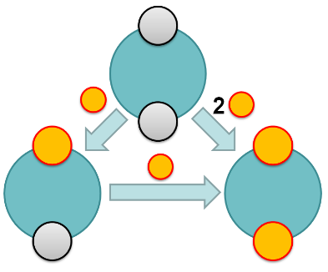

Insert Table of Contents artwork here

