Subjective memory complaints are involved in the relationship between mood and MCI
Jennifer A Yatesª, Linda Clare^{b}, Robert T Woodsª, Fiona E Matthews^{c} and the Cognitive Function and Ageing Study Wales
ªDementia Services Development Centre, Bangor University
^{b}School of Psychology, Bangor University
^{c}MRC Biostatistics Unit, The University of Cambridge
Present address of Jennifer A Yates (different from affiliation):
B109 Division of Rehabilitation & Ageing
School of Medicine
Queen’s Medical Centre
University Of Nottingham
NG7 2UH

Running title: Subjective memory complaints, mood and MCI

Correspondence address:
Jennifer A Yates
B109 Division of Rehabilitation & Ageing
School of Medicine
Queen’s Medical Centre
University Of Nottingham
NG7 2UH
Telephone: 0115 82 31519
Fax: 0115 82 30231
Email: Jennifer.yates@nottingham.ac.uk

Abstract
Subjective memory complaints (SMC) are a criterion in many definitions of mild cognitive impairment (MCI). However, there is controversy over whether they are useful and appropriate, as previous research has suggested that they may instead be a function of mood problems such as anxiety and depression. This paper aimed to establish the relationship between MCI and mood in older people and to investigate the role that SMC play in the relationship. Structured interviews were conducted with community dwelling older people in Wales to collect information regarding changes in cognitive functioning, mood and well-being that are experienced as people age. An algorithm was used to categorise participants into three groups of not cognitively impaired, MCI including SMC (MCI), and MCI without SMC (MCIW). The odds of experiencing anxiety or depression were calculated for each cognitive group. A mediation analysis was performed using cognition as a dichotomous variable, grouped using an age-, education-, and gender-adjusted median cut off point. Participants with MCI had increased odds of experiencing symptoms of both anxiety and depression, but the odds were not changed for participants in the not cognitively impaired or MCIW categories. Mediation analyses showed that SMC partially mediated the relationship between anxiety and cognition, and depression and cognition. Mood problems may be related to SMC rather than objective cognitive impairment, as only participants with MCI that included SMC showed increased odds of experiencing anxiety and depression. SMC are likely to play a mediating role in the relationship between mood and cognitive functioning.

Keywords: Anxiety, depression, mild cognitive impairment, memory

Introduction
Mild cognitive impairment (MCI) is a categorisation that may be applied to older people who experience a level of cognitive decline considered more severe than normal ageing but not thought sufficient in extent or severity to constitute dementia [1]. The broader MCI definition encompasses the following criteria: an objective impairment in memory or other cognitive domains such as language, a subjective memory complaint, absence of dementia, intact general cognition and intact activities of daily living [2-4]. Currently, several variants of this definition exist, and such variations differ in the extent to which they endorse the criteria above [5].
The role of subjective memory complaints (SMC) in the MCI definition is questioned by researchers as some studies have found it to lack accuracy as a diagnostic criterion [6]. SMC are common in the healthy older population [7] but were found to have little relationship with either informant reports or cognitive test results [8]. Previous research has also found that as many as 62% of individuals experiencing cognitive decline do not report it [9], suggesting that SMC can occur in those without impairments, and often do not occur in those with impairments.
Investigating SMC is important as evidence has shown a link between them and future cognitive decline. Schmand et al. [10] found that SMC were associated with greater odds of having a dementia diagnosis after four years. There is also a growing body of research investigating subjective cognitive decline as a distinct stage on the cognitive continuum between normal ageing and dementia. Subjective cognitive decline is thought to occur before MCI and potentially represents a stage when the person is aware of changes in their cognitive functioning, but these changes are not detected by formal testing.
One explanation for the discrepancy in the relationship between SMC and cognitive decline could be the influence of mood, such as symptoms of anxiety or depression. It was found that anxiety and depression are related to MCI [11, 12] and also to SMC [13, 14].
Previous research conducted by this team found that SMC are linked to symptoms of anxiety and depression but not necessarily to objective cognitive impairment. As such, this study aims to update this research using data that were collected more recently from a sample that matched the demographic of the original study as closely as possible. This study will answer the following questions:
- Are people with MCI more likely to have symptoms of anxiety or depression compared to people without cognitive impairment?
- Are people with SMC more likely to report symptoms of anxiety and depression than those without SMC?
- Do SMC mediate the relationship between cognitive impairment and symptoms of anxiety or depression?
Method
Design
Mood, cognitive functioning and SMC were examined using cross-sectional data from a large sample of community dwelling older people who participated in the Cognitive Functioning and Ageing Study Wales (CFAS Wales). CFAS Wales is a longitudinal population-based study which has gathered information about participants drawn from two research centres in urban and rural areas of Wales, investigating changes that people may experience as they age. Participants took part in face-to-face interviews, which were usually conducted in their own homes, with trained interviewers through the medium of English or Welsh, depending on the participant’s preference. Participants were followed up after 24 months to complete the interview again. Ethical approval was granted by the appropriate NHS Ethics committees. This paper presents baseline data.
Participants
Individuals over 65 years and living in the Gwynedd, Ynys Môn and Neath Port Talbot areas of Wales were randomly sampled between 2011 and 2013. Participants were excluded from the analysis if they had a diagnosis of dementia (n=129), impaired ADLs (n=52) or cognitive decline greater than that expected for a classification of MCI, but not meeting the criteria for dementia for other reasons (other cognitive impairment no dementia; OCIND; n=152) resulting in n=3137 participants included in this analysis.
Definition of subjective memory complaints
Subjective memory complaints were indicated by a self-report of memory problems by the participant. This was assessed using the following questions asked during the structured interview: “Have you ever had any difficulty with your memory?” and “Have you tended to forget things recently?” A positive answer to either question resulted in a participant being categorised as having SMC, which was a dichotomous category.
Assessment of mood
Symptoms of anxiety and depression were assessed during the structured interview. Anxiety and depression were defined using the Geriatric Mental State Automated Geriatric Examination for Computer Assisted Taxonomy (GMS-AGECAT) algorithm [15], where a score of two indicated mild symptoms and a score of three or above indicated a case of anxiety or depression. This study has considered all participants with a score of two or above in order to take into account milder symptoms.
Classification of cognitive status
MCI was defined using the cognitive status algorithm (See Figure 1). Participants classified as having MCI displayed an objective cognitive impairment, intact general cognitive functioning (indicated by a score of greater than 22 on the MMSE), intact ADLs, an absence of dementia and SMC. Objective cognitive impairment was defined using the CAMDEX CAMCOG [16] which formed a section of the structured interview. A score falling one standard deviation below age-adjusted norms on any cognitive domain measured in the CAMCOG represented impairment.
A further group of participants was created using the cognitive status algorithm (Figure 1) that included all participants who would otherwise meet criteria for MCI, except that they did not report SMC. This group was referred to as MCI-without (MCIW).
Participants in the OCIND, ADL or dementia categories, defined using the cognitive status algorithm (Figure 1) were excluded from analyses as they represented a level of impairment greater than would be expected for a classification of MCI.
For use in mediation analyses, the total CAMCOG score was separated into two groups split by the age, gender and education adjusted median score (See Supplementary Material, Table S3).
Statistical analyses
Analyses were conducted using SPSS 20.0. Differences between participants with and without SMC were described. Logistic regression was conducted to determine the odds of experiencing symptoms of anxiety or depression for each cognitive status and for participants with and without SMC. A mediation analysis was conducted using the median split of the CAMCOG, symptoms of anxiety or depression as the outcome variable and the presence of SMC as the mediating variable, using logistic regression and Sobel’s test to determine significance. Sensitivity analyses were also conducted and can be found in the supplementary material at the end of this chapter.
Results
The characteristics of the study sample are shown in Table 1. Data were analysed from 3173 participants who were classified according to cognitive status as having no cognitive impairment (NCI), MCI or MCIW. SMC were reported by 1050 participants (33.1%), with 200 participants (6.3%) meeting criteria for MCI and 329 participants (10.4%) being categorised as MCIW.

(((Table 1 here)))

Are people with MCI more likely to have symptoms of anxiety or depression compared to people without cognitive impairment?
Logistic regression showed that the odds of experiencing symptoms of anxiety were significantly increased in people who had been classified as having MCI (OR=1.93, CI=1.16-3.22, p=.012) but not for people classified as MCIW (OR=0.68, CI=0.37-1.23, p=.199) or people without cognitive impairment (OR=0.88, CI=0.59-1.32, p=.542). The same pattern was found for the odds of experiencing symptoms of depression, where the risks were significantly increased in people who had been classified as having MCI (OR=2.04, CI=1.52-2.74, p<.000) but not for people classified as MCIW (OR=1.01, CI=0.77-1.31, p=.968), and the odds were significantly decreased in participants with no cognitive impairment (OR=0.72, CI=0.59-0.88, p=.002).
Are people with SMC more likely to report symptoms of anxiety and depression than those without SMC?
The odds of experiencing symptoms of anxiety and depression were significantly increased in participants who had reported subjective memory complaints (anxiety OR=2.25, CI=1.64-3.09, p<.001; depression OR=2.02, CI=1.71-2.39, p<.001). The number of SMC reported for each AGECAT level of anxiety and depression are shown in Table 3. Data from participants in the NCI group were also analysed separately to determine whether the presence of SMC changed the odds of anxiety or depression in people without cognitive impairment. Logistic regression showed that the odds of both anxiety (OR=2.17, CI=1.53-3.08, p<.000) and depression (OR=2.02, CI=1.68-2.43, p<.000) were significantly increased in participants without cognitive impairment who reported SMC.

(((Table 2 here)))

Do SMC mediate the relationship between cognition and symptoms of anxiety or depression?
Logistic regression was used to investigate whether SMC mediate the relationship between cognition and anxiety. Sensitivity analyses conducted prior to mediation analyses indicated that using cognition as a dichotomous variable created by an age-, education- and gender-adjusted median split of the total CAMCOG score would be most appropriate, as this variable had a relationship with anxiety (OR=0.65, CI=0.47-0.89, p=.008), compared to measuring it as a continuous variable (see Supplementary Material, Table S1). Mediation analyses suggest that the association between cognition and anxiety is partially mediated by the presence of SMC (Figure 2A), and the results of the Sobel test suggest that the mediation is significant, z’=-2.30, p=.021.
The CAMCOG median split variable was also used as the measure of cognition in testing for mediation between cognition and depression in order to maintain continuity, although other measures of cognition were assessed in sensitivity analyses (see Supplementary Material, Table S2). In this analysis, the total effect of cognition on depression was significant (OR=0.70, CI=0.59-0.82, p<.000) and mediation analyses show that the association between cognition and depression is partially mediated by the presence of SMC (Figure 2B) and the results of the Sobel test suggest that this mediation is significant, z’=-2.48, p=.013.

(((Figure 2 here)))

Participants categorised as having no cognitive impairment were also analysed separately from the MCI and MCIW groups to investigate whether the mediation effect was maintained. The CAMCOG median split variable was again used as the measure of cognition. The relationship between cognition and anxiety in participants categorised as having no cognitive impairment was significant (OR=0.61, CI=0.43-0.86, p=.005) but mediation analyses suggested that SMC did not mediate this relationship (Figure 3A) and the results of the Sobel test were not significant, z’=1.52, p=.129. The relationship between cognition and depression in participants categorised as having no cognitive impairment was significant (OR=0.77, CI=0.64-0.92, p=.005), however the presence of SMC did not mediate this relationship either (Figure 3B) and the results of the Sobel test were not significant, z’=-1.59, p=.113.

(((Figure 3 here)))

Discussion
This study aimed to investigate the relationship between MCI, mood and SMC, using data from a large population study of people over 65 years old and living in Wales. The findings suggest that the odds of experiencing symptoms of both anxiety and depression are significantly increased in people categorised as having MCI (where SMC are part of the criteria), but the odds are not changed for people with no cognitive impairment or for those in the MCIW category. Reports of SMC were also associated with increased odds of having symptoms of anxiety and depression across all cognitive status groups compared to people who did not report SMC. Mediation analyses suggested that SMC partially mediates the relationship between cognition and mood.
The findings from the present study echo the results of previous studies that have also shown an association between MCI and mood [17-20]. SMC may occur due to an individual’s attribution style and may therefore be related to depression as a function of negative attributions, rather than due to cognitive impairment [8, 13]. The relationship between MCI and anxiety may operate in two directions. On one hand, concerns over memory may influence general levels of anxiety, as memory problems can be frightening and anxiety provoking [21]. However, anxiety could be a risk factor for reports of SMC [22] as older people may become more vigilant about their cognitive processes and aware of very subtle changes that are not detected by neuropsychological tests. Previous research has also shown that people reporting SMC were also more likely to report symptoms of anxiety and depression even after controlling for actual cognitive performance [23]. The findings of this study are in line with this research, as participants reporting SMC were more likely than those without SMC to experience mood problems regardless of cognitive status.
The MCIW category and mood problems were not significantly related, suggesting that it is likely that SMC mediate the relationship between MCI and mood, as the only difference between the MCI and MCIW categories is the presence of SMC. This idea is confirmed by mediation analyses, although it is likely that other factors also influence the relationship as the analyses suggest that SMC operate only as a partial mediator, and further investigation is required.
There are several limitations in the present study. The response rate to the interviews from which the data were collected was approximately 50% and it could be suggested that potential participants with anxiety, depression or cognitive impairment may have refused to participate, leaving a sample that is not entirely representative.
The number of participants reporting symptoms of anxiety was small and this could indicate that the questions included in the interview to assess anxiety may not have been sensitive enough. In addition, the AGECAT algorithm [15] used to categorise the level of anxiety may not be effective at classifying people with less severe but more frequent anxiety problems and consequently may miss individuals with sub-clinical levels of anxiety. In addition, older people may not report anxiety, as they may trivialise the symptoms or regard it as a normal part of the ageing process.
The present study has several strengths. Firstly, the data were collected from a large sample which incorporated community dwellers and older people living in institutions, from both urban and rural areas in Wales. In addition, the measures used within the interview to assess cognition such as the MMSE [24] and the CAMCOG [16] are very well established tools for use with older people. Lastly, the use of the MCI and MCIW categories for classifying the cognitive status of the participants made it possible to directly compare how SMC operate in relation to mood. This chapter builds on the previous chapter and adds to the literature regarding the questionable value of including SMC in the MCI definition.
The findings from this chapter have several applications. From a theoretical perspective, the results raise questions regarding the inclusion of SMC as a criterion within the MCI definition. By insisting on the presence of SMC, many people with objective cognitive impairment who could benefit from timely intervention may go undetected by healthcare professionals. In addition, the MCI and MCIW categories may represent different points on the continuum between normal ageing and pathological ageing. Research suggests that symptoms of anxiety and depression are associated with progression from MCI to dementia, and the lack of relationship between mood and the MCIW category compared to the relationship shown with the MCI category could indicate that MCI is a step further along on the pathway to pathological ageing. Alternatively, the MCIW category may represent a separate trajectory, on which participants may progress to further cognitive decline, remain stable or even improve their cognitive performance. It would be interesting to follow this sub-sample of participants over time and observe their cognitive journey.
Clinical applications of the findings could include the identification of symptoms of anxiety or depression in older people who report SMC, as the present study suggests that SMC may be related to mood rather than objective cognitive performance. Previous research found that an improvement in mood was associated with a decline in the reporting of SMC [21]. Coupled with research that suggests that SMC are related to a lower quality of life [25], this could mean that detecting and addressing mood problems could reduce SMC and in turn improve quality of life. Interventions to improve mood problems may in turn also help to reduce the chances of progression from MCI to dementia.
The findings of this study highlight the requirement for more research in this area. The association between MCI and anxiety could be investigated with more comprehensive measures of anxiety, such as a scaled measurement tool, instead of using the AGECAT algorithm [15]. A factor analysis could be conducted using questions regarding anxiety to determine the nature of anxiety in older people, and the worries or concerns that affect them. Understanding anxiety better in older people may help to develop a better understanding of how mood, cognitive function and SMC interact.
This study has shown that the odds of experiencing symptoms of anxiety and depression are increased in participants categorised as MCI, but the odds are not increased in those without cognitive impairment, or those categorised as MCIW, suggesting that SMC are more likely to be related to mood problems rather than objective cognitive impairment. The results suggest that SMC may play a mediating role in the relationship between MCI and mood problems. Awareness of the interplay between SMC and mood may help older people to obtain targeted assistance for both memory and mood problems which may in turn positively affect their quality of life.

References

[1] Matthews FE, Stephan BCM, McKeith IG, Bond J, Brayne C (2008) Two year progression from mild cognitive impairment to dementia: To what extent do different definitions agree? Journal of the American Geriatrics Society 56, 1424 - 1433.
[2] Petersen RC, Smith GE, Waring SC, Ivnik RJ, Tangalos EG, Kokmen E (1999) Mild cognitive impairment: Clinical characterization and outcome. Archives of Neurology 56, 303-308.
[3] Petersen RC, Doody R, Kurz A, Mohs RC, Morris JC, Rabins PV, Winblad B (2001) Current concepts in mild cognitive impairment. Archives of Neurology 58, 1985 - 1992.
[4] Petersen RC (2004) Mild cognitive impairment as a diagnostic entity. Journal of Internal Medicine 256, 183 - 194.
[5] Stephan BCM, Brayne C, McKeith IG, Bond J, Matthews FE (2008) Mild cognitive impairment in the older population: Who is missed and does it matter? International Journal of Geriatric Psychiatry 23, 863 - 871.
[6] Lenehan ME, Klekociuk SZ, Summers MJ (2012) Absence of a relationship between subjective memory complaint and objective memory impairment in mild cognitive impairment (MCI): is it time to abandon subjective memory complaint as an MCI diagnostic criterion? International Psychogeriatrics 24, 1 - 10.
[7] Podewils LJ, McLay RN, Rebok GW, Lyketsos CG (2003) Relationship of self-perceptions of memory and worry to objective measures of memory and cognition in the general population. Psychosomatics 44, 461-470.
[8] Jorm AF, Christensen H, Korten AE, Henderson AS, Jacomb PA, Mackinnon A (1997) Do cognitive complaints either predict future cognitive decline or reflect past cognitive decline? A longitudinal study of an elderly community sample. Psychological Medicine 27, 91-98.
[9] Iliffe S, Pealing L (2010) Subjective memory problems. BMJ 340, 703-706.
[10] Schmand B, Jonker C, Geerlings MI, Lindeboom J (1997) Subjective memory complaints in the elderly: Depressive symptoms and future dementia. The British Journal of Psychiatry 171, 373-376.
[11] Barnes DE, Alexopoulos GS, Lopez OL, Williamson JD, Yaffe K (2006) Depressive symptoms, vascular disease, and mild cognitive impairment: findings from the Cardiovascular Health Study. Archives of General Psychiatry 63, 273-279.
[12] Yates JA, Clare L, Woods RT (2013) Mild cognitive impairment and mood: a systematic review. Reviews in Clinical Gerontology 23, 317-356.
[13] Dux MC, Woodard JL, Calamari JE, Messina M, Arora S, Chik H, Pontarelli N (2008) The moderating role of negative affect on objective verbal memory performance and subjective memory complaints in healthy older adults. Journal of the International Neuropsychological Society 14, 327-336.
[14] Minett TSC, Da Silva RV, Ortiz KZ, Bertolucci PHF (2008) Subjective memory complaints in an elderly sample: a cross-sectional study. International Journal of Geriatric Psychiatry 23, 49-54.
[15] Copeland JRM, Dewey ME, Griffiths-Jones HM (1986) A computerized psychiatric diagnostic system and case nomenclature for elderly subjects: GMS and AGECAT. Psychological Medicine 16, 89-99.
[16] Huppert FA, Brayne C, Gill C, Paykel ES, Beardsall L (1995) CAMCOG - a concise neuropsychological test to assist dementia diagnosis: socio-demographic determinants in an elderly population sample. British Journal of Clinical Psychology 34, 529-541.
[17] Lyketsos CG, Lopez O, Jones B, Fitzpatrick AL, Breitner J, DeKosky S (2002) Prevalence of neuropsychiatric symptoms in dementia and mild cognitive impairment: results from the cardiovascular health study. JAMA : the journal of the American Medical Association 288, 1475-1483.
[18] Kruger TM, Abner EL, Mendiondo M, Schmitt FA, Smith CD, Jicha GA (2012) Differential reports of pain and depression differentiate mild cognitive impairment from cognitively intact elderly participants. Journal of Geriatric Psychiatry and Neurology 25, 107 - 112.
[19] Fernandez-Martinez M, Molano A, Castro J, Zarranz JJ (2010) Prevalence of neuropsychiatric symptoms in mild cognitive impairment and Alzheimer's disease, and its relationship with cognitive impairment. Current Alzheimer research 7, 517-526.
[20] Van der Linde R, Stephan BCM, Matthews FE, Brayne C, Savva GM (2010) Behavioural and psychological symptoms in the older population without dementia – relationship with socio-demographics, health and cognition. Biomed Central Geriatrics 10.
[21] Antikainen R, Hanninen T, Honkalampi K, Hintikka J, Koivumaa-Honkanen H, Tanskanen A, Viinamaki H (2001) Mood improvement reduces memory complaints in depressed patients. European Archives of Psychiatry and Clinical Neuroscience 251, 6-11.
[22] Derouesne C, Lacomblez L, Thibault S, LePoncin M (1999) Memory complaints in young and elderly subjects. International Journal of Geriatric Psychiatry 14, 291-301.
[23] Comijs HC, Deeg DJ, Dik MG, Twisk JW, Jonker C (2002) Memory complaints; the association with psycho-affective and health problems and the role of personality characteristics. A 6-year follow-up study. Journal of Affective Disorders 72, 157-165.
[24] Folstein MF, Folstein SE, McHugh PR (1975) ‘Mini-mental state’. A practical method for grading the cognitive state of patients for the clinician. Journal of Psychiatric Research 12, 189 - 198.
[25] Mol MEM, van Boxtel MPJ, Willems D, Jolles J (2006) Do subjective memory complaints predict cognitive dysfunction over time? A six-year follow-up of the Maastricht Aging Study. International Journal of Geriatric Psychiatry 21, 432–441.

Figure 1: Flow diagram of the cognitive status algorithm
START
Dementia
(AGECAT score of O3 or higher)
Objective memory or non-memory cognitive impairment
(below age adjusted norms on CAMCOG)
YES
NO
Categorised as dementia and coded as 3 in the dataset
NO
YES
Categorised as no cognitive impairment (NCI) and coded as 0 in the dataset
Subjective memory complaint
NO
YES
Categorised as mild cognitive impairment-without (MCIW) and coded as 2 in the dataset
Intact general cognition
(score >22 on MMSE)
NO
YES
Categorised as impaired ADLs (ADL) and coded as 5 in the dataset
Intact activities of daily living (ADLs)
Categorised other cognitive impairment (OCIND) and coded as 3 in the dataset
NO
YES
Categorised as mild cognitive impairment (MCI) and coded as 1 in the dataset
A | B
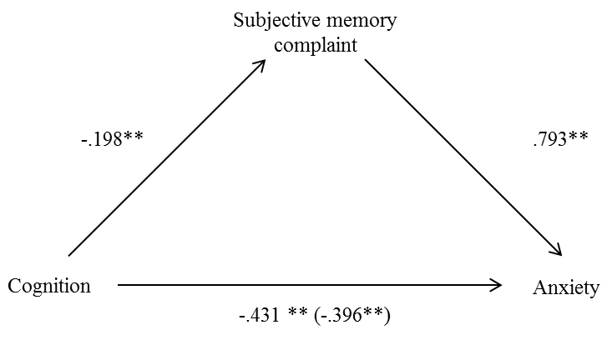 | 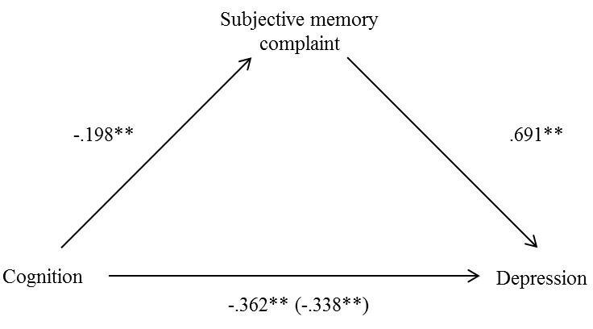
Figure 2:The relationships between cognition and anxiety (A) and cognition and depression (B) are partially mediated by subjective memory complaints

A | B
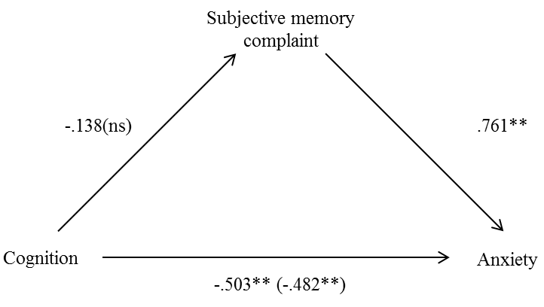 | 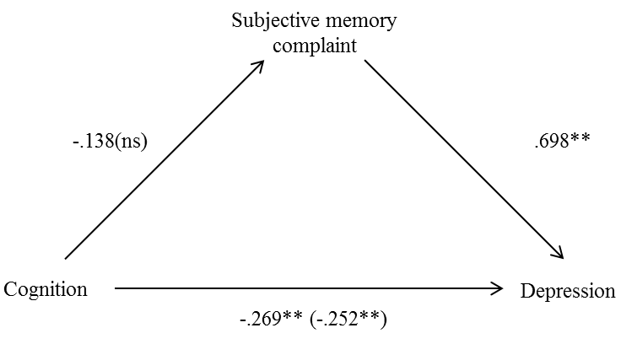
Figure 3: The relationships between cognition and anxiety (A) and cognition and depression (B) in participants categorised as having no cognitive impairment are not mediated by subjective memory complaints

Table 1: Sample characteristics for participants with and without SMC
 | No SMC | SMC | Total (%)
Age mean (SD) | 74.34 (6.89) | 74.34 (6.79)
MMSE mean (SD) | 27.55 (2.19) | 27.22 (2.30)
CAMCOG mean (SD) | 85.20 (10.65) | 84.83 (8.47)
Years in FT Education mean (SD) | 11.73 (2.69) | 11.73 (2.83)
Female N (%) | 1205 (56.8) | 524 (50.1) | 1729 (54.5)
With anxiety N (%) | 79 (3.7) | 84 (8.0) | 163 (5.1)
Without anxiety N (%) | 2044 (96.3) | 966 (92.0) | 3010 (94.9)
With depression N (%) | 431 (20.3) | 357 (34.0) | 788 (24.8)
Without depression N (%) | 1692 (79.7) | 693 (66.0) | 2385 (75.2)
Total (%) | 2123 (66.9) | 1050 (33.1) | 3173 (100)

Table 2: SMC reported for each AGECAT level of anxiety and depression
 | No SMC | SMC |  |  | No SMC | SMC
Anxiety Level 0 | 1352 | 518 |  | Depression level 0 | 1617 | 620
Anxiety Level 1 | 692 | 448 |  | Depression level 1 | 75 | 73
Anxiety Level 2 | 32 | 27 |  | Depression level 2 | 270 | 239
Anxiety Level 3 | 37 | 37 |  | Depression level 3 | 122 | 81
Anxiety Level 4 | 10 | 15 |  | Depression level 4 | 39 | 37
Anxiety Level 5 | 0 | 5

Supplementary material
Various measures of cognition were assessed using logistic regression to investigate the relationship with anxiety in order to select the most appropriate measure to include in the mediation model. The results of the logistic regressions are shown in Table S1. The CAMCOG median split measure of cognition is the only measure of cognition that is significant, and also yields a significant Sobel test statistic. Table S2 shows the sensitivity analyses conducted using logistic regression to investigate the relationship between cognition and depression.

Table S1: Sensitivity analyses using logistic regression to show the relationship between different measures of cognition and anxiety and results of the Sobel test for mediation with SMC as a mediating variable
 | OR | CI | P | Sobel test | P
MCItotal | 1.14 | 0.76-1.71 | .542 | 2.25 | .025
CAMCOG total score | 0.99 | 0.98-1.00 | .176 | -0.98 | .327
CAMCOG median split | 0.65 | 0.47-0.89 | .008 | -2.29 | .021
MCItotal groups MCI and MCIW together and compares them to no cognitive impairment
CAMCOG total score is the total score achieved by each participant on the CAMCOG questions asked in the interview
CAMCOG median split is a dichotomous variable created from splitting the CAMCOG scale into two groups using the median of the scale

Table S2: Sensitivity analyses using logistic regression to show the relationship between different measures of cognition and depression and results of the Sobel test for mediation with SMC as a mediating variable
 | OR | CI | P | Sobel test | P
MCItotal | 1.39 | 1.13-1.71 | .002 | 2.40 | .016
CAMCOG total score | 0.98 | 0.98-0.99 | .000 | -0.99 | .320
CAMCOG median split | 0.70 | 0.59-0.82 | .000 | -2.48 | .013
MCItotal groups MCI and MCIW together and compares them to no cognitive impairment
CAMCOG total score is the total score achieved by each participant on the CAMCOG questions asked in the interview
CAMCOG median split is a dichotomous variable created from splitting the CAMCOG scale into two groups using the median of the scale

Table S3: Median CAMCOG scores for each age/gender/education group
Age (years)
 | 65-69 |  | 70-74 |  | 75-79 |  | 80-84 |  | 85-90 |  | 90+
Education | L | H | L | H | L | H | L | H | L | H | L | H
Female | 87 | 89 | 83.5 | 88 | 86.5 | 85 | 82 | 85 | 80 | 80 | 70.5 | 78
Male | 88 | 89 | 86 | 89 | 84 | 87 | 81 | 85 | 81 | 85 | 76 | 80.5
L: Nine or less years in full time education
H: Ten or more years in full time education

